Form-wound Squirrel Cage Induction Motors—375 kW (500 Horsepower) and Larger

API STANDARD 541

SIXTH EDITION, XXXX 202X

**FINAL BALLOT DRAFT**

# General

## Scope

### This standard covers the minimum requirements for special purpose form-wound squirrel cage induction motors 375 kW (500 hp) and larger for use in petroleum, chemical, and other industry applications. This standard can also be used for induction generators by substituting “generator” for “motor” where applicable.

Notes following a paragraph in Sections 1 through 8 are informational only and are not enforceable as part of this standard.

* A special purpose machine typically has one or more of the following characteristics:
* is in an application for which the equipment is designed for uninterrupted, continuous operation in critical service, and for which there is usually no installed spare equipment;
* is larger than 2250 kW (3000 hp) for speeds 1800 rpm and below;
* is rated 600 kW (800 hp) or greater for two pole (3000 rpm or 3600 rpm) machines of totally enclosed construction, or rated 930 kW (1250 hp) or greater for two pole machines of open or guarded construction (including machines with WP-I or WP-II type enclosures);
* drives a high-inertia load (in excess of the load Wk2 listed in NEMA MG 1, Part 20);
* uses an adjustable speed drive (ASD) as a source of power;
* is an induction generator;
* is a vertical machine rated 375 kW (500 hp) or greater; or
* operates in abnormally hostile environments.

A round bullet (●) at the beginning of a paragraph indicates that either a decision is required or further information is to be provided by the purchaser. This information shall be indicated on the datasheets (see Annex A); otherwise, it shall be stated in the quotation request or in the order.

A diamond bullet (◻) at the start of a paragraph indicates additional requirements for motors applied with ASDs.

### The purchaser specifies machine details and features by completing the associated sections of the data sheets in Annex A.~~the associated standard requires the purchaser to specify details and features. The purchaser shall complete the datasheets in Annex A.~~

* Guidance for completion of the datasheets is provided in Annex C.

**1.1.3** The vendor completes the details and features by completing in the vendor sections of the data sheets in Annex A.

**1.1.4** This paragraph left intentionally blank.

**1.1.5** Super synchronous motor applications are addressed in Annex H.

## Alternative Designs

The vendor may offer alternative designs (see 8.4).

## Dimensions and Standards

### · Both the metric (SI) and U.S. customary (USC) system of units and dimensions are used in this standard. Data, drawings, and hardware (including fasteners) related to equipment supplied to this standard shall use the system of units specified by the purchaser. An alternate system of units for hardware (including fasteners and flanges) may be substituted if mutually agreed upon by the purchaser and the vendor.

### · This document recognizes two different systems of standards for the manufacturing and testing of electrical machines: the North American ANSI, IEEE, and NEMA standards and the international EN, IEC and ISO standards. The North American standards are the base documents. When specified by the purchaser, the corresponding international standards are acceptable for use as alternatives; however, this shall not be construed that they are identical to the North American standards.

* The purchaser should be aware that specific requirements contained within corresponding standards may differ.

**1.3.3** · When specified, the machine shall satisfy the additional requirements of the most current editions of IEC 60079-0 (General) and the standard for the particular protection type specified. These include IEC 60079-1 (flameproof enclosures “d”), IEC 60079-2 (pressurized enclosure “p”), IEC 60079-7 (increased safety “e”), or IEC 60079-15 (protection “n”).

NOTE 1: There are specific requirements within the IEC 60079 series of standards that exceed those of API 541.

NOTE 2: The are several commonly used IEC equipment types of protection that are appropriate for motors or generators applied in a Zone 1 or Zone 2 classified location installations. These include, but are not limited to, Equipment protection by flameproof enclosures (“d” for Zone 1 and Zone 2) per IEC 60079-1, Equipment protection by pressurized enclosure "p" (principally "pyb" for Zone 1 and "pzc" for Zone 2) per IEC 60079-2, Equipment protection by increased safety "e" ("eb" for Zone 1 and "ec" for Zone 2) per IEC 60079-7, and Equipment protection by type of protection “n” per IEC 60079-15.

## Conflicting Requirements

In case of conflict between the inquiry, order and datasheets, this document, and any referenced standards, the order of precedence shall be:

* inquiry or purchase order,
* datasheets,
* purchaser’s specifications,
* this API 541 standard, and
* referenced publications.

# Normative References

The editions of the following standards, codes, and specifications that are in effect at the time of publication of this standard shall (to the extent specified herein) form a part of this standard. The purchaser and the vendor shall mutually agree upon the applicability of changes in standards, codes, and specifications that occur after the inquiry.

API Standard 614, *Lubrication, Shaft-Sealing, and Control-Oil Systems and Auxiliaries*

API Standard 618, *Reciprocating Compressors for Petroleum, Chemical and Gas Industry Services*

API Standard 670, *Machinery Protection Systems*

API Standard 671, *Special Purpose Couplings for Petroleum, Chemical and Gas Industry Services*

API Recommended Practice 684, *Standard Paragraphs Rotordynamic Tutorial: Lateral Critical Speeds, Unbalance Response, Stability, Train Torsionals and Rotor Balancing*

API Recommended Practice 691, *Risk-Based Machinery Management*

API Q1, *Quality Management System Requirements for Manufacturing Organizations for the Petroleum and Natural Gas Industry*

ABMA 7 [1], *Shaft and Housing Fits for Metric Radial Ball and Roller Bearings (Except Tapered Roller Bearings) Conforming to Basic Boundary Plan*

ABMA 8.2, *Ball and Roller Mounting Accessories Inch Design*

ABMA 20, *Radial Bearings of Ball, Cylindrical Roller and Spherical Roller Types—Metric Design*

AGMA 9002 [2], *Bores and Keyways for Flexible Couplings (Inch Series)*

ANSI/ASA S12.54 [3], *Acoustics—Determination of Sound Power Levels and Sound Energy Levels of Noise Sources Using Sound Pressure—Engineering Methods for an Essentially Free Field Over a Reflecting Plane*

ASME *Boiler and Pressure Vessel Code*[4], *Section II—Materials (Customary) and (Metric)*

ASME Boiler and Pressure Vessel Code, *Section V—Nondestructive Examination*

ASME Boiler and Pressure Vessel Code, *Section VIII—Pressure Vessels*

ASME Boiler and Pressure Vessel Code, *Section IX—Welding and Brazing Qualifications*

ASME B1.1, *Unified Inch Screw Threads (UN, UNR and UNJ Thread Forms)*

ASME B1.20.1, *Pipe Threads, General Purpose (Inch)*

ASME B16.1, *Gray Iron Pipe Flanges and Flanged Fittings Classes 25, 125, 250*

ASME B16.5, *Pipe Flanges and Flanged Fittings NPS ½ Through NPS 24 Metric/Inch Standard*

ASME B16.11, *Forged Fittings, Socket-Welding and Threaded*

ASME B16.20, *Metallic Gaskets for Pipe Flanges*

ASME B16.21, *Nonmetallic Flat Gaskets for Pipe Flanges*

ASME B36.10M, *Welded and Seamless Wrought Steel Pipe*

ASME B106.1M, *Design of Transmission Shafting*

ASTM A278/A278M [5], *Standard Specification for Gray Iron Castings for Pressure-Containing Parts for Temperatures Up to 650 °F (350 °C)*

ASTM A345, *Standard Specification for Flat-Rolled Electrical Steels for Magnetic Applications*

ASTM A395/A395M, *Standard Specification for Ferritic Ductile Iron Pressure-Retaining Castings for Use at Elevated Temperatures*

ASTM A536, *Standard Specification for Ductile Iron Castings*

ASTM A668, *Standard Specification for Steel Forgings, Carbon, and Alloy, for General Industrial Use*

ASTM A976, *Standard Classification of Insulating Coatings for Electrical Steels by Composition, Relative Insulating Ability and Application*

ASTM D1868, *Standard Test Method for Detection and Measurement of Partial Discharge (Corona) Pulses in Evaluation of Insulation Systems*

ASTM E94/E94M, *Standard Guide for Radiographic Examination Using Industrial Radiographic Film*

ASTM E125, *Standard Reference Photographs for Magnetic Particle Indications on Ferrous Castings*

ASTM E142, *Method for Controlling Quality of Radiographic Testing*

ASTM E709, *Standard Guide for Magnetic Particle Testing*

AWS D1.1 [6], *Structural Welding Code—Steel*

CEN EN 10106 [7], *Cold Rolled Non-Oriented Electrical Steel Sheet and Strip Delivered in the Fully Processed State*

CEN EN 10228-3, *Non-destructive testing of steel forgings – Part 3: Ultrasonic testing of ferritic or martensitic steel forgings*

CEN EN 10250-1, *Open steel die forgings for general engineering purposes—Part 1: General requirements*

IEC 60034-1[8], *Rotating electrical machines - Part 1—Rating and performance*

IEC 60034-2-1, *Rotating electrical machines - Part 2-1: Standard methods for determining losses and efficiency from tests (excluding machines for traction vehicles)*

IEC 60034-2-2, *Rotating electrical machines - Part 2-2: Specific methods for determining losses of large machines from tests – Supplement to IEC 60034-2-1*

IEC 60034-5, *Rotating electrical machines – Part 5: Degrees of protection provided by the integral design of*

*rotating electrical machines (IP code) – Classification*

IEC 60034-6, *Rotating electrical machines – Part 6: Methods of cooling (IC Code)*

IEC 60034-8, *Rotating electrical machines – Part 8: Terminal markings and direction of rotation*

IEC 60034-9, Rotating electrical machines – Part 9: Noise limits

IEC 60034-15, *Rotating electrical machines - Part 15: Impulse voltage withstand levels of form-wound stator coils for rotating a.c. machines*

IEC 60034-18-1, *Rotating electrical machines - Part**18-1: Functional evaluation of insulation systems – General guidelines*

IEC 60034-18-21, *Rotating electrical machines - Part**18-21: Functional evaluation of insulation systems – Test procedures for wire-wound windings – Thermal evaluation and classification*

IEC 60034-18-22, *Rotating electrical machines - Part**18-22: Functional evaluation of insulation systems – Test procedures for wire-wound windings – Classification of changes and insulation component substitutions*

IEC 60034-18-31, *Rotating electrical machines - Part**18-31: Functional evaluation of insulation systems – Test procedures for form-wound windings – Thermal evaluation and classification of insulation systems used in rotating machines*

IEC 60034-18-32, *Rotating electrical machines - Part**18-32: Functional evaluation of insulation systems –**Test procedures for form-wound windings – Evaluation by electrical endurance*

IEC 60034-18-33, *Rotating electrical machines - Part**18-33: Functional evaluation of insulation systems – Test procedures for form-wound windings – Multifactor evaluation by endurance under simultaneous thermal and electrical stresses*

IEC 60034-27-1, *Rotating electrical machines – Part 27-1: Off-line partial discharge measurements on the winding insulation*

IEC 60034-27-2, *Rotating electrical machines - Part 27-2: On-line partial discharge measurements on the stator winding insulation of rotating electrical machines*

IEC 60034-27-3, *Rotating electrical machines - Part 27-3: Dielectric dissipation factor measurement on stator winding insulation of rotating electrical machines*

IEC 60034-27-4*, Rotating electrical machines - Part 27-4: Measurement of insulation resistance and polarization index of winding insulation of rotating electrical machines*

IEC 60034-29, *Rotating electrical machines – Part 29: Equivalent loading and superposition techniques – Indirect testing to determine temperature rise*

IEC 60038, *IEC standard voltages*

IEC 60072-1, Rotating Electrical Machines - *Dimensions and output series – Part 1: Frame numbers 56 to 400 and flange numbers 55 to 1080*

IEC 60072-2, Rotating Electrical Machines - *Dimensions and output series for rotating electrical machines – Part 2: Frame numbers 355 to 1000 and flange numbers 1180 to 2360*

IEC 60079-0, *Explosive atmospheres – Part 0: Equipment – General requirements*

IEC 60079-1, *Explosive atmospheres – Part 1: Equipment protection by flameproof enclosures “d”*

IEC 60079-2, *Explosive atmospheres – Part 2: Equipment protection by pressurized enclosure "p"*

IEC 60079-7, *Explosive atmospheres – Part 7: Equipment protection by increased safety "e"*

IEC 60079-10-1, *Explosive atmosphere*s – Part 10-1: Classification of areas – Explosive gas atmospheres

IEC 60079-10-2, *Explosive atmospheres – Part 10-2: Classification of areas – Explosive dust atmospheres*

IEC 60079-15, *Explosive atmospheres – Part 15: Equipment protection by type of protection "n"*

IEC 60270, *High voltage test techniques—Partial discharge measurements*

IEC 60404-1, *Magnetic materials—Part 1: Classification*

IEC 60404-1-1, *Magnetic materials*—Part 1-1: *Classification—Surface insulations of electrical steel sheet, strip and laminations*

IEC 60751, *Industrial platinum resistance thermometers and platinum temperature sensors*

IEEE 43 [9], *IEEE Recommended Practice for Testing Insulation Resistance of Rotating Machinery*

IEEE 56, *IEEE Guide for Insulation Maintenance of Electric Machines*

IEEE 112, *IEEE Standard Test Procedure for Polyphase Induction Motors and Generators*

IEEE 286, *IEEE Recommended Practice for Measurement of Power-Factor Tip-Up of Electric Machinery Stator Coil Insulation*

IEEE 522, *IEEE Guide for Testing Turn Insulation of Form-Wound Stator Coils for Alternating-Current Rotating Electric Machines*

IEEE 620, *IEEE Guide for the Presentation of Thermal Limit Curves for Squirrel Cage Induction Machines*

IEEE 841, *IEEE Standard for Petroleum and Chemical Industry—Premium-Efficiency, Severe-Duty, Totally Enclosed Squirrel Cage Induction Motors from 0.75 kW to 370 kW (1 hp to 500 hp)*

IEEE 1434, *IEEE Guide to Measurement of Partial Discharges in Rotating Machinery*

IEEE 1776, *IEEE Recommended Practice for Thermal Evaluation of Unsealed or Sealed Insulation Systems for AC Electric Machinery Employing Form-Wound Pre-Insulated Stator Coils for Machines Rated 15 000 V and Below*

ISO 15 [10], *Rolling bearings—Radial bearings—Boundary dimensions, general plan*

ISO 68-1, *ISO General purpose screw threads—Basic profile-Part 1: Metric screw threads*

ISO 261, *ISO General purpose metric screw threads—General plan*

ISO 286-1, *Geometrical product specifications (GPS)-ISO code system for tolerances on linear sizes—Part 1: Basis of tolerances, deviations and fits*

ISO 286-2, *Geometrical product specifications (GPS)-ISO code system for tolerances on linear sizes—Part 2: Tables of standard tolerance classes and limit deviations for holes and shafts*

ISO 492, *Rolling bearings—Radial bearings—Geometrical product specifications (GPS) and tolerance values*

ISO 683-1, *Heat-treatable steels, alloy steels and free-cutting steels —Non-alloy steels for quenching and tempering*

ISO 683-2 *Heat-treatable steels, alloy steels and free-cutting steels —Alloy steels for quenching and tempering*

ISO 3452-1, *Non-destructive testing—Penetrant testing—Part 1: General principles*

ISO 3506-1, *Fasteners-Mechanical properties of corrosion-resistant stainless steel fasteners-Part 1: Bolts, screws and studs with specified grades and property classes*

ISO 3506-2, *Fasteners-Mechanical properties of corrosion-resistant stainless steel fasteners-Part 1: Nuts with specified grades and property classes*

ISO 3744, *Acoustics—Determination of sound power levels and sound energy levels of noise sources using sound pressure—Engineering method for an essentially free field over a reflecting plane*

ISO 5579, *Non-destructive testing—Radiographic examination of metallic materials using X- or gamma rays—Basic rules*

ISO 5753-1, *Rolling bearings—Internal clearance—Part 1: Radial internal clearance for radial bearings*

ISO 5753-2, *Rolling bearings—Internal clearance—Part 2: Axial internal clearance for four-point-contact ball bearings*

ISO 6708, *Pipework components—Definition and selection of DN (nominal size)*

ISO 7005-1, *Pipe flanges—Part 1: Steel flanges for industrial and general service piping systems*

ISO 7483, *Dimensions of gaskets for use with flanges to ISO 7005*

ISO 9001, *Quality management systems - Requirements*

ISO 17640, *Non-destructive testing of welds – Ultrasonic testing – Techniques, testing levels, and assessment*

ISO 19232-1, *Non-destructive testing—Image quality of radiographs-Part 1: Determination of the image quality value using wire-type image quality indicators*

ISO 19232-2, *Non-destructive testing—Image quality of radiographs-Part 2: Determination of the image quality value using step/hole-type image quality indicators*

ISO 19232-3, *Non-destructive testing—Image quality of radiographs-Part 3: Image quality classes*

ISO 19232-4, *Non-destructive testing—Image quality of radiographs-Part 4: Experimental evaluation of image quality values and image quality tables*

ISO 19232-5, *Non-destructive testing—Image quality of radiographs-Part 5: Determination of the image unsharpness and basic spatial resolution value using duplex wire-type image quality indicators*

ISO 21940-11, *Mechanical vibration—Rotor balancing-Part 11: Procedures and tolerances for rotors with rigid behaviour*

ISO 29001, *Petroleum, petrochemical and natural gas industries – Sector-specific quality management systems – Requirements for product and service supply organizations*

ANSI/NEMA MG 1 [11], *Motors and Generators*

ANSI/NEMA C50.41, *Polyphase Induction Motors for Power Generating Stations*

NEMA 250, *Enclosures for Electrical Equipment (1000 Volts Maximum)*

NFPA 70 [12], *National Electrical Code*

SAE J1086, *Numbering Metals and Alloys*

## 3 Terms, Definitions, Acronyms, and Abbreviations

**3.1 Terms and Definitions**

For the purposes of this document, the following terms and definitions apply.

* .1

accelerating torque

The difference between the input torque to the rotor (electromagnetic for a motor or mechanical for a generator) and the sum of the load and loss torque; the net torque available for accelerating the rotating parts.

3.1.2

adjustable speed drive

ASD

Refers to the electronic equipment used to regulate the operating speed of the motor and driven equipment by controlling the frequency and voltage.

* Other terms commonly used are variable speed drive, adjustable frequency drive, ~~and~~variable frequency drive, and converter~~, however, use of these terms is discouraged~~.

3.1.3 This paragraph left intentionally blank

3.1.4

anchor bolts

Bolts used to attach the equipment to the support structure (concrete foundation or steel structure”.

Cf. “hold-down bolts”

3.1.5

approve

Provide written documentation confirming an agreement.

3.1.6

balance weight

Any mass added to a rotating component with the purpose of reducing unbalance to the required level in the balance device and not defined as a trim balance weight.

NOTE: Balance weight can also be defined as a correction mass

3.1.7

breakdown torque

Maximum torque that it will develop with rated voltage applied at rated frequency without an abrupt drop in speed.

3.1.8

cold start

~~A cold start is a motor start that o~~Occurs when the rotor and stator are initially at or below rated ambient temperature.

**3.1.9**

**comparable converter (ASD)**  
Converter where the losses in the motor supplied by the converter are not higher than the losses that would have occurred if the motor were used with the specific converter that was used during the type test.

NOTE 1 — This converter is similar with respect to the output voltage, output current, and switching frequency specifications so the machine limiting temperatures, for maximum surface temperature and material thermal stability, are not exceeded.

NOTE 2 — “Converter” is the IEC term used to denote an ASD.

**3.1.10**

**hold-down bolts**

**mounting bolts**

Bolts holding the equipment to the mounting plate

3.1.11

hot start

~~A hot start is a~~Any restart ~~of the motor~~ that occurs when the rotor and/or stator ~~motor is at a temperature~~ are above rated ambient temperature.

**3.1.12**

**hydrodynamic bearings**

Bearings that incorporate a fluid film to form an oil wedge, or wedges, that support the load without shaft-to-

bearing contact.

**3.1.13**

**informative**

For advice only.

Cf. “normative

**3.1.14**

**in-frame balance**

Process of balancing the rotor assembly in its own bearings and support structure (e.g. frame, brackets, pedestal) rather than in a balance device.

3.1.15

lateral critical speed

Shaft rotational speed at which the rotor-bearing-support system is in a state of resonance.

* The basic identification of critical speeds is made from the natural frequencies of the system and of the forcing phenomena. If the frequency of any harmonic component of a periodic forcing phenomenon is equal to or approximates the frequency of any mode of rotor vibration, a condition of resonance may exist. If resonance exists at a finite speed, that speed is called a critical speed. This standard is concerned with actual resonant speeds rather than various calculated values. Actual critical speeds are not calculated undamped values but are critical speeds confirmed by test-stand data. Critical speeds above the maximum test speed should be calculated damped values.

3.1.16

locked-rotor torque

Minimum torque that it will develop at rest for all angular positions of the rotor, with rated voltage applied at rated frequency.

**3.1.17**

**normative**

Required.

Cf. “informative

NOTE A normative reference or annex invokes a requirement or mandate of the specification.

3.1.18

oil mist lubrication

A lubrication system that employs oil mist produced by atomization in a central unit and transported to the bearing housing or housings by compressed air.

3.1.19

owner

Final recipient of the equipment who may delegate another agent as the purchaser of the equipment.

3.1.20

power factor

PF

Ratio of kilowatt input to kilovolt-ampere input for a motor or the ratio of kilowatt output to kilovolt-ampere output for a generator.

3.1.21

pressure lubrication

Applies to bearings that are either lubricated by filling the bearing with pressurized oil or bearings that are flood lubricated by oil directed at the bearing surfaces. This pressurized oil source may be either connected to or independent of the machine.

3.1.22 This paragraph left intentionally blank

3.1.23 This paragraph left intentionally blank

3.1.24

pull-up torque

Minimum torque developed by the motor during the period of acceleration from rest to the speed at which breakdown torque occurs. For motors that do not have a definite breakdown torque, the pull-up torque is the minimum torque developed up to the rated speed.

3.1.25 This paragraph left intentionally blank

3.1.26

purchaser

Agency that issues the order and specification to the vendor.

3.1.27

pure oil mist lubrication

Pure oil mist lubrication (dry sump) systems are those in which the mist both lubricates the bearing and purges the housing.

3.1.28

purge oil mist lubrication

Purge oil mist lubrication (wet sump) systems are those in which the mist purges the bearing housing. Bearing lubrication is by a conventional oil-bath, flinger, or oil ring lubrication system. 3.

**3.1.29**

**removable link**

Insulated copper bus bars that are installed in the main machine terminal box and located such that the

removal of the bus bars isolates each phase winding from the line side power connections and any terminal

box auxiliary devices.

3.1.30

self-lubricated

Hydrodynamic bearings that utilize rotation of the shaft to continuously apply lubricant to the bearing

surfaces from an oil reservoir located beneath the bearing. Self-lubricated bearings include bearings

partially immersed in the oil reservoir and bearings with rings in contact with the shaft.

3.1.31

service factor

A multiplier applied to the rated power of an AC motor, indicates an increased loading that may be carried under the conditions specified for the service factor (see NEMA MG 1).

NOTE For service factors above 1.0, the motor will run at an increased temperature and insulation life will be

adversely affected.

**3.1.32**

**soleplate**

Plate attached to the foundation, with a mounting surface for equipment or for a baseplate.

3.1.33

special tool

A tool or device that is not a commercially available catalog item.

3.1.34

torsional critical speeds

Correspond to resonant frequencies of the complete mass-elastic system in the drive train including motor, couplings, and driven equipment.

The first torsional natural frequency of motor-driven equipment combinations normally lies between twice the line frequency and zero frequency and may be excited from the motor or driven equipment. This means that at least the first torsional critical speed is traversed each time such a drive train is started. Depending on the mechanical characteristics of the drive train at the resonant speed defined by the intersection of the natural torsional frequency and the frequency of potential torque oscillations, the torque oscillation may be escalated to a point at which unacceptably high torsional stress occurs in the rotating system if there is not sufficient damping within the system.

**3.1.35**

**trim balance**

**trim balance weight**

Adding, modifying, or removing any mass from the completed rotor assembly after it has been balanced in

the balancing device.

3.1.36

trip speed

Speed at which the independent emergency speed device operates to shut down the machine.

**3.1.37**

**types of externally circulated lubrication**

Flood lubrication—Flood lubricated hydrodynamic bearings utilize an external source to continuously apply

low-pressure lubricant to the bearing loading surfaces. This source is typically a common lubrication system

that supplies oil to the multiple bearings of rotating equipment included in an equipment train. Oil is supplied

to the electrical machine at an elevated pressure and reduced to a slightly higher than atmospheric value

by a flow regulating device near the bearing housing(s). Oil flows between the babbitt material and shaft

for lubrication and cooling, then collects in the bearing housing sump and returns to the system through a

properly sized drain. See API 614.

Pressure lubrication—Pressure lubricated hydrodynamic bearings utilize an external source to continuously

apply high-pressure lubricant to the bearing loading surfaces where an over-riding force exists. For

example, external thrust on plate bearings. This source is typically a common lubrication system that

supplies pressurized oil to the multiple bearings of rotating equipment included in an equipment train. Oil is

supplied to the electrical machine at an elevated pressure then regulated near the bearing housing(s). Oil

flows between the babbitt material and stationary surface or shaft for lubrication and cooling, then collected

in the bearing housing sump and returned to the system through a properly sized drain. See API 614.

Hydrostatic jacking—Hydrostatic jacking applies to machines that require that the shaft be lifted, or raised,

from the bearing surface(s) prior to rotation to ensure separation or the development of an oil film. This

source is typically located close to the bearing(s) requiring jacking oil. Oil is injected at an elevated pressure

in specific areas of the shaft-bearing interface to produce separation. It is possible that not all bearings in

an equipment train require jacking oil. Hydrostatic jacking is also used to aid in maintenance where the

rotor or train components are spun or indexed at slow rpm by an external source.

3.1.38

unit responsibility

Refers to the responsibility for coordinating the technical aspects of the equipment and all auxiliary systems included in the scope of the order. The technical aspects to be considered include but are not limited to such factors as the power requirements, speed, rotation, general arrangement, couplings, dynamics, noise, lubrication, sealing system, material test reports, instrumentation, piping, conformance to specifications, and testing of components.

3.1.39

vendor

Manufacturer or manufacturer’s agent that supplies the equipment (also known as the supplier).

3.1.40

vibration forcing phenomena

~~Vibration forcing phenomena are e~~Excitation forces that may cause vibration. The exciting frequency may be less than, equal to, or greater than the synchronous frequency of the rotor. ~~Potential excitations to be considered in the design of the machine shall include but are not limited to the following sources:~~

* ~~mechanical unbalance in the rotor system;~~
* ~~oil film instabilities (whirl or whip);~~
* ~~alignment tolerances;~~
* ~~gear problems (e.g. unbalance and pitch line runout);~~
* ~~start-up condition frequencies;~~
* ~~twice the line frequencies;~~
* ~~electrical unbalance;~~
* ~~mechanical pulsations produced by the driven equipment;~~
* ~~short circuits (faults) and other transient conditions on the electrical system; and~~

~~j) ASDs.~~

**3.2 Acronyms and Abbreviations**

AIT autoignition temperature

ASD adjustable speed drive

DPG Dripproof guarded

IBC International Building Code

NDE non-drive end

NRTL nationally recognized testing laboratory

OEM original equipment manufacturer

RTD resistance temperature detector

SI International System of Units

TRL technical readiness level

UBC Uniform Building Code

USC United States customary

VDDR vendor drawing and data requirements

VPI vacuum pressure impregnated

WP-I weather protected type I

WP-II weather protected type II

# Basic Design

## General

### Equipment Reliability

~~The equipment (including auxiliaries) covered by this standard shall be suitable for the specified operating conditions and shall be designed and constructed for a minimum service life of 25 years and at least 5 years of uninterrupted continuous operation. It is recognized that this is a design criterion and that uninterrupted operation for this time period involves factors beyond the vendor’s control.~~

* ~~A self-lubricated bearing will require periodic lubricating oil changes. A five year continuous uninterrupted operation may require the installation of a forced oil lubrication system for the bearings. Additional interim maintenance at the manufacturer’s recommended intervals may be required while the machine is in operation.~~

~~The vendor shall supply a machine with all components and material constructed with the latest field proven design (minimum two years) and in current production. If the design dictates the necessity for equipment that has not been in continuous service for at least two years, the vendor shall provide adequate written documentation at the time of proposal describing the particular components and the extent of their experience with such a design or equipment. Obsolete components or those scheduled for discontinuation within the next two years shall not be used.~~

##### · Only equipment that is field proven, as defined by the purchaser, is acceptable.

NOTE Purchasers can use their engineering judgment in determining what equipment is field proven. API 691 can

### provide guidance.

**4.1.1.2** · If specified, the vendor shall provide the documentation to demonstrate that all equipment

proposed qualifies as field proven.

**4.1.1.3** In the event no such equipment is available, the vendor shall submit an explanation of how their

proposed equipment can be considered field proven.

NOTE A possible explanation can be that all components comprising the assembled machine satisfy the field-proven

definition.

### · Machines shall be designed for continuous operation and long periods of inactivity in an atmosphere that is made corrosive by traces of chemicals normally present in a petroleum processing facility. This environment may also include high humidity, storms, salt-laden air, insects, plant life, fungus, and rodents. Machines shall be suitable for operation, periods of idleness, storage, and handling at the ambient temperatures specified under “Site Data” on the datasheets (see Annex A). If additional considerations are necessary, the purchaser shall specify them.

### · Unless otherwise specified, the A-weighted maximum sound pressure level of the motor shall not exceed 85 dBA ~~at any location~~ at a reference distance of 1 m (3 ft) with the motor operating at no load, full voltage, rated frequency, and sinusoidal power. The measuring and reporting of sound pressure level data shall be in accordance with 6.3.5.1.1 g).

For machines that utilize sound insulation, a supplementary mechanical means shall be incorporated to

### prevent pieces of the insulation from coming loose and blocking cooling passages.

### ¨· When specified, a mutually agreed upon sound level shall be measured while the motor is being driven by the contract ASD or one that gives a similar waveform. The purchaser and vendor shall mutually decide the supply frequency. For concerns around increased motor sound levels due to the ASD application, the purchaser should address these issues with the ASD and motor suppliers and reach agreement on the resolution.

* Some ASDs may cause increased motor sound levels due to increased operating speed (if operated above line frequency), excitation of mechanical resonances, and magnetic noise caused by supply source harmonics.

### ¨· All equipment shall be designed to be mechanically stable at the overspeed and duration specified in NEMA MG 1, or IEC 60034-1; or at the specified trip speed (including overshoot) of the connected equipment, whichever is greater. For machines driven by ASDs, the purchaser and vendor shall mutually decide the overspeed capability (see 6.3.5.6).

### ¨· If a motor of type “eb” or “ec” (increased safety protection) is driven by an ASD (i.e., converter), it shall meet the additional requirements of IEC 60079-0 and IEC 60079-7.

### The arrangement of the equipment including number of bearings, terminal housings, conduit, piping, and auxiliaries shall be subject to the approval of the purchaser. The arrangement shall provide adequate clearance areas and safe access for installation, operation, and maintenance.

### The design of piping systems shall achieve the following:

* proper support and protection to prevent damage from vibration and during shipment, operation, and maintenance;
* easily accessible for operation, maintenance, and thorough cleaning;
* installation in a neat and orderly arrangement adapted to the contour of the machine without obstructing access openings;
* elimination of air pockets and traps;
* complete drainage through low points without disassembly of piping; and
* provision for easy removal of covers for maintenance and inspection.

### · The machine and all of its auxiliary devices shall be suitable for and in accordance with the area classification system specified by the purchaser on the datasheets. Auxiliary devices shall be listed or certified where required in accordance with the area classification system specified [e.g. NFPA 70, Article 500, Article 501, Article 502, and Article 505 (Class, Group, Division or Zone, and Temperature Code), IEC 60079-10-1, or IEC 60079-10-2 (Zone, Class, Group, and Temperature Code)] and specified local codes.

* See IEEE 303, IEEE 1349, and IEC 60079 for additional guidance and information on application of motors and accessories in hazardous locations.

### All equipment shall be designed to permit rapid and economical maintenance and inspection. Major parts (e.g. frame components and bearing housings) shall be designed and manufactured to ensure accurate alignment on reassembly. This shall be accomplished by the use of shouldering, cylindrical dowels, or keys.

### Easily removable covers shall be provided for inspection of the coil end turns. Easily removable covers shall be provided for the inspection of the air gap in at least three places at the end of the stator, each separated by 90 as specified in 4.4.7.2.4.

### The manufacturer shall bring to the attention of the purchaser any and all cases where the above requirements cannot be met.

NOTE: Inspection covers are not possible in all situations such as cast frames, smaller fabricated frames, TEAAC air

path, etc.

### If special tools or fixtures are required to disassemble, assemble, or maintain the equipment, they shall be included in the quotation and furnished as a part of the initial supply of the equipment. These special tools shall be used, and their use demonstrated, during shop assembly and post-test disassembly of the equipment.

### NOTE: For multiple-unit installations, the purchaser and vendor shall mutually agree upon the requirements for quantities of special tools and fixtures.

### If special tools are provided, each tool shall be labelled using metal stamps or have a permanently attached stainless steel tag to indicate its intended use. Tools that do not exceed 1 m (3 ft) in length, width, or height, and that weigh less than 40 kg (20 lbs) shall be packaged in one or more rugged metal boxes and shall be marked “special tools for (tag/item number), box x of x.” Larger tools do not need to be boxed but shall have a stainless steel tag permanently attached to indicate both the intended use and the tag/item number of the equipment for which they are intended.

### The equipment (machine and auxiliary equipment) shall perform on the test stand and on their permanent foundation within the specified acceptance criteria. The performance on the permanent foundation may differ from performance on the test stand (see 4.4.6). After installation, the performance of the combined units shall be the joint responsibility of the purchaser and the vendor who has unit responsibility.

### The equipment (including auxiliaries) covered by this standard shall be suitable for the specified operating conditions and shall be designed and constructed for at least 5 years of uninterrupted continuous operation. It is recognized that this is a design criterion and that uninterrupted operation for this time period involves factors beyond the vendor’s control.

NOTE: A self-lubricated bearing will require periodic lubricating oil changes. A five year continuous uninterrupted operation may require the installation of a flood lubrication system for the bearings. Additional interim maintenance at the manufacturer’s recommended intervals may be required while the machine is in operation.

### Oil reservoirs and housings that enclose moving lubricated parts, such as bearings, shaft seals, highly polished parts, instruments, and control elements, shall be designed to meet the requirements of IP55 as a minimum to reduce contamination by moisture, dust, and other foreign matter.

##### 4.1.17 The manufacturer shall have a quality management system in place that conforms to API Specification Q1, ISO 9001, or ISO 29001.

## Electrical Design

### Rating and Voltage

#### · Unless otherwise agreed by the purchaser, NEMA or IEC standard ratings shall be used. If the required rating falls between two listed ratings, the larger listed rating shall be selected.

#### · Unless otherwise specified, induction machines shall have rated voltages in accordance with 4.2.1.2.1, 4.2.1.2.2, and 4.2.1.2.3. The rated voltage shall be specified on the datasheets.

##### Refer to Table 1 for voltage ratings for three phase 60 Hz systems.

##### For 50 Hz supply systems, two different voltage systems are standardized in IEC 60038. Table 2 is widely used in countries following British standards. Table 3 is used for 50 Hz systems in general. Either one of the 50 Hz voltages series may be used as listed in IEC 60038.

~~Either one of the 50 Hz voltage series may be used as listed in IEC 60038.~~

NOTE ~~Other~~ Nonstandard supply voltages would lead to other ~~may be necessary to conform to nonstandard~~ voltages not listed above.

|  |  |  |
| --- | --- | --- |
| * 1—Voltage Ratings for Three Phase 60 Hz Systems | | |
| Horsepower | Motor Voltage | Bus Voltage |
| Up to 4,000 | 2,300 | 2,400 |
| Up to 7,000 | 4,000 | 4,160 |
| 1,000 to 12,000 | 6,600 | 6,900 |
| 3,500 or Above | 13,200 | 13,800 |

|  |  |  |
| --- | --- | --- |
| * 2—Voltage Ratings for Three Phase 50 Hz Systems (British Standards) | | |
| kW | Motor Voltage | Bus Voltage |
| Up to 4,000 | 3,300 | 3,450 |
| Up to 12,000 | 6,600 | 6,900 |
| 4,000 or Above | 11,000 | 11,500 |

|  |  |  |
| --- | --- | --- |
| * 3—Voltage Ratings for Three Phase 50 Hz Systems (General) | | |
| kW | Motor Voltage | Bus Voltage |
| 450 to 4,000 | 3,000 | 3,150 |
| 450 to 12,000 | 6,000 | 6,300 |
| 4,000 or Above | 10,000 | 10,500 |

##### ¨· For motors operating only on ASDs, the voltage and frequency ratings shall be mutually agreed upon by the purchaser and vendor.

* Although ASD output voltage, harmonics, and voltage-to-frequency ratio typically match motor design parameters (voltage and flux), the motor vendor should be informed by the purchaser of any deviations and appropriate design accommodations should be mutually agreed between purchaser and vendor.

#### · Unless otherwise specified, the machine shall operate with a maximum voltage variation of ±10 % and a maximum frequency variation of ±5 % and a total combined variation not to exceed ±10 %.

#### Machines shall have a 1.0 service factor rating. Machines shall be capable of continuous operation at rated load and temperature rise in accordance with 4.3.1.1 b) when operated both mechanically and electrically at rated power, voltage, and frequency. In applications that require an overload capacity, a higher base rating instead of a service factor rating shall be used to avoid exceeding the temperature rise specified in 4.3.1.1 b) and to provide adequate torque capacity.

* Applying a motor such that it will operate at greater than its rated power (i.e. using a service factor higher than 1.0), shortens the life of the machine. All motors that are rated for Class B rise have the inherent capacity to operate above rated power by utilizing the higher temperature capability of Class F insulation (i.e. the heat produced by operating above the rated power may still be within the insulating rating). This higher temperature operation negatively impacts the life of the insulation and other components of the machine. Therefore, machines should only be sized and selected based upon a standard 1.0 service factor rating (see Annex C Datasheet Guide for nameplate rating information).

##### This paragraph left intentionally blank

### Load Requirements

#### · Unless otherwise specified, the load torque characteristics and total load inertia referred to the motor shaft shall be in accordance with NEMA MG 1, Part 20. When the loads have characteristics other than those listed in NEMA MG 1, Part 20, the purchaser shall fully specify the load characteristics of the driven equipment. These characteristics include the following.

* The speed-torque characteristics of the load under the most stringent starting conditions.
* The speed-torque characteristics of the load during reaccelerating conditions when reacceleration following bus transfer is specified.
* Electrical machines are capable of developing transient current and torque considerably in excess of rated values when exposed to an out of phase bus transfer or momentary voltage interruption and reclosing. The magnitude of this transient torque may be many times rated torque and is a function of the machine design, operating conditions, switching time, rotating machine inertias, torsional spring constants, the number of motors on the bus, etc. See NEMA MG 1, Part 20 for bus transfer or reclosing information
* The total load inertia J (Wk2) referred to the motor shaft speed, where W is the rotating mass and k is the *radius of gyration*. This total load inertia shall include all loads connected to the motor shaft (e.g. couplings, gearbox and driven equipment).

To obtain Wk2 (lb-ft2), multiply *J* (kg-m2) by 23.73.

*J* = 0.25GD2

*D* = 2R

where

J is the polar mass moment of inertia (kg-m2);

G is the rotating mass (kg);

D is the diameter (m); ~~and~~

R is the radius of inertia (m);

W is the rotating mass (lb); and

k is the radius of gyration (ft).

### Motor Starting and Running Conditions

#### · Unless otherwise specified, the motor shall be designed to start and accelerate the connected load to running speed with 80 % of rated voltage at the motor terminals.

#### · When specified, the requirements for starting capability, speed-torque, and acceleration time shall be determined with the following information (as applicable) furnished by the purchaser:

* starting method (e.g. captive transformer, reactor, autotransformer, solid state, ASD);
* the minimum available voltage at motor terminals under specified locked rotor current; or
* the minimum available system short circuit MVA and X/R ratio, the base voltage, and the minimum motor terminal voltage during starting in percent of rated motor voltage.

#### When the motor speed-torque curve at the conditions specified in 4.2.3.2 a) or 4.2.3.2 b) is plotted over the load speed-torque curve, the motor developed torque shall exceed the load torque by a minimum of 10 % (motor rated torque as base) at all locations throughout the speed range up to the motor breakdown torque point.

* Some ASDs may limit motor accelerating torque at reduced speeds due to insufficient flux (V/Hz) levels or limitations in the drive’s momentary current capacity. If a this is a concern, the purchaser could work with the motor supplier to implement a special motor design.

#### For certain machine designs, high inertia loads, or power system limitations, the requirements provided in 4.2.3.1, 4.2.4.1, and 4.2.4.4 may not be practical. In these cases, the motor starting characteristics shall be jointly developed between the purchaser and vendor.

#### · When reacceleration is specified, the length of maximum voltage interruptions or fault-related voltage collapse and the expected voltage at the motor terminals during reacceleration shall be furnished by the purchaser.

#### · Unless otherwise specified for reciprocating loads, the current pulsations under the actual operating conditions shall not exceed 40 % of full load current as required by API 618.

* The inertias and torque versus crank angle data at rated and worst-case operating conditions are needed to determine the current pulsation. The results of this analysis and any subsequent design changes may impact the drive train torsional analysis, which is commonly performed by a party other than the motor vendor (see 4.4.6.2.2).

### Motor Starting Capabilities

#### · Unless otherwise specified, the machine shall be designed and constructed for a minimum of 5000 full-voltage starts. Fixed-speed motors shall also have the starting capabilities in Table 4. Starting capabilities for motors different from these shown in Table 4 shall be jointly developed between the purchaser and the vendor (See Note 2 following Table 4)

|  |  |
| --- | --- |
| * 4—Starting Capabilities | |
| Number of Consecutive Successful Starts Under Starting Conditions Specified in 4.2.3 and with the Motor Coasting to Rest Between Starts | |
| Motor initially at ambient temperature (cold start) | 3 |
| Motor at a temperature above ambient but not exceeding its rated operating temperature (hot start) | 2 |

* Typical petroleum process plant operations are such that a motor will have a period of initial use of about two months for pump and compressor run-in and initial plant operations. During this time, the maximum starting capability may be used. A need for maximum capability may also occur during subsequent start-ups. Between these start-up periods, there are usually longer periods of continuous running.
* The starting capabilities for large motors are normally a result of an individual design for the specific load characteristics of the driven equipment and the electrical power system for the most stringent conditions. Therefore, the number of starts could be reduced by one or waiting time between starts could be added for large, high inertia drives like gear-type turbo compressors. For pumps and other low inertia applications, the number of starts may be increased to allow maximum starting flexibility for the operation.

#### The motor vendor shall provide motor thermal capacity data (per 4.2.4.3) necessary for the purchaser to determine the waiting time before allowing a restart and to develop settings for the thermal time constant in the motor protective relay.  As a minimum, this data shall include the following:

* thermal limit curves (per IEEE 620) with the motor initially at ambient temperature;
* thermal limit curves (per IEEE 620) with the motor initially at rated temperature;
* acceleration time curves with the defined shaft load at rated voltage and at the starting voltage conditions specified in 4.2.1 and 4.2.3.1;
* required wait time prior to another start after exhausting the defined number of starts, with the motor running at rated load;
* required wait time prior to another start after exhausting the defined number of starts, with the motor stopped.

f) after exhausting the defined number of starts, required wait time for the motor to return to ambient conditions with the motor stopped

#### · The minimum safe hot stall (locked rotor) time shall be the greater of either five seconds more than or 150 % of the time required to accelerate the specified driven load with the starting voltage specified in 4.2.1 or 4.2.3.1. If these conditions cannot be met, the vendor shall notify the purchaser so that a workable solution can be jointly developed. When specified, the method of safe stall time calculation and the limits shall be described with the proposal. The minimum safe stall (locked rotor) time shall be clearly identified on the thermal limit curves.

#### With rated voltage and frequency applied, motors shall comply with the characteristics listed below. This does not apply to units started by or operated on ASDs. Where these limits shall have an adverse effect on other characteristics (particularly efficiency), the vendor shall state the effect and recommend preferred values.

* · The maximum locked-rotor current shall be between 450 % and 650 % of the rated full-load current unless otherwise specified.
* Induction motors with locked rotor currents less than 450 % may compromise important performance characteristics (e.g. efficiency, breakdown torque, and rotor thermal stability). The purchaser should use caution when specifying a motor with a locked rotor current less than 450 % and verify the vendor has satisfactory experience.
* The minimum locked-rotor, pull-up, and breakdown torques shall not be less than the values listed in NEMA MG 1, Part 20 or IEC 60034-1.

#### ¨· When the motor is started only by an ASD only (and is not designed for other starting methods), the characteristics may be different from those specified in 4.2.4.4 and shall be determined to optimize performance on the ASD.

NOTE 1 Use of motors on ASDs may lead to higher rotor and stator temperatures due to harmonic currents, which could be a concern for Division 2 and Zone 2 applications. In addition, the “displaced neutral” effect of some drive topologies could lead to the shaft being at an elevated voltage to ground which creates the possibility of electric discharge across the bearings and consequent ignition of flammable a mixture.

* Torsional oscillations may be caused by the drive harmonics, leading to the need for a torsional study.
* Damage to the motor and drive could be caused by improper application of system capacitance. Also, possible resonances may be caused by application of surge capacitors, which are not recommended for adjustable speed applications.

NOTE 4 Refer to IEEE 1349 and IEC 60079-0 for incendive energy calculation methods.

##### 4.2.5 This paragraph left intentionally blank.

## Winding and Insulation Systems

### Minimum Insulation Requirements

#### Insulation Class and Preparation

Winding and insulation systems shall have the following properties.

* · Stator windings (including connections between leads and coils) ~~connections~~ shall be copper and have an epoxy base, vacuum pressure impregnated (VPI) nonhygroscopic insulation system. When bus bars are used as interface connections, they shall have the same insulation properties as the wire lead and coil connections. As a minimum, the insulation system shall meet the criteria for Class F insulation listed in NEMA MG 1 or IEC 60034-1 as applicable. Strand insulation shall adhere tightly to the strand in order to minimize voids. Turn and ground wall insulation shall be resistant to the effects of partial discharge. The integrity of strand and turn insulation shall be maintained during forming, winding and VPI treatment. For windings operating at voltages of 6000 volts (line-to-line) or greater, the use of partial discharge suppressant materials is required.
* · The allowable temperature rise above ambient, 40 °C (104 °F) unless otherwise specified, shall not exceed that listed for Class B insulation in NEMA MG 1, Part 20 or IEC 60031-1, as appropriate. The Class B temperature rise requirements shall be satisfied by both resistance and resistance temperature detector (RTD) when corrected to the design maximum ambient temperature. For ambient temperatures above 40 °C (104 °F), the allowable temperature rise shall be reduced accordingly, so as not to exceed the total temperature limits for Class B insulation.

#### ¨· Motors for use on ASDs shall have temperature rises in accordance with 4.3.1.1 b) throughout the defined speed range when applied to the specified ASD and load. The purchaser shall provide the motor supplier with necessary harmonic data. The motor should be designed for the complete range of speed and torque requirements of the application to avoid excessive winding temperature due to insufficient cooling or excessive torque levels.

##### ¨· The purchaser shall provide the motor vendor with drive output voltage amplitude and rise time characteristics at the motor terminals so that the insulation system can be designed to avoid premature insulation breakdown.

##### ¨· Motors used on ASD designs that impose common mode voltage shall be provided with motor ground insulation capable of continuous operation with the resulting level of voltage at the motor terminals. The purchaser shall supply the motor vendor with the value of common mode voltage that will be imposed.

#### This paragraph left intentionally blank.

#### This paragraph left intentionally blank.

#### This paragraph left intentionally blank.

#### The winding insulation system for machines rated above 5 kV shall include a stress gradient tape layer at the slot exit.

#### The winding insulation system for machines rated 5 kV and above shall include a layer of corona suppression tape in the stator slot section.

### The insulation system shall be capable of withstanding the surge test specified in 6.3.4.2.

### All stator insulation systems shall be service proven and shall have been subjected to thermal evaluation in accordance with IEEE 1776 or IEC 60034-18-1 and subparts -21, -22, -31, -32, or -33 as appropriate.

### The total insulation system shall be impervious to the operating conditions specified in 4.1.2. Sheared exposed edges of insulation parts shall be sealed. All insulation, including lead insulation, shall be impervious to attack by the lubricating oil specified.

### The stator windings, including the lead connections, shall have a sealed insulation system that is capable of withstanding a sealed winding conformance test in accordance with NEMA MG 1, Part 20.

### Motors 750 kW (1000 hp) and larger or where differential protection is to be applied shall have both ends of each stator-phase winding brought out to a single terminal box. Owner shall specify the location of the terminal box and conduit or cable entry.

### The entire stator winding insulation system including winding connections and terminal leads shall be tightly secured to prevent insulation cracking and fatigue as a result of motion and vibrations during starting, operation, and electrical transient conditions that produce electromechanical forces in the stator windings. The windings shall withstand electromagnetic and mechanical forces under normal operating conditions, the starting requirements specified in 4.2.4, and the forces associated with phase-to-phase and three-phase short circuits with 110 % of rated voltage.

### Conductors from the stator windings to the main terminals shall be insulated and be separated from ground planes so that the effects of partial discharge are minimized. The machine leads shall have ~~Classs F (~~ a minimum~~)~~ temperature rating of 150 °C and be sized for a minimum of 125 % of rated current at Class B temperature rise. Conductors shall be braced and protected from chafing against the motor frame and terminal box. If used, electrical grade fiberglass shall be nonhygroscopic.

### · When specified, machines rated 6 kV and above shall use bus bar insulated for the rated voltage from the stator winding to the main terminal box connection.

### · When magnetic slot wedges are used, the vendor shall advise the purchaser in the proposal. This wedge system shall comply with the following:

* the magnetic slot wedge installation shall be a system that includes a rigid slot wedge and a global VPI system;
* the magnetic slot wedge shall be of the amorphous or composite design;
* magnetic wedges shall be limited to machines of 630 mm shaft height or less; and
* the manufacturer shall demonstrate a minimum of 10 years proven experience with the magnetic slot wedge machine designs offered.

### All winding connections except those completed in the main terminal box shall be brazed using a silver-based brazing material. Soft soldered connections are not permitted. Any exposed connections shall use a phosphorus free silver brazing material that is not subject to attack by hydrogen sulfide.

## Mechanical Design

### Enclosures

#### General Requirements

The following general requirements apply to enclosures.

* Enclosure parts shall be made of cast or nodular iron, cast steel, or steel plate. Purchaser-approved fiber-reinforced materials may be used for parts (e.g. covers or nonsupportive enclosure sections). All enclosure parts shall have a minimum rigidity equivalent to that of sheet steel with a nominal thickness of 3.0 mm (1/8 in.). Machines utilizing the foundation as part of the enclosure (e.g. large diameter machines) shall be identified in the proposal.
* Air deflectors shall be made of corrosion-resistant material or shall have corrosion-resistant plating or treatment.

c) The risks due to possible circulating currents in the enclosure shall be considered for machines using multi-section enclosures installed in classified locations. Overheating or sparking due to possible circulating currents shall be avoided (where necessary) by bonding together the conducting components in a secure electrical and mechanical manner, or by the provision of adequate bonding straps between the motor housing components. The means shall be functional over the design life of the machine.

d) · When enclosure pre-start purging (also referred to as “pre-start ventilation”) is specified, machines shall be provided with provisions for effective purging as described on the datasheet. The vendor shall state the maximum allowed purge pressure on the datasheet.

* See NFPA 496, IEEE 303, IEEE 1349, and IEC 60079 for information.

e) · Unless otherwise specified, machines rated 6 kV and above shall have TEFC, TEAAC, or TEWAC enclosures (IP44 or higher with IC411, IC511/16, IC611/16/66, or IC81W/6W type cooling; see Table 5).

#### · Motor Enclosures and Corresponding NEMA Specifications

##### Table 5 lists representative types of machine enclosures and the NEMA or IEC specifications to which they conform. The purchaser shall specify the type of enclosure on the datasheets. Designs in which the stator laminations form a part of the external enclosure are not acceptable. Enclosures shall also conform to the requirements of 4.4.1.2.2, 4.4.1.2.3, and 4.4.1.2.4.

|  |  |  |  |  |
| --- | --- | --- | --- | --- |
| * 5—Machine Enclosures and Corresponding NEMA or IEC Specifications | | | | |
| Common Enclosure Type | Designation NEMA MG 1 | Specifications NEMA MG 1 | Minimum Degree of Protection a  IP Code | Method of Coolingb |
| Dripproof guarded | DPG | 1.25.5 | IP22 | IC01 |
| Weather protected |  |  |  |  |
| Type I | WP-I | 1.25.8.1 | IP23 | IC01 |
| Type II | WP-II | 1.25.8.2 | IPW24 | IC01 |
| Totally enclosed |  |  |  |  |
| Fan cooled | TEFC | 1.26.2 | IP44/54 | IC411 |
| Pipe ventilated | TEPV | 1.26.4 | IP44 | IC31/37 |
| Water to air cooled | TEWAC | 1.26.7 | IP44/54 | IC81W c  IC86W d |
| Air to air cooled | TEAAC | 1.26.8 | IP44/54 | IC511c  IC516 d  IC611 c  IC616 d  IC666 e |
| * IEC 60034-5, NEMA MG 1, Section 5. * IEC 60034-6, NEMA MG 1, Section 6. * Shaft driven secondary fan. * Auxiliary secondary fan.   e) Auxiliary primary and secondary fans | | | | |

* The designation used for degree of protection consists of the letters IP followed by two characteristic numerals signifying conformity with the conditions indicated in the tables. When it is required to indicate a degree of protection by only one characteristic numeral, the omitted numeral is replaced by the letter X (e.g. IPX5 or IP2X).

##### Dripproof guarded (DPG), weather protected type I (WP-I), and weather protected type II (WP-II) enclosures (or the IEC equivalents) shall meet the following criteria.

* Ventilation openings shall be limited to a maximum size of 6.0 mm (1/4 in.) by design or by the use of metal screens in accordance with 4.4.10.5 and 5.5.1.
* Weather protected enclosures shall be constructed so that any accumulation of water shall drain from the motor.
* · When abrasive dust conditions have been specified, the exposed winding insulation shall be protected from the abrasive action of airborne particles. This protection shall be in addition to the VPI resin and the vendor’s standard coating.
* Dripproof or weather protected type I (WP-I) enclosures are not recommended for the operating conditions specified in 4.1.2 (e.g. outdoor operation without a protective shelter). Purchasers applying this degree of protection should expect reduced reliability (see 4.1.1 and Table 5).

##### Totally enclosed machines (TEFC, TEPV, TEWAC, and TEAAC) shall meet the following criteria.

* Fan covers shall be made of metal having a minimum rigidity equivalent to that of steel plate with a nominal thickness of 3.0 mm (1/8 in.). Purchaser-approved fiber-reinforced materials may be used. The air intake opening shall be guarded by a grill or a metal screen fastened on the outside of the fan cover. Requirements for grills or metal screens are covered in 4.4.10.5.
* Sheet metal covers or wrappers used to form air passages over the enclosure shall have a minimum rigidity equivalent to that of steel plate with a nominal thickness of 3.0 mm (1/8 in.).
* Totally enclosed machines shall be equipped with a plugged, threaded drain connection located at the lowest point of the frame. This connection shall be shown on the outline drawing.
* Requirements for heat exchanger tubes are outlined in 4.4.10.8.
* Where an enclosure make-up air intake is required, the intake shall be provided with filters suitable for the site data given on the datasheets.

##### Totally enclosed water to air cooled (TEWAC or the IEC equivalents) machines shall be designed for the following conditions.

* · Unless otherwise specified, cooling water system or systems shall be designed on the water side (see Table 6). The vendor shall notify the purchaser if a conflict will arise affecting performance, size, cost, or integrity of the cooler. The purchaser shall approve the final selection. When specified, coolers shall be designed to operate with a water and glycol solution.

Table 6 — Cooling Water System Design Criteria

|  |  |  |
| --- | --- | --- |
| Velocity over heat exchange surfaces | 1.5 m/s to 2.5 m/s | 5 ft/s to 8 ft/s |
| Maximum allowable working pressure (MAWP) (gauge) | 700 kPa (7 bar) | 100 psig |
| Test pressure (1.5 MAWP |  1050 kPa (10.5 bar) | 150 psig |
| Maximum pressure drop | 70 kPa (0.7 bar) | 10 psig |
| Maximum inlet temperature | 30 C | 90 F |
| Maximum outlet temperature | 50 C | 120 F |
| Maximum temperature rise | 20 K | 30 F |
| Minimum temperature rise | As needed to maintain minimum velocity ~~11 K~~ | As needed to maintain minimum velocity ~~20 °F~~ |
| Water side fouling factor | 0.35 m2 K/kW | 0.002 hr-ft2-F/Btu |
| Corrosion allowance for carbon steel | 3 mm | 1/8 in. |

NOTE 1 The criterion for velocity over heat exchange surfaces is intended to minimize water-side fouling; the criterion for minimum temperature rise is intended to minimize the use of cooling water.

NOTE 2 When using this table, the column appropriate to the system of units specified applies (see 1.3.1)

* · When specified, machines shall be provided with multiple coolers to allow one cooler to be removed from service without reducing the continuous operating capability.
* · The location of the cooler, orientation of the water box inlet and outlet, materials and construction of the cooler, and means of leak detection shall be specified on the datasheets. Leak detectors shall be provided to sense tube leakage. For double tube coolers, these detectors shall sense inner tube leakage and when specified, outer tube leakage.
* · Cooler designs shall be of the water-tube type (water in the tubes). U-tube construction is not permitted. The construction of the water box and header shall be such that leaking tubes can be plugged and all tubes are accessible for cleaning. When specified, coolers shall be of double tube construction.
* The machine’s interior shall be baffled or otherwise constructed to prevent cooler-tube leakage or condensation from striking the windings and so that leakage will collect and drain.
* In pressurized enclosures, a liquid seal shall be provided for drain holes.
* · When specified, a flow-sensing device with a local indicator and remote monitoring capability shall be provided for mounting in the water supply piping to each cooler.
* · When specified, temperature sensors shall be provided to sense air temperature into and out of the coolers.
* Provision shall be made for complete venting and draining of the system or systems.

j) Unless otherwise specified, the cooling pipe flanges shall be located on the side opposite from the main terminal box.

### Frame and Mounting Plates

#### The frame shall be of cast or nodular iron, cast steel, or welded steel plate construction with removable end brackets or end plates to permit removal of the rotor and facilitate repairs. The frame of the completely assembled machine on its permanent foundation with the rotor installed and rotating shall be free from structural resonance between 40 % and 60 % of operating speed and the frequency ranges defined by Equation (1) and Equation (2):

 (1)

 (2)

where

N is the frequency range (in Hz);

Nop is the operating speed frequency (in Hz);

Nel is the electrical power frequency (in Hz); and

n is 1 and 2.

~~Transfer of vibration from surrounding equipment is avoided by proper layout of the foundation, which is the responsibility of the purchaser. After the machine is erected, the natural frequency of the foundation and machine system should differ by at least ±15 % from one and two times the running speed frequency, by at least ±15 % from one and two times the electric poser frequency, and not occur between 40 % and 60% of running speed [e.g. for 2 x 60 Hz electric operating frequency, N = (2 x 60) ± (0.15 x 60) = 111 Hz or 129 Hz]. See API 686.~~

NOTE 1 The reason for requiring margin from the 2X multiple as well as 1X, is that electric machines can have a significant electrical vibration component at the 2X multiple. Margin requirements are based upon percentage of rated operating frequency. For example, for two times the electric operating frequency on a 60 Hz system, natural frequencies do not occur between 111 Hz and 129 Hz [2 x 60 Hz electric operating frequency, N = (2 x 60) ± (0.15 x 60) = 111 Hz or 129 Hz].

NOTE 2 Transfer of vibration from surrounding equipment is avoided by proper layout of the foundation, which is the responsibility of the purchaser. For guidance, see API 686.

##### ¨ For machines operating at adjustable speed with an operating speed range where it may not be possible to avoid all machine frame or enclosure resonances, the purchaser and machine supplier shall agree on a strategy to avoid damage to the machine or drive train. The owner may waive this requirement if the supplier can demonstrate that the vibration requirements of 6.3.3.13 are satisfied. Other strategies may include limiting speed range, blocking problematic frequency range(s), or adding stiffeners or damping means to the base and mounting arrangement.

#### · The stress values used in the design of the frame shall not exceed the values given for that material in Section II of the ANSI/ASME Boiler and Pressure Vessel Code or ISO 10721-1 at the maximum operating temperature. For cast materials, the factors specified in Section VIII, Division I of the ANSI/ASME Boiler and Pressure Vessel Code or ISO 10721-1 shall be applied. The conditions evaluated shall include short circuits, out-of-phase reclosing per ANSI/NEMA C50.41, thrusts, handling, and specified seismic loading.

#### The frame (including transition base if supplied with the machine and the bearing supports) shall be designed to have sufficient strength and rigidity to limit changes of alignment caused by the worst combination of torque reaction, conduit and piping stress, magnetic imbalance, and thermal distortion to 0.05 mm (0.002 in.) at the coupling flange. (This is not to be confused with the normal repeatable thermal growth between ambient and operating temperatures.)

#### Supports and the design of jackscrews and their attachments shall be rigid enough to permit the machine to be moved by the use of its lateral and axial jackscrews.

#### Horizontal machines shall be equipped with vertical jackscrews appropriately located to facilitate alignment. If size and mass prohibit the use of jackscrews, other provisions shall be made for vertical jacking.

#### · When specified, the machine shall be furnished with soleplates or a baseplate.

#### The term mounting plate refers to both baseplates and soleplates.

##### Mounting plates shall be equipped with vertical jackscrews to permit leveling of the mounting plates.

* For baseplates, a minimum 16 mm (5/8 in.) diameter jackscrew hole shall be located a minimum of 100 mm (4 in.) from each anchor bolt hole along the same centerline as the anchor bolt holes.
* For soleplates, a minimum of four jackscrew holes shall be supplied. These holes shall be designed for a minimum of 16 mm (5/8 in.) jackscrew and shall be located in each corner of the soleplate. In addition, for soleplates longer than 0.9 m (3 ft) two additional jackscrew holes shall be installed in the soleplate at midspan with their centerlines similar to the corner jackscrew holes. Sole plates 1.8 m (6 ft) and longer shall have a maximum span of 0.9 m (3 ft) between jackscrew holes on each side of the soleplate. All jackscrew holes shall be located a minimum of 100 mm (4 in.) from the anchor bolt holes.
* Jackscrew holes shall be drilled and tapped a length equal to the diameter of the jackscrew. The soleplate shall be counterbored at the jackscrew hole locations to a diameter large enough to allow the use of a socket drive over the head of the jackscrew. The depth of the counterbore shall be equal to the thickness of the soleplate minus the diameter of the jackscrew.

##### To assist in machine positioning, the mounting plates shall be furnished with horizontal jackscrews (for machine movement in both directions of the horizontal plane) the same size as or larger than the vertical jackscrews. The lugs holding these jackscrews shall be attached to the mounting plates so that they do not interfere with the installation or removal of the drive element and the installation or removal of shims used for alignment.

##### To minimize grout stress cracking, mounting plates that are to be grouted shall have 50 mm (2 in.) radius on the outside corners (in the plan view). The bottom edges of the soleplate shall have a 25 mm (1 in.) 45 chamfer.

##### Mounting plate anchor bolts shall not be used to fasten the machine to the mounting plates.

##### Mounting plates shall be designed to extend at least 25 mm (1 in.) beyond the outer sides of the machine feet.

##### The vendor of the mounting plates shall furnish AISI 300 series stainless steel shim packs at least 3.0 mm (1/8 in.) thick between the machine feet and the mounting plates. All shim packs shall straddle the hold-down bolts.

##### Anchor bolts shall be furnished by the purchaser.

##### Fasteners for attaching the components to the mounting plates and jackscrews for leveling the soleplates shall be supplied by the vendor.

##### The horizontal and vertical jackscrews shall be minimum M16 size ISO 68-1 (5/8 in. ~~minimum diameter~~ with UNC threads) and have a round nosed end.

#### Frame mounting surfaces shall meet the following criteria.

* They shall be machined to a finish of 6.3 µm (250 µin.) arithmetic average roughness (Ra) or better.
* To prevent a soft foot, they shall be in the same horizontal plane within 125 µm (0.005 in.).
* Each mounting surface shall be machined within a flatness of 40 µm per linear m (0.0005 in. per linear ft) of mounting surface.
* Different mounting planes shall be parallel to each other within 0.17 mm per m (0.002 in. per ft).
* In a horizontal machine, the mounting planes shall be parallel to a horizontal plane through the bearing centerline within 0.17 mm per m (0.002 in. per ft).

NOTE During manufacturing, it is typically possible to verify this tolerance with applicable component level measurements (e.g. from the frame centerline or other frame feature) to the mounting planes.

* The upper machined or spot faced surface shall be parallel to the mounting surface.
* Anchor or hold-down bolt holes shall be drilled perpendicular to the mounting surface or surfaces and be drilled 13 mm (0.5 in.) larger in diameter than the anchor or hold-down bolt. Due to the extra-large clearance hole, properly designed load bearing washers shall be provided. The mounting faces shall be parallel to the feet mounting surfaces and large enough so that the load bearing washers can still contact the mounting faces when the machine is aligned in its extreme position where a bolt is touching one side of its clearance hole. Unmachined or uneven top surfaces shall be spot-faced to a diameter three times that of the hole diameter.

#### The mounting surface on a vertical motor shall be machined perpendicular to the motor’s centerline and this surface shall not deviate from that perpendicular plane by more than 0.17 mm per m (0.002 in. per ft).

#### The machined finish of the mounting surface shall not exceed 6.35 µm (250 µin.) arithmetic average roughness (Ra). Hold-down or foundation bolt holes shall be drilled perpendicular to the mounting surface or surfaces, and when the surface is a cast or other unmachined uneven surface, it shall be spot faced to a diameter three times that of the hole diameter.

#### The frame support or supports shall be provided with two pilot holes for dowels. The holes shall be as near the vertical as practical and shall be located to provide adequate space for field drilling and reaming (if required), and placement of dowels. Only the supports or mounting feet on the drive end of horizontal machines shall be doweled. Vertical machines shall have a rabbeted fit to the base and two dowels.

#### Alignment dowels or rabbeted fits shall be provided to facilitate disassembly and reassembly of end bells or plates, bearing housing mounting plates, and bearing housings. When jackscrews are used as a means of parting contacting faces, one of the faces shall be counterbored or recessed to prevent a leaking joint or an improper fit caused by marring of the face.

#### When the vendor provides tapered dowel pins, the top end of the dowel shall have an undercut shank threaded to the nominal diameter nearest the dowel’s outside diameter. The first two threads shall be machined off, and the shank shall be beveled to prevent damage when the pin is driven. A hex nut shall be provided with each pin.

#### · Lifting lugs, through holes or eyebolts shall be provided for lifting major components and the assembled machine. Any special mechanisms for lifting major components and the assembled machine shall be supplied in the quantities shown on the datasheets.

#### All fabricated-welded structural steel shall be postweld stress relieved. This does not apply to sheet metal components. If postweld stress relieving is not possible, the vendor shall advise methods to keep the frame free of unacceptable internal stresses.

##### This paragraph left intentionally blank.

### Frame Connections

#### · Unless otherwise specified, inlet and outlet connections for field piping including those for air, lubrication, cooling medium, instrumentation, conduit, and drains shall have the vendor’s standard orientation and size, except ISO-6708 sizes of DN 32, DN 65, DN 90, DN 125, DN 175, and DN 225 (1 ¼ in., 2 ½ in., 3 ½ in., 5 in., 7 in., and 9 in.) shall not be used.

#### Tapped openings not connected to piping or conduit shall be plugged with solid round head steel plugs furnished in accordance with ANSI B16.11. Plugs that may later require removal shall be of a compatible corrosion-resistant material. Threads shall be lubricated. Tape shall not be applied to threads of plugs inserted into oil passages. Plastic plugs are not permitted.

#### Bolting and threading shall be furnished as specified in 4.4.3.3.1 through 4.4.3.3.3.

##### The details of threading shall conform to ASME B1.1 or ISO 68-1 and ISO 261.

##### Hexagonal head bolts or cap screws shall be supplied on all frame connections except oil piping unless the purchaser specifically approves studs.

##### Adequate clearance shall be provided at bolting locations to permit the use of socket or box wrenches.

#### Openings for piping connections, except bearing oil inlet lines, shall be at least 20 mm (3/4 in.) nominal pipe size. Oil inlet lines shall be not less than 12 mm (1/2 in.). All pipe connections shall be flanged. Where flanged openings are impractical, threaded openings in sizes through 40 mm (11/2 in.) nominal pipe size shall be fitted in accordance with the requirements below:

* a pipe nipple, preferably not more than 150 mm (6 in.) long, shall be screwed into the threaded opening;
* pipe nipples shall be a minimum of Schedule 80, ASME B36.10M; and
* tapped openings and bosses for pipe threads shall conform to ASME B16.5.

#### Piping flanges shall conform to ASME B16.20, ASME B16.5, ISO 7005-1as applicable. Flat-faced flanges with full raised-face thickness may be used on frames other than cast iron.

##### This paragraph intentionally left blank.

##### This paragraph intentionally left blank.

#### Machined and studded connections shall conform to the facing and drilling requirements of ASME B16.5. Studs and nuts shall be furnished installed.

#### Tapped openings and bosses for pipe threads shall conform to ASME B16.5. Pipe threads shall be taper threads conforming to ASME B1.20.1.

* Openings for duct connections shall be flanged and bolted. Connection facings shall be adequate to prevent leakage with proper gaskets and bolts in accordance with ASME B16.20, ASME B16.21, or ISO 7483. Gaskets and bolts shall be provided by the vendor.
* Studded connections shall be furnished with studs installed. Blind stud holes in casings shall be drilled deep enough to allow a preferred tap depth of 1 ½ times the major diameter of the stud. The first 1 ½ threads at both ends of each stud shall be removed.

### · External Moments and Forces

Frames and housings are generally designed to accept small external forces and moments from duct, conduit, and piping connections. If the auxiliary equipment (e.g. ducting, coolers, silencers, and filters) is not supplied by the vendor, it is the purchaser’s responsibility to specify on the datasheets the external loads expected to be imposed on the enclosures from this equipment. The vendor shall design the frame to accept the specified loads.

NOTE For offshore applications, the motor is designed for the motion to which it will be subjected. This motion criteria is typically stated in regulatory requirements, by certifying bodies or by the purchaser (refer to Annex C, 3-32,33 for more information).

### Rotating Element

#### General

##### Shafts shall comply with the following:

* suitable fillets shall be provided at all changes in diameter and in keyways; stress concentration factor calculations shall be performed to ensure that the shaft stresses have a fatigue life as required in 4.1.1 and 4.2.4;
* components (such as keys, fan hubs, thrust collars, etc.) shall have a minimum chamfer equal to or greater than the adjacent radii;
* c) welded shaft, bar shaft, and spider constructions are not allowed for two pole machines; and
* d) shaft straightening techniques shall not be used during or after fabrication of the rotor.

##### Heat-treated forged steel shafts shall be used for machines having any of the following characteristics:

* finished shaft diameter 200 mm (8 in.) and larger;
* two pole machine;
* operation above the first lateral critical speed;
* driving a reciprocating load; or
* using a tapered hydraulic fit coupling.

Hot-rolled shafts may be used for all other machines if the vendor can demonstrate a minimum of two years successful operating experience with the design in that application.

##### 4.4.5.1.3 · When specified, the shaft and spider shall be machined from a one-piece heat-treated forging.

##### ~~Heat-treated forged steel s~~4.4.5.1.4 Shafts shall be AISI 4000 series (see SAE J1086) and comply with ASTM A668 or equivalent in CEN EN 10250-1, ISO 683-1 or ISO 683-2. ~~Any inclusions in the forging shall be limited to a value that shall not have any adverse impact on the finished shaft.~~

##### 4.4.5.1.5 For motors driving reciprocating loads and generators driven by a reciprocating type prime mover, a complete torsional analysis shall be performed in accordance with 4.4.6.2.2 by the party specified by the purchaser. This analysis shall include all operating conditions including transient starting, no load, and full load. The stress concentration shall not exceed the values specified in ASME B106.1M and shall have a safety factor of at least two for all continuous cyclic load conditions and shall have a fatigue life as specified in 4.2.4.1.

##### 4.4.5.1.6 When vibration and axial position probes are furnished or when provisions for probes are required as described in 5.8.1, the rotor shaft sensing areas to be observed by the radial probes shall be concentric with the bearing journals. All sensing areas (both radial vibration and axial position) shall be free from stencil and scribe marks or any other surface discontinuity (e.g. an oil hole or a keyway) for a minimum of one probe-tip diameter plus one half of the total end float on each side of the probe. These areas shall not be metallized, sleeved, or plated. The final surface finish shall be a maximum of 0.8 µm (32 µin.) Ra, preferably obtained by honing or burnishing. These areas shall be properly demagnetized to the levels specified in API 670 or otherwise treated so that the combined total electrical and mechanical runout does not exceed the following when measured in accordance with 6.3.3.1:

* for areas to be observed by radial vibration probes, 25 % of the allowed unfiltered peak-to-peak vibration amplitude or 6.4 µm (0.25 mil), whichever is greater; and
* for areas to be observed by axial position probes, 12.7 µm (0.5 mil).

##### 4.4.5.1.7 · When specified, shaft forgings shall be ultrasonically inspected in accordance with 6.2.2.3.1.

##### 4.4.5.1.8 · The shaft extension type shall be as specified on the datasheets. Tapered shaft extensions shall conform to the requirements of API 671. Cylindrical shaft extensions shall conform to the requirements of AGMA 9002. Surface finish of the shaft for a hydraulic mounting or removal design coupling hub shall be 0.8 µm (32 µin.) Ra or better at the hub mounting area. When a tapered shaft extension is supplied, the fit shall be verified with a ring gage supplied by the purchaser of the coupling. When an integral flange is supplied, the machine purchaser shall provide flange geometry and the drill fixture (or template) if required.

**4.4.5.1.9** This paragraph left intentionally blank.

#### Assembly

##### Rotor laminations shall have no burrs larger than 0.076 mm (0.003 in.). Laminations shall be distributed to minimize uneven buildup and evenly distribute magnetic properties in grain orientation.

The method of assembly shall prevent scoring of the shaft surface, assure positive positioning, and minimize bowing. All load torque and starting torque conditions shall be transmitted via rotor core and shaft interference fit.

##### Rotor cages shall be of fabricated-bar construction with copper or copper alloy bars and end rings. If approved by the purchaser, cast or fabricated aluminium cage designs may be used if the vendor can demonstrate successful experience and can meet the starting duty requirements specified in 4.2.3 and 4.2.4.

* Industry experience has demonstrated that aluminum cage designs through 1000 hp are generally acceptable.

##### End rings without circumferential joints are required for motors intended to operate at synchronous speeds greater than or equal to 1000 revolutions per minute.

##### To ensure good heat transfer to the rotor core and to limit vibration and fatigue of bars, all bars shall be maintained tightly in their slots. The rotor cage shall be maintained centered (e.g. swedged, center locked or pinned) to prevent axial movement.

##### The method by which the bars are attached to the end ring shall be selected to minimize localized heating and the nonuniform stresses that result. The bars shall be radially supported as necessary in the current-carrying end ring to prevent the braze or weld from being overstressed and to maximize the joint contact area. The metal joining material shall not be subject to attack by hydrogen sulfide (e.g. it shall be free from phosphorus). Inert gas welding, induction brazing, and multi-torch full-circle gas brazing are the acceptable methods. Outward bending of the ends of the rotor bars and articulation of the end ring shall be limited by design, material selection, or shrunk-on or fitted nonmagnetic metallic retaining rings.

##### The material and processes used to fabricate copper and copper alloy bars and end rings shall be selected to minimize hydrogen embrittlement.

##### · Rotors shall be designed to withstand overspeeds without permanent mechanical deformation (see 4.1.5). Overspeed requirements more stringent than those of NEMA MG 1 or IEC 60034-1 shall be specified by the purchaser where required.

##### Two, four, or six pole machines shall not have fans bolted to the end rings. Separable fans shall be permanently indexed angularly and axially to allow field removal and reassembly of the fans on the rotor without increasing the machine vibration. Slip-fitted fans secured to the shaft by means of setscrews only are not acceptable.

##### Fans shall be capable of being balanced in accordance with 4.4.6.3. Welding is not an acceptable means of balancing a fan. Removal and reassembly of the fans on the rotor shall not change the rotor balance enough to exceed the allowable residual unbalance limits.

##### The design of the stressed parts of fans shall include fillets and proper evaluation of stress concentration factors (SCF) for the geometry to fulfill the combined operational requirements defined in 4.2.2, 4.2.3 and 4.2.4. Areas of concern include the fan, blade-to-disk intersections, keyways, and shaft section changes. For machines having fans with tip speeds in excess of 75 m/s (250 ft/s), all accessible areas of welds on fans shall be subjected to magnetic particle or liquid penetrant inspection (see 6.2.2.4 or 6.2.2.5).

**4.4.5.2.11** Internal fans shall be mounted on all machine rotors by one of the following methods:

a) split hub on shaft;

b) shrink fit hub on shaft;

c) directly bolted to shaft;

##### d) bolted to a retaining ring.

**4.4.5.2.12** This paragraph left intentionally blank.

**4.4.5.2.13** This paragraph left intentionally blank.

**4.4.5.2.14** This paragraph left intentionally blank.

### Dynamics

#### Resonances

##### Lateral natural frequencies which can lead to resonance amplification of vibration amplitudes shall be removed from the operating speed frequency and other significant exciting frequencies by at least 15 %.

##### ¨ Machines intended for continuous operation on ASDs shall meet the requirement of 4.4.6.1.1 over the specified speed range. If it is not practical to avoid lateral natural frequencies by at least 15 % in an ASD application, it shall be stated in the proposal and a well damped resonance [see 6.3.5.3 e) and Annex F] may be permitted with purchaser approval.

##### · If the machine is to be supported in the field by a structure other than a massive foundation, the purchaser shall specify this on the datasheets, and the machine vendor shall supply the following data (as a minimum) to the purchaser so that a system dynamic analysis can be made and an adequate foundation designed:

* a detailed shaft section model with masses, mass elastic data including mass and rotational inertia (Wk2), shaft section lengths, and inner and outer diameters;
* for the minimum and maximum design bearing clearances plus minimum and maximum oil operating temperature, an eight-coefficient bearing model with damping and spring constants;
* horizontal and vertical bearing housing stiffness; and
* foundation dynamic stiffness requirements.
* The rigidity of a foundation is a relative quantity. It should be compared with the rigidity of the machine bearing system. The ratio of bearing housing vibration to foundation vibration is a characteristic quantity for the evaluation of foundation flexibility influences. One indication that a foundation is massive is if the vibration amplitudes of the foundation (in any direction) near the machine feet or base frame are less than 30 % of the amplitudes that could be measured at the adjacent bearing housing in any direction.
* A massive foundation is recommended. See 4.4.2.1 for information on the foundation natural frequencies.

##### · When specified, for offshore applications, the machine and auxiliary components shall conform to the motion criteria noted on the data sheet.

**4.4.6.1.5** Resonances of structural support systems that are within the vendor’s scope of supply shall not occur within the specified operating speed range or the specified separation margins.

#### Dynamic Analysis

##### · When specified, the vendor shall provide a lateral critical speed analysis of the machine to assure acceptable amplitudes of vibration at any speed from zero to maximum operating speed. The vendor shall identify the foundation data required from the purchaser to perform this analysis. When the vendor provides a machine modal analysis model that is utilized in the system and train analysis, the accuracy of that model shall be confirmed during final test. If the first critical speed identified by the vendor model differs from the test results by more than ±5 %, then the vendor model shall be updated as necessary. (This only applies if the first critical speed is identified by test to be below the specified maximum overspeed.)

###### The damped unbalance response analysis shall include but shall not be limited to the following considerations.

* Foundation stiffness and damping.
* Support (base, frame, bearing housing, and bearing tilting pad or shell) stiffness, mass, and damping characteristics, including effects of rotational speed variation. The vendor shall state the assumed support system values and the basis for these values (e.g. tests of identical rotor support systems and assumed values).
* Bearing lubricant film stiffness and damping characteristics including changes due to speed, load, preload, oil temperatures, accumulated assembly tolerances, and maximum to minimum clearances.
* Starting conditions, operating speed ranges (including agreed-upon test conditions if different from those specified), trip speed, and coastdown conditions. The analysis of the starting and coastdown conditions shall allow for any resonance to fully evolve. If the acceleration and deceleration of the shaft string is taken into consideration to limit the evolution of any resonance, this shall be clearly stated and presented in addition to the above results.
* Rotor masses including the stiffness and damping effects (e.g. accumulated fit tolerances).
* · Mass moment of the coupling half (including mass moment of coupling spacer).
* Asymmetrical loading (e.g. eccentric clearances).
* For machines equipped with antifriction bearings, the vendor shall state the bearing stiffness and damping values used for the analysis and either the basis for these values or the assumptions made in calculating the values.
* The location and orientation of the radial vibration probes which shall be the same in the analysis as in the machine.
* Unbalanced magnetic pull.

k) The basis for assumptions shall be stated for calculating shaft stiffness at sections where rotor core assembly is mounted.

l) Items a) to k) shall be included with the rotor dynamics report.

###### In the case of a nonmassive foundation, dynamic foundation stiffness shall be mutually agreed by the vendor of the electrical machine and the vendor who has responsibility for the train. In this case, an adequate model of the machine shall be given to the vendor who has the responsibility for the train.

###### Separate damped unbalanced response analysis shall be conducted for each critical speed within the speed range of zero to the next mode occurring above the maximum operating speed. Unbalance shall analytically be placed at the locations that have been determined by the undamped analysis to affect the particular mode most adversely. The mode shapes predicted by the undamped response analysis shall be compared to the examples shown in Figure 1 and the analytic weights attached accordingly. For the translatory modes as shown in the three left-hand side examples of Figure 1, the unbalance shall be applied at the location of maximum displacement. The magnitude of the unbalance shall be four times the value of U as calculated by Equation (3) or Equation (4). The unbalance shall be based on the total static bearing load in the case of major deflection between the bearings or the overhung mass in the case of major defection outboard of the bearings. For conical modes as illustrated in the three right-hand side examples of Figure 1, the unbalances shall be added at the location of maximum displacement nearest to each journal bearing. These unbalances shall be 180° out of phase and of magnitude four times the value of U as calculated by Equation (3) or Equation (4), based on the static load on the bearing adjacent to the unbalance placement.

In SI units:

U = 6350W/N g-mm (3)

In USC units:

U = 4W/N oz-in. (4)

where

U is the input unbalance for the rotor dynamic response analysis in g-mm (oz-in.);

N is the operating speed nearest to the critical speed of concern, in revolutions per minute; and

W is the journal static load in kg (lb) or for bending modes where the maximum deflection occurs at the shaft ends, the overhung mass (e.g. the mass of the rotor outboard of the bearing) in kg (lb) (see Figure 1).

* For machines rated at less than or equal to 1800 rpm, it may be necessary to increase the mass of the added unbalance weights to get a sufficient unbalance response.

###### If an unbalance response analysis has been performed and the foundation data used in the unbalanced response analysis are significantly different from the test floor conditions, additional analyses shall be made for use with the verification test specified in 6.3.5.3. The location of the unbalance shall be determined by the vendor. Any test stand parameters that influence the results of the analysis shall be included.

|  |
| --- |
|  |
| Figure 1—Typical Rotor Mode Shapes |

###### As a minimum, the unbalanced response analysis shall produce the following:

* identification of the frequency of each critical speed in the range from zero to the next mode occurring above the maximum operating speed;
* frequency, phase, and response amplitude data (Bode plots) at the vibration probe locations through the range of each critical speed resulting from the unbalance specified in 4.4.6.2.1.3;
* the plot of the deflected rotor shape for each critical speed resulting from the unbalances specified in 4.4.6.2.1.3 showing the major-axis amplitude at each coupling, the centerlines of each bearing, the locations of each radial probe, and at each seal throughout the machine as appropriate; the minimum design diametral running clearance of the seals shall also be indicated; and

additional Bode plots that compare absolute shaft motion with shaft motion relative to the bearing housing for machines where the support stiffness is less than 3.5 times the oil film stiffness.

##### · When specified, the vendor(s) with unit responsibility shall perform a steady-state and transient torsional and stress analysis of the complete mechanical train including gears, pumps, compressors, fans, shaft driven auxiliaries, and the effects of the electrical system including ASDs (if applicable). The equipment vendors shall be responsible for providing the data required for the torsional analysis to the purchaser or the party responsible for the analysis as specified to allow for any system modifications that may be necessary to meet the requirements of 4.4.6.2.2.3, 4.4.6.2.2.4, 4.4.6.2.2.5, 4.4.6.2.2.6, and 4.4.6.2.2.7.

###### Excitation of torsional natural frequencies may come from many sources, which may or may not be a function of running speed and should be considered in the analysis. These sources shall include but are not limited to the following:

* gear characteristics (e.g. unbalance, pitch line runout, and cumulative pitch error);
* cyclic process impulses;
* torsional transients (e.g. phase-to-phase, three phase, and if applicable, phase-to-ground faults);
* torsional excitation resulting from reciprocating equipment and rotary type positive displacement machines;
* control loop resonances from hydraulic governors, electronic governors, or adjustable speed drives;
* one and two times line frequency;
* running speed or speeds;
* harmonic frequencies from an ASD; and
* torsional excitation caused during motor starting, including both rated voltage and minimum starting voltage conditions.

###### The torsional analysis shall include but not be limited to the following:

* a complete description of the method used to complete the analysis;
* a graphic display of the mass-elastic system;
* a tabulation identifying the polar mass moment of inertia and torsional stiffness for each component identified in the mass-elastic system;
* a graphic display or expression of any torsional excitation versus speed or time;
* e) this paragraph left intentionally blank; and
* f) a graphic display of torsional critical speeds and deflections (a mode shape diagram).

###### The torsional natural frequencies of the complete train shall be at least 10 % above or 10 % below any possible excitation frequency within the specified operating speed range (from minimum to maximum continuous speed).

###### Torsional natural frequencies at two or more times running speeds shall preferably be avoided, or in systems in which corresponding excitation frequencies occur, shall be shown to have no adverse effect.

For motors driving reciprocating compressors, torsional natural frequencies of the complete driver-compressor

system (including couplings and any gear unit) shall not be within 10 % of any operating shaft speed and within

5 % of any multiple of operating shaft speed in the rotating system up to and including the tenth multiple. The torsional stiffness and inertia of all rotating parts shall provide at least a 20 % difference between any inherent exciting frequency of the compressor and the torsional frequency of the motor rotor oscillation with respect to the rotating magnetic field.

NOTE See API 618.

###### ¨ For ASDs, the torsional analysis shall also verify that the calculated shaft torque at any resonance point up to the maximum operating speed does not result in shaft torsional stresses that exceed the allowed maximum for the shaft design. Any design changes required to achieve this shall be agreed by the vendor with unit responsibility, purchaser, ASD supplier and motor vendor.

###### When torsional resonances are calculated to fall within the margin specified in 4.4.6.2.2.3 (and the purchaser and the vendor have agreed that all efforts to remove the critical from within the limiting frequency range have been exhausted), a stress analysis shall be performed to demonstrate that the resonances have no adverse effect on the complete train. The assumptions made in this analysis regarding the magnitude of excitation and the degree of damping shall be clearly stated. The acceptance criteria for this analysis shall be mutually agreed upon by the purchaser and the vendor.

###### For machines that drive a load where torsional oscillations occur (e.g. a reciprocating compressor), the torsional study shall include an analysis of the rotor bar and end ring structure plus the fan design and any attachments to confirm that the components will have infinite fatigue life. The stress in the rotor bar-ring interface as well as fan stresses shall be analyzed in relation to the fundamental through 6th harmonic of the compressor torque pulsation frequency.

As a minimum the analysis shall consider:

* the applied forces on the components and systems under all normal operating conditions;
* the resonant frequencies of the systems;
* the metallurgy of the materials involved; and

d) stress concentration factors.

#### Balancing

##### All rotors shall be dynamically balanced in two or more planes. Rotors operating at speeds in excess of the first lateral critical bending mode shall be balanced in at least three planes, including a center plane at or near the axial geometric center of the rotor assembly. If a center balance plane is not practical, the vendor shall propose an alternate balancing arrangement that shall satisfy the requirements of 6.3.3.12 for purchaser approval. When a keyway is provided for a coupling hub, the rotor shall be balanced with the keyway fitted with a crowned half-key or its dynamic equivalent. Where rotor mounted fan(s) are utilized on two, four, and six pole machines, the complete rotor assembly shall also be balanced prior to mounting the fan(s) except where the fan contains a main rotor balance plane. Individual fans which do not contain a main rotor balance plane shall be dynamically balanced independently.

##### Balance weights and fasteners added to the final assembly shall be readily removable and replaceable and made of AISI 300 series (see SAE J1086) or ISO 3506-1 and ISO 3506-2 stainless steel or a purchaser-approved corrosion-resistant material. If parent metal is to be removed to achieve balance, it shall be removed only from an area designed for that purpose. The material shall be removed by drilling in a manner that maintains the structural integrity of that component and does not cause harmful or distortive hot spots during operation. Chiseling, grinding, sawing, or torch burning is not permitted. The use of solder or similar deposits for balancing purposes is not acceptable. Balance corrections shall not be made to the fan blades.

##### For the final balancing of the rotor in the balancing device, the maximum allowable residual unbalance in the correction plane (per journal) shall be calculated from Equation (5) or Equation (6):

In SI units:

 (5)

In USC units:

 (6)

where

UB is the residual unbalance in g-mm (oz-in.);

Wr is the journal static loading determined from the mass distribution in the rotor in kilograms (pounds) (typically one-half rotor mass); and

Nmc is the maximum continuous speed in revolutions per minute.

###### Where a rotor is asymmetrical or the correction planes are asymmetrically located, the allocation of residual unbalance between the correction planes by reference to journal static loading may not be appropriate. In this case, the proportionate allocation of residual unbalance to the correction planes should be determined by reference to ISO 21940-11. However, the total residual unbalance shall be less than 6350 *W/N*mc (4*W/N*mc), where W is the rotor mass and not the ISO 21940-11 balance grade.

4.4.6.3.3.2 For rotors operating above the first bending mode and balanced at operational speed(s), the residual unbalance verification check is not required. For these machines, the 1X component measured in the balance machine shall not exceed 80% of the 1X vibration limits given in 6.3.3.12.4.

NOTE See API RP 684 for additional information.

##### · When specified, the residual unbalance of the rotor shall be determined in accordance with 4.4.6.3.3 and Annex D.

* Annex D provides a method of determining the residual unbalance remaining in the completely assembled rotor and balancing machine sensitivity check.

##### A balancing device is either a conventional balancing machine or the actual machine frame assembly with the rotor installed. When the machine frame is used as a balance device, the residual unbalance of the rotor shall be determined in accordance with 4.4.6.3.3 and Annex D.

#### Vibration

Machines shall be designed so that they meet the acceptance criteria stated in 6.3.3. Machine design shall consider all applicable vibration forcing phenomena.

### Bearings, Bearing Housings, and Seals

#### Bearings

##### · Unless otherwise specified, hydrodynamic radial bearings (e.g. sleeve or tilting pad) shall be provided on all horizontal machines.

* To limit bearing babbitt wear, bearings and lubrication should be evaluated for application of hydraulic jacking means when applying hydrodynamic bearings in motors that require multiple starts per day or are supplied from an ASD and may operate at very slow speeds.

##### Hydrodynamic radial bearings shall be split for ease of assembly, precision bored, and of the sleeve or pad type with steel-backed or bronze-backed, babbitted replaceable liners, pads, or shells. These bearings shall be equipped with anti-rotation pins and shall be positively secured in the axial direction. The bearing design shall suppress hydrodynamic instabilities and provide sufficient damping to limit rotor vibration to the maximum specified amplitudes while the machine is operating loaded or unloaded at specified operating speeds, including operation at any critical frequency if that frequency is a normal operating speed. The bearings on each end of horizontal machines shall be identical.

The design of the bearing housing shall not require removal of the lower half of end bells or plates, ductwork, or the coupling hub to permit replacement of the bearing liners, pads, or shells. Bearing temperatures measured with bearing metal temperature detectors shall not exceed 93 C (200 F) at rated operating conditions.

##### · When specified, antifriction bearings shall be used for horizontal machines provided that the following conditions are met.

* The dN factor is less than 300,000. [The dN factor is the product of bearing size (bore) in millimeters and the rated speed in revolutions per minute.]
* Antifriction bearings meet an ABMA L10 rating life of either 100,000 hours with continuous operation at rated conditions or 50,000 hours at maximum axial and radial loads and rated speed. (The L10 rating life is the number of hours at rated bearing load and speed that 90 % of a group of identical bearings shall complete or exceed before the first evidence of failure. See ABMA 9 or ABMA 11, or ISO 281 or ISO 76, as applicable or.)

##### Antifriction guide bearings may be used for vertical machines provided the conditions of 4.4.7.1.3 a) and 4.4.7.1.3 b) are satisfied.

##### Antifriction thrust bearings may be used for vertical machines provided that the following conditions are met.

* Thrust bearings for vertical motors shall be on top.
* Multiple bearings to accommodate thrust in the same direction shall not be permitted.
* The thrust bearings for vertical machines shall be rated for ABMA L10 life of at least 5000 hours with continuous operation at 200 % of the maximum up and down thrust that may be developed during starting, stopping, or while operating at any capacity on the rated performance curve. Vendor shall notify the purchaser if testing is affected by the presence of bearing springs or the reorientation of mounting position during testing.
* Spherical roller bearings often have springs designed to compress with the down thrust, and if the thrust is less than design, the rotor rides higher than normal and there may be increased vibration during no load testing.

##### Antifriction bearings shall be retained on the shaft and fitted into housings in accordance with the requirements of ABMA 7, ISO 286-1 or ISO 286-2; however, the device used to lock ball thrust bearings to the shaft shall be restricted by a nut with a tongue-type lock washer (e.g. Series W per ABMA 8.2).

##### Except for the angular-contact bearings and lower guide bearings in vertical machines, antifriction bearings shall have a radial internal clearance equivalent to ABMA C3 as defined in ABMA 20, or Group 3 as defined in ISO 5753-1. Single-row or double-row bearings shall be of the deep-groove (Conrad) type. Filling-slot (maximum-load) antifriction bearings shall not be used. Bearings shall be commercially available from more than one bearing vendor.

##### Bearings shall be electrically insulated. A shorting device shall be provided in the bearing housing on the drive end. For double-end drivers, the coupling on one end also shall be electrically insulated and the bearing housing shorting device provided on the opposite end.

NOTE This includes design and installation of components, such as temperature detectors, bearing dowel pins, shaft seals, vibration detectors, etc. so that they do not compromise bearing insulation.

4.4.7.1.9¨· For ASD applications where it is determined that the bearing currents may be noncharacteristic or where the rotor may become electrically charged, special measures may be required and shall be proposed by the vendor. These measures may involve special isolation procedures, shaft bonding devices, or winding connection design modifications. If bonding devicesare used, they shall be redundant and replaceable without shutting down the machine. When specified, there shall be a monitoring system installed to annunciate the need for bonding devicereplacement.

##### 4.4.7.1.10 Hydrodynamic thrust bearings for vertical machines shall be of the babbitted multiple-segment type. Tilting-pad bearings shall incorporate a self-leveling feature that assures that each segment carries an equal share of the thrust load. With minor variation in pad thickness, each pad shall be designed and manufactured with dimensional precision (thickness variation) that shall allow interchange of individual pads. The thrust collar shall be replaceable. Fretting and axial movement shall be prevented. The thrust faces of the collar shall have a surface finish of not more than 0.4 µm (16 µin.) Ra, and the total indicated axial runout of either thrust face shall not exceed 12 µm (500 µin.). Split thrust collars are not acceptable.

##### 4.4.7.1.11 Hydrodynamic thrust bearings for vertical machines shall be selected such that under any operating condition the load does not exceed 50 % of the bearing vendor’s ultimate load rating. The ultimate load rating is the load that produces the minimum acceptable oil film thickness without inducing failure during continuous service or the load that does not exceed the creep-initiation yield strength of the babbitt at the location of maximum temperature on the pad, whichever load is less. In sizing thrust bearings, consideration shall be given to the following for each specific application:

* · the thrust loads from the driven equipment under all operating conditions (see 4.4.7.1.12 and 4.4.7.1.13);
* the shaft speed;
* the temperature of the bearing babbitt;
* the deflection of the bearing pad;
* the minimum oil film thickness;
* the feed rate, viscosity, and supply temperature of the oil;
* the design configuration of the bearing;
* the babbitt alloy; and
* the turbulence of the oil film.

The sizing of hydrodynamic thrust bearings shall be reviewed and approved by the purchaser.

##### 4.4.7.1.12 If a nonaxially locating gear-type or spline-type coupling (nonlimited end-float type where sliding may take place at the tooth mesh) is considered, the transmitted external axial force shall be calculated from Equation (7) and Equation (8).

In SI units:

 (7)

In USC units:

 (8)

where

F is the external force, in kilo-Newtons (pounds);

Pr is the rated power, in kilowatts (horsepower);

Nr is the rated speed, in revolutions per minute;

d is the gear tooth pitch circle diameter (CD) in mm (in.),

(use d = 2 times the shaft diameter if coupling details are unknown); and

µ is the coefficient of friction at the gear teeth,

(use µ = 0.25 unless a definite value is available).

##### 4.4.7.1.13 Thrust loads for diaphragm-type and disk-type couplings shall be calculated on the basis of the maximum allowable deflection permitted by the coupling vendor.

##### 4.4.7.1.14 Sufficient cooling (including an allowance for fouling) shall be provided to maintain oil and bearing temperatures as follows, based on the specified operating conditions and an ambient temperature of 40 C (104 F).

* For flood or pressurized systems ~~(i.e. pressure lubrication)~~ with an oil outlet temperature of 50 C (122 F) or below, the oil passing through the bearing during shop testing and in operation shall not exceed a temperature rise of 20 C (36 F) and the maximum bearing metal temperature shall not exceed 93 C (200 F).
* For self lubricated systems (e.g. ring-oiled or splash ~~(e.g. self lubrication~~), oil sump temperature shall not exceed 80 C (176 F) on test and in operation. Bearing metal temperature on test and in operation shall not exceed 93 C (200 F).

NOTE ~~To avoid~~ cCondensation can be avoided if~~,~~ the minimum inlet water temperature to water cooled bearing housings is kept ~~should preferably be~~ above the ambient air temperature.

##### 4.4.7.1.15 For ambient conditions which exceed 40 C (104 F) or when the inlet oil temperature exceeds 50 C (122 F), special consideration shall be given to bearing design, oil flow, and allowable temperature rise.

##### 4.4.7.1.16 · When specified, bearing oil temperature indicators shall be provided on the bearing housing of non-pressure-fed bearings or in the drain lines of pressure-fed bearings. The sensor shall be removable without loss of oil.

##### 4.4.7.1.17 At ambient temperature, the fit between the outside of the bearing shell and the bearing housing shall be zero clearance to an interference fit.

#### Bearing Housings

##### Bearing housings for pressure-lubricated hydrodynamic bearings shall be arranged to minimize foaming. The drain system shall be adequate to maintain the oil and foam level below shaft end seals and to allow a sufficient oil level for operation.

##### · On horizontal machines, bearing housings for self-lubricated, oil bearings shall have oil reservoirs of sufficient depth to serve as settling chambers. The housings shall be provided with tapped and plugged fill and drain openings at least DN 15 (1/2 in. NPT). A permanent indication of the proper oil level shall be accurately located and clearly marked on the outside of the bearing housing with permanent metal tags, marks inscribed in the castings, or other durable means. If the oil-level indicator breaks, the resulting drop in oil level shall not result in loss of bearing lubrication (e.g. reduction of the oil level below the level required for oil-ring operation). When specified, the housings shall be equipped with constant-level oilers at least 0.25 liter (8 fluid ounces) in size, with a positive level positioner (not a set screw), clear glass containers, protective stainless steel wire cages, and supplemental support in addition to the piping.

##### Housings for ring-oil-lubricated bearings shall be provided with plugged ports positioned to allow visual inspection of the oil rings while the equipment is running.

##### Bearing housings shall be positively located by cylindrical precision dowels and/or rabbeted fits. Bearing housings and support structures shall be designed so that upon assembly, none of the air-gap measurements taken in at least three positions (spaced 90 apart) at each end of the stator deviates from the limit given below as defined by Equation (9):

 (9)

where

D is the percentage deviation;

H is the highest of the readings at one end of the stator;

L is the lowest of the readings at the same end of the stator; and

A is the average of the readings at the same end of the stator.

The air gap between the exterior of the rotor and the interior of the stator shall be measured at both ends of the stator. Measurements should be taken at the same positions on both ends. The percentage deviation (D) shall not exceed 10 %. This data shall be recorded and made part of the final report. To allow for accurate measurement, stator and rotor surfaces at the measuring positions shall be free from resin buildup.

* Air gap measurements are not possible on many vertical and some horizontal machines. For those cases, the vendor and purchaser should mutually agree on the process for addressing the air gap. Typically, this is by review of tolerances on the mating surfaces, rotor diameter, and stator inner diameters.

##### Bearing housings shall be machined for mounting vibration detectors as described in 5.8.1.

#### Shaft Seals

Shaft seals shall conform to the following.

* · Enclosure or housing shaft seals shall be made from nonsparking materials and centerable about the shaft. Where aluminum is used, it shall have a copper content of less than 0.2 %. Split type seals shall be provided to allow replacement without shaft or coupling removal. Where end-shield supported bearings are used, the inner seal shall be maintained at atmospheric pressure. Pressure balancing from the cooling fan shall be by use of copper or steel tubing, unless other materials are approved by the purchaser. Seals shall be designed to minimize the entry of fumes, dirt, and other foreign material into the stator enclosure. When specified, seals shall be constructed so that a purge gas can be introduced. If possible, self-aligning seals shall be used.
* · When specified, the shaft seals shall be fabricated from electrically nonconducting materials.
* Bearing housings for horizontal machines shall be equipped with split labyrinth-type end seals and deflectors where the shaft passes through the enclosure. Lip-type seals shall not be used. The sealing system shall meet the requirements of IP55. If replaceable shaft seals are used to achieve this degree of protection, they shall be the noncontact or noncontacting while rotating type with a minimum expected seal life of five years under usual service conditions. No oil shall leak past the seals during both stationary and operating conditions, while circulating lube oil.

#### Oil Mist Provisions

##### · The requirements of 4.4.7.4.2 through 4.4.7.4.6 apply when oil mist lubrication is specified.

##### A threaded 6 mm (1/4 NPT) oil mist inlet connection shall be provided in the top half of the bearing housing. The pure oil or purge oil mist fitting connections shall be located so that oil mist shall flow through antifriction bearings. On pure mist systems, there shall be no internal passages to short circuit oil mist from inlet to vent.

##### A threaded 6 mm (1/4 NPT) vent connection shall be provided on the housing or end cover for each of the spaces between the antifriction bearings and the housing shaft closures. Alternatively, where oil mist connections are between each housing shaft closure and the bearings, one vent central to the housing shall be supplied. Housings with only sleeve type bearings shall have the vent located near the end of the housing.

##### Shielded or sealed bearings shall not be used.

##### · When pure oil mist lubrication is specified, oil rings or flingers (if any) and constant level oilers shall not be provided and a mark indicating the oil level is not required. When purge oil mist lubrication is specified, these items shall be provided and the oiler shall be piped so that the oiler is maintained at the internal pressure of the bearing housing.

* At process operating temperatures above 300 C (570 F), bearing housings with pure oil mist lubrication may require special features to reduce heating of the bearing races by heat transfer. Typical features are:
* heat sink type flingers;
* stainless steel shafts having low thermal conductivity;
* thermal barriers;
* fan cooling; and
* purge oil mist lubrication (in place of pure oil mist) with oil (sump) cooling.

##### The oil mist supply and drain fittings shall be provided by the purchaser.

### Lubrication

#### · Unless otherwise specified, hydrodynamic bearings shall use hydrocarbon oil and shall be arranged for ring-type lubrication in accordance with the bearing vendor's recommendations. Oil rings shall have a minimum submergence of 6 mm (0.25 in.) above the lower edge of the bore of the oil ring. If oil rings are not practical, as with tilting pad bearings, the vendor shall advise and obtain approval from the purchaser. Where the shaft circumferential speed exceeds the limits for the use of oil rings, a flood or pressure lubricated (see 3.1.37) ~~(forced)~~ oil system shall be used.

The vendor shall notify the purchaser when oil rings are not provided with the bearings so that adequate provision can be made for lubrication during loss of oil pressure emergency coastdown situations.

#### This paragraph left intentionally blank.

#### · When specified, thermostatically controlled heating devices shall be provided in the bearing housings. The heating devices shall have sufficient capacity to heat the oil in the bearing housing from the specified minimum site ambient temperature to the vendor’s minimum required temperature in four hours. The thermostatic enclosure shall be compatible with the area classification requirements.

#### · Where a pressure lubricated or circulating lubrication system is required by the driven equipment, the electrical machine bearing oil may be supplied from that system when specified. The purchaser will specify the supplier of the complete lubrication system.

#### · Where oil is supplied from a common system to two or more machines (e.g. a compressor, a gear, and a motor), the oil's characteristics shall be specified on the datasheets by the purchaser on the basis of mutual agreement with all vendors supplying equipment served by the common oil system.

* The usual lubricant employed in a common oil system is a hydrocarbon-based oil that corresponds to ISO Grade 32, as specified in ISO 3448.
* If flammable or combustible materials are handled in some part of the equipment train, means should be taken to ensure that these materials cannot enter the electrical machine through a common lube oil system. In some cases, this may require a separate lube oil system for the electrical machine.

#### · When specified, lubrication oil systems shall conform to the requirements of API 614. The recommended system code in the 6th Edition (February 2022) for API 541 motors is: LO-PRAA0-R1-HE-BP2-CS1-F2-A0-PV0-TV1-OT0, corresponding to Figure H.1 in Annex H.

#### When supplied with the machine, oil piping (inlet and drains), orifices, and throttle valves shall be AISI 300 series stainless steel (see 4.4.3.4 for additional lube oil piping requirements).

#### · The purchaser shall specify on the datasheet the type of oil used for the application.

The use of synthetic lubricants for machine bearings requires special design. When the use of synthetic lubricants is specified, it is important that the purchaser inform the vendor of the specific type and brand used.

### End Play and Couplings

#### Horizontal hydrodynamic radial bearing machines shall have a total end play of at least 13 mm (0.5 in.). The design of the motor shall ensure that the magnetic center shall be within 20 % of the total end float from the center of the end float limit indicators [e.g. 2.6 mm (0.1 in.) for a 13 mm (0.5 in.) total end float]. Running at this position provides sufficient clearances between the rotor journal shoulders and the bearing and seal faces under all operating conditions when a limited end float coupling is used (see 4.4.9.2).

#### Flexible couplings used with horizontal hydrodynamic radial bearing machines shall be of the limited-end-float-type. The total end float shall be limited to 4.8 mm (3/16 in.).

#### When horizontal hydrodynamic bearings are provided, the machine shall have a permanent indicator to show the actual limits of total rotor end float and magnetic center. The indicator shall be durable and shall be adjacent to the drive end shaft shoulder.

**4.4.9.4** · When specified, the electrical machine vendor shall install the motor coupling hub (plus mass moment simulator, if applicable) and perform the vibration test in 6.3.1.5.2.

### Materials

#### General

##### All components used for the purchaser interface shall be in accordance with applicable local standards, as specified on the datasheet (e.g. ANSI standard threads in the United States).

##### · The purchaser shall specify any corrosive agents present in the environment including constituents that may cause stress corrosion cracking.

##### Where mating parts (e.g. studs and nuts) of 18-8 stainless steel or materials having similar galling tendencies are used, they shall be lubricated with a suitable anti-seizure compound.

##### Unless specifically approved by the purchaser, no component shall be repaired by plating, plasma spray, metal spray, impregnation, or similar methods.

**4.4.10.1.5** · External bolts, studs, and other fastening devices up through M12 (1/2 in.) size shall be AISI 300 series or ISO 3506-1 and ISO 3506-2 stainless steel. When the machine is specified to be installed offshore on a production platform or similar marine installation, or when specified, AISI 316 material shall be supplied. The use of non-stainless steel fastening devices for structural reasons may be permitted if approved by the owner.

**4.4.10.1.6** Internal fastening devices shall use locknuts, lock washers, locking plates, or tie wires. Use of nonmechanical thread-locking means (e.g. anaerobic adhesive or similar epoxy bonding agents) is not permitted.

#### Castings

##### Castings shall be sound and free from porosity, hot tears, shrink holes, blow holes, cracks, scale, blisters, and similar injurious defects. Surfaces of castings shall be cleaned by sandblasting or chemical methods. Any other cleaning method requires approval by the purchaser. Mold-parting fins and remains of gates and risers shall be chipped, filed, or ground flush.

##### Ferrous castings shall not be repaired by welding, peening, plugging, burning in, or impregnating, except as specified in 4.4.10.2.2.1 and 4.4.10.2.2.2.

###### Weldable grades of steel castings may be repaired by welding using a qualified welding procedure based on the requirements of Section IX of the ANSI/ASME Boiler and Pressure Vessel Code.

###### Cast gray iron or nodular iron may be repaired by plugging within the limits specified in ASTM A278/A278M, ASTM A395, or ASTM A536. The holes drilled for plugs shall be carefully examined using liquid penetrant to ensure that all defective material has been removed. All necessary repairs not covered by ASTM specifications shall be subject to the purchaser’s approval.

##### Fully enclosed cored voids including voids closed by plugging are prohibited.

#### Welding

##### Structural welding including weld repairs shall be performed by operators and procedures qualified in accordance with AWS D1.1. Other welding codes may be used if specifically approved by the purchaser.

##### The vendor shall be responsible for the review of all repairs and repair welds to ensure that they are properly heat treated and nondestructively examined for soundness and compliance with applicable qualified procedures.

##### All butt welds shall be continuous full-penetration welds.

##### Intermittent welds, stitch welds, and tack welds are not permitted on any structural part of the machine or portions that provide enclosure sealing. If specifically approved by the purchaser, intermittent welds may be used where significant problem-free operating experience exists and well-established design procedures are available. NOTE - Welds that provide enclosure sealing form part of the IP rating, so are continuous. This includes items that are not part of the main frame, such as terminal boxes and air handling components.

##### Welding of or to shafts is not acceptable for balancing purposes on finished shafts or on two pole machines. Any shafts or spiders subjected to welding shall be postweld stress relieved prior to finish machining.

#### · Low Temperature Service

To avoid brittle failures, materials and construction for low temperature service shall be suitable for the minimum design metal temperature in accordance with the codes and other requirements specified. The purchaser and the vendor shall agree on any special precautions necessary with regard to conditions that may occur during operation, maintenance, transportation, erection, commissioning, and testing.

* Good design practice should be followed in the selection of fabrication methods, welding procedures, and materials for vendor furnished steel pressure retaining parts that may be subject to temperatures below the ductile-brittle transition temperature. The published design-allowable stresses for many materials in internationally recognized standards (e.g. the ANSI/ASME Boiler and Pressure Vessel Code and ANSI standards) are based on minimum tensile properties. Some standards do not differentiate between rimmed, semi-killed, fully killed hot-rolled, and normalized material, nor do they take into account whether materials were produced under fine-grain or coarse-grain practices. The vendor should exercise caution in the selection of materials intended for services below –30 C (–22 F).

#### Protective Grills or Metal Screens

Protective grills or metal screens shall be fabricated from not less than 1.2 mm (0.047 in.) AISI 300 series stainless steel with a maximum mesh of 6.4 mm (0.25 in.). On enclosures equipped with filters, the screens downstream of the filters may have a maximum mesh of 12.7 mm (0.5 in.).

#### Fans

##### · Fan systems, blades, and housings shall be designed to prevent sparking as a result of mechanical contact or static discharge. Fans shall be constructed to minimize failure from corrosion or fatigue. When specified, the vendor shall demonstrate to the purchaser’s satisfaction that the nonsparking qualities and durability required are provided by the fan system.

* Materials that are typically used are: aluminum (with a copper content of less than 0.2 %), bronze, reinforced thermosetting conductive plastic (to bleed off static charges) or epoxy coated steel fans.

##### Shaft mounted cooling fans and any other similar shaft mounted components shall be designed and constructed so that they will not resonate at any frequency within the defined operating speed range.

##### · Auxiliary Motor Driven Fans

When specified on the datasheets, cooling shall be provided by redundant motor driven auxiliary fans. Fans shall be directly mounted on the motor enclosure or may be on the inlet ducting in the case of TEPV motors. In all cases, the fan motor assembly shall be designed for easy access and replacement. Fan assemblies shall meet the requirements of 4.4.10.6.1. Motors shall be in accordance with IEEE 841 and externally accessible for lubrication.

**4.4.10.6.4**  Where offshore platform or a similar marine environment is specified, fans external to the stator end shields shall not be aluminum or epoxy coated steel.

#### Stator Laminations

Stator laminations shall be produced from magnetic steel per ASTM A345 (IEC 60404-1, IEC 60404-1-1 or CEN EN 10106) utilizing methods that will produce a core structure capable of passing the interlaminar insulation integrity tests described in 6.3.4.1 and shall have burr heights not exceeding 0.076 mm (0.003 in.). The insulation applied to the laminations shall be of at least C-5 quality per ASTM A976 (IEC 60404-1 or IEC 60404-1-1). The stator core assembly shall be capable of withstanding a burnout temperature of 400 C (750 F) without damage or loosening.

#### Heat Exchangers

Heat exchangers shall conform to the following.

a) · Air to air exchanger tubes shall be made of copper, copper-based alloy, aluminum, aluminum alloy containing no more than 0.2 % copper, or AISI 300 series stainless steel. If stainless steel is specified, AISI 316 shall be used for all offshore applications.

* · Water to air heat exchanger tubes shall be not less than 15 mm (0.625 in.) outside diameter and 1.25 mm (0.049 in.) wall thickness made of 90-10 Cu-Ni material. Purchaser has the responsibility to provide the cooling water chemistry to be checked for material compatibility.
* On double tube water to air coolers, the water-side tubes shall conform to 4.4.10.8 b) above. The air side outer tube material shall be copper or copper based alloy and have a minimum wall thickness of 0.7 mm (0.028 in.).

### Nameplates and Rotation Arrows

#### All nameplates and rotation arrows shall be of AISI 300 series stainless steel. The main motor nameplate shall be AISI 316 stainless steel. Nameplates shall be securely fastened by pins of similar material and attached at readily visible locations. All information (including title fields) shall be permanently inscribed, embossed, or engraved. Nameplates shall be provided on the machine and on or adjacent to each auxiliary device or junction box.

#### As a minimum, the data listed below shall be clearly stamped on the motor's nameplate(s):

* vendor’s name;
* serial number;
* horsepower or kW;
* voltage(s);
* phase;
* full load power factor and efficiency;
* frequency (in Hz);
* for antifriction bearings, the vendor and model number;
* for bearings with an external oil supply, the oil flow rate in liters (gallons) per minute and the oil pressure required in kilopascals (pounds per square inch) gauge;
* full-load current (amps);
* locked-rotor amperes (amps);
* full-load speed in revolutions per minute;
* this line left intentionally blank
* n) this line left intentionally blank
* o) this line left intentionally blank
* p) this line left intentionally blank
* q) time rating;
* r) temperature rise in degrees Celsius, the maximum ambient or cooling-air temperature for which the motor was designed, and the insulation system’s designation;
* s) service factor (not applicable to IEC motors);
* t) starting limitations;
* u) location of the magnetic center per 4.4.9.3 in mm (in.) (from the drive end bearing housing on a horizontal machine with a sleeve bearing);
* v) for machines installed in Class I or Class II, Division 2 or Zone 2 locations, labeling or marking requirements as required in NFPA 70, or IEC 60079-10-1, or IEC 60079-10-2;

NOTE The “T-Code designations of the two systems are not identical.

* w) manufacturer frame designation
* x) enclosure type;
* y) total motor mass and rotor mass;
* z) year of manufacture;
* aa) location of manufacture;
* ¨ ab) the frequency and speed range for ASD driven units;
* ¨ ac) type of torque and speed characteristic for which the motor is designed [e.g. VT (variable torque) or CT (constant torque)] down to a specified speed; and

w) ¨ ad) type of inverter for which the motor is intended to be used.

#### Separate connection diagrams or data nameplates shall be located near the appropriate connection box (or device location if there is no box) for the following:

* machines with more than three power leads;
* space heater operating voltage and wattage, and maximum surface temperature or class (T-Code, see IEC 60079-0, NFPA 70, or CSA C22.1 as applicable) for Class I or II, Division 2 or Zone 2 locations when applicable;
* temperature detectors (resistance, in ohms, or junction type);
* vibration and position detectors (vendor and model number);
* connections for proper rotation (including bidirectional);
* current transformer secondary leads (when provided) with polarity marks;
* lube oil supply orifice size;
* ¨ connection diagram for tachometer (when provided); and

i) bearing oil heater operating voltage and wattage.

j) this line left intentionally blank

#### · When specified, the purchaser’s identification information shall be stamped on a separate nameplate.

**4.5** This section left intentionally blank

# Accessories

## Terminal Boxes

### Main terminal boxes shall be constructed of steel plate with a minimum thickness of 3 mm (0.125 in.). Minimum dimensions and usable volumes shall not be less than those specified in NEMA MG 1, Part 20 for Type II terminal housings, in addition to a minimum of 508 mm (20 in.) from the cable entry point into the terminal box to the motor termination for 2300-4800V motors. Copper bus bars and standoff insulators shall be supplied and sized so that the bus does not exceed 90 C (194 F) total temperature at 125 % of motor full load current. Standoff insulators shall be either porcelain or cycloaliphatic resin material rated for line-to-line voltage. Electrical insulating materials shall be nonhygroscopic.

### · The terminal box(es) for main power lead terminations shall be capable of withstanding the pressure buildup resulting from a three phase fault of the specified MVA (one-half cycle after fault inception) for a duration of 0.1 sec. If a rupture device is used to relieve pressure buildup, it shall not compromise the environmental rating of the box and the discharge from the pressure release shall be directed away from locations where personnel may be normally present.

#### · For motors fed from fused motor starters, the terminal box withstand capability shall be coordinated with the I2t (ampere-squared sec.) let-through energy specified on the datasheet.

### For machines rated at 601 V and higher, accessory leads shall terminate in a terminal box or boxes separate from the machine’s main power terminal box. However, secondary connections for current and voltage transformers located in the main terminal box are permitted to terminate in the main terminal box if they are separated from power leads or buses by a suitable physical barrier to prevent accidental contact and are accessible without removal of the main terminal box door or cover. For machines rated at 600 V and lower, the termination of leads of accessory items that normally operate at 50 V root mean square (rms) or less shall be separated from other leads by a suitable physical barrier to prevent accidental contact or shall be terminated in a separate box.

### Terminal Box and Auxiliary Equipment Enclosure Construction

#### · Terminal boxes and auxiliary equipment enclosures shall be constructed per IP55 (NEMA 250, Type 4) and be suitable for the area classification shown on the datasheets. When specified, auxiliary equipment enclosures shall be ISO 3506-1 and ISO 3506-2 or AISI 300 series stainless steel. Where the motor will be installed offshore on a production platform or similar marine installation, AISI 316 material shall be supplied in lieu of the 300 series material.  Terminal boxes shall be arranged and be suitable for conductor entry as specified on the datasheets. Each terminal box shall be equipped with a breather and drain fitting. All auxiliary device wires shall be terminated on 600 V rated moisture resistant terminal blocks.

#### · Each terminal box shall have a bolted, gasketed cover that is arranged for convenient front access. If explosion-proof boxes are used, they shall conform to NEMA 250, Type 7R or IEC 60079-0 requirements. All vertical covers or doors having gasketed surfaces shall be provided with a drip shield at the top. The gasket material shall be impervious to attack by the specified lube oil or other chemicals noted on the datasheet.

### Grounding for field wiring inside the terminal box shall conform to the requirements of NEMA MG 1, Part 4, IEC 60072-1 or IEC 60072-2.

### · When specified, the main terminal box shall be supplied with the following items as detailed on the purchaser datasheet:

* thermal insulation on the interior top side;
* space heaters in accordance with 5.4;
* provisions for purging;
* removable links;
* adequate space for termination of shielded cables [minimum of 508 mm (20 in.) for 2300-4800V motors];
* quick disconnect type bushings or receptacles;
* arresters and surge capacitors (not applicable with ASDs);
* differential and phase current transformers;
* copper bus with silver or tin-plated bus connections;
* voltage transformers;
* copper ground bus;
* partial discharge sensors; and
* insulated terminations and interior jumpers.

n) External ground pad that is drilled and tapped for a 12.0 mm (1/2 in. NC) thread bolt.

### When surge protection is provided in accordance with 5.6.2, a low-impedance ground path shall be provided between the surge protection and the stator core. This low-impedance path shall be provided by running a copper conductor in parallel with the machine leads. The minimum conductor size shall be 107 mm2 (4/0 AWG). This wire shall be as short as possible and have only gradual bends with a minimum bending radius greater than 10 cable diameters (where practical), and bond the stator core to the terminal box by means of compression fittings at the ground point as specified in 5.1.5.

### When differential current transformers are provided in accordance with 5.6.3, the secondary leads shall be routed (in a workmanlike manner) away from high-voltage motor leads and protected by a physical barrier to prevent accidental contact. These leads shall be terminated at an appropriate shorting and grounding terminal block housed in an auxiliary box. The auxiliary box shall be accessible without removal of the main terminal box cover.

### Wiring and terminal blocks in all terminal boxes shall be clearly identified. The method for marking the wiring shall be a stamped sleeve of the heat-shrinkable type. The terminal blocks shall be permanently and suitably labeled. Stator leads shall be identified in accordance with NEMA MG 1 or IEC 60034-8. Current transformer leads shall have polarity identification markings at the transformer and at the terminal block in the auxiliary terminal box. All wiring markings shall agree with the notations on the special nameplates required by 4.4.11.3.

### All wiring shall have insulation that is suitable for the operating conditions specified in 4.1.2 and be impervious to the lubricating oil specified. All wiring shall be adequately supported and protected against physical damage.

### · Where practical, accessory wiring shall be run inside of the motor enclosure. Except as noted in 5.1.12, all accessory wiring outside the motor enclosure and junction boxes shall be run in rigid metal conduit or other purchaser approved means.

### Liquid tight flexible metal conduit may be used as the adjacent component to connect to the auxiliary device to facilitate the installation, maintenance or removal of auxiliary devices. Where liquid tight flexible metal conduit is used, the length shall be less than 0.9 m (3 ft).

### Conduit and cable entrances to auxiliary terminal boxes shall be in the back, bottom, or sides of the terminal boxes. The back is preferred for machine wiring, and the bottom is preferred for purchaser interface wiring. Entrances to boxes shall be through threaded openings or by use of suitable weather-tight hubs or cable glands. Low points in conduit systems shall be equipped with drain fittings to prevent accumulation of condensation. Fittings shall be suitable for the area classification.

### · Terminal heads or boxes (as specified) shall be supplied for bearing temperature detectors and the bearing vibration sensing units.

### All power connection leads shall be terminated with two-hole, long barrel compression lugs with multiple crimps that are rated for the operating voltage of the motor and suitable for the cable. The lugs shall be sized so that they shall not exceed a total temperature of 90 C (194 F) when connected to their cable and landed on their associated bus.

### Where both ends of each stator winding are brought out to the terminal box as required in 4.3.6, removable links shall be provided to allow access to each end of the phase windings. Each link shall be installed so that it can be removed without disturbing other parts and connections. The removable links shall be copper bus bars sized in accordance with 5.1.1 and have a minimum two-hole connection on each end. The bus bar used for removable links shall be insulated when the option for insulated terminations has been specified per 5.1.6 m). All removable link connection hardware shall be consistent with the internal current path hardware for the motor terminal box.

### There shall be a maximum of two wires under any control or auxiliary wiring terminal. If a two-wire lug is used the lug shall have the appropriate size range for the conductors and be approved (labeled or listed) for the service. Where connections are made to box type compression terminals and wire sizes are 0.9 mm2 (#18 AWG) and smaller, crimp type pin terminals shall be used.

### Analog signal wires shall be twisted pairs and routed or shielded to minimize interference from power conductors. All other classes of service shall be grouped together by service and voltage and physically isolated from each other.

## Winding Temperature Detectors

### Stator winding resistance temperature detectors (RTDs) shall be supplied.

#### · Unless otherwise specified, RTD elements shall be platinum, three-wire elements with a resistance of 100  at 0 C (32 F) in accordance with IEC 60751, tolerance class W 0,3. These elements shall have tetrafluoroethylene-insulated, stranded, tinned copper wire leads with cross sections at least equal to 0.4 mm2 (22 AWG) in size. The leads shall meet the requirements of NFPA 70 or IEC 60079.

#### · A minimum of three sensing elements per phase shall be installed, suitably distributed around the circumference in the stator winding slots. When specified, one lead of each of these elements shall be grounded in the terminal box.

### To prevent damage, the leads for all detectors shall be protected during manufacture and shipment. The vendor’s drawings shall show the location and number of each sensing element in the stator winding and its connection point on the terminal strip.

**5.2.3** RTD wiring shall not compromise winding end turn stress control arrangements.

## Bearing Temperature Detectors

### · Bearing temperature detectors (at least one per bearing) shall be provided in machines with hydrodynamic radial and thrust bearings. Detectors shall be installed so that they measure bearing metal temperature. Bearing temperature detectors shall be installed in such a way that they do not violate the integrity of the bearing insulation. Unless otherwise specified, RTD elements shall be platinum, three-wire elements with a resistance of 100  at 0 C (32 F) in accordance with IEC 60751, tolerance class W 0,3. These elements shall have tetrafluoroethylene-insulated, stranded, tinned copper wire leads with cross sections at least equal to 0.4 mm2 (22 AWG) in size. The leads shall meet the requirements of NFPA 70 or IEC 60079.

### When specified, bearing temperature sensors shall be provided in accordance with API 670.

* In certain bearing designs, API 670 requires temperature measurement in two locations (axially colinear).
* If redundant temperature detectors are desired, separate detectors are preferred. Where space is limited, the use of dual element sensors may be considered.

## Space Heaters

### · Unless otherwise specified, machines shall be equipped with completely wired space heaters brought out to a separate terminal box. Heaters with exposed elements are prohibited. The heater sheath material shall be as specified. The heaters shall be installed inside the enclosure in a location suitable for easy removal and replacement. Heaters shall be located and insulated so that they do not damage components or finish. Direct contact of the space heater elements with the surface of the stator winding is not acceptable, except flexible silicone rubber insulated heaters specifically designed for the purpose shall be allowed to touch the winding on TEFC motors.

### · Space heaters shall be low power density, one or three phase with a frequency and voltage as specified, and shall have all energized parts protected against contact. Low dissipation space heaters shall be provided and wired using high temperature insulation lead material rated 200°C (392°F) or higher. Unless otherwise specified, surface temperatures of an unlabeled heating element and its supply wire shall not exceed 160 C (320 F). Unless otherwise specified, labeled heating elements shall be identified with a temperature code of T3 or lower temperature.

### Space heaters shall be selected and mounted to meet the equipment requirements of 4.1.1 and arranged so that heat is radiated from both sides to provide as equally distributed heating of the stator windings as possible. The heaters shall maintain the temperature of the machine windings at approximately 5 C (9 F) above the ambient temperature.

**5.4.4** Terminal boxes or auxiliary equipment enclosures that contain space heaters or space heater power supply wiring shall have an externally visible, permanently affixed, cautionary label indicating potential hazards from power sources that may remain energized with the main power supply isolated. The label shall conform to ANSI Z535.4 or ISO 7010.

**5.4.5** Space heaters in the main terminal box (if supplied) shall be provided with a safety guard to prevent accidental contact with the heater element(s).

## Screens and Filters

### When airflow inlet and outlet screens are provided, see 4.4.10.5 for material requirements.

### · When specified, provisions for future airflow inlet filters in standard types and sizes shall be provided for dripproof guarded (ODPG) and weather protected type I (IP23) (WP-I) enclosures. Filter requirements shall be in accordance with 5.5.4.

### Airflow inlet filters in standard types and sizes shall be furnished in all machines having a weather protected type II (WP-II) enclosure. Filter requirements shall be in accordance with 5.5.4.

### When filters are provided, they shall be of the reusable, cleanable type and shall meet the service requirements indicated on the datasheets. Filters shall be selected to remove 90 % of particulates 10 micron and larger or as specified on the datasheet. The entire filter element and assembly shall be constructed of AISI 300 series stainless steel.

### · When filters or provisions for future filters are provided, connections shall be furnished for an external sensing deviceto measure the pressure drop across the filters.

### Air filters shall be designed to permit easy removal and replacement while the machine is running.

## Alarms and Control Devices for Motor Protection

### · Switches

Unless otherwise specified, alarm and control devices shall be equipped with single pole, double-throw switches with a minimum rated capacity of 10 amperes at 120 V AC and 125 V DC.

### Surge Protection

#### · When specified, surge capacitors shall be furnished. The capacitors shall be three individual single phase units. The surge capacitors shall be the last devices connected to the leads before the leads enter the stator. When partial discharge capacitive couplers are used, the couplers shall be the last device before the leads enter the stator. For motors supplied by an ASD, surge capacitors shall not be specified.

#### · When specified, metal-oxide surge arresters shall be furnished and shall be installed in the terminal box. For motors supplied by an ASD, surge arresters shall not be specified.

#### · The connection leads to the capacitors and arresters shall be at least 107 mm2 (4/0 AWG). Leads shall have only gradual bends (if any) and shall be as short as possible with the total lead length (line-side and ground-side combined) on each capacitor and arrester not to exceed 0.6 m (2 ft). The surge arresters shall be rated for the system voltage and the method of system grounding specified on the datasheets (see 5.1.7 for bonding requirements).

* See Annex C, “Datasheet Guide” for assistance in determining the proper voltage ratings for surge capacitors and surge arrestors.

### · Differential Current Transformers

When specified, differential protection current transformers shall be provided. The purchaser shall advise the vendor of the size, type, and source of supply of the current transformers (see 5.1.8 for installation requirements).

### Partial Discharge Detectors

#### · When specified, the vendor shall supply and install stator winding partial discharge monitoring equipment. The make and type shall be as specified by the purchaser in the datasheets. The installed system shall include sensing transducers, signal cables, interface equipment, termination devices, wiring, power supplies, and terminal boxes as required to provide a complete system. The system output shall be either raw signals, relay contacts, or processed data as appropriate to the particular system.

#### The sensing devices shall be mounted either in the main terminal box or in the stator windings as required by the particular system. Sensing devices that are energized at line potential shall be subjected to a minimum of 30 kV RMS for one minute for devices used on machines rated above 6.9 kV and at a minimum of 15 kV for one minute for machines rated 6.9 kV or less. Each device shall also be tested to have a partial discharge extinction voltage above 120 % of machine rated voltage with 5 pC sensitivity. The partial discharge test of the sensors shall be in accordance with ASTM D1868 or IEC 60270. All wiring from the sensors shall be routed along a conductive, grounded metal surface inside the machine and in rigid metallic conduit external to the machine.

#### · The coupling system shall be installed and wired in accordance with the system vendor’s recommendations and terminated in a terminal box. Unless otherwise specified, the terminal box shall be mounted at an easily accessible location on an outside vertical surface of the main terminal box. The box shall contain either the output terminals from the sensors or the output device supplied by the system vendor. Output terminals shall be permanently identified. If the system requires an external power supply, the vendor shall supply terminals in the output terminal box for that power supply. Terminal boxes shall be grounded with a separate 16 mm2 (#6 AWG) or larger copper wire and shall meet the requirements of 5.1.5 of this standard.

**5.6.5** This section left intentionally blank

## Ground Connectors

Visible ground pads shall be provided at opposite corners of the machine frame. A ground connection point shall be provided by drilling and tapping the frame for a 12.0 mm (1/2 in. NC) thread bolt.

## Vibration Detectors

### · Motors with hydrodynamic bearings and synchronous speeds greater than or equal to 1200 rpm, or when specified for other speeds, shall be equipped with noncontacting vibration probes and a phase-reference probe, or shall have provisions for the installation of these probes. Noncontacting vibration probes and phase-reference probes shall be installed in accordance with API 670. Shaft surface preparation in the probe area shall be in accordance with 4.4.5.1.6.

#### · The leads of the noncontacting vibration probes shall be physically protected by the use of conduit or other purchaser specified means and shall be secured to prevent movement.

#### Oscillator-demodulators shall be located in a single dedicated terminal box attached to the machine frame. The box shall be mounted on spacers or an intermediate rigid mounting plate so that a spacing of at least 25 mm (1.0 in.) from the motor frame is provided for ventilation purposes. The spacers or mounting plate and associated hardware shall not be subject to corrosion in the specified atmosphere. The box mounting location shall be selected and arranged so that:

* the oscillator-demodulators are not subject to ambient temperatures exceeding –35 C to 65 C (–30 F to 150 F);
* resonances are avoided and minimal vibration is imparted; and
* ease of access, best routing of cabling, optimization of conduit fittings, and the minimum amount of exposed surplus cabling are facilitated.

### · When specified, machines with hydrodynamic bearings shall have provisions for the mounting of four radial vibration probes in each bearing housing.

### · When specified, four probes at each bearing shall be installed

* When the probes cannot be accessed during operation and the machine cannot be stopped conveniently to change defective probes, four probes at each bearing are recommended. Two of the probes are connected to the oscillator-demodulators and the other two probes have their leads run to the oscillator-demodulator terminal box and are not connected, but held as spares.

### Where hydrodynamic thrust bearings are provided, they shall have provisions for two axial position probes at the thrust end.

### · When specified, seismic vibration sensors or provisions for such shall be supplied in accordance with API 670.

* Axial position probes are normally applied to monitor thrust loading and hydrodynamic thrust bearing conditions in vertical motors. Axial probes are occasionally used to monitor a rotor’s axial vibration. On horizontal motors, axial probes should not generally be applied because no thrust bearing is present and because axial probes used as vibration sensors will not generally accommodate the rotor’s relatively large amount of axial motion. Noncontacting vibration systems are generally used on high-speed machines with hydrodynamic radial bearings, and accelerometer systems are generally used on units with antifriction bearings that have high transmissibility of shaft-to-bearing force.
* Noncontacting vibration detectors are typically not used on machines 514 rpm and slower. Acceleration or velocity sensing devices can be considered for slower-speed applications where vibration monitoring is required.

# Inspection, Testing, and Preparation for Shipment

## General

### Whenever the specification or purchase order calls for shop inspections and tests to be witnessed, observed, or performed by a purchaser’s representative, the vendor shall provide sufficient advance notice to the purchaser before each inspection or test. If inspections or tests are rescheduled, the vendor shall provide similar advance notice. At all other times the purchaser’s representative, upon providing similar advance notice to the vendor, shall have access to all vendor and sub-vendor plants where work on or testing of the equipment is in progress. In each instance, the actual number of working days considered to be sufficient advance notice shall be established by mutual agreement between the purchaser and the vendor but shall not be less than five working days.

### The vendor shall notify sub-vendors of the purchaser’s inspection and testing requirements.

### · The purchaser will specify the extent of his/her participation in the inspection and testing.

#### “Witnessed” means that a hold shall be applied to the production schedule and that the inspection or test shall be carried out with the purchaser or his/her representative in attendance. For vibration, unbalance response, and heat run tests, this requires confirmation of the successful completion of a preliminary test. Preliminary test data shall be supplied to the attending observer within 24 hours after the testing is completed. Completed documentation of testing shall be supplied within 3 business days after the testing.

#### “Observed” means that the purchaser shall be notified of the timing of the inspection or test; however, the inspection or test shall be performed as scheduled, and if the purchaser or his/her representative is not present, the vendor shall proceed to the next step.

If the purchaser or his/her representative is present for the observed testing, then the observance of that

notified testing is allowed but not the authority to delay progression of manufacturing. Preliminary test data

shall be supplied to the attending observer within 24 hours after the testing is completed. Completed

documentation of that test shall be supplied for informational purpose within 3 business days after the

#### testing.

#### “Required” means that the paragraph in question applies or that certified documentation shall be recorded for the purchaser.

### · Unless otherwise specified, all required test and inspection equipment shall be provided by the vendor. 6.1.5 During agreed factory visits, the purchaser’s representative shall be granted permission to photograph the equipment in the scope of the Purchase Order at vendor and sub-vendor plants. Alternatively, the vendor may take pictures and provide them to the purchaser’s representative.

## Inspection

### General

#### The vendor shall keep the following data available for at least five years for examination by the purchaser or his/her representative upon request:

* certification of materials (e.g. mill test reports on shafts, forgings, and major castings);
* purchase specifications for all items on bills of materials;
* test data to verify that the requirements of the specification have been met;
* results of all quality-control tests and inspections; and
* · when specified, final assembly clearances of rotating parts (e.g. air gap, bearing and seal clearances).

#### Pressure-containing parts shall not be painted until the specified inspection and testing of the parts are complete.

### · Material Inspection

#### General

When radiographic, ultrasonic, magnetic particle or liquid penetrant inspection of welds or materials is required or specified, the criteria in 6.2.2.2 through 6.2.2.5 shall apply unless other corresponding procedures and acceptance criteria have been specified. Cast iron may be inspected only in accordance with 6.2.2.4 and 6.2.2.5. Welds, cast steel, and wrought material may be inspected in accordance with 6.2.2.2 through 6.2.2.5. Regardless of the generalized limits in 6.2.2, it shall be the vendor's responsibility to review the design limits of the equipment in the event that requirements that are more stringent are necessary. Defects that exceed the limits imposed in 6.2.2 shall be removed to meet the quality standards cited as determined by the inspection method specified.

#### Radiography

##### Radiography shall be in accordance with ASTM E94/E94M or ISO 5579 and ASTM E142 or the appropriate Parts of ISO 19232.

##### The acceptance standard used for welded fabrications shall be Section VIII, Division 1, UW-51 (continuous weld) and UW-52 (spot weld) of the ANSI/ASME *Boiler and Pressure Vessel Code*. The acceptance standard used for castings shall be Section VIII, Division 1, Annex 7 of the ANSI/ASME *Boiler and Pressure Vessel Code*.

#### Ultrasonic Inspection

##### Ultrasonic inspection shall be in accordance with Section V, Article 5 and Article 23 of the ANSI/ASME *Boiler and Pressure Vessel Code* or CEN EN 10228-3 (for forgings) or ISO 17640 (for welded fabrications).

##### The acceptance standard used for welded fabrications shall be Section VIII, Division 1, UW-53 of the ANSI/ASME *Boiler and Pressure Vessel Code*. The acceptance standard used for castings shall be Section VIII, Division 1, Annex 7 of the ANSI/ASME *Boiler and Pressure Vessel Code*.

#### Magnetic Particle Inspection

##### Both wet and dry methods of magnetic particle inspection shall be in accordance with ASTM E709.

##### The acceptance standard used for welded fabrications shall be Section VIII, Division 1, Annex 6 and Section V, Article 25 of the ANSI/ASME *Boiler and Pressure Vessel Code*. The acceptability of defects in castings shall be based on a comparison with the photographs in ASTM E125. For each type of defect, the degree of severity shall not exceed the limits specified in Table 6.

|  |  |  |
| --- | --- | --- |
| * 6—Maximum Severity of Defects in Castings | | |
| Type | Defect | Degree |
| I | Linear discontinuities | 1 |
| II | Shrinkage | 2 |
| III | Inclusions | 2 |
| IV | Chills and chaplets | 1 |
| V | Porosity | 1 |
| VI | Welds | 1 |

#### Liquid Penetrant Inspection

##### Liquid penetrant inspection shall be in accordance with Section V, Article 6 of the ANSI/ASME *Boiler and Pressure Vessel Code* or ISO 3452-1.

##### The acceptance standard used for welded fabrications shall be Section VIII, Division 1, Annex 8 and Section V, Article 24 of the ANSI/ASME *Boiler and Pressure Vessel Code*.

#### Hydrostatic Testing

##### Pressure-containing parts of water-cooling circuits (including auxiliaries) shall be tested hydrostatically with liquid at a minimum of 1 1/2 times the maximum allowable working pressure but not less than 138 kilopascals (20 lb per square in.) gauge.

##### The test liquid shall be at a higher temperature than the nil-ductility transition temperature of the material being tested. The hydrostatic test shall be considered satisfactory when neither leaks nor seepage is observed for a minimum of 30 minutes.

### Inspection

#### During assembly of the lubrication system and before testing, each component (including cast-in passages) and all piping and accessories shall be inspected to ensure they have been cleaned and are free of foreign materials, corrosion products and mill scale.

#### · When specified for machines having externally circulated oil systems (e.g flood lubrication, pressure lubrication and hydrostatic jacking) with a rated pump capacity of 19 liters (5 gallons) per minute or more, the oil system furnished shall meet the cleanliness requirements of API 614.

#### · When specified, the purchaser may inspect the equipment and all piping and appurtenances furnished by or through the vendor for cleanliness before final assembly.

#### The purchaser’s representative shall have access to the vendor’s quality program for review.

## Final Testing

### General

#### During a witness or observed test, the purchaser shall have the right to observe any dismantling, inspection, and reassembly of a machine occurring due to expected or unexpected parts of the test.

#### The vendor shall provide calculated data from final witnessed testing immediately upon completion of testing. The final results of critical parameters shall be determined prior to the inspector leaving the test facility.

#### Tests shall be made on the fully assembled machine, using contract components, instrumentation, and accessories.

#### · If a baseplate is supplied by the motor vendor, testing of the fully assembled motor shall include the baseplate when specified.

#### The vendor shall notify the purchaser not less than 5 working days before the date that the equipment will be ready for testing. If the testing is rescheduled, the vendor shall notify the purchaser not less than 5 working days before the new test date.

#### 6.3.1.5.1 · When specified, at least six weeks before the first scheduled test, the vendor shall submit to the purchaser, for his/her review and comment, detailed procedures for all tests including acceptance criteria for all monitored parameters. The following items (when applicable) shall be included in the test procedures.

* Types of tests (electrical or mechanical).
* Testing sequence.
* Detailed testing schedule.
* Guarantee limits (e.g. overall and filtered vibration levels, frequency and amplification factors of critical speeds, motor efficiency, noise levels, and stator temperature rise).
* Data measurements to confirm guarantee limits and proper operation of equipment components including but not limited to the following:
* power, voltage, current, power factor, full load speed, and torque;
* shaft and bearing vibration, unfiltered and filtered, and 1X phase angle for each probe;
* journal bearing temperatures;
* stator winding temperatures;
* cooling water flow and temperature;
* temperature on air inlets and discharges;
* lube oil flows, pressures, and inlet and drain temperatures for each bearing; and
* all instrumentation and data points that are to be monitored in the field.
* Calculated lateral critical speed analysis.
* A complete set of test datasheets which are to be used during the testing.
* A listing of all alarm and shutdown levels.
* Calibration sheets for all switches, vibration probes, and oscillator-demodulators.
* General arrangement drawings.
* Residual rotor unbalance worksheet.
* list of the test equipment and data acquisition systems, including vibration measuring equipment, that will be used during the testing and how and when it was calibrated (or the calibration schedule).
* ¨ When a motor is tested in the factory with the project ASD or one of equivalent design, the following test conditions shall be included:
* the speeds and loads at which the tests are performed; and
* measurement of the harmonic contents of the motor input voltage and current waveforms.

3) Detailed data to determine that a comparable converter (ASD) will be used during the tests.

#### 6.3.1.5.2· When the half-coupling assembly (including any mass moment simulator, if applicable) is installed in accordance with 4.4.9.4, the following vibration check shall be made. The machine shall be properly installed on a massive foundation and run at a voltage suitable to maintain magnetic center until the bearing temperatures stabilize and a complete set of vibration data recorded. With the coupling mounted, the test shall be repeated. All data shall be within the limits given in Figure 2, Figure 3, Figure 4, or Figure 5 as appropriate. The magnitude of the vectorial change in the 1X vibration on the shaft and bearing housings shall not exceed 10 % of the vibration limits given in Figure 2, Figure 3, Figure 4, or Figure 5 as appropriate. If the vibration change or amplitude exceeds the allowable limits, the vendor and purchaser shall mutually agree on the appropriate corrective action.

* 1 Excessive radial shaft runout can cause high vibration after a balanced coupling has been mounted on the rotor. Shaft extension radial runout should be checked against the vendor’s drawings prior to making any corrections.
* 2 Annex J provides guidance and an alternative procedure if the purchaser and motor vendor agree to its use.

|  |
| --- |
|  |
| * 2—Shaft Vibration Limits (Metric Units, Relative to Bearing Housing Using Noncontact Vibration Probes) for All Hydrodynamic Sleeve Bearing Machines with the Machine Securely Fastened to a Massive Foundation |

|  |
| --- |
|  |
| * 3—Shaft Vibration Limits (U.S. Customary Units, Relative to Bearing Housing Using Noncontact Vibration Probes) for All Hydrodynamic Sleeve Bearing Machines with the Machine Securely Fastened to a Massive Foundation |

|  |
| --- |
|  |
| * 4—Bearing Housing Radial and Axial Vibration Limits (Metric Units) for Sleeve and Antifriction Bearing Machines with the Machine Securely Fastened to a Massive Foundation |

|  |
| --- |
|  |
| * 5—Bearing Housing Radial and Axial Vibration Limits (U.S. Customary Units) for Sleeve and Antifriction Bearing Machines with the Machine Securely Fastened to a Massive Foundation |

#### Where applicable, all oil pressures, flow rates, and temperatures shall be measured and maintained within the range of operating values recommended in the vendor’s operating instructions for the specific unit being tested. The lube oil used during testing shall be as specified on the datasheet.

#### During the mechanical running tests (where vibration data is being collected), the lube oil inlet temperature shall be adjusted to the maximum specified operating temperature.

#### Test stand oil filtration shall not exceed 10 µm (0.0004 in.) nominal. Oil system components downstream of the filters shall meet the cleanliness requirements of API 614 before any test is started.

#### All detection, protective, and control devices except current transformers, voltage transformers, surge capacitors, lightning arresters, and partial discharge couplers shall be tested to verify satisfactory performance. Devices not tested by the motor vendor as permitted in this clause shall have satisfactory test reports available from the device supplier.

#### During the running tests, the mechanical operation of all equipment being tested and the operation of the test and purchased instrumentation shall be satisfactory.

#### If replacement or modification of bearings or seals or dismantling to replace or modify other parts is required to correct mechanical performance deficiencies, the mechanical vibration and unbalance response tests shall be repeated after these replacements or corrections are made.

#### Internal or external oil leakage from the machine or contract components shall not occur during the tests. Any violation of this condition requires termination of the test until the necessary correction is made. Additional testing sufficient to verify that the oil leak is corrected shall then be performed.

#### The vendor shall maintain a complete, detailed log and plots of all final tests and shall submit the required number of copies to the purchaser. This information shall include but not be limited to data for electrical performance, winding temperatures, bearing temperatures, rotor balancing, critical speeds, vibration measurements taken over the operating speed range, and the vibration spectrums. A description of the test instrumentation and certified copies of the instrument calibrations shall be kept available for the purchaser's review.

#### All test results shall be certified by the vendor and transmitted to the purchaser in reproducible form.

#### · When specified, before the start of testing, the vendor shall demonstrate the accuracy of his/her test equipment and automated data acquisition systems. The calibration and maximum deviation from a recognized standard at all phase angles and anticipated frequencies and harmonics shall be demonstrated. A maximum deviation of no more than 0.5 %, including all voltage transformers, current transformers, test leads, shunts, voltage dividers, transducers, analog to digital converters, and computers that are part of the test set-up, shall be demonstrated. Every element of the test equipment setup shall be included in the accuracy demonstration.

#### Prior to any mechanical running test, a check for “soft feet” shall be made. After the machine has been aligned, shimmed, and firmly secured to the test base, a dial indicator micrometer oriented in the vertical direction shall be attached at the mounting foot to be checked. The micrometer is then zeroed, the mounting bolt or bolts loosened at the foot, and the change in micrometer reading noted. If the micrometer reading exceeds 0.025 mm (0.001 in.), the mounting requires cleaning or re-shimming. This soft foot check shall be performed at each mounting foot with the other feet secured until all micrometer change readings are less than 0.025 mm (0.001 in.). If there are intermediate bases, this check shall be performed at each interface between the machine and the test floor.

### **6.3.1.17** During the shop running test of the assembled machine, vibration measurements shall be made with the machine properly shimmed and securely fastened to a massive foundation or a test floor stand that satisfies the characteristics of a massive foundation (see Note 1 to 4.4.6.1.3). Elastic mounts are not permitted.Routine Test

Each machine shall be given a routine test to demonstrate that it is free from mechanical and electrical defects. These tests shall be conducted and test results for all testing specified shall be provided to the purchaser in accordance with the applicable portions of API 541, NEMA MG 1, IEEE 112, IEC 60034-2-1, or IEC 60034-2-2. The tests shall include the following items.

* Measurement of no-load current (each phase).
* A determination of locked-rotor current by calculation.
* An AC high potential test on the stator windings, space heaters, and stator RTDs. During testing of the stator windings, each phase shall be tested separately when possible with the other phases and RTDs grounded. Leakage current in each phase, ambient temperature, and humidity shall be documented. The end windings shall be observed during the test where access is practical. After reaching the test voltage level, the voltage and current shall remain stable (without rapid fluctuations) for the duration of the test. If an abnormality in the test occurs without an obvious failure, the vendor and purchaser shall jointly decide whether additional testing, inspection or repairs are required to demonstrate acceptable results.
* An insulation resistance test by megohmmeter and polarization index per IEEE 43 or IEC 60034-27-4. The insulation resistance measurement and polarization index shall be performed in accordance with Table 7 and on each phase separately when possible. (The polarization index is the ratio of the 10-minute resistance value to the 1-minute resistance value.) The minimum acceptable value for the stator winding polarization index is 2. The stator winding polarization index values shall be determined both before and after the high-potential test of the stator winding.
* If the 1-minute insulation resistance is above 100 G, the calculated polarization index may not be meaningful. In such cases, the polarization index may be disregarded as a measure of winding condition and the minimum acceptable value of 2 may not apply.

|  |  |
| --- | --- |
| * 7—DC Test Voltages for Insulation Resistance and Determination of Polarization Index | |
| Motor Voltage | Test Voltage |
| <1000 | 500 |
| 1000 to 2500 | 1000 |
| 2501 to 5000 | 2500 |
| 5000 | 5000 |

* Measurement of stator winding resistance, using a digital low resistance meter.
* Measurement of vibration (see 6.3.1.5. and 6.3.3).
* A test of the bearing insulation.
* A test of the bearing temperature rise. The motor shall be operated at no load for at least one hour after the bearing temperatures have stabilized. Stable temperature is defined as a change of not more than 1 C in 30 minutes. The no load run shall demonstrate that bearing operation is without excessive noise, heating, vibration, or lubrication leaks.
* Insulation resistance test of bearing RTDs and any other nonstator RTDs.
* Inspection of the bearings and oil supply (when furnished). After all running tests have been completed, the shaft journals and bearings shall be inspected by completely removing both the top and bottom halves of each sleeve bearing. The contact between the shaft journal and the bearing bore shall be a minimum of 80 % of the axial length and symmetrical with no edge loading or metal transfer between the shaft and the bearing. Where the lubricant is accessible, its condition shall be visually examined after the run.
* · When specified before the tests are run, each bearing’s journal-to-bearing clearance and bearing-shell-to-bearing-cap crush and alignment shall be determined and recorded.
* · When specified after the tests are run, each bearing’s journal-to-bearing clearance shall be determined and recorded.
* Measurements of the machine air gap. Allowable limits are per 4.4.7.2.4.
* This paragraph left intentionally blank
* o) Shaft voltage measurements.

### Vibration Test

#### Electrical and mechanical runout shall be determined with the rotor supported at the bearing journal centers by lubricated v-blocks, lunettes (hydrodynamic bearing segments), or other nondamaging means of support. The rotor shall be rotated through the full 360 while measuring runout with a noncontacting vibration probe and a dial indicator. Measurements shall be made at the centerline of each probe location and one probe tip diameter to either side. Alternative methods that determine out-of-roundness of the journal and track, concentricity between the journal and track, and electrical runout that achieve the above results are also acceptable. Measurements utilizing this method shall be taken at least every 10 of rotation. The acceptance criteria are specified in 4.4.5.1.6.

#### For hydrodynamic bearing machines, accurate records of electrical and mechanical runout for the full 360 at each probe location shall be included in the test report.

#### When noncontacting vibration probes or provisions are specified for hydrodynamic bearing machines, combined electrical and mechanical runout shall also be measured in the assembled machine with the rotor at slow roll speed (200 rpm to 300 rpm). The continuous unfiltered trace of the probe output shall be recorded for a 360 shaft rotation at each probe location. The rotor shall be held at its axial magnetic center during recording. The acceptance criteria for the combined total electrical and mechanical runout in the assembled machine shall not exceed 30 % of the allowed peak-to-peak unfiltered vibration amplitude. This runout data shall be used to compensate the shaft vibration readings filtered at running speed.

#### Vibration measurements shall be taken in the horizontal and vertical radial directions and the axial direction on the bearing housings. All shaft radial-vibration measurements shall be taken using noncontacting eddy-current probes when equipped with them or when provisions for noncontacting probes are specified. Where shaft noncontacting probes or provisions for probes are not specified, only bearing housing vibration measurements are required (see 4.4.5.1.6 for requirements at probe sensing areas). Shaft and bearing housing vibration data shall be recorded for unfiltered amplitudes and for filtered amplitudes at one half running speed, one times running speed (including phase angle), two times running speed, and one and two times line frequency.

#### Unfiltered and filtered radial and axial vibration, electrical input, and temperature data shall be recorded at 30-minute intervals during all mechanical running tests. If the vibration pulsates, the high and low values shall be recorded.

#### For two pole motors after the bearing temperatures have stabilized, filtered and unfiltered vibration readings at each position shall be recorded continuously for a period of 15 minutes. This data shall be continuously plotted or tabulated at 1-minute increments over the 15-minute period. If the vibration modulates, the high and low values of vibration and the frequency of the modulation shall be recorded.

#### When specified, the purchaser may use his/her monitoring or recording equipment in conjunction with the vibration transducers mounted on the machine to record the dynamic behavior of the machine during testing.

#### All purchased vibration probes, transducers, oscillator-demodulators, and accelerometers shall be in use during the test. If vibration probes are not furnished by the equipment vendor or if the purchased probes are not compatible with shop readout facilities, then shop probes and readouts that meet the accuracy requirements of API 670 shall be used.

#### Shop test facilities shall include a computer-based data acquisition and reduction system with the capability of continuously monitoring, displaying, and plotting required unfiltered and filtered vibration data to include revolutions per minute, peak-to-peak displacement, phase angle, and zero-to-peak velocity. The data shall be submitted to the purchaser together with the final test report. In addition, an oscilloscope and spectrum analyzer shall be available.

#### The vibration characteristics determined by the use of the instrumentation specified in 6.3.3.4, 6.3.3.7, and 6.3.3.8 shall serve as a basis for acceptance or rejection of the machine.

#### If a vibration at a particular station and frequency and at full-load steady state temperature exceeds the limits of 6.3.3.12, and when specifically approved by the purchaser, the corresponding value taken at ambient temperature on the massive base and corrected for thermal effects shall be used as the criterion for acceptance. The method allows for “responsive amplification” due to the setup at the dynamometer. Following the full load run, the coupling shall be quickly disconnected. The motor shall be run with full voltage, and the vibration level at the particular station and frequency shall be recorded. This hot value shall be divided by the corresponding value in the same setup (at the dynamometer but uncoupled) but with the rotor at ambient temperature. This ratio shall be used as a multiplier to be applied to the corresponding value recorded on the massive foundation.

#### · During the shop test of the motor, operating at its rated voltage and rated speed or at any other voltage and speed within the specified operating speed range, the shaft displacement and bearing housing velocity of vibration shall not exceed the limits specified in 6.3.3.12.1 through 6.3.3.12.5. If a temperature test is specified [see 6.3.5.1.1 e)], the vibration shall be within the filtered and unfiltered limits specified in 6.3.3.12.1 through 6.3.3.12.5 throughout the temperature range from the test ambient temperature to the total design temperature. When specified, lower vibration limits shall apply as noted on the datasheets.

##### The unfiltered vibration limits for machines up to 5300 rpm rated speed shall not exceed 38.2 µm (1.5 mil) peak-to-peak (p-p) displacement. For machines with rated speeds in excess of 5300 rpm, the unfiltered vibration limit shall not exceed the values calculated by Equation (10) or Equation (11):

In SI units:

 (10)

In USC units:

 (11)

where

N is the maximum rated speed (rpm).

These shaft readings include a maximum allowance for electrical and mechanical runout in accordance with 6.3.3.1. The vibration limits are shown graphically in Figure 2 and Figure 3.

##### Shaft vibration displacement at any filtered frequency below running-speed frequency shall not exceed 2.5 µm (0.1 mil) p-p or 20 % of the measured unfiltered vibration displacement, whichever is greater.

##### Shaft vibration displacement at any filtered frequency above running-speed frequency shall not exceed 12.5 µm (0.5 mil) p-p.

##### Shaft vibration displacement filtered at running speed frequency (runout compensated) shall not exceed 80 % of the unfiltered limit.

##### Bearing housing radial and axial vibration velocity shall not exceed, in total (unfiltered) or at an individual frequency, 2.5 mm/s (0.1 in./s) zero-to-peak (0-p) or the velocity calculated by Equation (12) and Equation (13), whichever is less.

In SI units:

 (12)

In USC units:

 (13)

where

N is the maximum rated speed (rpm).

The vibration limits are shown graphically in Figure 4 and Figure 5.

#### The magnitude of the resultant vector (filtered 1X vibration) change from no load temperature to rated temperature shall not exceed 15 µm (0.60 mil) p-p for shaft vibration and 1.25 mm/s (0.05 in./s) 0-p for the bearing housing vibration. Annex E outlines a procedure for determining the resultant vector change.

#### For motors that do not comply with the vibration vector change limits in 6.3.3.13 or Annex E (see figure E.4) while remaining within the limits of 6.3.3.12, subsections 6.3.3.14.1 through 6.3.3.14.3 represent an alternate vibration acceptance criterion, which can be applied when specifically approved by the purchaser.

##### The vendor shall repeat the temperature test of 6.3.3.13.

##### Prior to starting the repeat temperature test and again after completing the repeat temperature test, the motor shall be cooled down to no load stabilized temperatures.

##### The magnitude of the resultant 1X running speed vibration vector change between subsequent tests for the motor at no load temperature and for the motor at rated temperature shall be within 10 % of the allowable limits in 6.3.3.12. This is illustrated graphically by example in Annex E, Figure E.4.

#### The magnitude of the unfiltered horizontal vibration of any loaded structural member of the frame along the axis of the shaft centerline shall not exceed two times the limit given in 6.3.3.12.5 when operating at no-load, full voltage, and rated frequency. Measurements shall be taken on the outside of the machine at the loaded structural member of the frame. A loaded structural member of the frame is defined as one of the steel plates or structural sections that support the stator core in the case of box frames. For other designs, measurement points shall be agreed between the vendor and purchaser prior to the purchase order.

##### In small- or medium-size machines, all measurement points may not be accessible due to the location of conduit or accessory boxes that can block the required position of the sensor. In that case, if the location for the sensor on the opposite side of the motor is accessible, the frame vibration at the sensor location that is not accessible does not need to be measured. If neither sensor location is accessible, then the test shall be conducted with conduit or accessory boxes removed as required to provide access for the measurement.

##### ¨ For ASD driven units, it may not be possible to guarantee the above value across the entire speed range due to local panel resonances that can be present and affect the overall value at the measurement points. For such cases, an acceptance value shall be agreed between the vendor and the purchaser prior to the purchase order, and the vendor shall demonstrate that the frame has infinite fatigue life for the frequency where the peak vibration occurs.

#### While the equipment is operating at maximum continuous speed and a stable temperature, sweeps shall be made for vibration amplitudes at frequencies other than running speed. These sweeps shall cover a frequency range from 25 % of the running-speed frequency to four times the line frequency. Limits on individual frequency components are set in 6.3.3.12.1 through 6.3.3.12.5.

#### · When specified, an electronic copy of the vibration data shall be provided in a format mutually agreed upon between the purchaser and vendor.

#### In-frame balancing shall require owner approval prior to order entry (or manufacturing) Any trim balancing shall require approval of the owner. If addition or modification of balance weights is approved, details of the change including at a minimum the balance weight location and procedure of the balance addition shall be documented and provided to the owner. A residual unbalance test (4.4.6.3.4 and Annex D) shall be performed after any trim balancing has occurred, even if the residual unbalance test was not selected on the datasheet. Trim balancing shall not be used to compensate for thermal bow, or other mechanical instability. Any balancing done after the start of testing shall void any prior vibration (6.3.3 and 6.3.5.3) or heat run (6.3.5.1.1 and 6.3.5.2.2) testing, and these tests shall be repeated.

#### ¨ The vibration limits for motors driven by ASDs are the same as for fixed speed units. The limits shall be met at all supply frequencies in the specified operating speed range. Complete shaft, bearing housing, and frame vibration data as specified in 6.3.3.4 and 6.3.3.15 shall be documented at the maximum operating speed plus other mutually agreed upon speeds that represent the normal operating or worst-case vibration conditions.

### Stator Tests

#### · Stator Core Test

When specified, prior to insertion of the stator coils into the core, the stator core interlaminar insulation integrity shall be verified.

The test shall be performed by inducing flux in the stator to magnetize the core at rated flux density by placing coils through it in a manner similar to a transformer winding as described in IEEE 56. Rated flux shall be maintained for a minimum of 30 minutes while continuously monitoring stator temperatures with an infrared camera. There shall be no location (hot spots) on the stator core having a temperature greater than 5 C (9 F) above the adjacent core temperature. Adjacent core is defined as packs of laminations and teeth next to each other and separated by radial vents as shown in Figure 6. When radial vents do not exist, an adjacent core hot spot is defined as being within 6 cm (2.2 in.).

The rated flux and the watts loss per kilogram (watts loss per pound) of back iron at that flux shall also be recorded for reference purposes only and for comparison with other similar machines using the same test equipment.

* The watts loss at any flux density varies with the frequency, harmonics and test equipment and will not necessarily be the same under different test conditions. However, comparison with data from other machines from the same manufacturer may help diagnose future problems.

|  |
| --- |
|  |
| * 6—Adjacent Core |

#### Surge Test

Surge comparison tests shall be made of the turn insulation for each coil in the fully wound stator just before the coil-to-coil connections are made, at test levels and methods for uncured coils in accordance with IEEE 522-2004 Figure 1, or IEC 60034-15.

##### · When specified, two additional stator coils for special surge tests of the main and turn insulation shall be manufactured at the same time as the complete stator winding. These coils shall be completely cured and tested as follows.

* Coils that use semi-conductive coating in the slot section shall be subjected to a partial discharge test at rated line-to-neutral AC voltage. When the slot sections are wrapped with grounded conductive foil or enclosed in a grounded metallic simulated slot, the partial discharge shall be measured at rated line-to-neutral voltage in accordance with IEC 60034-27. Test calibration shall be in accordance with ASTM D1868 or IEC 60270. The acceptance criteria shall be mutually agreed between the vendor and purchaser at the time of proposal. This test shall be performed before any other tests listed below.
* Only limited data is presently available on partial discharge performance of individual coils. Until more data becomes available, it is recommended that a 100 pC acceptance level be used as guidance in discussions for acceptance criteria.
* The main insulation shall be subjected to three successive applications of a 1.2/50 µs impulse voltage with a crest value of 5 PU. The impulse voltage shall be applied to both terminals of the coil conductor while the conducting surfaces of the simulated slot portions of the coil are grounded.
* The test of the turn insulation shall consist of successive applications within 1-minute intervals of voltage impulses having a rise time of 0.1 µs to 0.2 µs applied between the coil terminations. The test voltages shall include values of 2.0 PU and 3.5 PU. After successfully passing the test, the crest value of the voltage impulse shall be gradually increased until the point of insulation failure is reached.

NOTE Increasing the voltage to the point of failure is for informational purposes only. When a failure occurs, the cut described in 6.3.4.2.1 d) would typically be made at the location of the failure.

d) · At the completion of the tests, the sacrificial coils shall be cut into a minimum of three segments and be available at the test location to the purchaser or their representative on the same day the surge test is completed. Unless otherwise directed by the purchaser or their representative, the coil segments shall be cut from the following locations: 1) from under the simulated stator slot plate, 2) at the point where the coils transition out of the simulated stator slot plate, and 3) at the start of the first bend.

#### · Power Factor Tip-Up Test

When specified, a power factor tip-up (tan-delta) test shall be performed on the completely wound stator in accordance with IEEE 286 or IEC 60034-27-3. The acceptance criteria shall be mutually agreed upon between the vendor and purchaser.

#### · Sealed Winding Conformance Test

When specified, motor stators shall be tested in accordance with NEMA MG 1, Part 20 by means of a water-immersion or spray test. These tests shall be in addition to all other tests.

At the completion of the water-immersion or spray test, the stators shall be rinsed and dried at which point any other required tests may be performed.

Any internal ionization or carbonization initiated during a failure of the test will weaken the insulation and shall be repaired. If the winding fails the AC overpotential test upon the second attempt, the winding shall be replaced at the purchaser’s option.

* This test exposes certain parts of the insulation to stress levels that are in excess of what it sees during normal operation.

#### · Stator Inspection Prior to VPI

When specified, the fully wound and connected stator shall be inspected prior to VPI.

#### · Partial Discharge Test

When specified for machines rated 6 kV and greater, an off-line partial discharge test shall be performed on the stator windings, in accordance with Clause 10.2 of IEEE 1434-2014 or IEC 60034-27-1. Where possible, the tests shall be performed on each phase individually with the other phases grounded. Test voltage shall be 120 % of the rated phase-to-neutral voltage, and the test voltage shall be maintained for at least five minutes conditioning time. As a minimum, partial discharge inception voltage and partial discharge extinction voltage shall be recorded for each phase as well as the power supply frequency, temperature and humidity at the time of test. The vendor shall provide the purchaser with partial discharge test data of similar machines with the same insulation system for comparison. The acceptance criteria shall be mutually agreed upon between the vendor and purchaser prior to performing the tests.

* Partial discharge performance of insulation systems varies between vendors and specifying absolute levels is not presently considered appropriate. Of greater importance is that the performance of a particular machine’s insulation system is consistent with the performance of similar systems from the same source. Significant variation in performance may be an indication of voids or other problems with the insulation.

NOTE 2 The performance of a particular machine’s insulation system often improves after some time in service. Therefore, comparison of factory test results with site performance of existing machines may not be valid.

#### External Discharge Test

When specified, an external discharge (corona) test shall be performed on the completed stator according

to the line-to-line test per IEEE 1799 on each phase in turn with the other phases grounded. The test shall

be performed using either a UV camera or a “blackout” test. Acceptance criteria shall be mutually decided

between the purchaser and the vendor.

NOTE This test is typically useful on machines rated 6 kV and greater.

### Special Test

#### Complete Test

##### · When specified, each motor shall be given the complete test described below [Items a) through g)] in addition to the tests specified in 6.3.2. This test shall be in accordance with the applicable portions of IEEE 112 and NEMA MG 1 or IEC 60034-2-1 and shall include the following items.

* Determination of efficiency and power factor at 100 %, 75 %, and 50 % of full load and any other specified load point(s). The purchaser (in consultation with the vendor) shall specify which method given in IEEE 112 (e.g. Method B/B1—dynamometer, Method E/E1—electrical power measurement or Method F/F1—equivalent circuit calculation) or IEC 60034-2 shall be used in determining the performance data.
* When comparing competitive bids, it is necessary that all vendors quote efficiencies determined by the same method. Not all vendors have facilities for performing Method B/B1—dynamometer testing for large motors or Method E/E1-electrical power measurement. Alternate methods (e.g. Method F/F1) can be used by all vendors. The vendors should be consulted when the capability of test facilities is in question.
* ¨ Losses in a motor driven by an ASD may be significantly different than those when the motor is driven by a constant frequency sinusoidal source. Efficiency determination method and supply frequencies of motors on ASDs are to be determined by consultation between the purchaser and the vendor. Motors that are designed to be operated only on an ASD do not require tests in Items b), d), and f) below.
* Determination of the locked-rotor current, power factor, and torque.
* Determination of full-load current and slip.
* Determination of breakdown torque.
* A heat run at maximum continuous rated service factor for a minimum of four hours or until the bearing and stator winding temperatures stabilize (whichever is greater) in accordance with IEEE 112, IEC 60034-1, or IEC 60034-29. Temperature rise shall be in accordance with 4.3.1.1 b) including worst case allowances for any uncertainties associated with the test and temperature rise determination methods used that could result in a higher actual temperature.
* The heat run may actually be a temperature test without a shaft-connected load. This would allow the use of dual-frequency or forward stall heat runs. Vertical motors may be tested in a horizontal mounting provided that airflow is representative of the actual vertical mount.
* A test for the determination of the speed-torque curve.
* Noise test in accordance with ANSI/ASA S12.54 (IEC 3744), IEC 60034-9, or ISO 1680 with the motor operating at no load, full voltage, rated frequency, and sinusoidal power.

##### · When specified, the motor’s insulation shall be tested by means of a DC high-potential test to the maximum voltage listed in Table 8. The test procedure shall be to apply voltage in not less than four approximately equal steps, pausing one minute at each step and five minutes at the final voltage, taking 15 seconds to increase the voltage slowly at the beginning of each step. During the test, a micro ammeter shall be watched closely for the inception of any leakage-current advance and the results recorded at each step.

|  |  |
| --- | --- |
| * 8—DC High-Potential Test Voltage Levels | |
| Motor Rated Voltage (Kilovolts) E | DC High-Potential Test Voltage (Kilovolts)  (2E + 1)(0.75)(1.75) |
| 2.3 | 7.4 |
| 2.4 | 7.6 |
| 4.0 | 11.8 |
| 4.16 | 12.2 |
| 6.6 | 18.6 |
| 6.9 | 19.4 |
| 13.2 | 36.0 |
| 13.8 | 37.5 |

**6.3.5.1.3** This paragraph left intentionally blank

#### Rated Rotor Temperature Vibration Test

##### · When specified for machines that do not receive the complete tests of 6.3.5.1.1, a heat run test in accordance with 6.3.5.1.1 e) shall be performed.

##### If the heat run test specified in 6.3.5.1.1 e) cannot be performed due to test stand limitations, the vendor shall submit complete details of an alternative test that permits measurements of vibration for at least four hours with the rotor reaching full load temperature.

#### · Unbalanced Response Test

When specified, satisfactory dynamic performance (see 4.4.6.1.1) shall be verified by attaching the machine to a massive foundation support and subjecting the machine to the following unbalanced response test. Special considerations may be required for super-synchronous machines (see Annex H). For critical speed considerations, the test shall be made with a mass moment that simulates the mass and center of gravity of all components supported by the motor shaft extension (e.g. motor coupling hub and half of the coupling spacer). The purchaser shall supply either a complete half-coupling mass moment simulator, or the contract motor coupling hub plus any additional mass moment simulator necessary to facilitate the preceding, or shall provide applicable half-coupling mass moment and center of gravity data to facilitate provision of a coupling mass moment simulator by the machine manufacturer. The test specified in 6.3.1.5 to check vibration with the half-coupling assembly installed shall be performed prior to the unbalance response test.

* If the vendor provides the purchaser with a lateral critical speed study showing adequate separation margin and no significant effect on the separation margin by including the simulated mass moment, then the mounting of these devices may not be required. Adequate separation margin and no significant effect of the mass moment inclusion is defined as at least a 25 % separation margin and less than or equal to 2 % change when including the simulated mass moment. If the above is satisfied, then the physical inclusion of these devices for the unbalance response test may not be required if mutually agreed upon by the purchaser and vendor.
* A balanced coastdown shall be performed with the machine in balanced state. The machine shall be run to 120 % of its rated speed and then allowed to coast to rest. The shaft vibration and phase angle relative to the bearing housing and the bearing housing vibration shall be plotted vs. speed at increments of no more than 50 rpm and recorded for reference purposes.
* A deliberate unbalance of 4UB per plane [see 4.4.6.3.3, Equation (5) or Equation (6)] shall be applied to the rotor. The weights shall be placed at the balance planes in-phase to excite the first lateral critical speed. In cases where the 2nd or higher order lateral critical speeds may encroach on the running speed range separation margin, the test shall also be performed with the weights placed at the balance planes 180 out-of-phase. In cases where an overhung mass is present (e.g. a fan or coupling) resulting in a bending mode with maximum deflections at the shaft end, the tests shall also be performed with unbalance weights placed on the coupling. The amount of unbalance to be added to the overhung mass shall be based on four times the allowable residual unbalance in the overhung mass (e.g. from API 671, the assembled coupling may be balanced to 40Wc/N, where Wc is the weight of the coupling and N is the maximum continuous speed; in this case, the amount of unbalance to be added to the coupling should be 160*W*o/*N*, where *W*o is the weight of the overhung mass).
* The unbalance weights may be placed at any location on the balance planes or coupling. Each test also shall be repeated with the weights moved to new positions 90 from the original positions to determine the sensitivity of the rotor response to unbalance weight placement. The maximum response obtained shall be used as the acceptance criteria.
* The machine shall be run to 120 % of its rated speed with the unbalance weights attached and then allowed to coast to rest. The shaft vibration relative to the bearing housing shall be plotted vs. speed at no increments of no more than 50 rpm and recorded. Machines shall meet the following criteria.
* The 1X runout compensated shaft displacement relative to the bearing housing at any speed within the operating speed range or 15 % separation-margin limit shall not exceed the smaller of 1.5 times the vibration limit at the operating speed nearest the resonant speed of concern from 6.3.3.12.1 or 55 % of the minimum design shaft-to-bearing and seal diametric running clearances.
* The 1X runout compensated shaft displacement relative to the bearing housing at any speed outside the operating speed range or separation-margin limits shall not exceed 80 % of the minimum design shaft-to-bearing and seal diametric running clearance.
* For machines that do not comply with the separation margin of 4.4.6.1.1 and when specifically approved by the purchaser, a well-damped resonance (response) shall be demonstrated. The motor shall be run to 120 % of its rated speed with the unbalance weights attached as described in 6.3.5.3 a), 6.3.5.3 b), and 6.3.5.3 c) and then allowed to coast to rest. The 1X runout compensated shaft displacement over the entire speed range, from 0 % to 120 %, shall not exceed 1.5 times the vibration limit at the maximum rated speed from 6.3.3.12.1. (When specifically approved by the purchaser, Annex F may be used as alternate criteria for defining a well-damped resonance.)

#### Bearing Housing Natural Frequency Test

##### · When specified, bearing housings or end bracket supports shall be checked for resonance on one fully assembled machine (see 6.3.1.3) of each group of identical machines. The resulting response shall be plotted for a frequency sweep of 0 % to 400 % of line frequency. In order to eliminate the interaction between the bearing housings, the rotor shall be turned at a slow roll (200 rpm to 300 rpm). The response plots shall be made on each bearing housing in the horizontal, vertical and axial directions. The application of the excitation force shall be made in these same directions.

##### No significant resonance shall occur within ±15 % of one and two times running speed, ±15 % of one and two times line frequency, or between 40 % and 60 % of running speed as required by 4.4.2.1. A significant resonance is defined as a peak that lies within 6 dB in amplitude (displacement) of the fundamental bearing housing resonance in the particular direction being tested. Percentages are based upon one times running speed and electric line frequency.

##### ¨ On adjustable speed machines where the criteria in 6.3.5.4.2 cannot be satisfied, the vendor shall propose an alternate method in the proposal to verify that the natural frequency of the bearing housing will not be excited within the operating speed range. The purchaser shall approve this method.

#### · Heat Exchanger Performance Verification Test

When specified for machines with TEWAC heat exchangers, the performance of the heat exchanger shall be demonstrated. The test shall be conducted during a heat run of at least four hours with the cooling water flow and temperature maintained as close as practical to rated conditions while the machine is operating as close as practical to rated voltage, current, and frequency. During this test, all pertinent mechanical, electrical, temperature, and flow rate data shall be recorded. The heat exchanger air outlet temperature shall not exceed the specified value, usually 40 C. If the heat exchanger test at rated conditions is not possible due to either the machine size or the test facility capabilities, the vendor and purchaser shall jointly develop a test method to satisfactorily demonstrate the heat exchanger performance.

* If a complete test is specified, this heat exchanger test may be performed in conjunction with the heat run required as part of the complete test.

#### ¨· Overspeed Test

When specified, the motor shall be run for two minutes at the overspeed listed in NEMA MG 1, Part 20; IEC 60034-1; or to the specified trip speed (including overshoot) of the connected equipment (whichever is greater). The magnitude of the vectorial change in the 1X vibration on the shaft and bearing housings, when operated at running speed after the overspeed test shall not exceed 10 % of the vibration limits given in Figure 2, Figure 3, Figure 4, or Figure 5 as appropriate. If the vibration change or amplitude exceeds the allowable limits, the vendor and purchaser shall mutually agree on the appropriate corrective action. For machines driven by ASDs, the purchaser and vendor shall mutually decide the overspeed capability.

#### Bearing Insulation test

Bearing insulation resistance shall be a minimum of 1 M-ohm as measured using a megohmmeter at a

minimum 100 VDC test voltage for 1 continuous minute.

## Preparation for Shipment

### · Each unit shall be suitably prepared for the type and mode of shipment specified. Preparation for shipment shall be performed after all testing and inspection have been completed and the purchaser has released the equipment for shipment. The vendor shall provide the purchaser with the instructions necessary to preserve the integrity of the storage preparation after the equipment arrives at the job site and prepare the motor for start-up. One copy of the vendor’s standard installation instructions shall be packed and shipped with the equipment. NOTE If the motor is being delivered to an intermediate destination (e.g. prime equipment supplier for base mounting, pre-alignment or other fit up) additional information can be provided to communicate proper motor preservation.

* Exterior surfaces (except for machined surfaces or corrosion resistant material) shall be coated with the vendor’s standard paint. Exposed shafts and shaft couplings shall be wrapped with an easily removed waterproof coating or wrapping. Bearing assemblies shall be fully protected from the entry of moisture and dirt. Machined surfaces and exposed threads of soleplates and baseplates shall be suitably protected for shipping and storage.

After thorough cleaning, internal areas of bearings and auxiliary equipment shall be coated with a suitable oil-soluble rust preventive

NOTE See ISO 12944 for further information.

* For shipping purposes, flanged openings shall be provided with metal closures at least 5.0 mm (3/16 in.) thick, with synthetic rubber gaskets and at least four full-diameter bolts.
* For shipping purposes, threaded openings shall be provided with steel caps or solid-shank steel plugs. Nonmetallic threaded plugs may only be used for terminal box openings.
* The equipment shall be mounted on a rigid skid or base suitable for handling by forklift, truck, or crane. This skid shall extend beyond all surfaces of the machine.
* Lifting points and lifting lugs shall be clearly marked. Each machine shall be properly identified with item and serial numbers. Material shipped in separate crates shall be suitably identified with securely affixed, corrosion-resistant metal tags indicating the item and serial number of the equipment for which it is intended. The recommended lifting arrangement shall be identified on boxed equipment.
* If vapor-phase-inhibitor crystals in bags are installed in large cavities to absorb moisture, the bags shall be attached in an accessible area for ease of removal. Where applicable, bags shall be installed in wire cages attached to flanged covers, and corrosion-resistant tags attached with stainless steel wire shall indicate bag locations.
* The fit-up and assembly of machine-mounted piping, coolers, terminal boxes, and other equipment shall be completed in the vendor’s shop before shipping, unless specifically approved otherwise by the purchaser. Auxiliary piping connections furnished on the purchased equipment shall be impression stamped or permanently tagged to agree with the vendor’s connection table or general arrangement drawing. Service and connection designations shall be indicated. Components (both individual pieces and packaged sets) shipped with mounted preassembled piping, tubing, or wiring shall comply with the requirements of the Occupational Safety and Health Administration (OSHA).
* Machines that are disassembled for shipment or storage shall be provided with marine type plywood over all openings and sloped for proper watershed when protected with exterior covering.
* The rotor shall be blocked to prevent axial and radial movement, and clearly marked or tagged.
* · When specified or when required by machine size, configuration, or method of transportation, the normal running bearings shall be removed and shipped in protective crates, and the machine shall be equipped with special bearings for shipment.
* Space heater leads shall be accessible without disturbing the shipping package and shall be suitably tagged for easy identification.
* m) Each bearing that is shipped with a temporary shipping liner shall be clearly identified with a tag.

### · When specified, the preparation shall make the equipment suitable for at least six months of outdoor storage from the time of shipment and shall include 6.4.1 a) through 6.4.1 l) as required.

**6.4.3** Instructions for removal of bracing, blocking and other shipping preparations (refer to 6.4.1) shall be provided. Instructions shall also be provided to properly repackaging the motor if it has been delivered to an intermediate destination (e.g. prime equipment supplier for base mounting, pre alignment or other fit up).

NOTE This information can be provided on motor drawings, in the instruction manual, or in supplementary shipping documentation.

# Guarantee and Warranty

The details of the guarantee and warranty shall be developed jointly by the purchaser and vendor subsequent to submission of the proposal and supporting documentation included in the contract documents.

# Vendor’s Data—General

## The purchaser may specify the content of proposals, meeting frequency and vendor data content/format identified in Annex I. Annex I provides a general outline of information that potentially may be requested by the purchaser.

## · If specified, the information in Annex I shall be provided.

## · If specified, the vendor shall complete the Vendor Drawing and Data Requirements (VDDR) Form (see Annex B) detailing the schedule of transmission of drawings, curves, and data as agreed to at the time of the order, as well as the number and type of copies required by the purchaser.

## The vendor shall provide a specific statement that the complete machine and all auxiliary equipment are in strict accordance with this standard. If the machine and auxiliary equipment are not in strict accordance, the vendor shall include a specific list that details and explains each exception. Exceptions may include alternative designs or systems equivalent to and rated for the specific duties.

Bibliography

* API RP 14F, *Recommended Practice for Design, Installation, and Maintenance of Electrical Systems for Fixed and Floating Offshore Petroleum Facilities for Unclassified and Class I, Division 1, and Division 2 Locations*
* API RP 14FZ, *Recommended Practice for Design, Installation, and Maintenance of Electrical Systems for Fixed and Floating Offshore Petroleum Facilities for Unclassified and Class I, Zone 0, Zone 1, and Zone 2 Locations*
* API Recommended Practice 500, *Recommended Practice for Classification of Locations for Electrical Installations at Petroleum Facilities Classified as Class I, Division 1 and Division 2*
* API Recommended Practice 505, *Recommended Practice for Classification of Locations for Electrical Installations at Petroleum Facilities Classified as Class I, Zone 0, Zone 1 and Zone 2*
* ABMA 9, *Load Ratings and Fatigue Life for Ball Bearings*
* ABMA 11, *Load Ratings and Fatigue Life for Roller Bearings*
* ASCE/SEI 7-16, *Minimum Design Loads and Associated Criteria for Buildings and Other Structures*
* CSA C22.1 [13], *Canadian Electrical Code*
* IEEE 303, *IEEE Recommended Practice for Auxiliary Devices for Rotating Electrical Machines in Class I Division 2 and Zone 2 Locations*
* IEEE 432, *IEEE Guide for Insulation Maintenance for Rotating Electric Machinery (5 Hp to less than 10 000 Hp)*
* IEEE 1349, *IEEE Guide for the Application of Electric Motors in Class I, Division 2 and Class I, Zone 2 Hazardous (Classified) Locations*
* IEEE C62.21, *IEEE Guide for the Application of Surge Voltage Protective Equipment on AC Rotating Machinery 1000 V and Greater*
* ISO 76, *Rolling bearings—Static load ratings*
* ISO 281, *Rolling bearings—Dynamic load ratings and rating life*
* ISO 3448, *Industrial liquid lubricants—ISO viscosity class*ification
* ISO 3453, *Non-destructive testing*—*Liquid penetrant inspection*—*Means of verification* ISO 12944, *Paints and varnishes – Corrosion protection of steel structures by protective paint systems*
* NFPA 496, *Purged and Pressurized Enclosures for Electrical Equipment*
* NFPA 497, *Recommended Practice for Classification of Flammable Liquids, Gases, or Vapors and of Hazardous (Classified) Locations for Electrical Installations in Chemical Process Areas*

**Annex A**

(Informative)

**Induction Motor Datasheets**

This annex comprises data sheets for induction motors purchased to API 541, Sixth edition. There are two sets of sheets, one for metric units and one for USC Units.

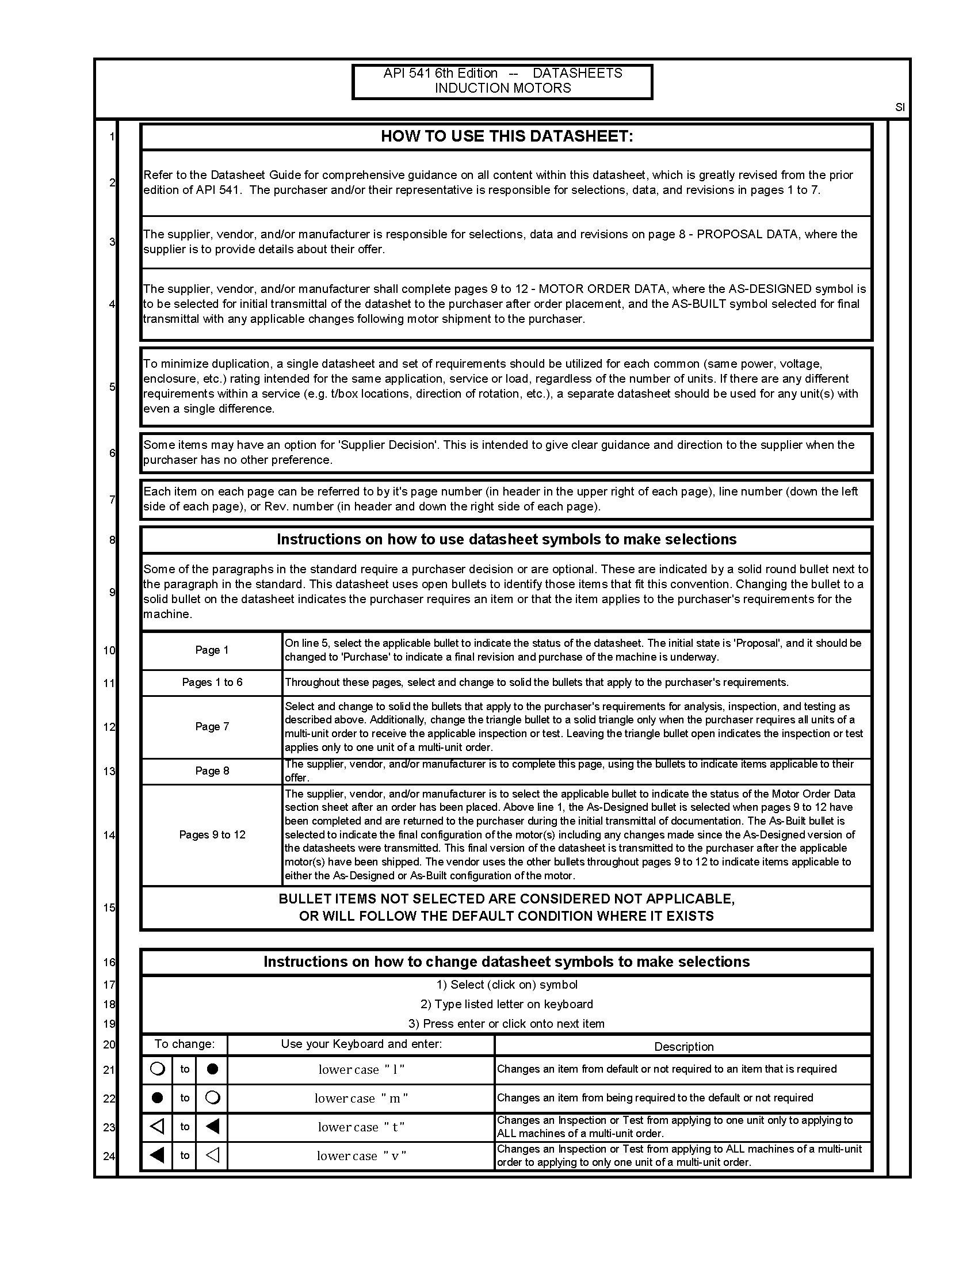**A.1 Inductor Motor Datasheets: SI Units**

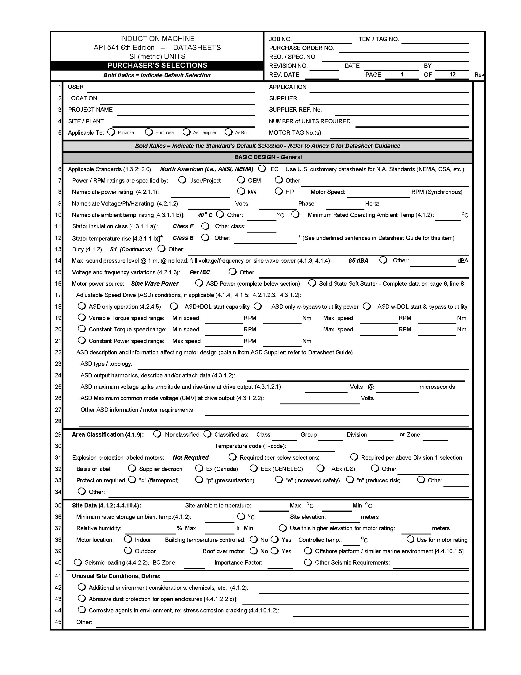

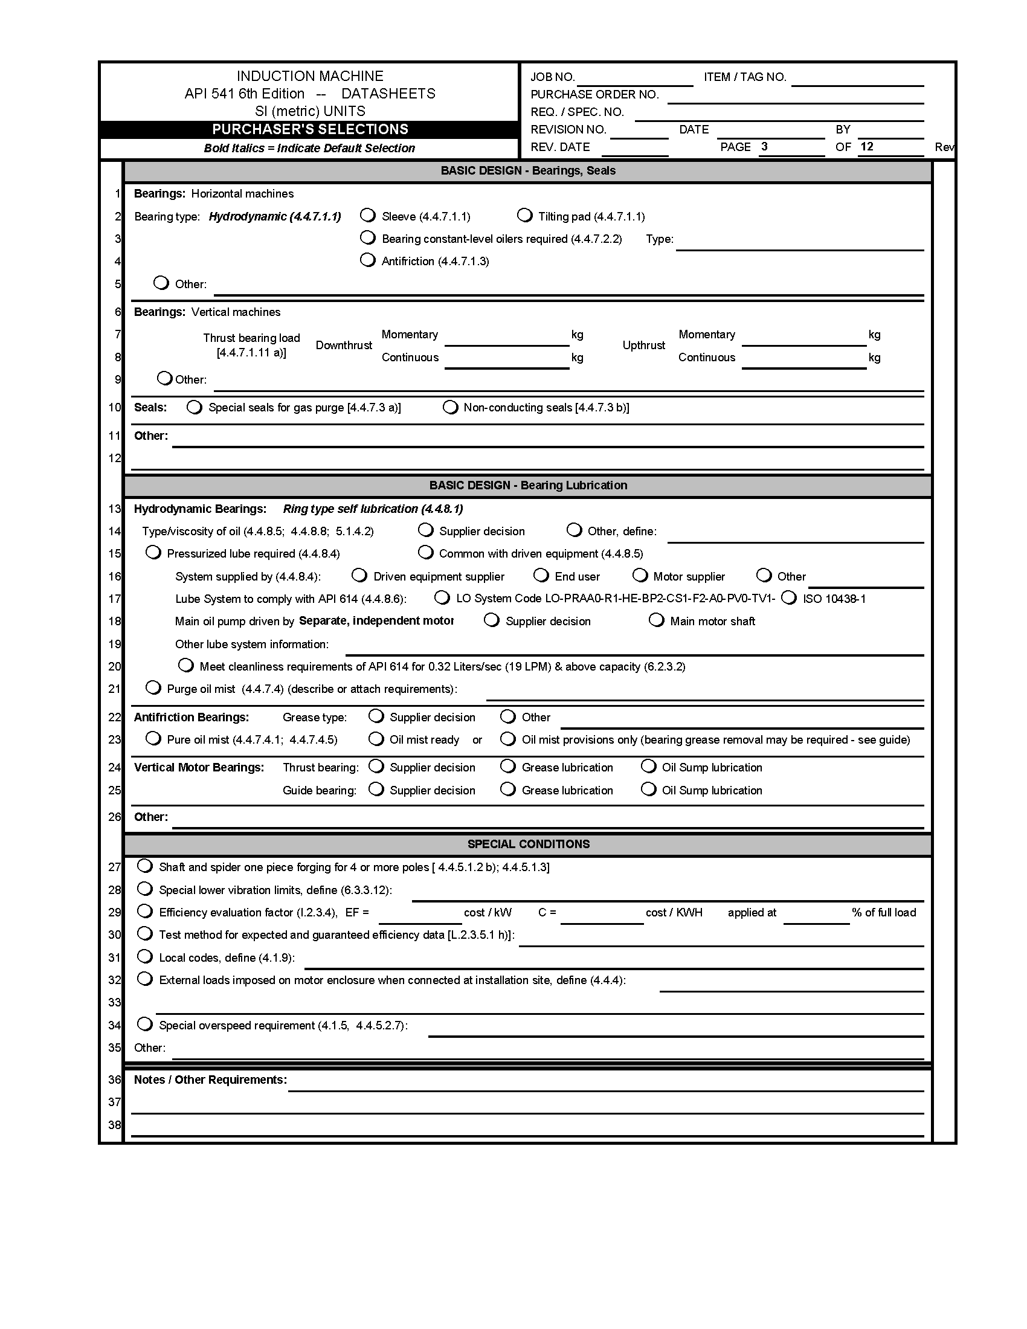

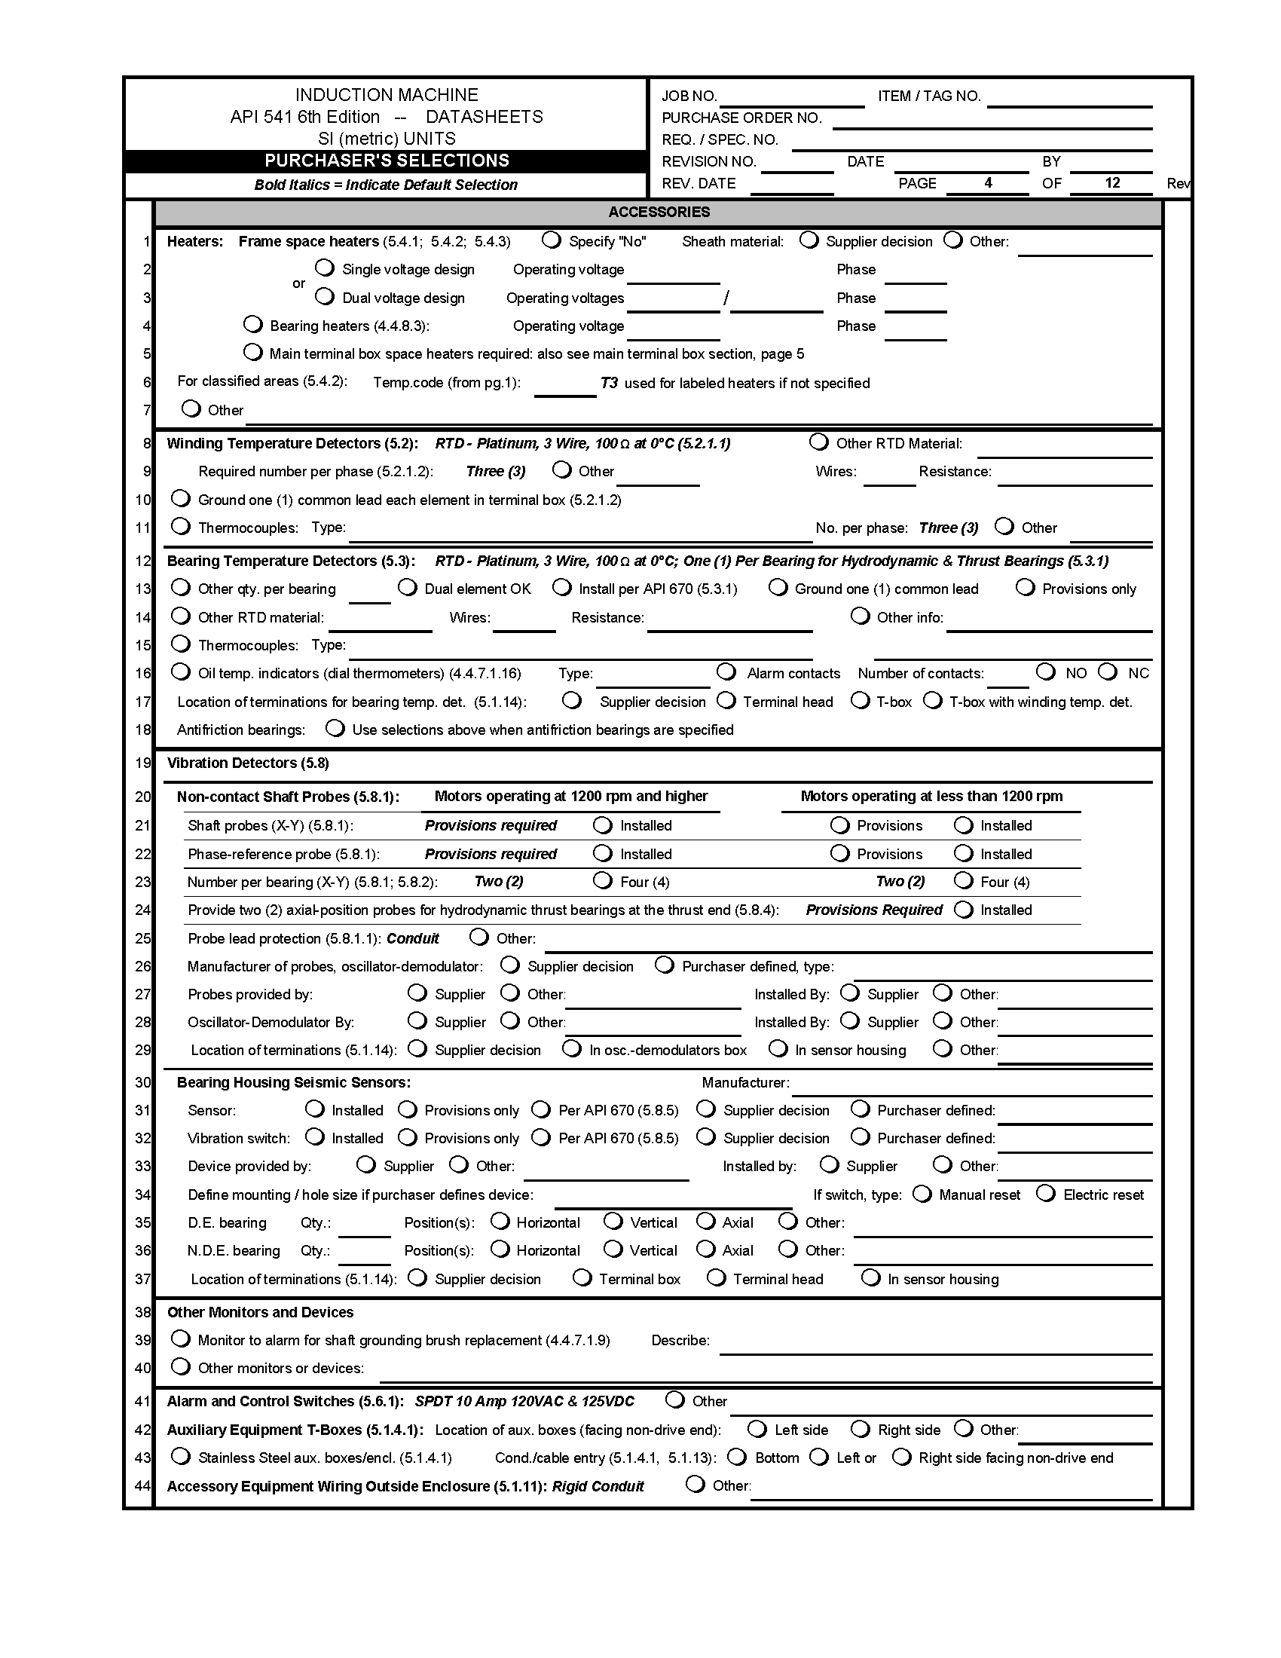

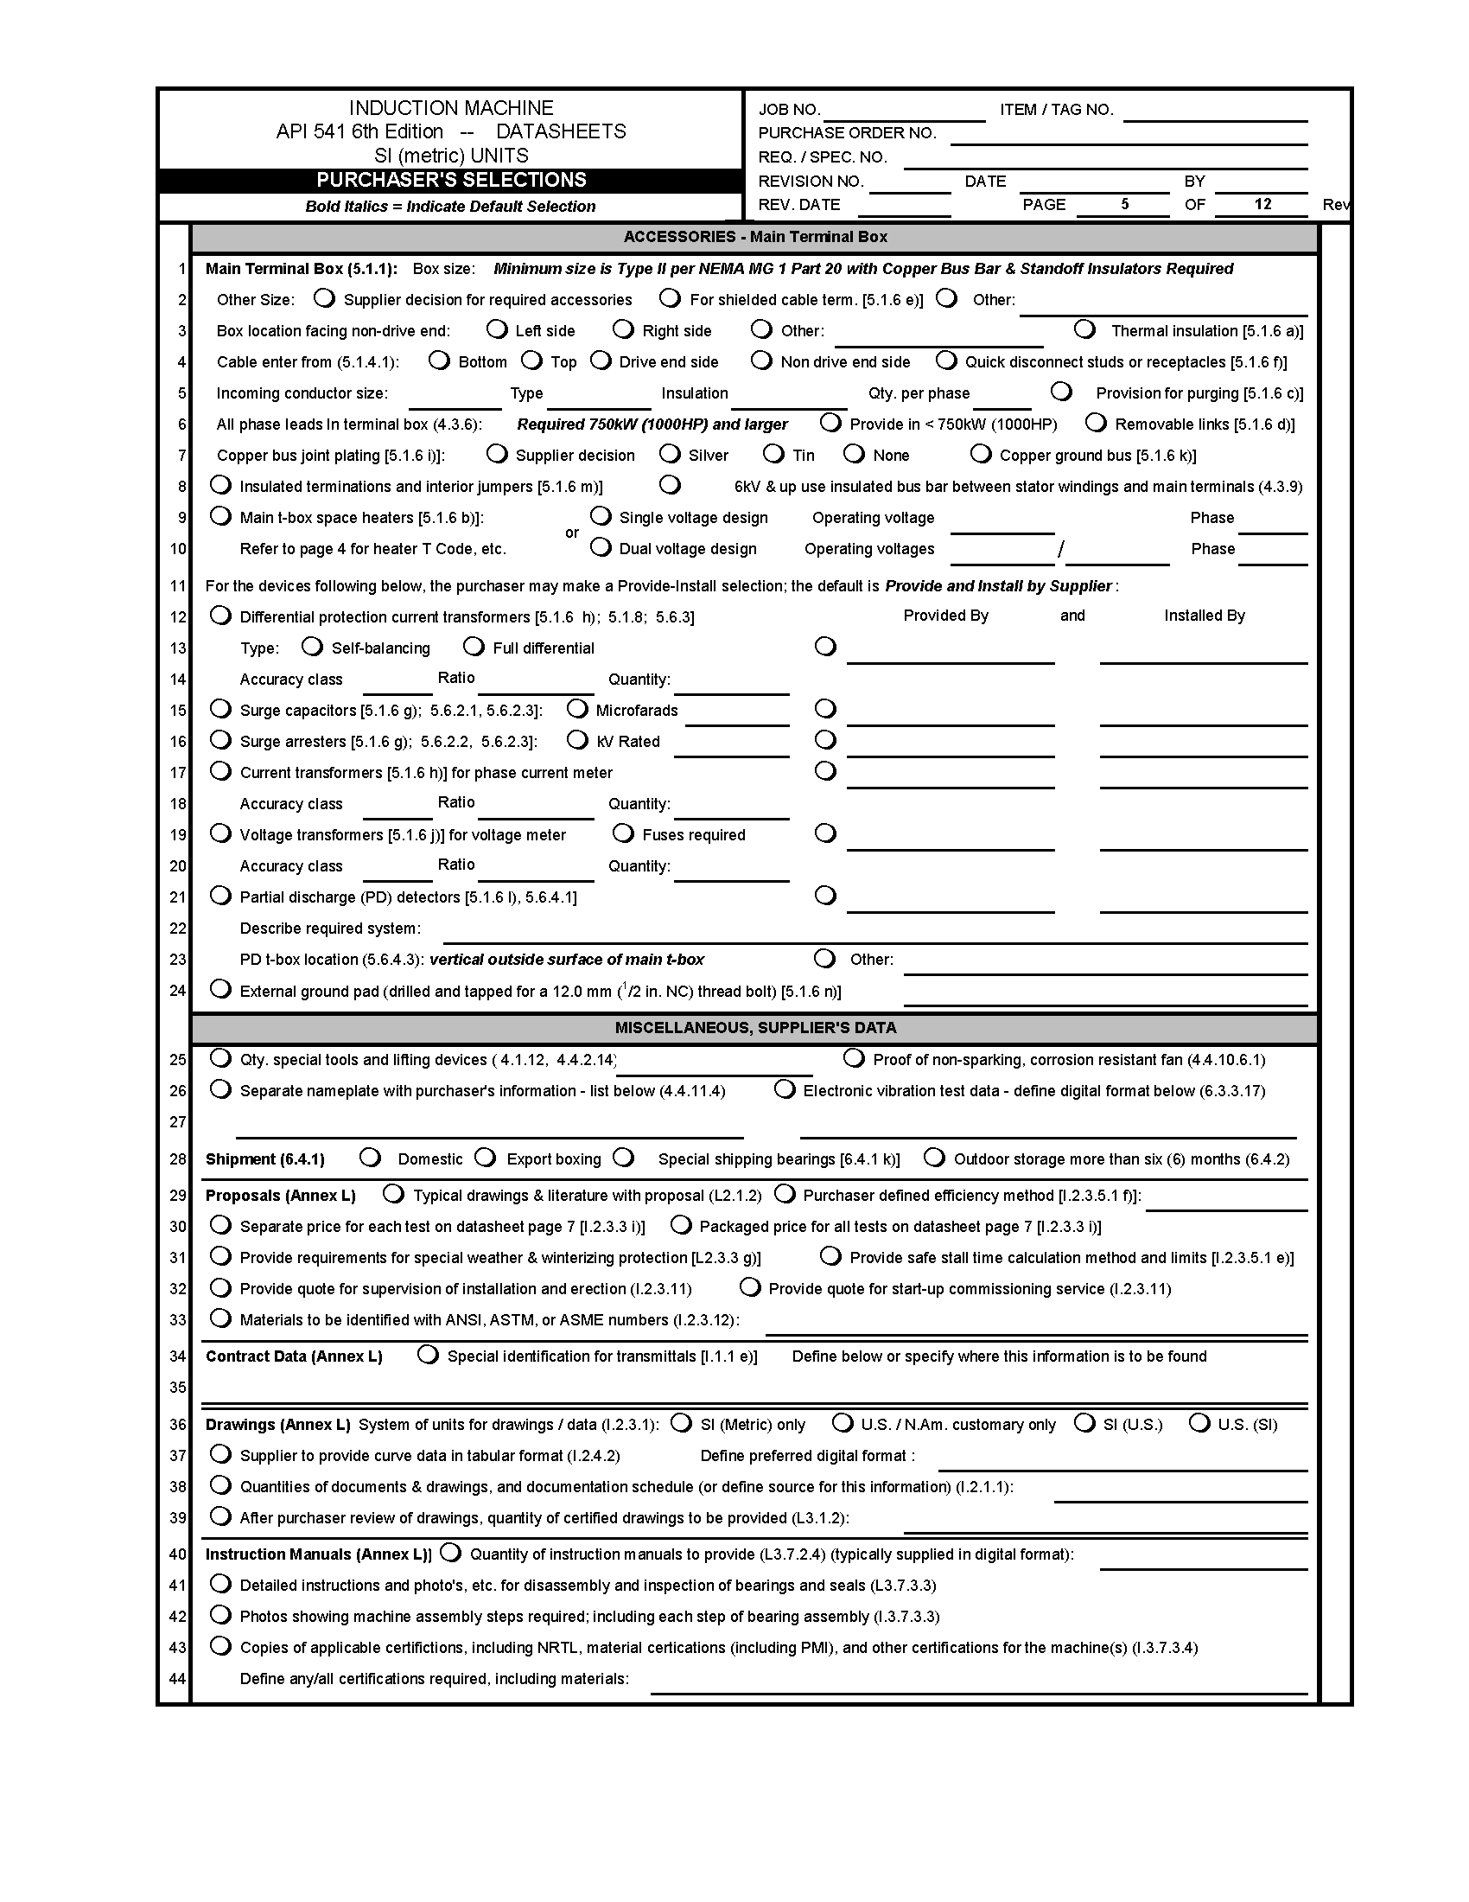

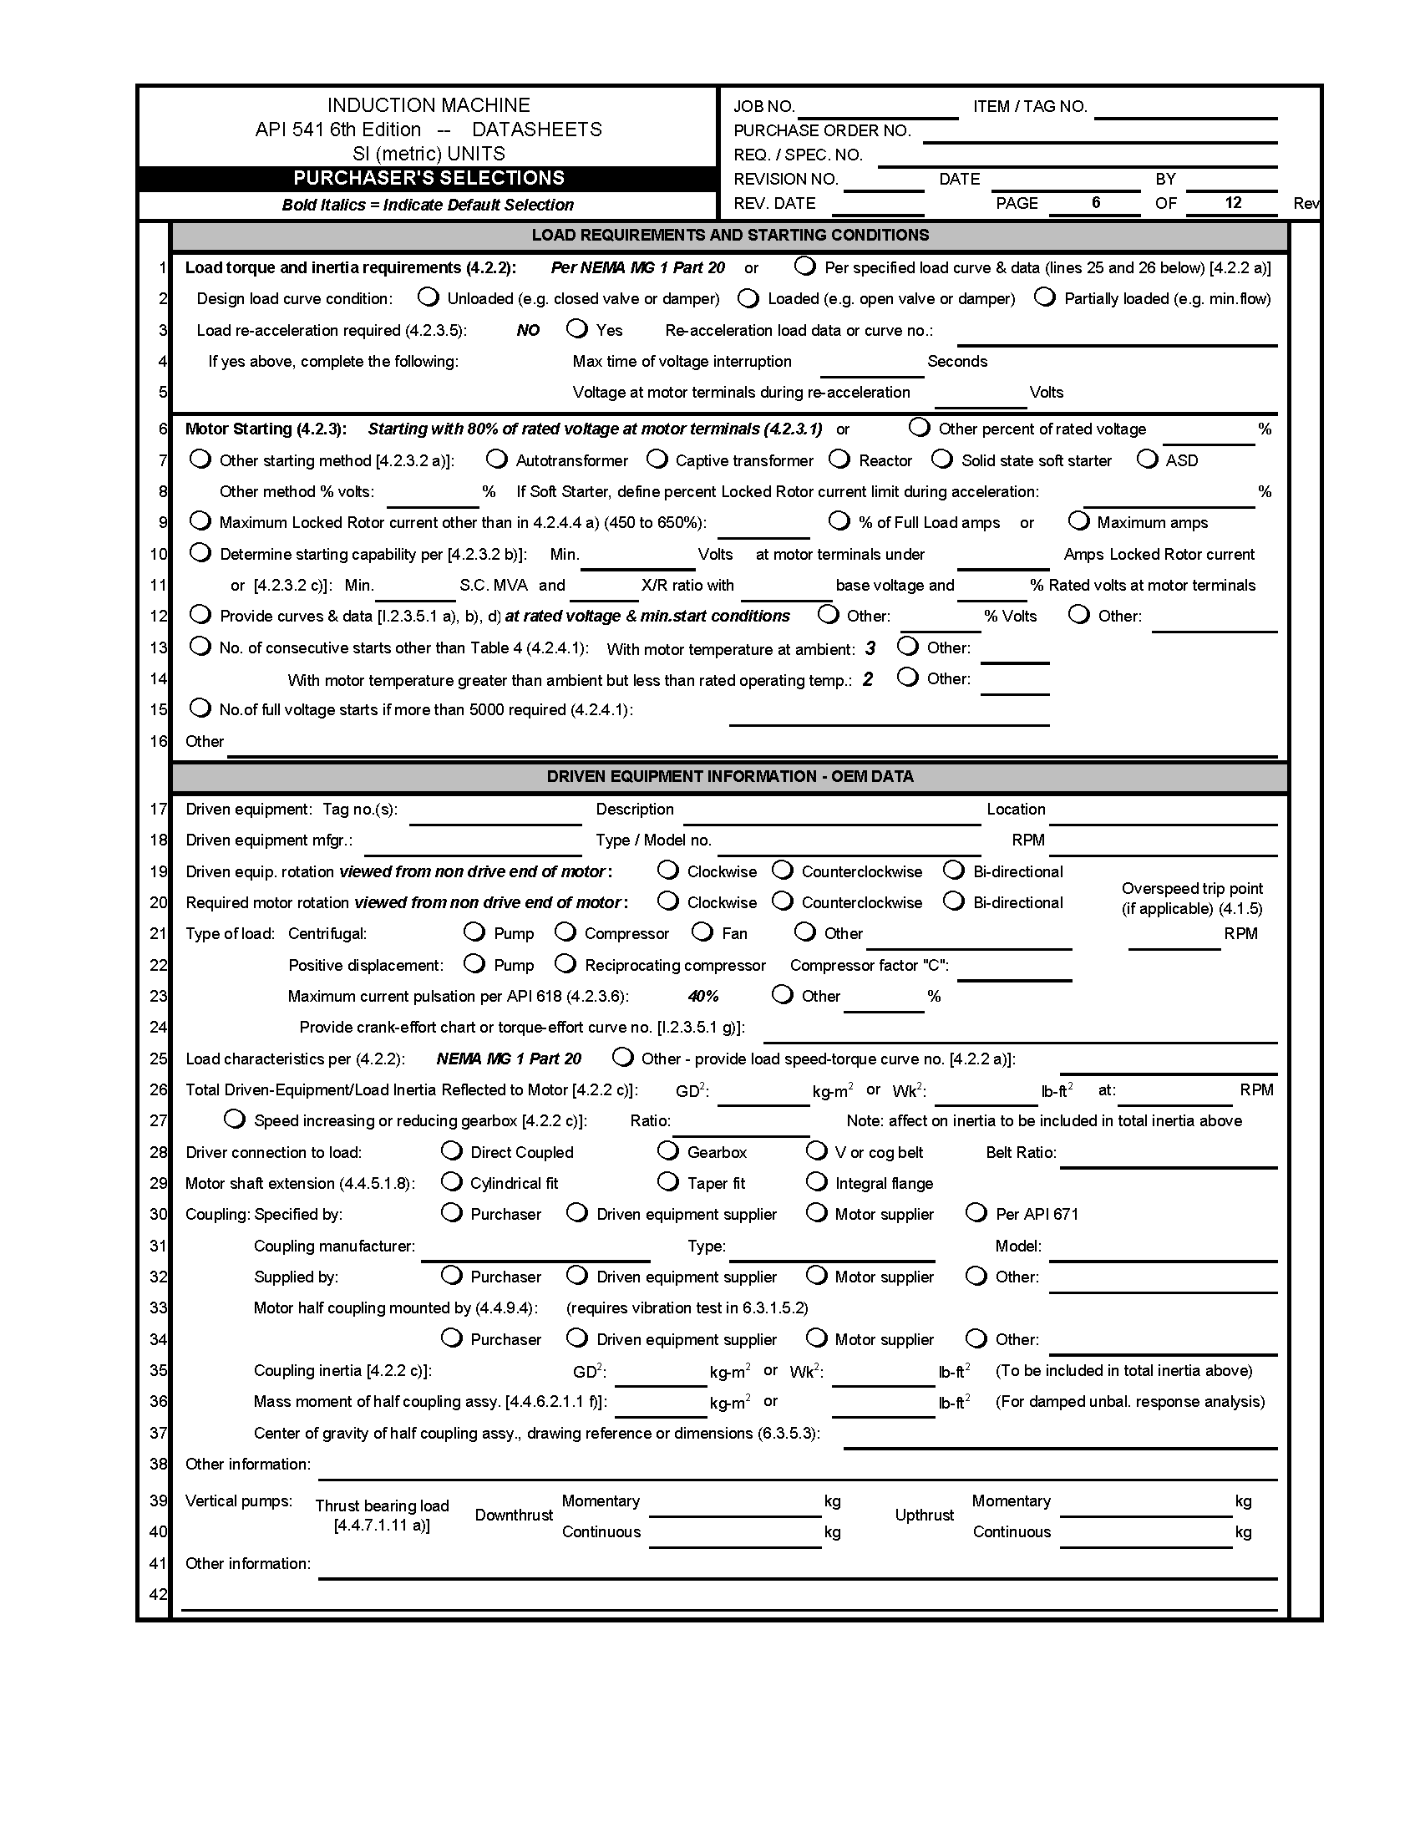

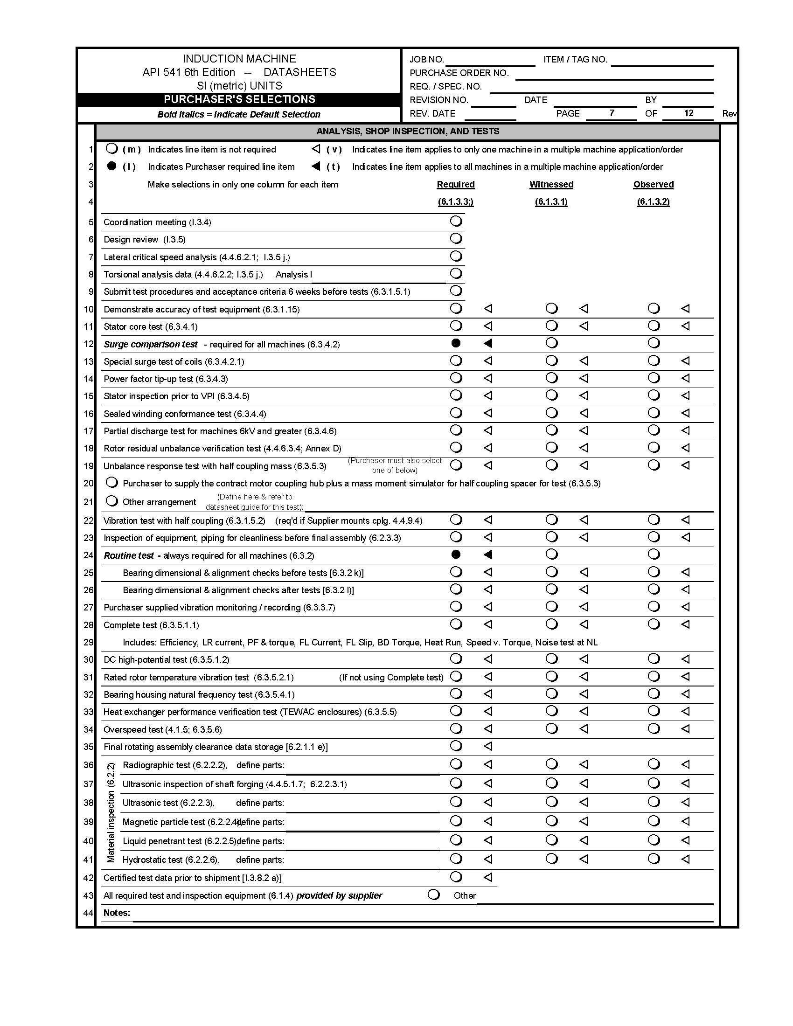

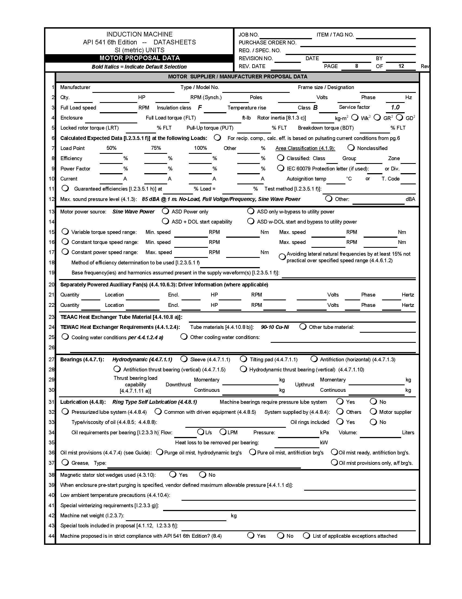

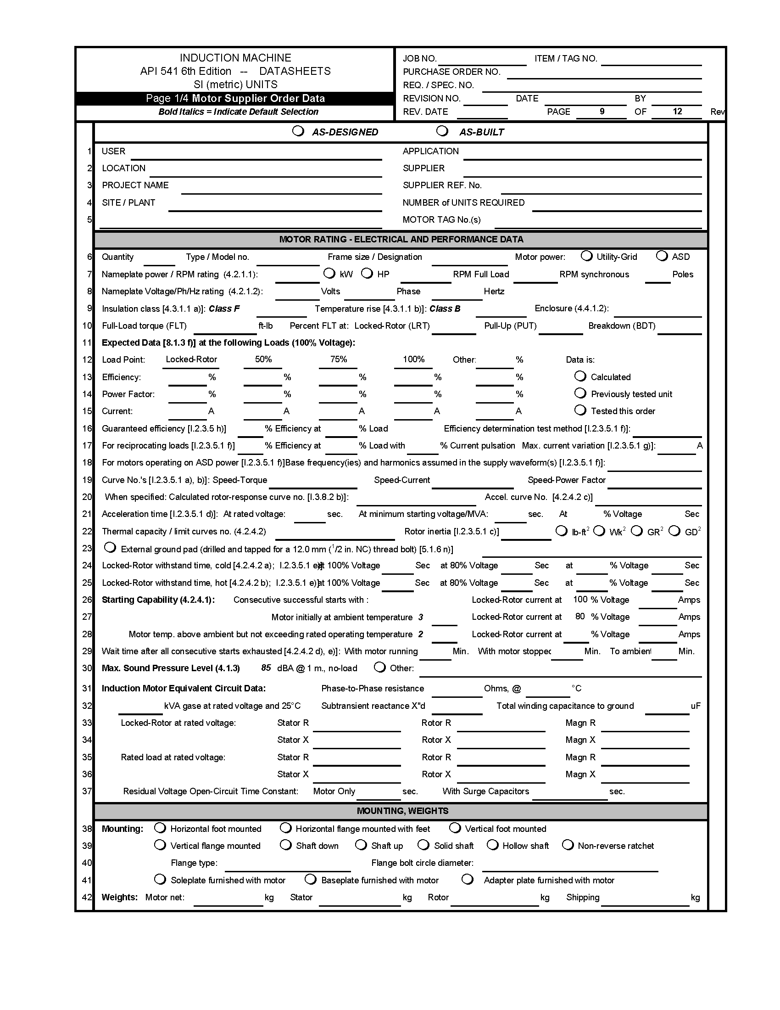

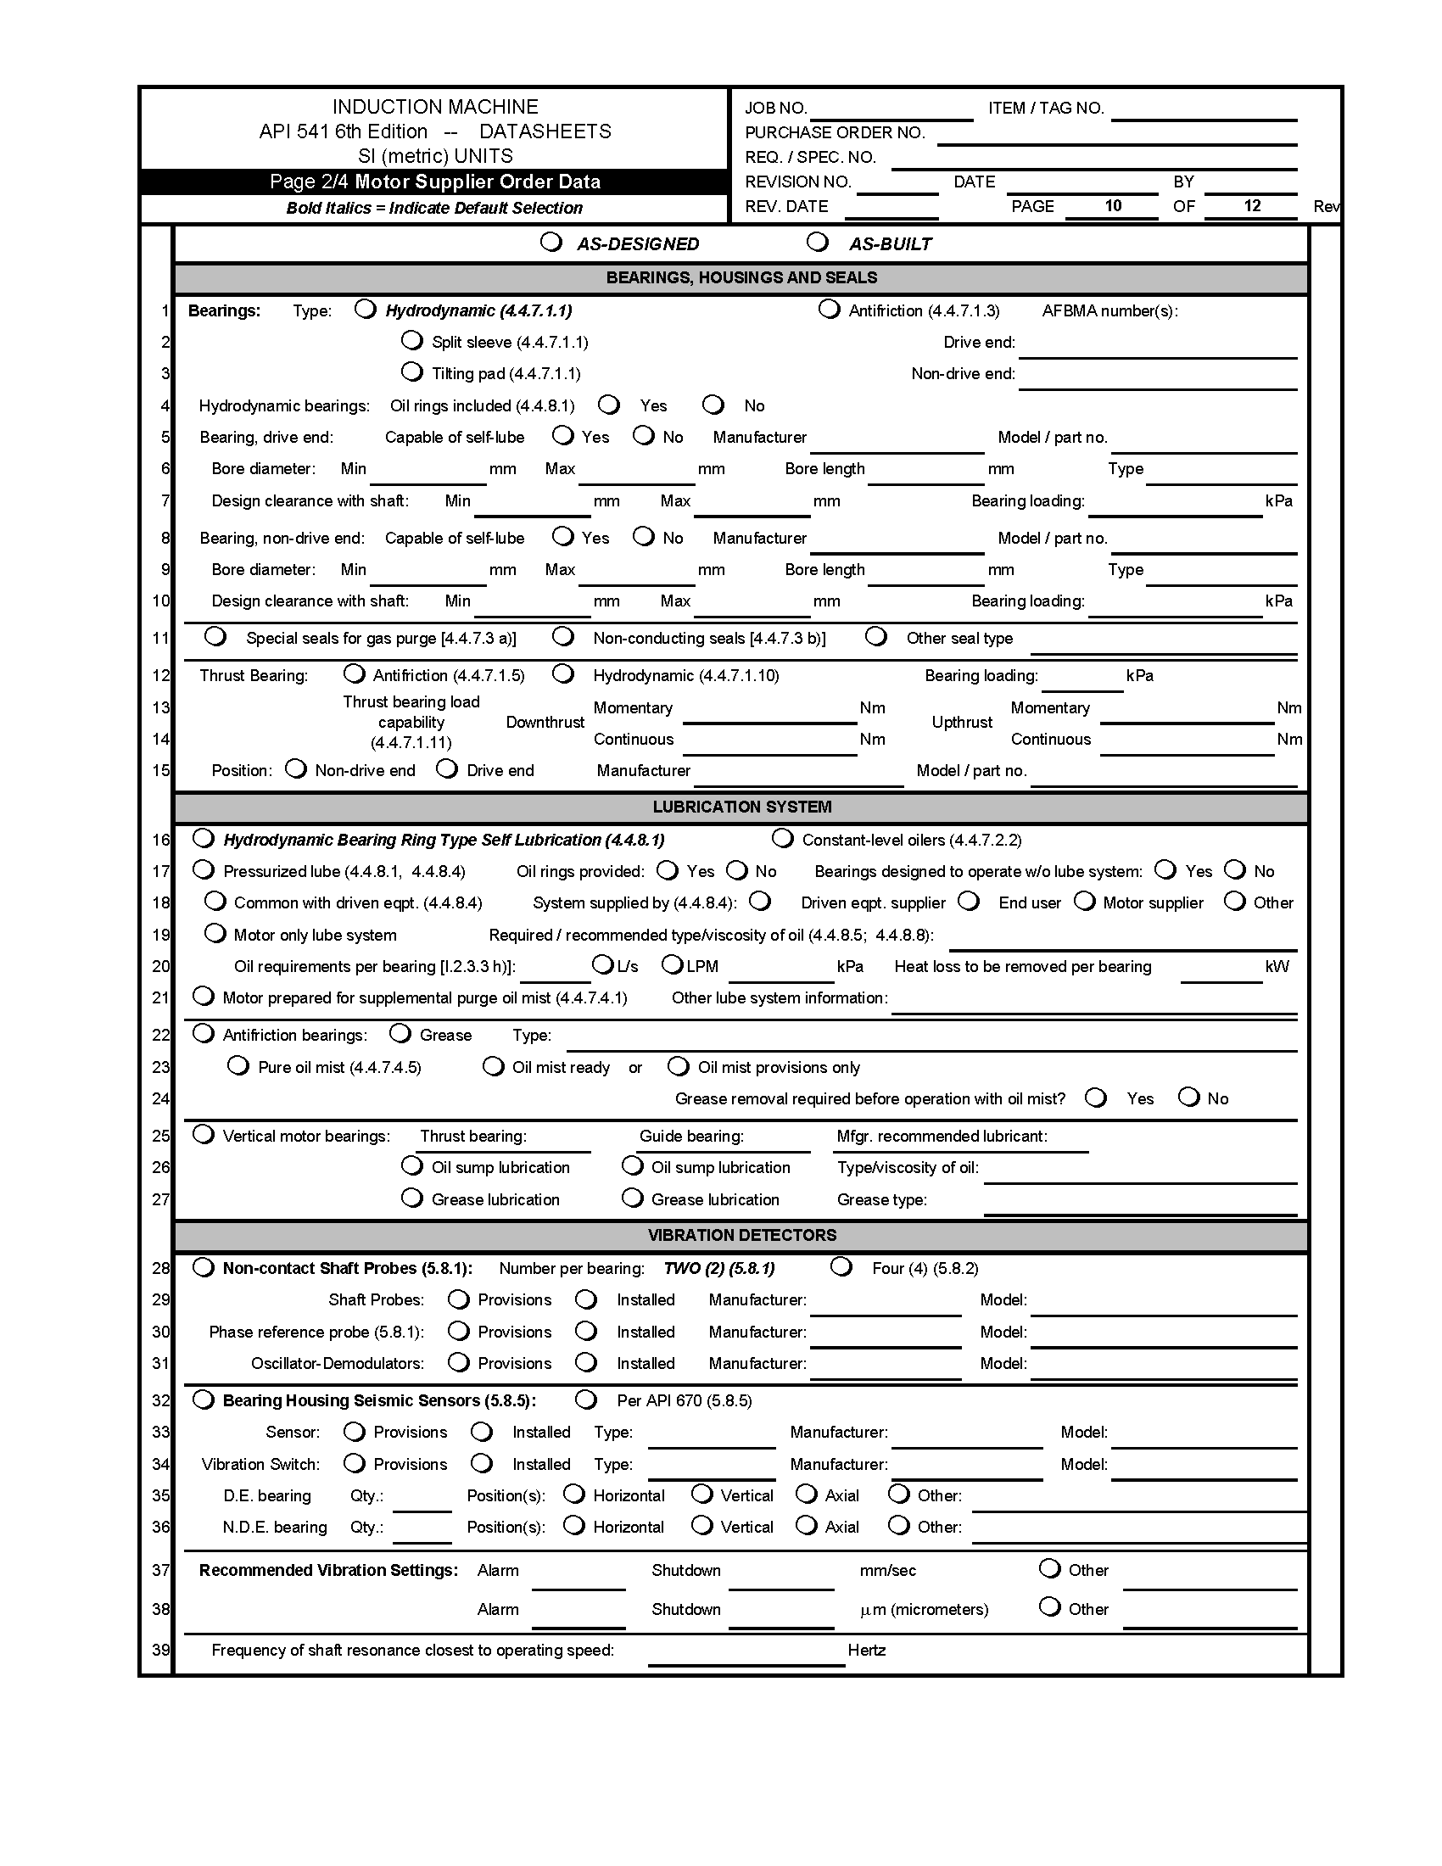

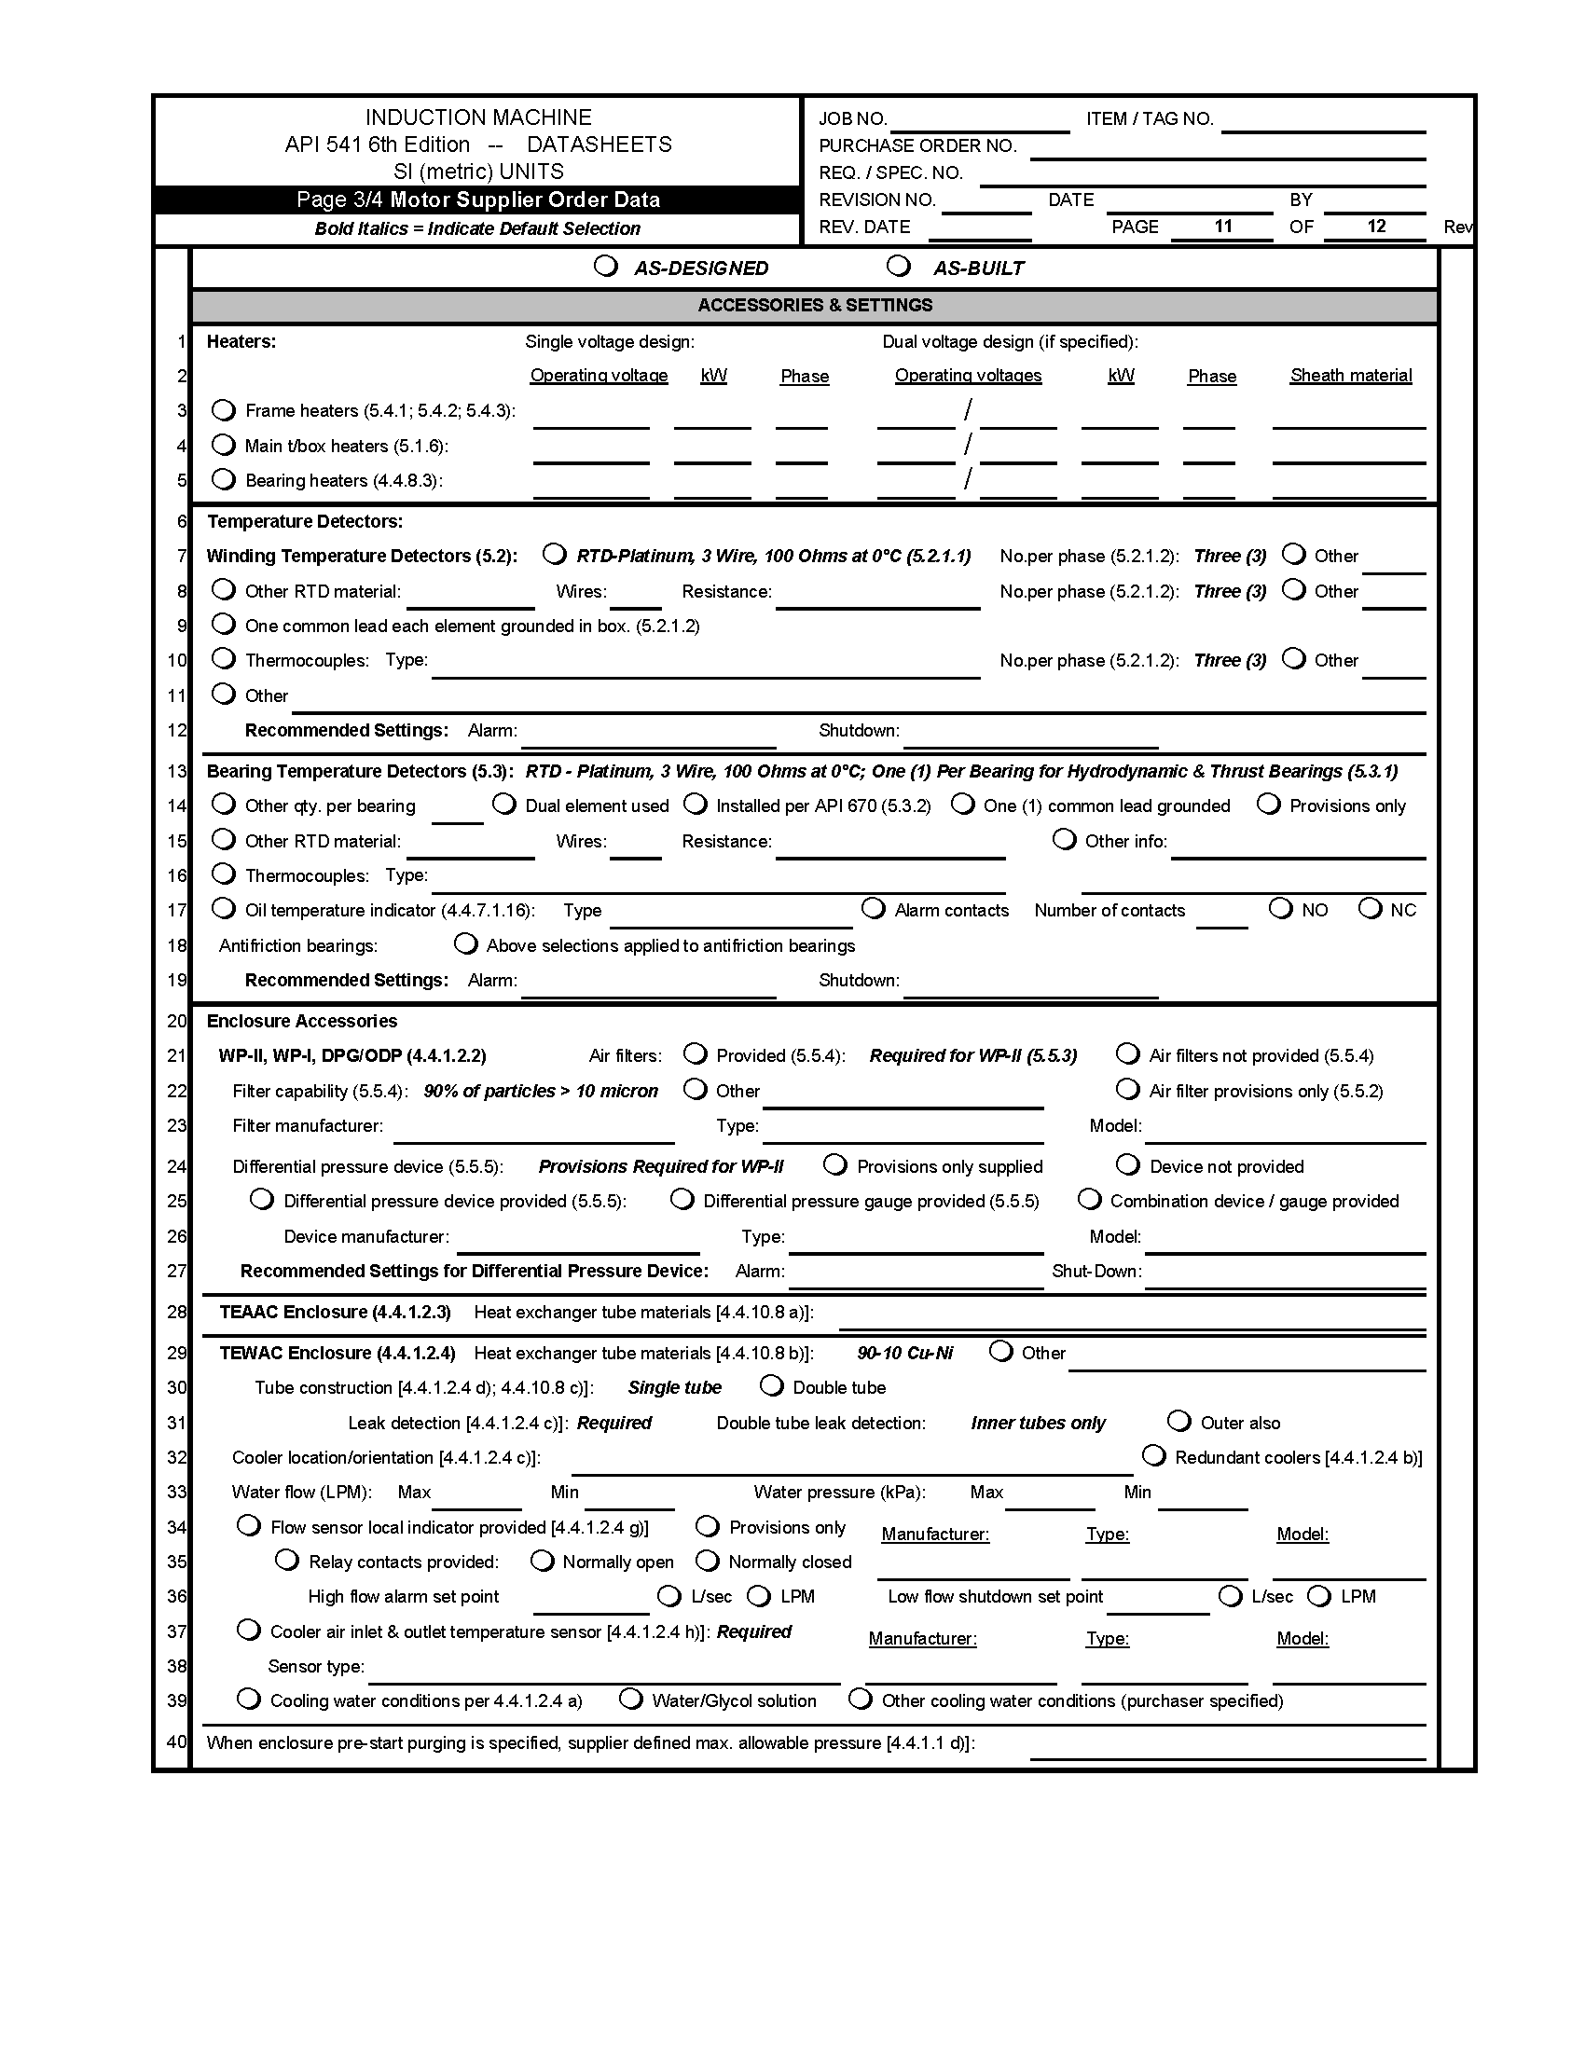

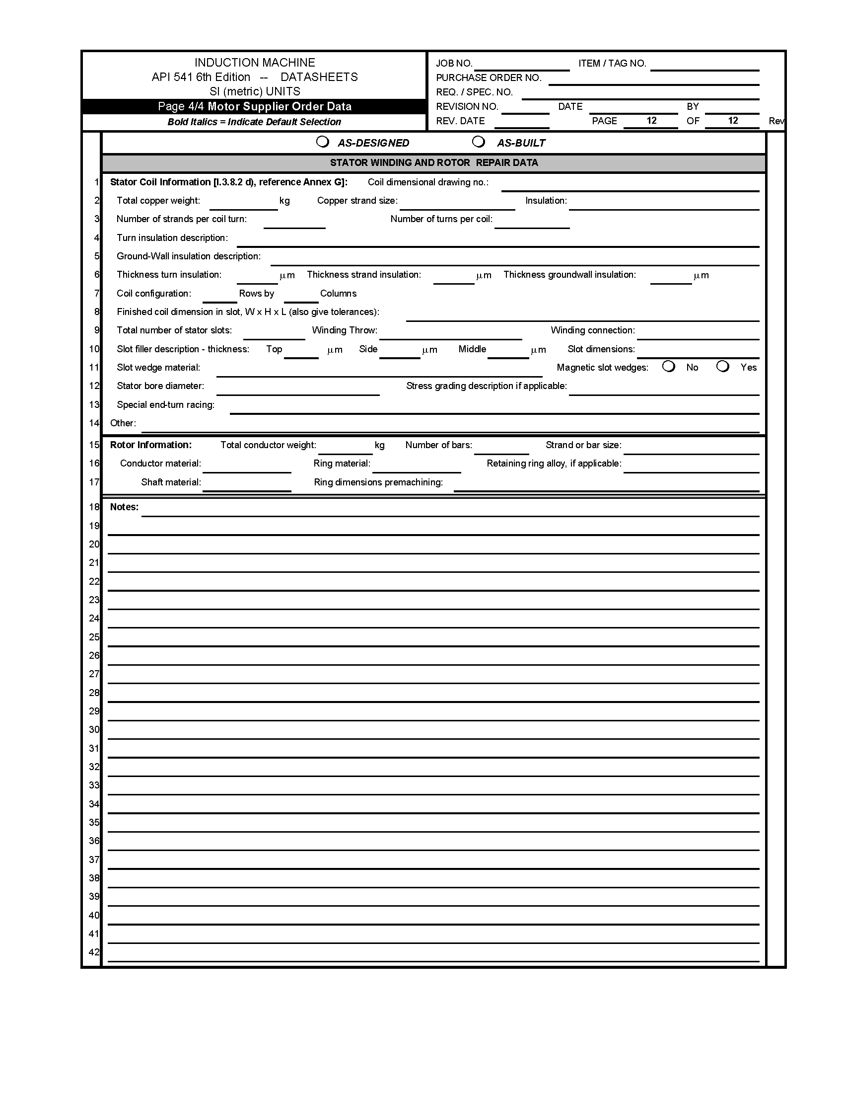

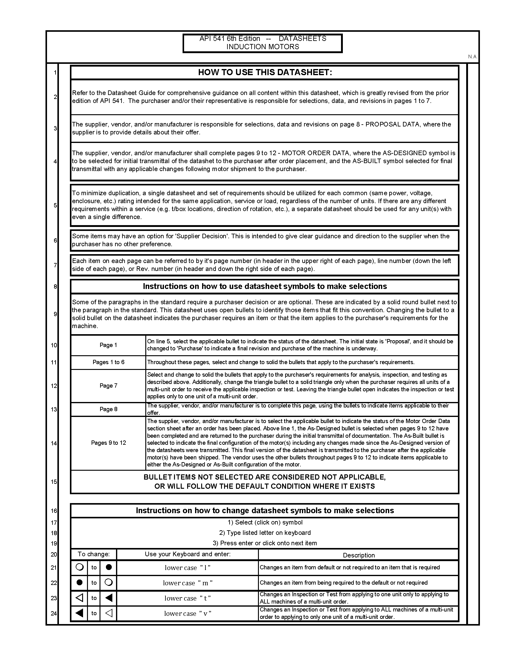**A.2 Inductor Motor Datasheets: USC Units**

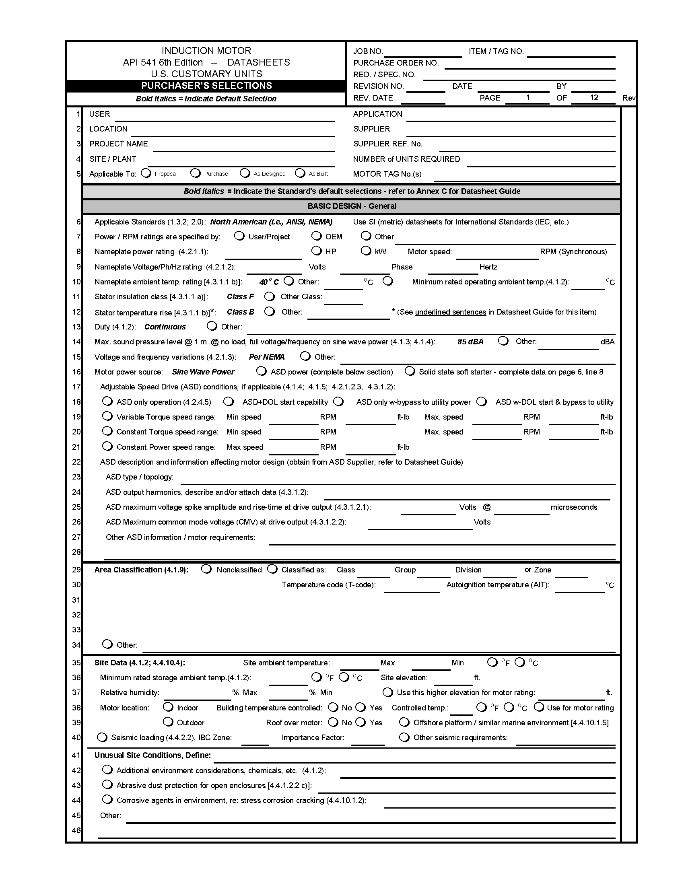

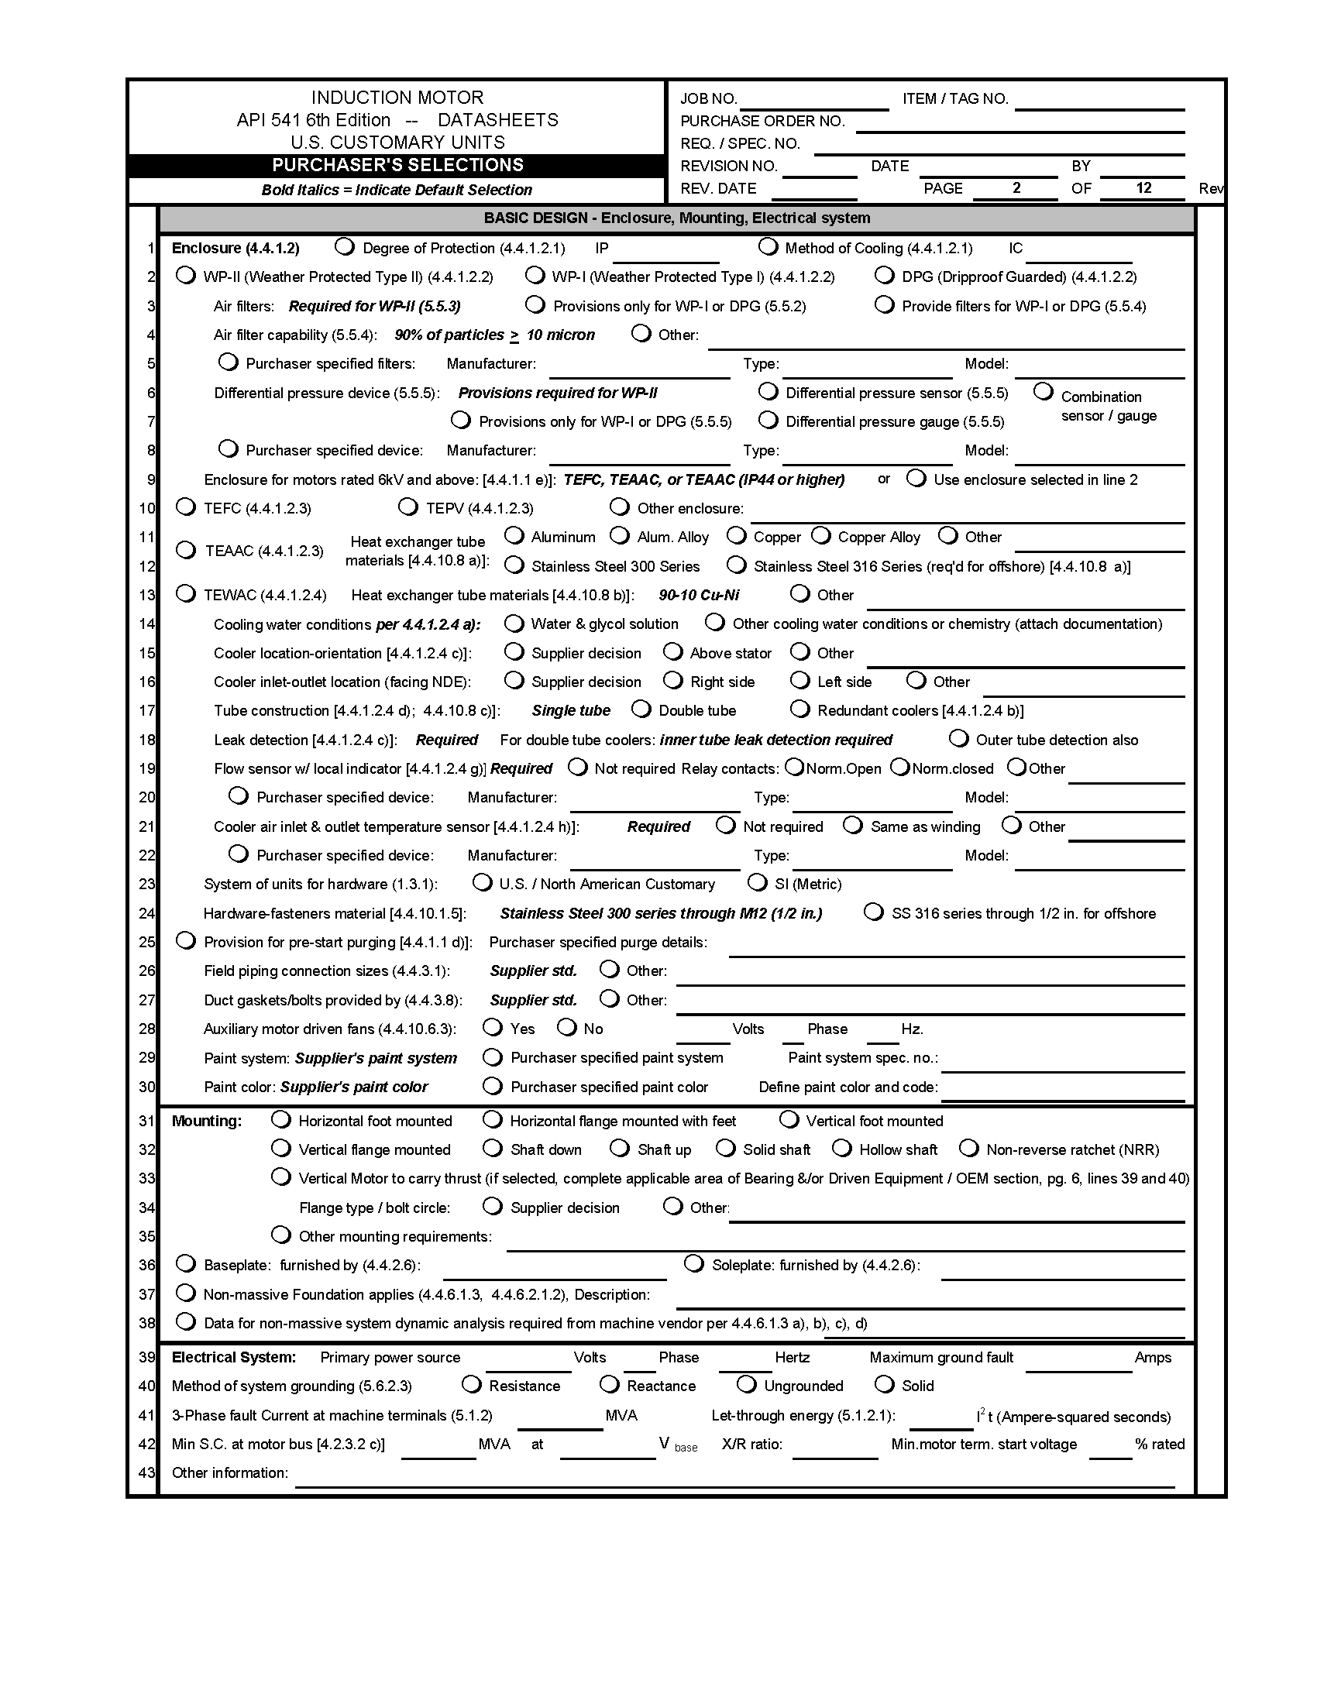

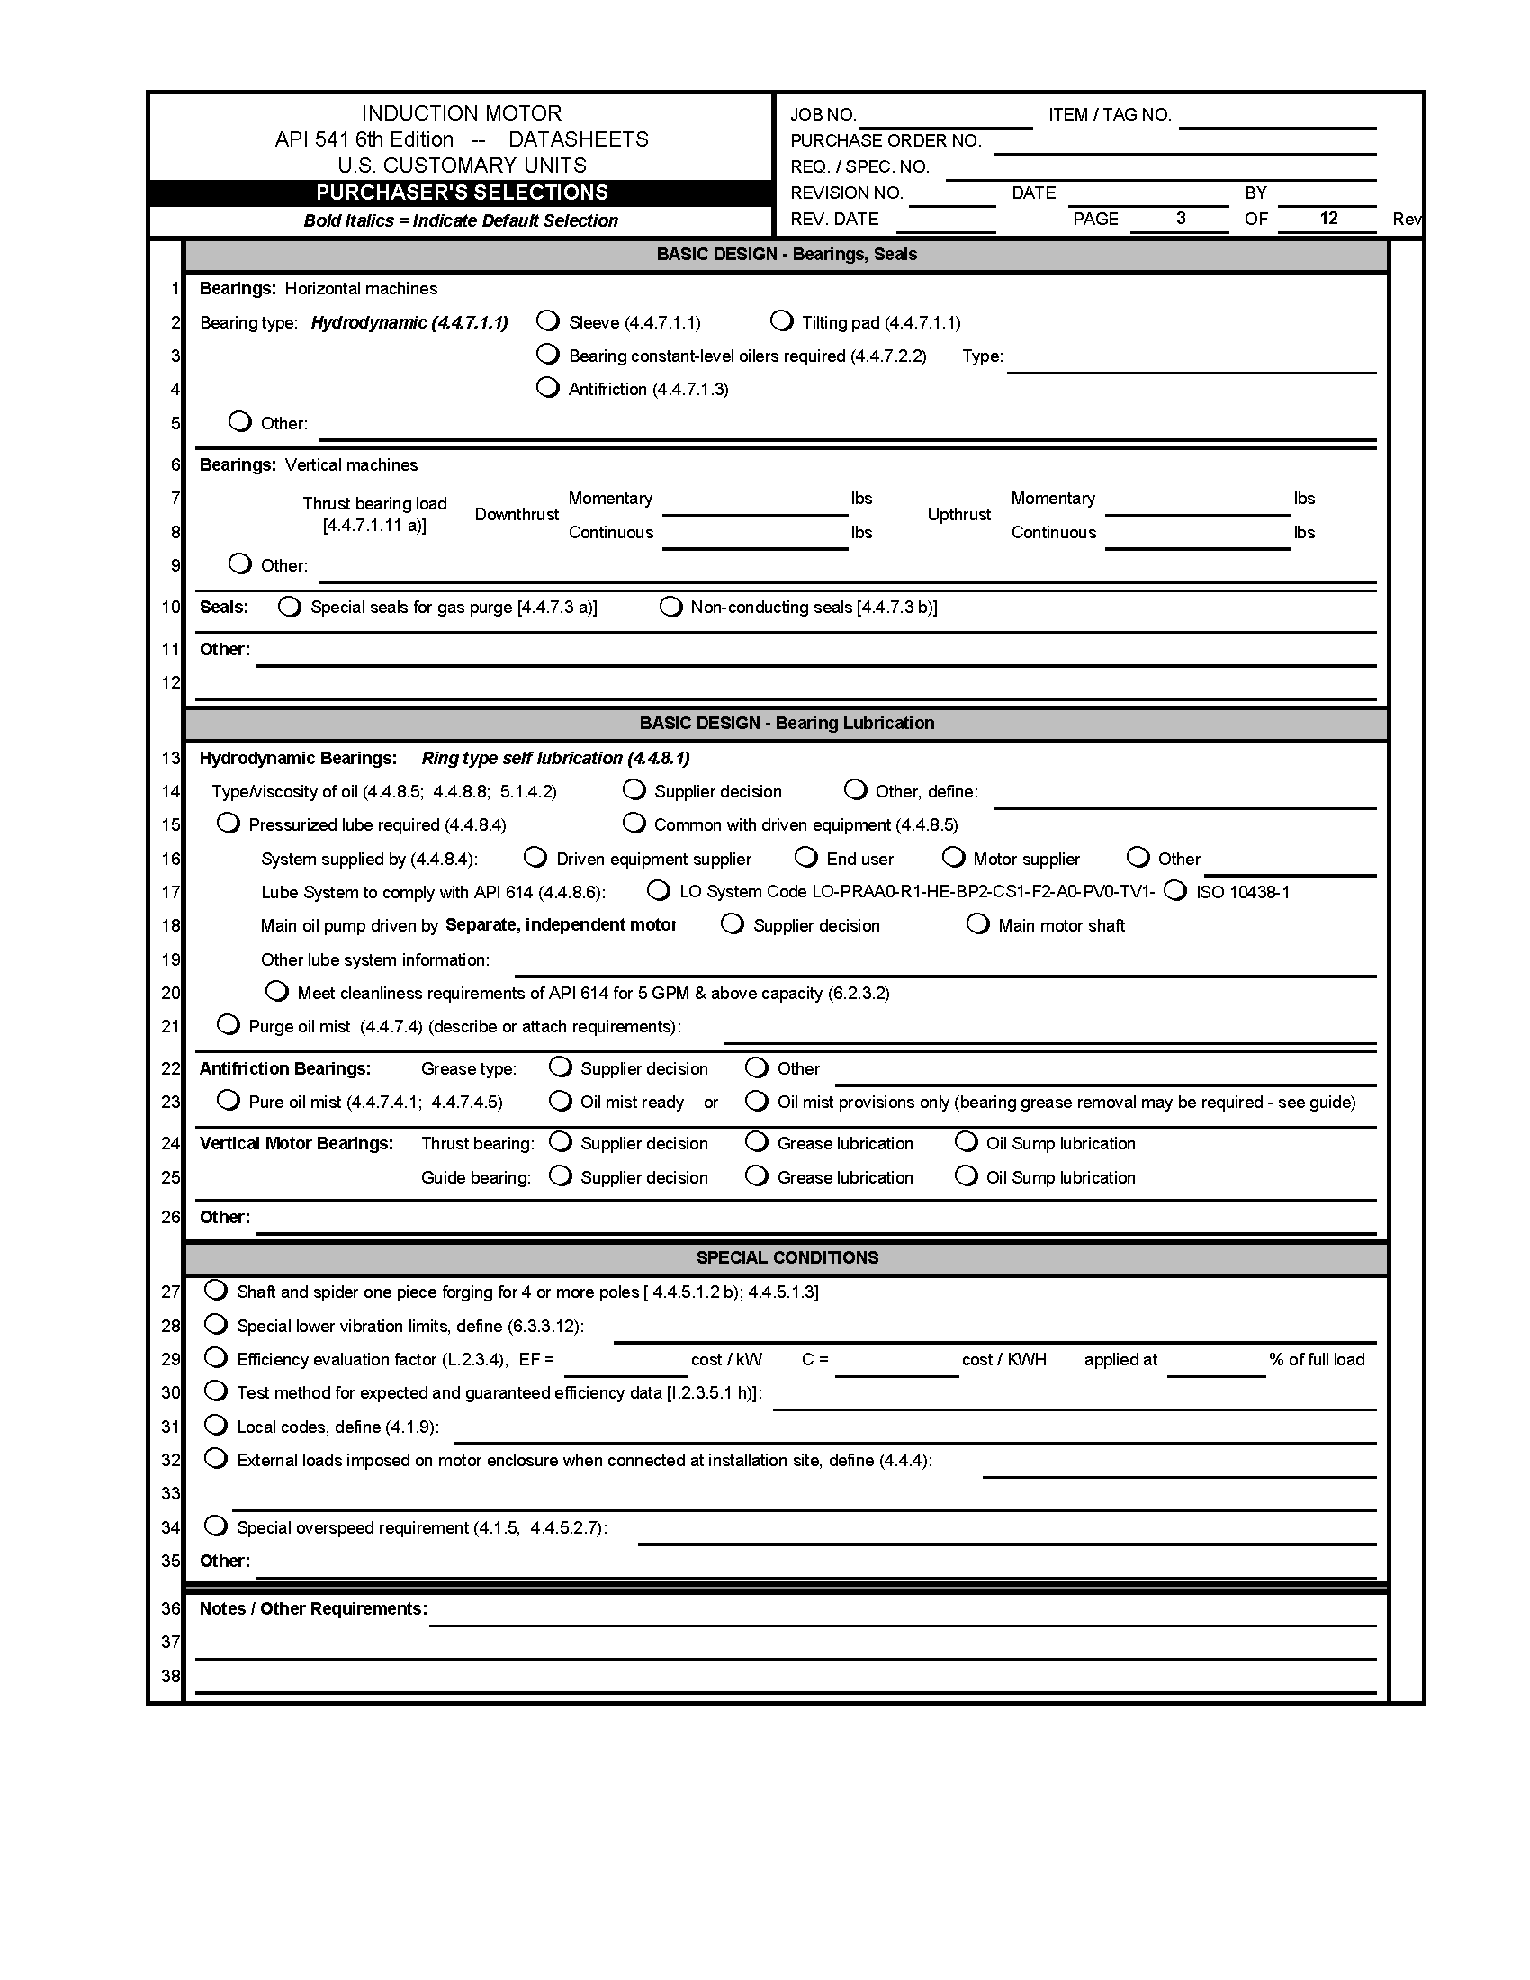

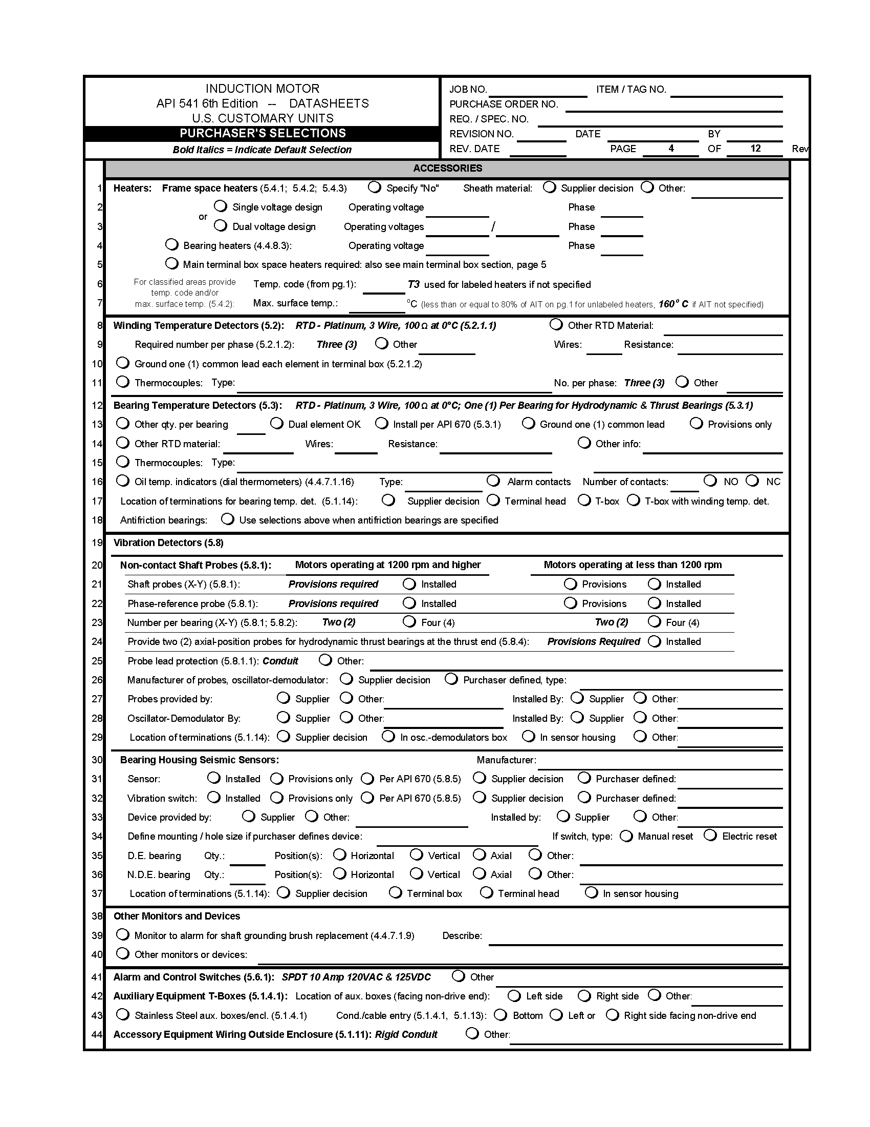

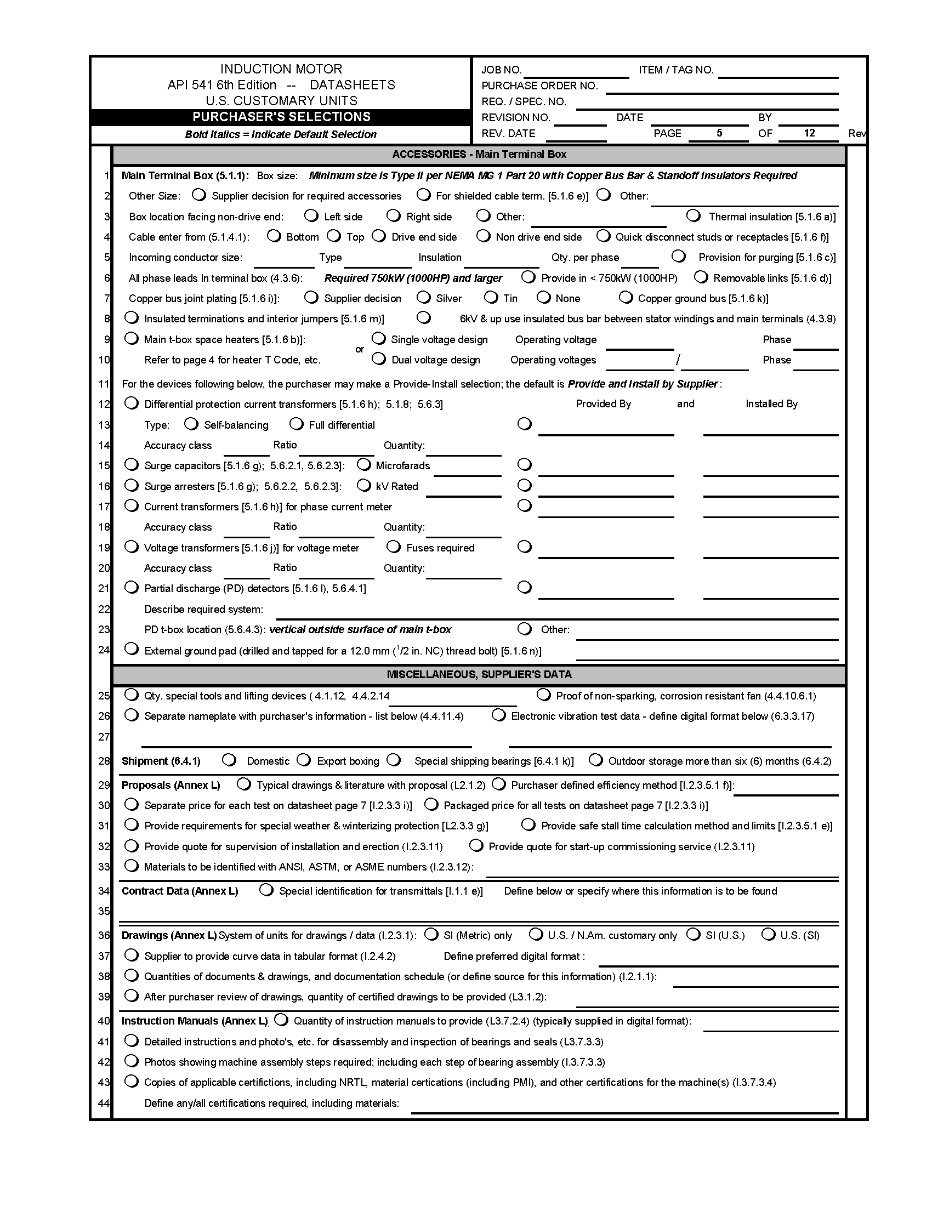

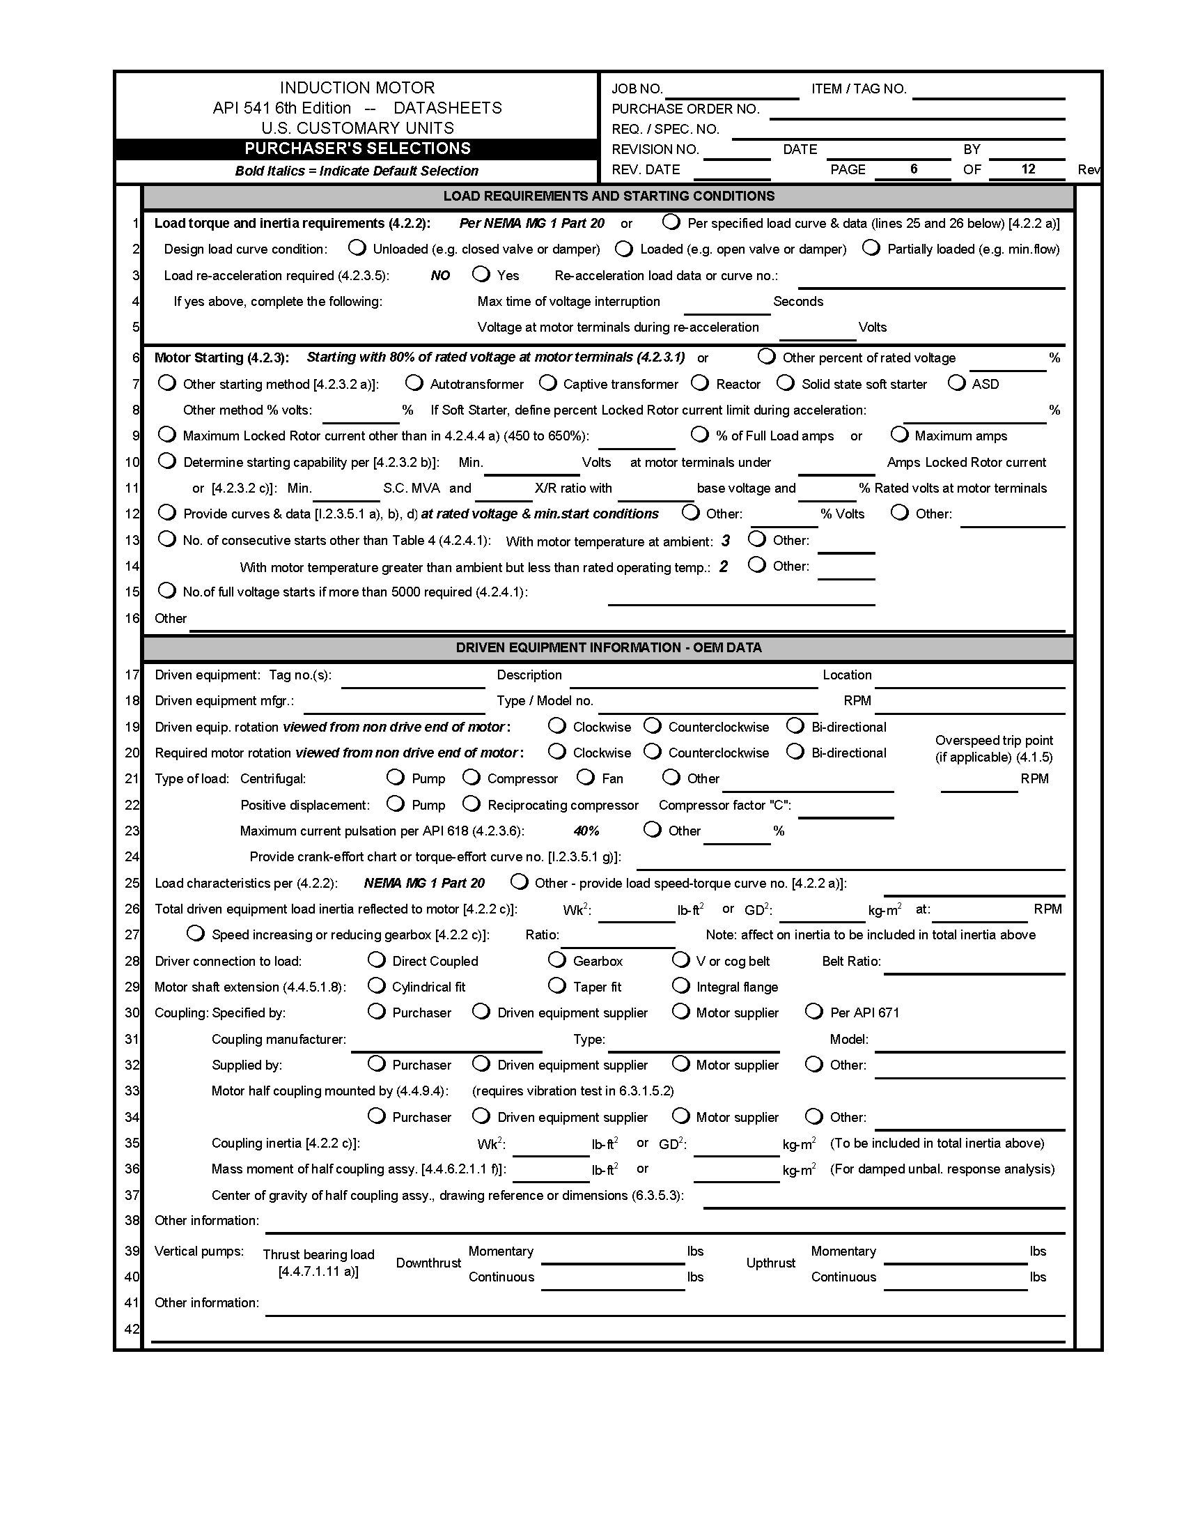

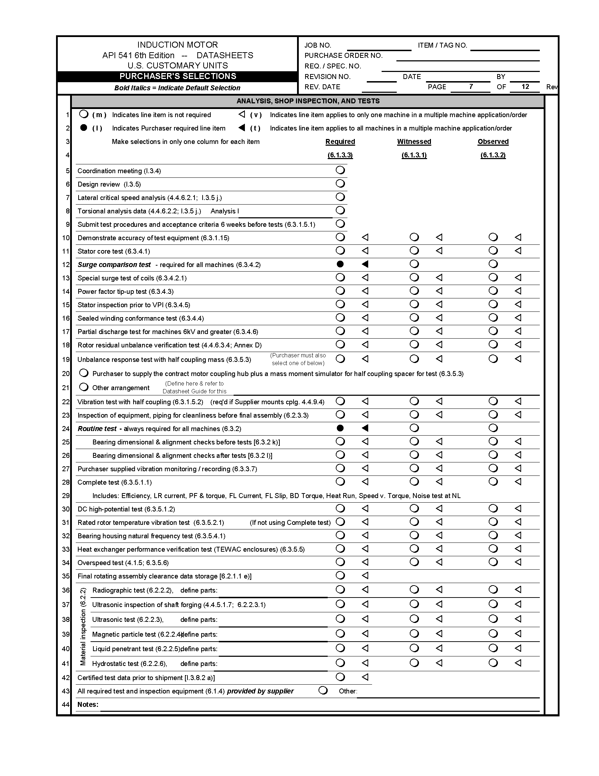

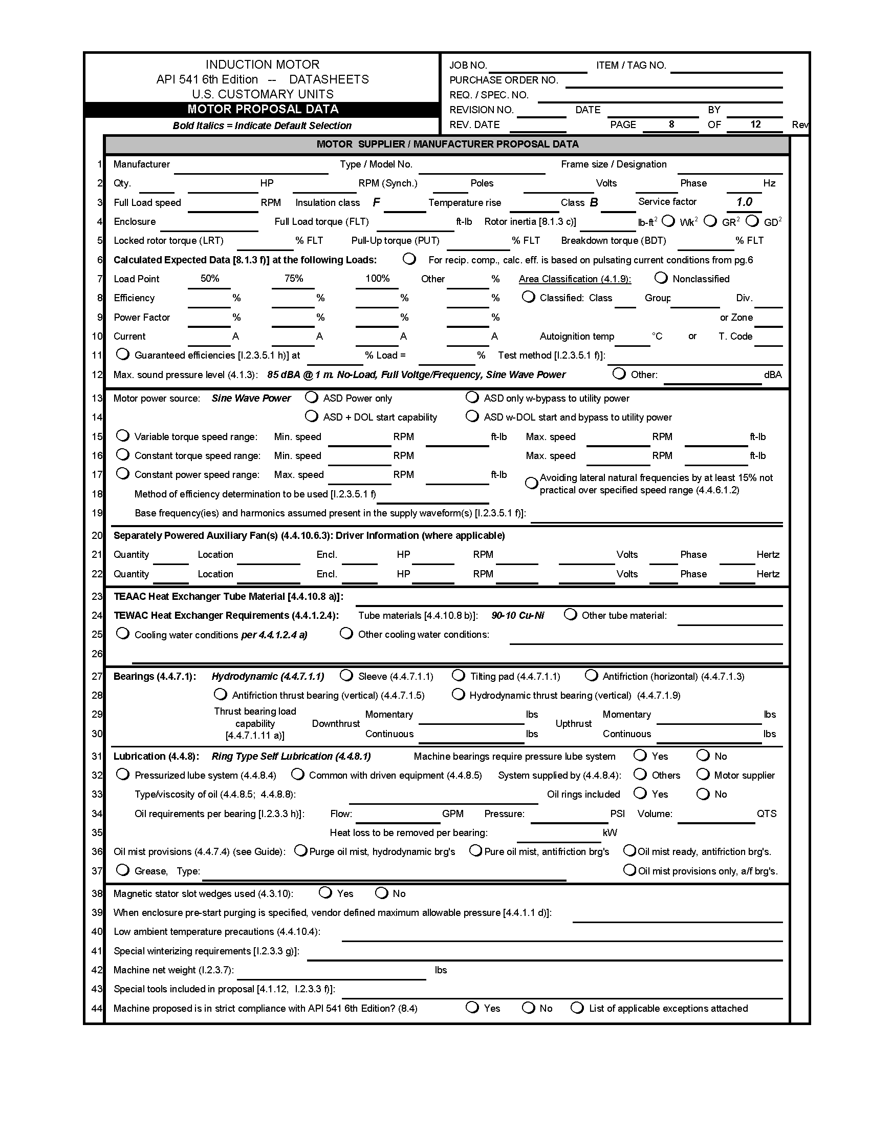

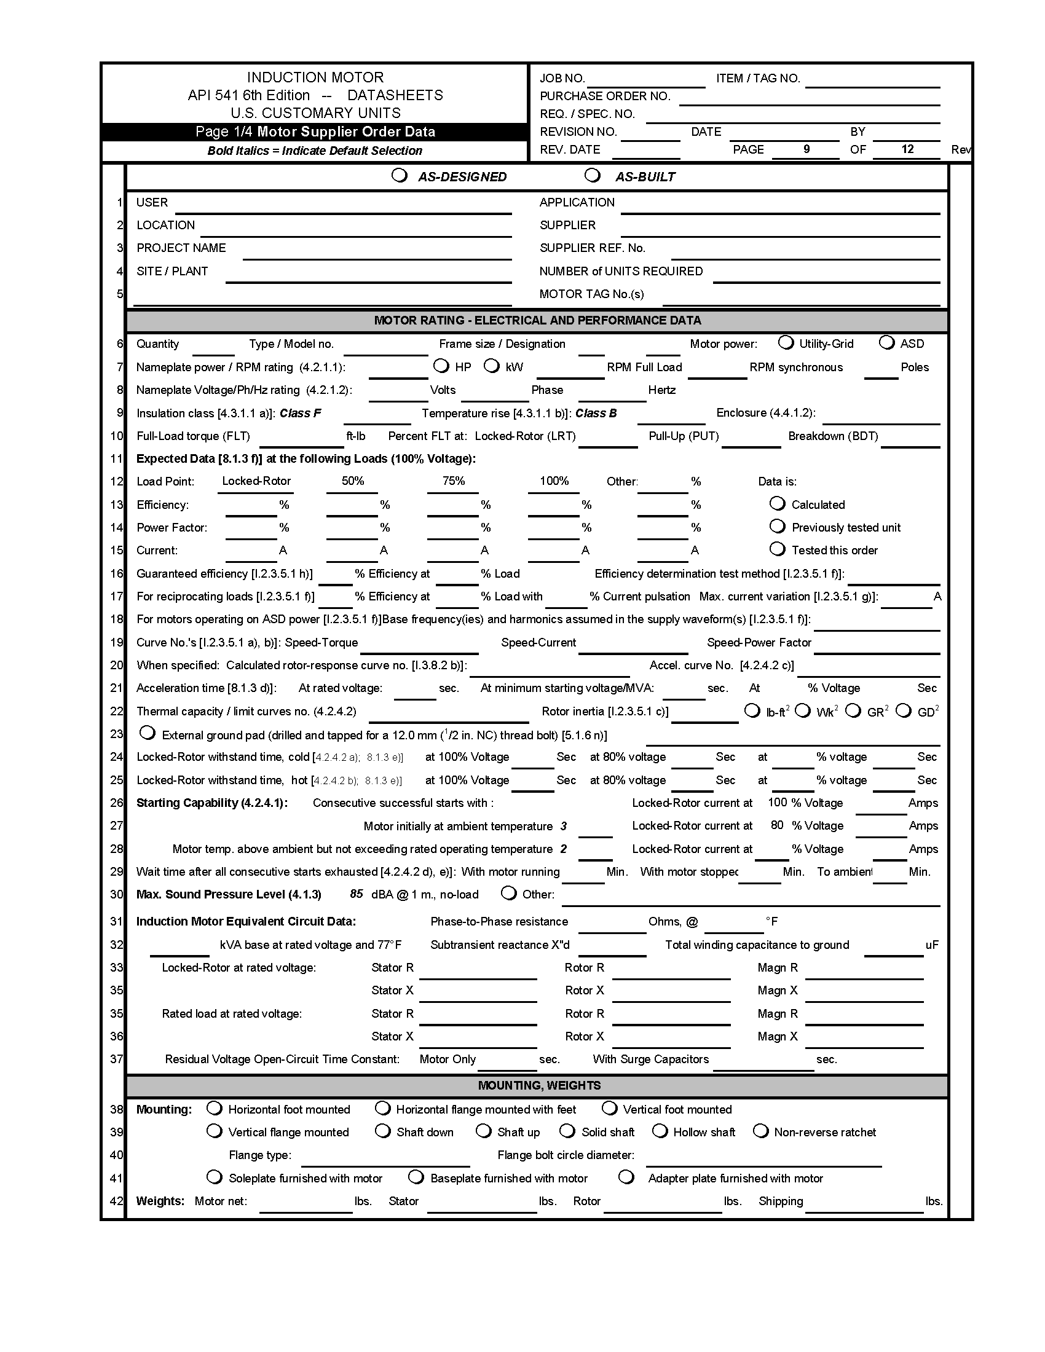

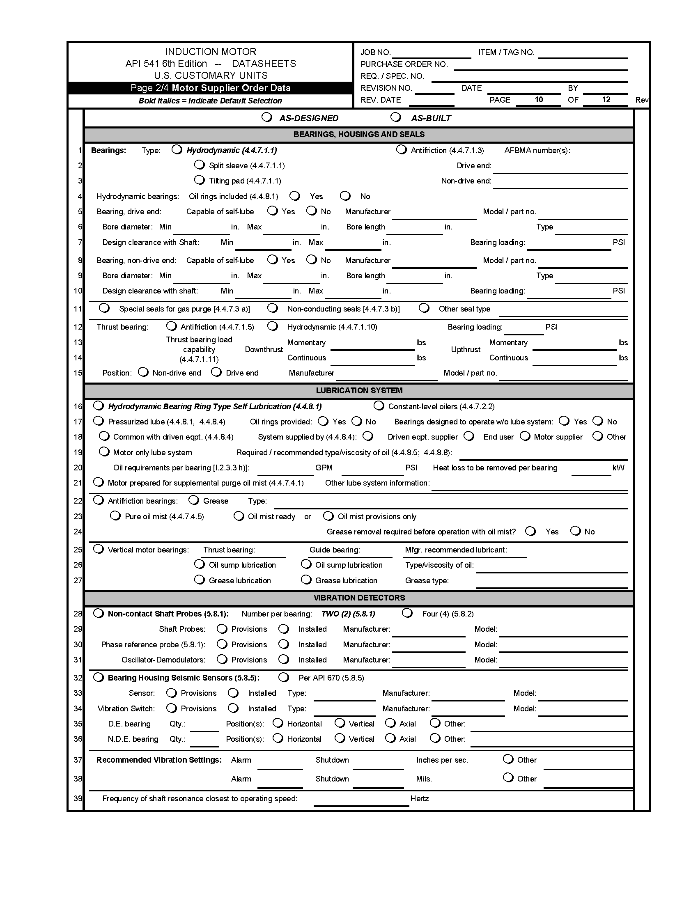

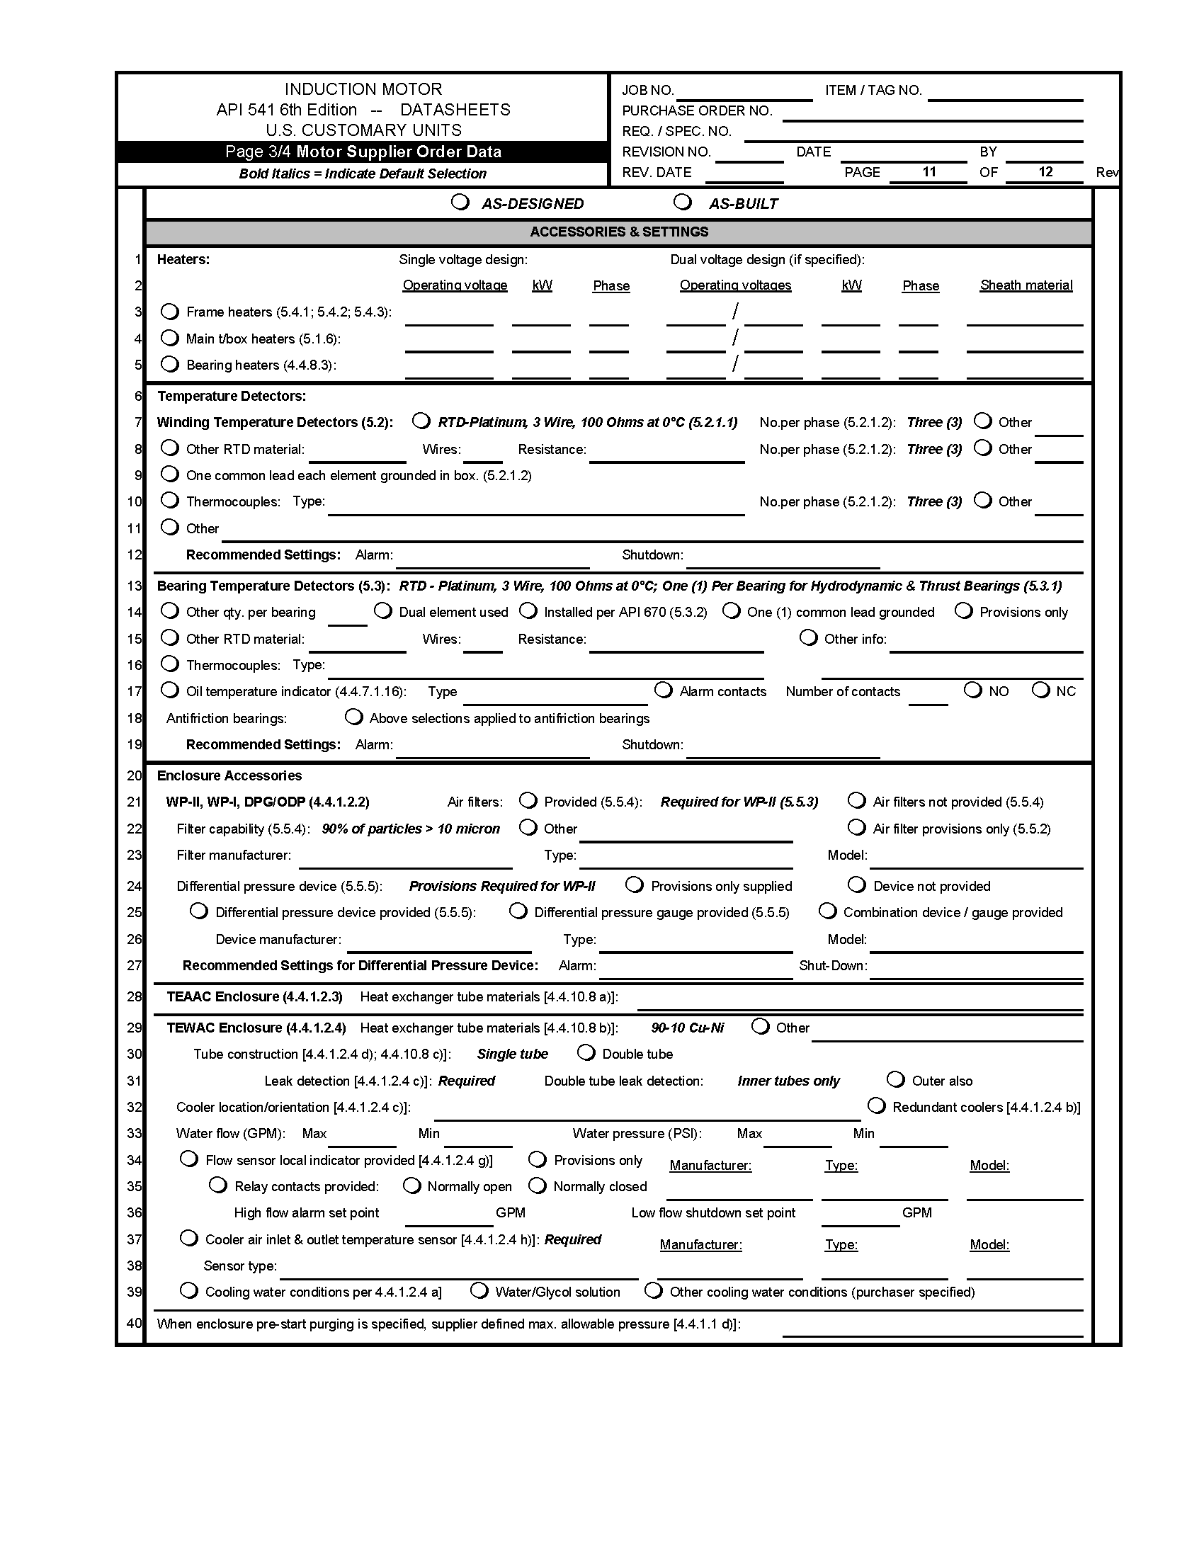

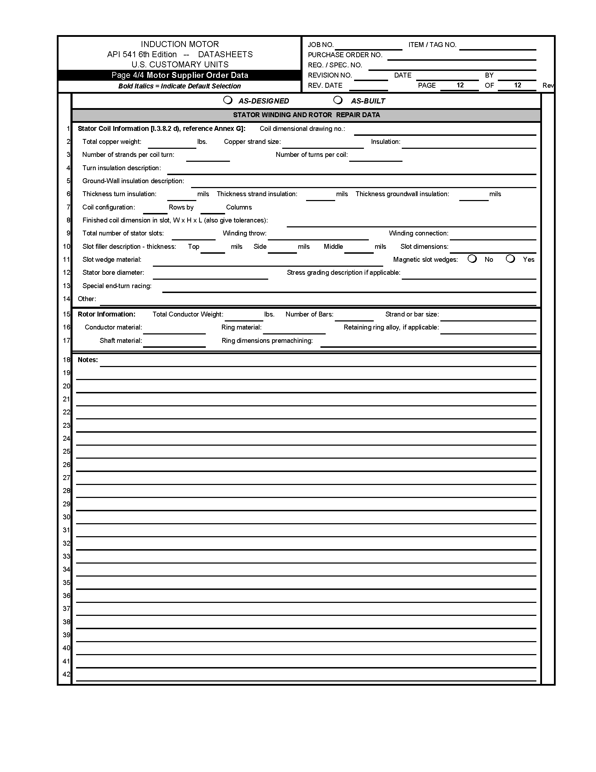

**Annex B**

(Normative)

**Vendor Drawing and Data Requirements**

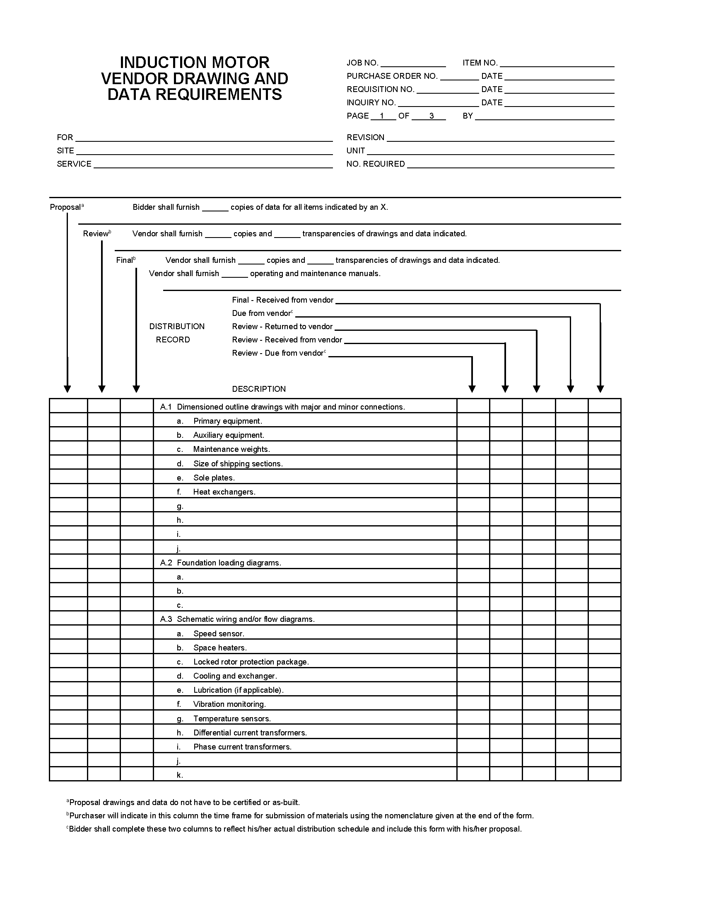

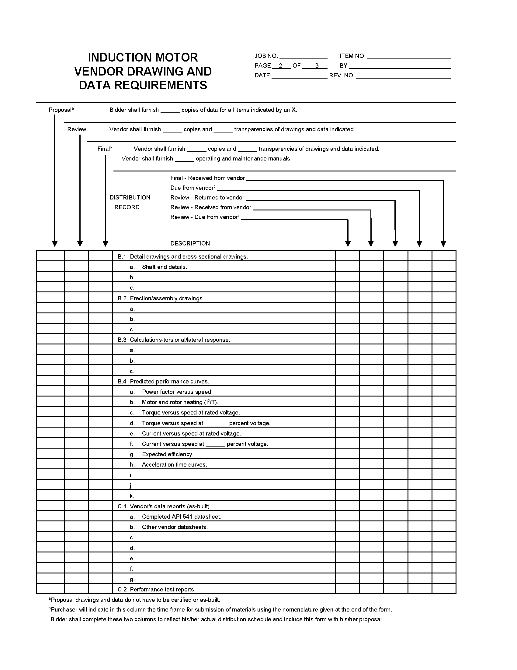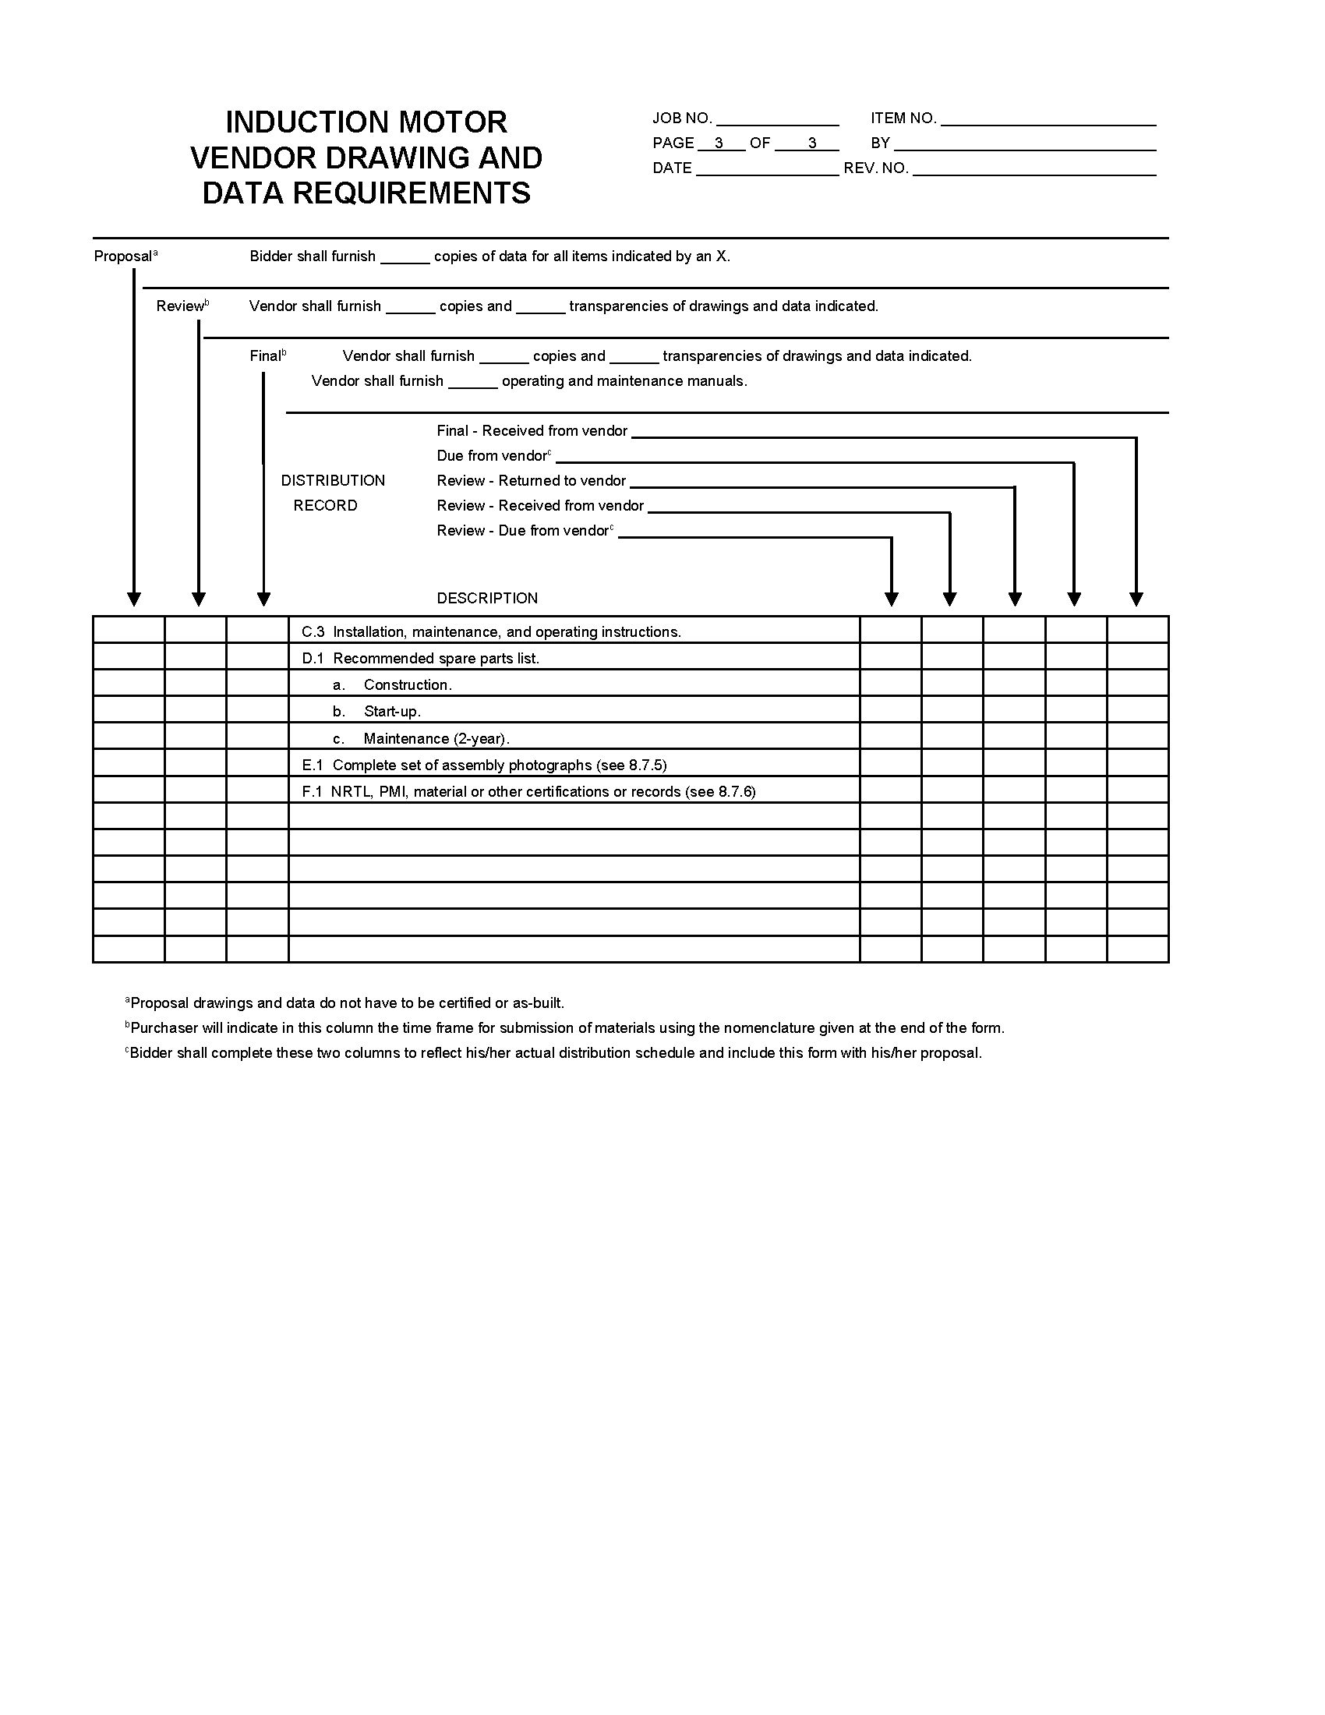

**Annex C**

(informative)

**Datasheet Guide**

**Purpose**

This datasheet guide provides instructions for completing the API 541, Sixth Edition datasheet in Annex A. In order to properly apply this standard, it is a requirement that the purchaser’s specifying engineer complete the purchaser’s section of this datasheet (pages 1 to 7) before obtaining bids. This datasheet guide presumes the specifying engineer:

* is familiar with the process of procuring driver equipment;
* is familiar with the basic components and construction of form-wound squirrel cage induction motors; and
* is familiar with API 541, Sixth Edition and the purpose, format, and use of datasheets.

This guide does not cover all possible applications. The specifying engineer should consider the specific installation when filling out the datasheet.

**Scope**

The datasheet covers all squirrel cage induction motors rated 375 kW (500 hp) and larger. There are two versions of the motor datasheets: one is provided using USC units (e.g. hp, lb) and a second version uses SI (metric) units (e.g. kW, kg). Certain datasheet line numbers on pages 1 and 2 are different in the two versions and, where applicable, the guide shows the line number for the SI version in parentheses [e.g. 1-27 (30)].

Paragraph numbers corresponding to API 541 are indicated in (parentheses) on the datasheet where applicable. Features that are defined in the standard as the default for that particular item are shown in the datasheets as ***bold italics***. The default for the item will be assumed by the supplier unless an alternate selection is identified. Items for which the standard defines specific requirements and there are no alternatives (e.g. stainless steel nameplates) are not shown on the datasheets. If an option not presented in the datasheet is desired, it should be listed under “Other.”

**Symbol Explanatory Page**

The initial page (page 0) of the datasheet is used to explain how to insert or change the symbols used to mark selections in the digital form datasheet. The symbols are based on “Wingdings” font and are helpful when filling out the datasheets for digital transmission.

**Datasheet Criticality**

It is imperative that the datasheet be supplied to the motor supplier if compliance to API 541 is expected. The more thoroughly it is completed, the higher probability of achieving a satisfactory outcome and compliance. Additionally, if the purchaser expects the motor vendor to provide a completed motor proposal datasheet page, the driven equipment section on page 6 should be completed thoroughly.

**Page Header**

**Job No.**—For the user or purchaser project reference number.

**Item or Tag No.**—For the driven equipment identification and tag number.

**Purchase Order No.**—For the user or purchaser purchase order number.

**Req. or Spec. No.**—For the user or purchaser project requisition or specification number.

**Revision No.**—Identify the current revision of the datasheet here and change each time the datasheet is reissued.

**Date**—For the date the datasheet is originally issued.

**By**—Name or initials of the person who is responsible for completing the purchaser’s selections.

**Rev. Date**—For the date a revision of the datasheet is issued.

**Page 1 Identificaiton**

1-1 **User**—Enter the end user’s company name.

1-1 **Application**—Enter the type of the motor application (e.g. “Pump,” “Compressor,” or “Fan”).

1-2 **Location**—Enter the geographical location (e.g. City or State)

1-2 **Supplier**—Enter the name of the party the purchaser will hold responsible for supplying the motor and, if known, the name of the motor manufacturer [e.g. if a pump original equipment manufacturer (OEM) will procure and supply the motor, and the motor manufacturer is known, the entry should be “ABC Pumps/XYZ Motor Company”]. Anyone who knows this information could enter this, but the motor manufacturer should ensure it is completed at the time they issue the as-built version of the datasheet.

1-3 **Project Name**—Enter the purchaser’s name for the project for which the motor is being purchased.

1-3 **Supplier Ref. No.**—For capturing any supplier or motor manufacturer reference number (e.g. a purchase order and sales order number). Generally, the motor manufacturer should fill in this data when they issue the as-built version of the datasheet.

1-4 **Site or Plant**—Indicates the name of the plant (e.g. Plant 18) or the equipment-train identification.

1-4 **Number of Units Required**—Enter the quantity of identical motors required. Create a separate datasheet for a motor with any different selection, requirement, or configuration.

1-5 **Applicable to**—Select “Proposal” when the datasheet is sent out for quotation (purchaser), “Purchase” when a final document is complete for order placement (purchaser), “As Designed” when the motor supplier order data is issued for the first time (motor supplier) and “As Built” to reflect the final completed datasheet after all design details inclusive of any changes during manufacturing and testing have been completed (motor supplier).

1-5 **Motor Tag No(s)**—List all individual motor identification numbers on this line and the open line below this line.

**Page 1 Basic Design - General**

1-6 **Applicable Standards**—Indicate which standards apply, either North American or international. North American standards are the default. Generally, if international standards apply, the metric version of this datasheet should be used, and other standard options are listed in it.

1-7 **Basic Design**

1-7 **Power/RPM Ratings Are Specified by**—Identify who is responsible for determining the motor power and rpm rating requirements. Motor suppliers usually do not perform this task.

1-8 **Nameplate Power Rating**—Enter the output rating of the motor where known, and select either horsepower (hp) or kilowatt (kW). Use standard power ratings defined by NEMA and IEC. A service factor of 1.0 is recommended. If output beyond the 1.0 service factor output rating is required, the next higher motor rating should be chosen. This is primarily done to assure adequate torque margin for the motor (accelerating, pull-up, and breakdown torques) and to ensure long insulation life when applied to a Class F winding insulation system. Operation of a motor above 1.0 service factor may reduce insulation life due to increased temperature. The increased temperature may also adversely affect life expectancy of other motor components (e.g. motor lead insulation, bearings, oil, sealing materials, gaskets, and noise abatement materials). Also note that IEC standards do not provide for service factor above 1.0, and IEC standards for hazardous (classified) motors do not allow the employment of service factors above 1.0.

1-8 **Motor Speed**—Enter the no-load (synchronous) speed in rpm of the motor, where known. Typical available speeds on 60 Hz power systems include 3600 rpm, 1800 rpm, 1200 rpm, 900 rpm, and 720 rpm. For 50 Hz power systems, 3000 rpm, 1500 rpm, 1000 rpm, 750 rpm, and 600 rpm speeds are available. Lower speeds are available but infrequently used for induction motor applications. Synchronous speed is calculated using the formula: Speed in rpm = 120  f /p, where “f   ” is the electrical frequency and “p” is the number of poles in the motor (e.g. 2, 4, 6, 8, 10).

1-9 **Volts**—Normally specified utilization voltages for fixed speed North American applications are 2300 V, 4000 V, 6600 V, or 13200 V supplied by 60 Hz, three phase power systems of 2400 V, 4160 V, 6900 V, and 13800 V. Outside North America, 3000 V, 6000 V, and 10000 V, 50 Hz are common, while 3300 V, 6600 V, and 11000 V, 50 Hz are often used in British applications. Occasionally, a motor voltage of 460 V or 575 V might be specified for a motor of “form-wound” winding construction supplied by a 480 V or a 600 V power system. Motors for use on ASDs sometimes have nonstandard voltages and frequencies as required by the drive and the application.

1-9 **Phase**—Three phase power systems are almost always applicable—enter “3.” If the power system has a different arrangement, identify it here and explain further in the notes section.

1-9 **Hertz**—Enter the applicable frequency of the power system (usually 60 Hz or 50 Hz). For motors to operate on an ASD, list the drive output frequency range intended (e.g. 30 Hz to 60 Hz) and complete the section beginning on line 16.

1-10 **Nameplate Ambient Temperature**—The ambient temperature to be used in defining the motor ratings and that should appear on the motor nameplate should be specified here. This is a critical starting point for motor design. Typically, the base or “rated” ambient for motors is 40 C, and this is the default found in most standards. It is often the same as the site ambient, but not always the same as the maximum ambient specified for the site, which may only be realized for short periods. If it is determined that the site ambient is higher than 40 C, the higher value should be used for the motor nameplate ambient as well. If the maximum site ambient is lower than 40 C, the purchaser may agree to use the lower value for the nameplate ambient, otherwise 40 C should be used. If the motor is to be used in a heated indoor location where the site ambient is lower than 40 C, the purchaser may also elect to utilize the 40 C for the nameplate ambient instead of the lower outdoor site ambient. The rated ambient temperature affects the design of the motor’s physical size, stator windings, bearings, lubrication, and other characteristics.

1-10 **Min. Rated Operating Ambient Temp.**—The minimum rated operating ambient temperature should be filled in here. It normally is equal to the site minimum ambient temperature, but there may be circumstances where the purchaser will desire or agree to higher or lower minimum temperatures. The minimum ambient temperature is important to the motor supplier in several areas of motor design as described above and also in terms of materials of construction.

1-11 **Stator** **Insulation Class**—This pertains to the winding electrical insulation. This standard specifies “Class F” insulation as a minimum and this is the default. It is the standard of the industry and is rated for 155 C total operating temperature. This value is based upon the sum of the standard 40 C ambient and a temperature rise. See temperature rise below. Class H insulation may be available and is rated for higher temperatures (180 C), but it is not often needed and seldom used for machines of the size covered by this standard.

1-12 **Stator Temp. Rise**—This item specifies the maximum increase in temperature of the stator windings permitted over ambient air temperature. There are two methods used to measure and determine the temperature rise: the detector method (usually with a resistance temperature detector—RTD) and the resistance method (where the change in stator winding resistance from “cold” to “hot” at rated power is measured—RES). This standard requires stator temperature detectors for all motors covered, thus the detector method of determining temperature rise applies to the nameplate ratings of these motors. These machines are also required to comply with the temperature limits of the resistance method (RES) as well. See the following table for reference.

|  |  |  |
| --- | --- | --- |
| Motor Rating | Method | Class B Rise  (Above 40 °C Ambient) |
| All hp ratings | RES | 80 C |
| 1500 hp and less | RTD | 90 C |
| Over 1500 hp, 7000 V and less | RTD | 85 C |
| Over 1500 hp, over 7000 V | RTD | 80 C |

The Class B rise given above is specified even though the insulation system is rated for the higher Class F temperature. This is to assure long insulation life. The cost associated with losses (life cycle costs—see 8.1.2) also results in lower than Class B rise in most cases, since losses result in heat. The above values are for a maximum ambient air temperature of 40 C. If the maximum ambient temperature is above 40 C, the values for temperature rise in the above table are expected to be reduced by the number of degrees that the ambient temperature exceeds 40 C. Note that the “ambient” is taken as the temperature of the cooling air entering the machine cooling air circuit for air cooled machines. For machines with a water to air cooled heat exchanger, the cooling air temperature is that of the air which exits the heat exchanger and flows into the cooling air circuit. Refer to NEMA 20.8.3, NEMA 20.8.4, and NEMA 20.8.5 for explanation of temperature rise adjustments in this and other conditions [e.g. altitude above 1000 m (3300 ft) and ambient temperatures lower than 40 C].

1-12 **Other**—Where the temperature rise requirement is lower than the table above due to high ambient air temperature, use of a heat exchanger, or other reason, enter the appropriate temperature rise in the space provided.

1-13 **Duty**—Many petrochemical applications are continuous duty where the motor normally runs continually, and this is the default. Even if some do not, they may be expected to do so in operational guidelines. The vast majority of motors purchased for industrial service are rated for continuous duty. If some other motor duty is required (IEC 60034-1 defines other types, S2 through S10), describe here and schedule discussions with the motor supplier for design considerations.

1-14 **Max Sound Pressure Level**—The standard requires a maximum of 85 dBA at a distance of 1 m (3 ft) at no load at full voltage on sine wave power. This is consistent with OSHA rules so that hearing protection is not required while the motor is in operation. Remote, unattended equipment may not require 85 dBA. Lower sound levels may be desired but may be difficult and expensive to achieve. Certain rare installations near noise sensitive areas (e.g. residential dwellings) may require reduced noise levels of 80 dBA or 75 dBA. The noise level of the equipment train is affected by each individual machine’s contribution to the total sound level and other external effects (e.g. nearby equipment, walls or other reflective surfaces). Motor noise levels are based upon a free-field measurement at no-load conditions when tested at the supplier’s facility and may be different under loaded or installed conditions. Consider the alternative of accepting supplier-standard noise levels and enclosing the entire drive train in a sound enclosure that does not affect cooling air flow. Consult a local safety engineer for more guidance. If lower sound levels are required from the motor, document it here.

1-15 **Voltage and Frequency Variations**—This standard requires compliance to power system voltage and frequency variations normally specified for industrial equipment—voltage variation of ±10 %, a maximum frequency variation of ±5 %, and a total combined variation not to exceed ±10 %. Any other non-ASD variations that may apply are to be documented here.

1-16 **Motor Power Source**—Sine wave power is the fixed frequency utility supply. An ASD (adjustable speed drive) gives an adjustable frequency and voltage to adjust the motor speed. If an ASD is to be used, select this bullet and describe the ASD type in the space provided. The type of drive affects the motor design, particularly the winding configuration and the stator insulation. List the type of drive [e.g. voltage source pulse width modulated (PWM), current source PWM, neutral point clamped (NPC), load commutated inverter (LCI), etc.]. Then complete the ASD application section that follows. Note that diamond bullets (◻) are used throughout the standard to designate paragraphs with additional requirements for motors used on ASDs. These additional data and operating conditions are necessary for the supplier to properly design the equipment for ASD use.

1-17 **Adjustable Speed Drive Conditions**—Motor design is affected when operation from an ASD is required, and changes may be needed compared to a motor intended to operate only on constant frequency sine-wave power; particularly the magnetics, insulation, and cooling system. A motor may be intended to be started and operated on ASD power only, started and operated on either ASD or utility power, started on ASD power only and switched to utility power, or started on either utility or ASD power with the ability to switch between the two sources during operation. If starting on utility power is a requirement, load inertia and torque versus speed characteristics as well as the voltage dip expected at that time are required by the motor designer. Select which of these conditions apply on line 18.

1-18 **ASD Only, or…**—See guide for line 16.

1-19 **Variable Torque Speed Range**—A variable torque load is one where the load torque reduces with the square of the speed. Most centrifugal pumps and compressors are variable torque loads. This is the most usual load type for petrochemical applications. Select this line if this is the case and give the minimum and maximum speeds that are required and the torque at those points if known. A typical speed range for a pump is a 2:1 (e.g. 3600–1800) range. If there is a requirement for continuous or temporary operation above the motor’s synchronous (rated) speed, give details in the notes section.

1-20 **Constant Torque Speed Range**—A constant torque load is one where the load torque remains essentially the same (constant) as the full load rated torque condition as the speed is reduced. This is not very common in petrochemical applications. If required, select this line if this is the case and give the minimum and maximum speeds that are required and the torque at those points if known. Motor size and cooling are much more affected by constant torque loads than variable torque loads.

1-21 **Constant Power Speed Range**—When a motor is to operate above its synchronous speed, it is entering the constant power range. In this range, the power demand remains the same, but the proportional torque requirement reduces at some rate. Again this is not common in petrochemical applications, but it might need to be addressed whenever the application requires either continuous or temporary operation above synchronous (base) speed. Give the maximum speed and torque at that speed.

1-22,23 **Describe ASD Type**—It can be beneficial to all parties for the type and topology of the ASD to be described in brief detail. Include this information if possible.

1-24 **ASD, Output Harmonics**—If the ASD output current harmonics are significant, they may impact the motor design. These details need to be provided to the motor supplier with full harmonic data. Give reference to this in this section (if applicable) and supply further data as needed.

1-25 **ASD Maximum Voltage Spike Amplitude and Rise Time**—Because of the drive output semiconductor devices, pulses are generated which can stress motor windings. Motor suppliers should be given this data so they can design suitable insulation systems. Enter the maximum peak voltage spike and rise time the ASD may impose onto the stator winding. This information must be provided by the ASD supplier.

1-26 **ASD Maximum Common Mode Voltage**—Because of the drive design, an additional AC voltage may be imposed on the output waveform, which can stress the stator insulation with higher voltages to ground plus possibly inducing voltages to ground on the rotor. The stator insulation and other parts of the motor must to be designed for this common mode voltage. Enter the maximum common mode voltage the ASD configuration may impose onto the stator winding. This information must be provided by the ASD supplier.

1-27 **Other**—Add additional information relative to the ASD section (if necessary).

1-29 **Area Classification**—If the application for the motor is in an unclassified area, select Nonclassified.

If it is in a classified area, fill in all the data required in this section. The motor supplier requires all this information to properly configure a motor for a classified area. Classified areas are normally defined for existing plants, and new plants or projects.

Refer to API 500, API 505, and NFPA 70, the U.S. National Electrical Code (NEC) Section 5, or the Canadian Electric Code (CEC) Section 18. The definitions of Class, Group, and Division, and alternatively Class, Group, and Zone are found there. IEC 60079-10 may also be referenced where applicable, in addition to local codes or regulations.

Almost all areas in petrochemical facilities are “Division 2” or “Zone 2.” The most commonly specified area classifications for process areas are Class I, Division 2, Group D or Class 1, Zone 2, Group D. “Class I” covers a flammable gas or liquid, “Division 2” applies where gas, vapor, or liquid is present only during abnormal conditions, and “Group D” covers a category of materials including gasoline. Motors used in Division 2 or Zone 2 areas are not required to be “explosion-proof” but cannot have any component that in normal operation may generate a spark (e.g. a contact type switch) unless that component is in a certified enclosure. While Division 2 and Zone 2 areas in North America do not require special motor enclosures, Zone 2 areas outside of North America do require special motor enclosures (e.g. nonsparking type) so precautions should be used for applications outside North America.

A “Division 1” area means the flammable gas or vapor is often present and special enclosures or provisions for ventilation should be used. A “Zone 1” area is one where the gas or vapor is likely to exist under normal conditions or that is adjacent to a “Zone 0” area and also requires motors with special enclosures. A “Zone 0” area is one where the gas or vapor is present continuously **(no motors are allowed in a Zone 0 location)**. In the Zone system Group IIA is similar to Group D in the Division system, Group IIB is similar to Group C in the Division system and Group IIC is similar to Groups A and B in the Division system. However, not all chemicals retain this relationship. Some materials change group designations depending upon the evaluating authority. API 505 discusses the Zone system in more detail. Care should be exercised when using the Zone system to avoid confusion with the Division system.

1-30 **Temperature Code (USC and SI) and Autoignition Temperature (USC)**—If the application is in a classified area, enter the applicable temperature code (T-Code) here, and enter the applicable autoignition temperature (AIT). The T‑Code represents a temperature class applied to equipment and must be less than the minimum AIT for a group of gases, vapors or liquids defined to apply for the Division or Zone area classification for a given site. See NFPA 70, Table 500.8 (C) for a listing of T-Codes and temperatures. Note that space heaters have additional requirements in classified areas as they are required to either have sheath temperatures that do not exceed 80 % of the applicable AIT or be listed with a T-Code that is suitable for the AIT. Refer to NEC 70, 501.125 (B) and the information in this guide on space heaters for datasheet page 4, lines 6 and 7. If nothing is entered for T-Code or AIT in classified areas, this standard requires use of a T3 T-Code or 200 C as the AIT applicable to space heaters for any ignitable vapors or gases that may exist around the motor while it is in service. However, some liquids have ignition temperatures lower than 200 C, and the purchaser should list the applicable AIT here. Refer to the below table of selected flammable gases and vapors of liquids having an AIT of less than 200 C. This table is NOT applicable to gasses and vapors tested to European standards. There are a few but significant differences between the two reporting systems. See the current edition of NFPA 497M for a complete listing of liquids and gasses.

|  |  |  |  |
| --- | --- | --- | --- |
| List of Liquids with an Autoignition Temperature (AIT) of Less than 200 C, Requiring Space Heaters with Heater Element Surface Temperature Less than 160 C (Extracted from NFPA 497-2008) | | | |
| Material | Cl 1 (Div.) Group | AIT C | 80 % of AIT C |
| Acetaldehyde | C a | 175 | 140 |
| Allyl Glycidyl Ether | B(C) b | 57 | 45 |
| Carbon Disulfide | — a c | 90 | 72 |
| Diethyl Ether (Ethyl Ether) | C a | 160 | 128 |
| Dimethyl Sulfate d | D | 188 | 150 |
| Hyrdrazine | C | 23 | – |
| Dimethyl Sulfate d | D | 188 | 150 |
| 1,4-Dioxan | C | 180 | 144 |
| 2-Ethylhexaldehyde e | C | 191 | 152 |
| Isobutyraldehyde | C—gas | 196 | 156 |
| Iso-octyl Aldehyde e | C | 197 | 157 |
| Monomethyl Hydrazine | C | 194 | 155 |
| Propyl Nitrate | B d | 175 | 140 |
| * Material has been classified by test. * Where all conduit runs into explosion-proof equipment are provided with explosion-proof seals installed within 450 mm (18 in.) of the enclosure, equipment for the group classification shown in parentheses is permitted. * Certain chemicals have characteristics that require safeguards beyond those required for any of the above groups. Carbon disulfide is one of these chemicals because of its low autoignition temperature and the small joint clearance necessary to arrest its flame propagation. * Flash point of these materials is between 140 F (60 C) and 200 F (93.3 C). Special electrical equipment is required only if these materials are stored or handled above their flash points. * Flash point of these materials is between 100 F (37.8°C) and 140 F (60 C). Special electrical equipment is required only if these materials are stored or handled above their flash points. | | | |

(1-31–33) (SI only) **Explosion Protection Labeled Motors** [as found only in the SI units version of datasheet]—In the SI units version of the API 541, Sixth Edition datasheet, lines 30 through 32 provide the ability to specify options for motors to be provided with labels validating their certification to one of the various explosion protection standards. Motors labeled as such are not commonly used in North America but may be required in other regions of the world. Care should be exercised to ensure clear understanding of the impact of choosing any of these options, and assumptions should be avoided. The default for this section is “not required.” Make choices in this section only when definitive requirements exist.

1-34 **Other**—Add any other requirements relative to area classification for this application here.

1-35 **Site Data**—Fill in as much as possible for site data. This data can directly affect the motor design.

1-35 **Site Ambient Temperature**—Enter the maximum and minimum ambient air temperatures defined for the site the motor will be operating in. This data becomes significant if the maximum is above 40 C (104 F) and if the minimum is below –15 C (5 F). Maximum temperature above 40 C may determine a derating factor for the motor design (typically a 1 C reduction in allowed temperature rise for every 1 C by which the ambient exceeds 40 C) or may dictate a special oil cooling system. Minimum temperature below –15 C may determine the need for bearing housing oil heaters or special steels with increased cold temperature toughness.

1-36 **Minimum Rated Storage Ambient Temperature**—Certain precautions may be necessary if motors are to be stored in conditions with ambient temperatures lower than minimum operating temperatures. If this is known to be the case, enter the lowest ambient storage temperature here.

1-36 **Site Elevation**—Enter the applicable elevation for the site where the motor will be operating. This is significant if over 1000 m (3300 ft) above sea level. Due to the decreased air density of higher elevations, machines are normally derated by approximately 1 % per 100 m (330 ft) above 1000 m (3300 ft). The supplier should be consulted for elevations above 2000 m (6600 ft) as other factors may affect this estimation. For new equipment, the supplier can take the elevation into consideration during the design stage and offer a machine fully rated for the conditions without derating. In this case, an indication of design-for-elevation should be made on the main rating nameplate. There are cases where other elevations are to be used or the user may desire interchangeability with similar motors installed at other elevations. If this is the case, use the bullet and space provided on line 34 (36) to define what elevation should be used.

1-37 **Relative Humidity**—Enter the maximum and minimum humidity of the site for reference.

1-38,39 **Motor Location**—Select Indoor on line 38 or Outdoor on line 39. This may impact the enclosure design along with the other options in this section.

1-38  **Building Temperature Controlled, Controlled Temp.**—If the motor is in a temperature controlled building and the controlled temperature is different than the outdoor ambient, the motor design and rating may be able to take advantage of the controlled temperature ambient and may be less costly than one specified to meet the site outdoor ambient. Make the applicable selection and indicate if the controlled ambient can be used for the motor design and nameplate. If this is the case, also edit the Nameplate Ambient space in line 10 accordingly.

1-39  **Roof over Motor**—Select if applicable. It may affect some aspect of the enclosure design, particularly with respect to the effects of solar radiation.

1-39  **Offshore Platform…**—This standard requires 300 series stainless steel on enclosure fastening devices up through M12 (1/2 in.) in diameter. If the motor is intended for use on an offshore platform or similar marine application, 316 series stainless steel is required for fasteners and for tube material in the heat exchangers of TEAAC enclosures. Select this item to indicate this site location applies, and also see the related bullet items for tube material and hardware on page 2 of the datasheet.

1-40  **Seismic Loading**—Select if the motor is to be installed in an area requiring compliance to seismic loading. The current standard for defining seismic loading is the International Building Code (IBC), which has superseded the Uniform Building Code (UBC). Within the IBC, different seismic zones are defined. Earthquake prone areas have the highest seismic loading and zone criteria. Identify the applicable zone here. Also identify the applicable Importance Factor. This factor is used to increase the margin of safety for essential and hazardous facilities which will affect the design of motor enclosure and attached components. This data can be critical in what the motor supplier can provide for a given seismic zone. This should usually be an issue for sites on the U.S. West Coast.

1-41  **Unusual Conditions**—Define any unusual site conditions in the following section.

1-42  **Additional Environment…**—If the motor is subject to any specific chemicals, vapors, or liquids, specify what those chemicals are.

1-43  **Abrasive Dust Protection…**—If abrasive dust conditions are specified, winding insulation protection is required for dripproof or weather protected enclosures. This treatment may reduce the air-cooling effectiveness and raises the winding temperature above that without the treatment, resulting in a larger and more costly motor. Specify any other dust conditions here (e.g. adhering dust or corrosive dust). See the descriptions of weather protected type I and II enclosures. Totally enclosed machines should be used where possible in these situations.

1-44 **Corrosive Agents…**—Include environmental exposure that could result in stress-corrosion cracking. This may include salt air or trace hydrogen-sulfide.

1-45 **Other**—Indicate any other unusual conditions (e.g. hose down or tropical environment).

**Page 2 General**

2-1 **Enclosure**—Select the desired motor enclosure and related options in the following section. The motor cannot be configured without this information. See the standard for a table that cross-references NEMA defined enclosures with the IEC designations (also found in NEMA). For motors to be used in classified areas, reference NFPA-70 Section 500 or 505, CEC Clause 18, or IEC-60079. Note that per 4.4.1.1 f), “machines rated 6kV and above shall have a TEFC, TEAAC or TEWAC enclosure.” The intent of this requirement is to ensure machines with this level of voltage rating are not exposed to environmental conditions that may lead to stator contamination and the increased potential of insulation system damage or failure related to the elevated operating voltage. In applications where the purchaser chooses to utilize an open enclosure (e.g. WP-II), it may be noted on the datasheet on line 9.

2-1 **Enclosure Identification**—Degree of protection (IP) and method of cooling (IC) are most often used to specify IEC equipment. This approach has also been incorporated into the NEMA standards in addition to the historical NEMA enclosure definitions. It is not necessary to specify both IP and IC as well as NEMA enclosure requirements, but it is an acceptable practice. Thus, the typical approach of specifying only IP and IC codes for an IEC motor application is viable, and for NEMA based requirements it is not necessary to select IP and IC codes in addition to the NEMA designations. In either case, there are additional enclosure options that follow that should be addressed where applicable.

2-2 **WP-II**—The WP-II enclosure (weather protected type II as defined by NEMA) is a common enclosure. Air from outside the motor is drawn into and passed through its interior for cooling. The WP-II enclosure is intended for outdoor applications. It is constructed so that high-velocity air and dirt ingested by the motor can be discharged without entering the internal air passages to the electric parts of the motor. It may not be an appropriate choice where adhering dust is present or if the area does not have free air exchange. The hot air discharged from the motor can cause a closed-in area to become excessively hot. WP-II machines with a rated voltage over 4000 V may have a shorter insulation life due to contamination and the related tracking.

2-2 **WP-I**—The WP-I enclosure (weather protected type I as defined by NEMA) is not commonly used in petrochemical applications. Air from outside the motor is drawn into and passed through its interior for cooling. The WP-I enclosure should be limited to sheltered or indoor locations which may be subject to slight weather intrusion or splashing water. It may not be an appropriate choice where adhering dust is present or if the area does not have free air exchange. The hot air discharged from the motor can cause a closed-in area to become excessively hot. WP-I machines with a rated voltage over 4000 V may have a shorter insulation life due to contamination and the related tracking.

2-2 **DPG**—The DPG or ODP enclosure (dripproof guarded or open dripproof as defined by NEMA) offers the least amount of protection from the local environment. If used, it should only be applied in an indoor environment with clean air. It is not recommended for outdoors and would likely give reduced reliability in all applications.

2-3 **Air Filters**—Air filters are required for WP-II machines by the standard. They may also be specified for WP-I or DPG machines. In lieu of filters, provisions for filters can be specified also. It is highly recommended that either an air-filter differential-pressure switch, winding temperature detectors or both be used and wired to the control system as a means to annunciate and alarm operators when the filters become dirty. The standard requires that the filters capture 90 % of 10 micron dust particles. When filters are specified, it is wise to order a set of spares so they can be exchanged with those in the motor and cleaned.

2-4 **Air Filter Capability**—The default requirement of the standard is for filters that capture 90 % of 10 micron dust particles. If a different capability is required or if the purchaser desires to further define what type of air filters are required, use the Other option provided.

2-5 **Purchaser Specified Filters**—If the purchaser wants to specify a particular type of air filter, provide all the detail listed on line 5.

2-6–8 **Differential Pressure Device**—This device is recommended for any machine with air filters. The standard only requires that provisions for a differential pressure (DP) device are supplied. There are a variety of devices available that will detect the pressure differential across the air filters which will increase as they become clogged with dust and retard cooling air flow into the motor. Select one of the options provided on lines 6 and 7. Provisions may also be selected for WP-I and DPG machines. Local practice at the site usually dictates if a gauge or switch or both are supplied. Note that if the motor is to be used in a Division 2 or Zone 2 area, and the DP device that is supplied has contact type switches, the device should be housed in a certified enclosure. If the purchaser wishes to specify a particular brand of DP device, then supply the details requested on line 8.

2-9 **Enclosure for 6 kV and Above**—The standard now requires the use of a totally enclosed type of motor enclosure when the motor voltage rating is 6000 V or greater. However, there may be applications where the purchaser has successfully used a WP-II or similar enclosure and desires it again. To help clarify this for the supplier, select this bullet if this choice is applicable.

2-10 **TEFC**—The TEFC enclosure (totally enclosed fan cooled as defined by NEMA) is a construction where free exchange of air is prevented between the inside and outside of the motor. The motor is cooled by a shrouded shaft-mounted fan external to the main frame or enclosure which forces air axially over and along the outside of the frame. This design is typically characterized by the body or frame of the enclosure having external fins that act as a heat exchanger. TEFC machines are relatively simple and are recommended for severe environments. No further options are defined by the standard, although an option to have the supplier give proof of a nonsparking fan design is provided on datasheet page 5 under Miscellaneous. There are other variations of the TEFC enclosure [e.g. one that utilizes a blower mounted on the machine to replace the shaft mounted fan and deliver a constant flow of cooling air, totally enclosed blower cooled (TEBC)], which may be found in ASD applications where shaft mounted fans do not provide adequate cooling at lower speeds. TEFC enclosures are typically available up to approximately 1500 kW (2000 hp), and are very common in sizes under 600 kW (800 hp). Alternatives for larger totally enclosed machines include the TEAAC enclosure or the TEWAC enclosure described below. Refer to previous guide information for 2-1 on enclosures in reference to machines with voltage rating equal or greater than 6 kV.

2-10 **TEPV**—The TEPV enclosure (totally enclosed pipe ventilated as defined by NEMA) is usually based on a motor design similar to a WP-II with the difference being that there is no free exchange of air between the inside of the motor and the air immediately outside the motor enclosure. It is suitable where the motor is located in very dirty locations when it is desirable to remove motor lost heat from the area or if the motor is installed in a Division 1 hazardous location. It requires air inlet and outlet ducts to duct air to and from the motor, inlet air filters, and usually inlet air blowers. If inlet air blowers are used, the motor is usually at a slight positive pressure. The term “totally enclosed force ventilated (TEFV)” is sometimes used to describe this configuration. See NFPA 496 for ventilation and instrumentation requirements. Note that the TEPV motor is normally not certified separately for Division 1 areas. It may be certified within a certification given to a system of components in a Division 1 area, typically done for each individual application by an appropriate Nationally Recognized Testing Laboratory (NRTL).

2-10 **Other Enclosure**—Use this option if there is a requirement for an enclosure type not described in the standard or the datasheet. This may include other NEMA or IEC designations. It could also designate use of a “dust ignition proof” (DIP) motor for Class II (explosive dust) environments. The DIP motor is totally enclosed and is constructed so that dust does not enter the enclosure. It also prevents heat or sparks inside the enclosure from causing ignition outside the motor, similar to the design of a Division 1 motor for Class 1 areas.

2-11,12 **TEAAC**—The TEAAC enclosure (totally enclosed air to air cooled as defined by NEMA) has an air to air heat exchanger usually mounted on the top of the motor to remove heat from the internal air of the motor. Outside air is directed through the inside of the exchanger tubes by an external shaft mounted fan (or independent blower) while internal air is circulated around the outside of the tubes by internal fans (or independent blower). This style is most often used for larger power ratings [starting at 750 kW (1000 hp)] and locations with severe environments not involving adhering dust. Choose the heat exchanger material based on what is most compatible with air contaminants. Aluminum or aluminum alloy is often the standard from motor suppliers. Copper-free aluminum is less expensive than stainless steel and also has better heat transfer characteristics, which could result in a smaller heat exchanger. Stainless steel is often specified for offshore platforms due to the corrosive environment. Refer to previous guide information for 2-1 on enclosures in reference to machines with a voltage rating equal or greater than 6 kV.

2-13–22 **TEWAC**—The TEWAC enclosure (totally enclosed water to air cooled as defined by NEMA) may be used in environments with adhering dust or dirt where it is desired to remove the motor-loss heat from a building or if the motor is critical and none of the other totally enclosed constructions are applicable. It usually has a higher efficiency and lower noise compared to a TEAAC motor. This style employs a water to air cooler, similar in operation to the air to air cooler noted above. A source of cooling water is needed, usually 1 GPM for each kilowatt of motor loss [0.746  hp  (100 – efficiency %)]. A water-glycol mix may be necessary in conditions where ambient temperatures approach the freezing temperature of water alone. This standard specifies the cooling tube material to be 90/10 copper and nickel. If a different material is required, select the “Other” bullet on line 13 and identify the material required in the space provided. Numerous other characteristics should be reviewed and specified for a TEWAC enclosure; see the following. Refer to previous guide information for 2-1 on enclosures in reference to machines with a voltage rating equal or greater than 6 kV.

2-14 **Cooling Water Conditions**—The cooling water system is designed for the conditions listed below and given in the standard [4.4.1.2.4 a)]. If the conditions vary from this, changes to the heat exchanger may be required; therefore, the water conditions should be defined and attached to the datasheet if different from those given.

|  |  |  |
| --- | --- | --- |
| Velocity over heat exchange surfaces | 5ft/s to 8 ft/s | 1.5 m/s to 2.5 m/s |
| Maximum allowable working pressure (MAWP, gauge) | 100 psig | 700 kPa (7 bar) |
| Test pressure (minimum of 1.5 x MAWP) | >150 psig | >1050 kPA (10.5) |
| Maximum pressure drop | 10 psig | 70 kPa (0.7 bar) |
| Maximum inlet temperature | 90 F | 30 C |
| Maximum outlet temperature | 120 F | 50 C |
| Maximum temperature rise | 30 F | 20 K |
| Minimum temperature rise | As needed to maintain minimum velocity | As needed to maintain minimum velocity |
| Fouling factor on water side | 0.002 hr-ft2-F/Btu | 0.35 m2 K/kW |

2-15 **Cooler Location and Orientation**—The heat exchanger (cooler) is most often mounted on the top of the motor. This reduces floor space requirements compared to side mounted coolers, which reduce the risk of water leakage into the motor and reduce the overall height. The motor supplier may be able to customize the cooler for a given application. As there are numerous other factors involved in cooler design and placement, cooler location other than above the stator should be discussed with the supplier.

2-16 **Cooler Inlet and Outlet Location (Facing NDE)**—The purchaser should specify which side of the machine the supplier should locate the coolant inlet and outlet fittings when the machine is viewed from the non-drive end (NDE).

2-17 **Tube Construction**—The standard specifies single tube cooler construction as the default. Drip trays and leak detectors are required within the motor. “Single tube” means that the motor cooling air is in direct contact with the finned tube through which cooling water flows. When a water leak occurs, the motor should be shut down. Alternately, double tube construction may be selected. Double tube cooler construction is warranted for nonspared service or other applications where immediate shutdown due to a leak should be avoided. “Double tube” means that every tube through which water flows is enclosed within a second tube. The clearance between the tubes is small and empties into a separate header. If a water leak should develop in an inner tube, the leak is enclosed in the second, outer tube and collects in the header. This header is usually equipped with a water detector and will trigger an alarm circuit. Both sets of tubes are rated for the operating water pressure, so no leakage occurs in the air path used for the motor cooling. The motor can continue in operation until a shutdown can be scheduled to repair the cooler. Double tube type coolers are larger, less efficient and more costly than single tube types.

2-17 **Redundant Coolers**—A second, redundant cooler may be possible where high availability is required. This significantly affects cost but is especially useful for high availability and reliability unspared applications where the added cost may be small in proportion to downtime to repair or acquire and replace a cooler. If necessary, select this bullet and work out details with the supplier.

2-18 **Leak Detection**—Leak detection is required by the standard as it is essential to protect the motor from water leakage. For single tube exchangers, the detector is usually in a drip pan between the cooler and the motor. With double tube exchangers, the leak is enclosed in the second, outer tube and collects in the header. This header usually is equipped with a water detector and will trigger an alarm circuit. Both sets of tubes are rated for the operating water pressure, so no leakage occurs in the air path used for the motor cooling. The motor can continue to operate until a shutdown can be scheduled to repair the cooler. Outer tube leak detection should also be considered for double tube coolers since an outer tube leak requires a more urgent response than an inner tube leak. If a leak detector system is also required for the outer tubes of a double tube cooler, select the bullet provided for it.

2-19,20 **Flow Sensor**—A water flow transmitter and air inlet and outlet temperature resistance temperature detector (RTD) is recommended to alarm a loss of cooling water. If a switch type device is selected, also identify what type of control contacts are to be supplied, either Normally Open or Normally Closed contacts. This is dictated by the control scheme for the process.

2-20 **Purchaser Specified Device**—If the purchaser wants to specify a particular type of water flow switch, provide all the detail listed on line 20.

2-21,22 **Air Temperature Sensor**—An air inlet and outlet temperature sensor is recommended to alarm on abnormal temperature and provide useful heat exchanger performance information. If selected, also identify what type of sensor is required (e.g. RTD—resistance temperature detector).

2-22 **Purchaser Specified Device**—If the purchaser wants to specify a particular brand or model of temperature sensor, provide all the detail listed on line 22.

2-23,24 **Hardware**—This standard leaves the choice of dimensional system for hardware up to the purchaser. Both USC and SI (metric) hardware and fasteners are used broadly. With all the various components utilized in a machine of the scope covered by this standard, it may be difficult for a supplier to meet 100 % compliance to either system. It may be unlikely that a supplier can offer the choice of either system without added cost. If there is no preference, do not select either bullet provided and the supplier will provide their normal hardware. If there is a preference, select the applicable bullet and discuss this with the supplier.

2-25 **Provision for Pre-Start Purging**—Specify this for totally enclosed machines in hazardous locations if it is desired to replace all possible explosive atmosphere in the motor enclosure with air from a nonhazardous location before starting. It is not practical to provide pre-start purging for WP machines and it should not be called for in these cases. If selected, provide any details of the requirements in the space provided or reference to an attachment with more detail of the pre-start system expectations.

2-26 **Field Piping Connection Sizes**—The standard states, “Unless otherwise specified, inlet and outlet connections for field piping including those for air, lubrication, cooling medium, instrumentation, conduit, and drains shall have the vendor’s standard orientation and size, except ISO-6708 sizes of DN 32, DN 65, DN 90, DN 125, DN 175, and DN 225 (1 1/4 in., 2 1/2 in., 3 1/2 in., 5 in., 7 in., and 9 in.) shall not be used.” If the purchaser requires variation from this, select this item and describe further in the space provided.

2-27 **Duct Gasket and Bolts Provided by**—When the enclosure utilizes ducting that requires the purchaser to connect mating ducting (typically for external supply of cooling air), the supplier is required to supply flanged surfaces, gaskets and bolts for this connection. If the purchaser prefers to manage the supply of gaskets and bolts, select this bullet.

2-28 **Auxiliary Motor Driven Fans**—Auxiliary blowers (motor driven fans) may be used to provide a constant flow of forced air cooling in any type of enclosure but is more commonly seen in TEAAC or TEWAC types. This cooling method is often applied when ASD operation is required. These blowers will require the purchaser to provide additional motor starters and interlocking control circuits. The advantage of blowers is better cooling and, in the case of TEAAC enclosures, better access to the non-drive end (NDE) of the motor (bearings, vibration probes, lube systems). However, a reliable source of power should be available for the blower motors. If these auxiliary blowers are not acceptable, make the applicable selection here. If they are acceptable, indicate the phase and voltage to be used. The standard requires that IEEE 841 be used for the blower motors. If there are any other requirements to apply to the blower motors, attach separately.

2-29 **Paint System**—As the standard does not specify a paint system, the Supplier’s Paint System is the default. If a special paint system is required (e.g. for offshore environments), select the applicable bullet, identify the relevant paint system specification and surface preparation requirements, and supply copies to the motor supplier for quotation.

2-30 **Paint Color**—In addition, the Supplier’s Paint Color is the default, unless the purchaser specifies a paint color. If a particular color is desired, provide the applicable color name and code. Sometimes a sample paint chip will be required if the color cannot be readily identified by a code.

2-31–38 **Mounting**—Specify the required mounting orientation with the options that follow.

2-31 **Horizontal Foot Mounted**—The vast majority of applications make use of horizontally mounted (e.g. feet and shaft are parallel with the ground) motors that have four feet for use in bolting the motor to the base or foundation. Unless you know otherwise, choose this option.

2-31 **Horizontal Flange Mounted with Feet**—This would be a rare mounting arrangement for a motor in the 375 kW (500 hp) and up class that this standard covers. If this does apply, also provide the required flange type and diameter in the space provided on line 35.

2-31 **Vertical Foot Mounted**—This is another rare mounting arrangement for machines covered by this standard, but may be required, especially in smaller sizes. Make this selection (if necessary) and complete the applicable items following this item.

2-32 **Vertical Flange Mounted**—Most vertically mounted motors make use of a flange that is integral with the drive end bearing bracket or end shield normally with a shaft down orientation in which the motor bearings are commonly designed to absorb the down and up thrust developed by the vertical pump. IEC vertical motors are typically not designed to carry thrust. Normally, the motor is mounted on a stand or base above the pump provided by the pump OEM. If applicable, select this bullet and identify the flange type and diameter in the space provided on line 35.

2-32 **Shaft Down, Shaft Up, Solid Shaft, Hollow Shaft**—For vertical motors, make the applicable selections for shaft configuration.

2-32 **Non-reverse Ratchet (NRR)**—In some applications, a device to prevent shaft and pump rotation in the direction opposite normal rotation is used to prevent potential damage to the equipment in a high backflow situation. Select this bullet if it applies.

2-33 **Vertical Motor to Carry Thrust…**—When vertical motors are required to carry thrust, select this bullet and fill in the applicable data in the Driven Equipment Information section of the datasheet. See the guide for this data in order to ensure all the required data is supplied.

2-34 **Flange Type and Bolt Circle**—Flange types and dimensions vary considerably, so consult the supplier for flange dimensions if not known or select Supplier Decision. If known, use the Other space on this line to define the type of flange and or dimension requirements. A common form of flange for vertical motors is dimensionally defined by the NEMA P-base construction, which may apply to machines in the 375 kW to 600 kW (500 hp to 800 hp) range covered by this standard. IEC standards also define a range of flange sizes.

2-35 **Other Mounting Requirements**—Use this space to define any other variations or additions for machine mounting arrangement requirements.

2-36 **Baseplate Furnished by**—A baseplate, base, or skid to which the machine is mounted is usually supplied by the driven-equipment supplier to support both the machine and the driven equipment. It may be supplied by the OEM with or without a motor. In other instances, an existing baseplate may be used or a third party may supply it. The primary purpose of this selection is to notify the motor supplier if they are to supply a baseplate. This is not the usual practice as a common baseplate supplied by others is the norm. Indicate who owns this responsibility, and if it is the motor supplier, further communications will be required to define what the purchaser’s needs are.

2-36 **Soleplate**—Soleplates are steel plates used to establish a smooth, level mounting surface for the motor when a concrete foundation is used to support the motor directly. The soleplate is embedded into the concrete foundation onto which the motor is mounted. They are normally furnished by the motor supplier for installation by the purchaser. These are not normally supplied when a baseplate is being used or supplied. If a concrete foundation mounting is to be used for the motor, consider selecting this option and identify who will supply it.

2-37 **Non-massive Foundation**—The foundation should be designed to meet the criteria of a massive foundation. There may be certain installations where this is not possible (e.g. on offshore platforms). If the foundation is not considered a massive foundation, select this item and detail these structures on the datasheet. A non-massive foundation may affect the mechanical dynamic performance of the motor, and special mechanical design and construction steps may be required. Refer to the discussion of a massive foundation in Note 1 under 4.4.6.1.3.

2-38 **Data for Non-massive System Dynamic Analysis**—If the “Non-massive Foundation” selection is made, the standard requires the motor supplier to supply data identified in the standard to the purchaser for dynamic analysis. If the bullet in this line is selected, the supplier will know the purchaser wants the data, and it can be quoted as there may be costs associated with this data. If this bullet is not selected, the supplier will assume the purchaser does not need this information.

2-39 **Electrical System**—The information in this section documents data that the purchaser can provide for the supplier to reference when necessary.

2-39 **Primary Power Source**—Document the electrical system as it relates to the motor. For sine wave utility powered motors, indicate the nominal voltage, the number of phases, and the power frequency of the electrical system where the motor will be connected. For ASD powered motors, indicate these conditions at the nameplate rated power (hp/kW) condition and ensure the section for ASD information is completed on page 1.

2-39 **Maximum Ground Fault Amps**—Identify the maximum ground fault current of the electrical system.

2-40 **Method of System Grounding**—Specify how the power system source to the motor is grounded. Most applications will be either low-resistance grounded (50 amperes to 400 amperes) or high-resistance grounded (10 amperes maximum). Some systems are solidly grounded where the ground fault current may be some thousands of amps. A few systems still have “delta” connected transformer secondaries at their source with no intentional connection to ground and are therefore “ungrounded.” The method of grounding will affect the voltage rating of surge arresters applied to the motor.

2-41 **Three Phase Fault Current at Machine Terminals**—Enter the maximum momentary or 1/2 cycle short circuit level (MVA) that can be delivered by the power system. Typically use the maximum expected supply switchgear or circuit breaker duty. This is for determining terminal box pressure release (withstand) requirements.

2-41 **Let-through Energy**—If the motor is fed from a fused-contactor motor starter, enter the maximum let-through energy in I2t (ampere-squared seconds) for the fuse selected in the motor starter that results from the maximum system short circuit capacity.

2-42 **Min S.C. at Motor Bus**—Enter the minimum short circuit contribution from the power system with no short circuit current contribution from other motor sources. This reflects the capacity of the utility company or the generation system and is used to calculate the voltage drop during a motor start.

2-42 **X/R Ratio**—This is the ratio of reactance to resistance for the minimum short circuit MVA condition from the power system. This is used in conjunction with the short circuit MVA for voltage drop calculations. As an alternative to listing the short circuit MVA and the X/R ratio, it may be acceptable to list the system impedance as a complex number in the form R + jX, where R and X are the power system resistance and reactance at the motor bus, either in ohms or per unit on a specified base.

2-43 **Other**—Include other electrical system information, which may include details on the electric power system (e.g. “fast-bus transfer” of the supply during power failure or line reclosure during system short circuits that could affect winding mechanical bracing and the shaft design). If the motor is to be fed from an ASD, include details or references when applicable.

**Page 3 Bearings, Housings, and Seals; Lubrication System; Special Conditions**

3-1 **Bearings—Horizontal Machines**—Apply the purchaser’s requirements for bearings in horizontal motors in this section.

3-2 **Bearing Type**—The default bearing construction required by this standard is the hydrodynamic type. This is due to their long life expectancy and relative ease of maintenance without removal and dismantling of the motor. These may be the supplier’s normal choice on large machines due to the size of the shaft or speed-diameter considerations. Various sub types of hydrodynamic bearings (sleeve, tilt pad, four lobe) are used, depending on the application. Cylindrical sleeve journal bearings are very common.

3-2 **Split Sleeve, Tilting Pad Bearing Types**—The standard requires that hydrodynamic bearings be split for ease of assembly and maintenance. The sleeve bearing is the most common type of hydrodynamic bearing but is not required. Another type in common use is the tilting pad bearing, which the supplier may use to achieve different characteristics of dynamic stiffness and damping. This type of bearing requires a circulating oil system. Unless the purchaser has a specific reason to require tilting pad bearings, select the bullet for sleeve bearings.

3-3 **Bearing Constant Level Oilers; Type**—Constant level oilers are commonly specified for self-lubricated bearings. These devices act as a backup reservoir to the oil sump below the bearings and maintain the oil sump at a constant level. They have glass housings that can be easily viewed next to the motor, and should the level of oil in them become reduced, preventative action can be taken to investigate a possible oil leak. It is not common to use these devices when an external circulating lube system is to be used. Select this bullet if the purchaser requires constant level oilers. If the purchaser has a specific brand, type or model of oiler to be used, indicate this in the space provided.

3-4 **Antifriction**—Although most API 541 horizontal motors have hydrodynamic bearings, antifriction bearings are an acceptable option within the standard but are required to meet the parameters defined within it. There are limitations where antifriction bearings can be applied, and each supplier has their own set of limits or capabilities. For motors covered by the scope of this standard, a typical limit of motor size where antifriction bearings may be considered is up to 600 kW (800 hp). If antifriction bearings are preferred, it may be more appropriate to utilize API 547 for General Purpose Motors. If the purchaser requires API 541 and antifriction bearings, select this bullet, and address the type of lubrication required on lines 21 and 22.

3-5 **Other**—Add any other information or requirements regarding horizontal machine bearings on this line.

3-6 **Bearings, Vertical**—Where vertical machines are applied in vertical pump service in which the thrust loads are superimposed upon the motor shaft and bearing system, complete the following section.

3-7,8 **Thrust Bearing Load**—Where applicable, the purchaser or OEM should confirm bearing type and thrust loads applied to the motor bearings. Make the appropriate selections and provide these details to give the supplier the necessary information to comply. Antifriction thrust bearings are available in many sizes and fit the low to high range of thrust requirements. Hydrodynamic thrust bearings may be required to fit the higher ranges of thrust loading and may require additional cooling equipment. Either type may require oil lubrication. The motor supplier may be able to offer one or both types, will apply the supplied thrust data to their bearing selection, design to meet the requirements of the standard, and offer a quote. This data should be available from the pump OEM and should also be entered into the Driven Equipment section on the bottom of datasheet page 6.

3-9 **Other**—Add any other information or requirements regarding vertical machine bearings on this line.

3-10 **Special Seals for Gas Purge**—In unusually severe environments, gas or air purging systems may be used to purge bearing seals to help protect them. This requires that such a purging system is present and has the capacity to be used with the motor, in addition to other rotating equipment for which it may be used. If this is applicable and required, select this bullet.

3-10 **Nonconducting Seals**—Bearing seals for this class of motors are usually made from iron, steel, aluminum or bronze. These seals are of the noncontact type and do not make contact with the motor shaft under normal operation. Contact could occur from a bearing failure, but a nonconducting seal will not be of benefit in this situation. This standard also requires the use of insulated bearings. When the bearing and seal system is designed and manufactured properly, the use of electrically nonconductive seals should not be necessary. If there is concern or reason for the use of seals that are nonconducting (e.g. made from electrically insulating material), the subject should be discussed with the machine supplier. If nonconducting seals are required, select this bullet.

3-11,12 **Other**—If any other criteria for bearings or seals are required, add here or attach other documentation.

**Bearing Lubrication**—The various features of the lubrication system are selected in this section. Often, the many points in this section are coordinated and determined by the motor supplier, OEM, package supplier, and purchaser working together.

3-13 **Hydrodynamic Bearings**—The default lubrication scheme for this standard is ring type self-lubricating for hydrodynamic bearings. Other systems are available, preferred or required for the application. The purchaser should specify any details that are required beyond the default in the following section.

3-14 **Type and Viscosity of Oil**—The purchaser should identify the type and viscosity of oil that is expected for the motor lube system. If a common lube system is to be used, the purchaser should coordinate the type of oil used between the driven equipment supplier and the motor supplier. A typical oil viscosity required for the motor is ISO Grade 32, while the driven equipment may sometimes require higher viscosity oil. Higher viscosity oil may impact the temperature of the motor bearings and should be clarified. The type of oil may require discussion as some synthetic oils may not be compatible with materials in the motor. The standard specifies hydrocarbon based (‘mineral”) oil unless otherwise specified.

3-15 **Pressurized Lube Required**—Pressure-fed lubrication is recommended wherever possible for more reliable motor operation. An industry standard, general purpose lubrication system may be acceptable where the motor has “back-up” oil-ring lubrication, but the driven equipment requirements should also be considered where a common lube oil system is used. Bearings without oil rings either require a lube system or will have improved reliability with a lube system. The motor supplier will need to supply data and fittings for the lube system to attach to the motor bearing housings.

3-15 **Common with Driven Equipment**—Select this bullet to confirm that the lube system will be used for the driven equipment and the motor. Note that shared systems may pose a risk of gases from the driven equipment entering the motor through the lube system. This possibility should be considered and any necessary precautions taken.

3-16 **System Supplied by**—Generally, where a pressurized lube oil system is used with or required by the driven equipment, it is also used for the motor. If a pressurized lube system is used, it is typically supplied by the driven equipment supplier, or others. If such a system is be used, the purchaser should identify who will supply it on this line. If the motor supplier is to provide a lube system, it is important for the purchaser to provide all details on the following lines.

3-17 **Lube System to Comply with API 614**—This item is pertinent to the motor supplier only if the purchaser intends the motor supplier to include the lube system in their scope. Typically, if a lube system is common to both the motor and the driven equipment, the team working with the driven equipment specifications and supplier will specify the lube system. Depending on the criticality of the application, the purchaser may specify a commercially available industry standard system (Supplier Decision) or one compliant to API 614. The Sixth Edition is a comprehensive specification whereby oil systems are defined by a coding system that details the 11 major components included. Table 2 lists the requirements for oil system code by API equipment type. Make the appropriate selection on this line, especially if the system is to be provided by the motor supplier. If API 614 is specified, provide the API 614 datasheet.

3-18 **Main Oil Pump Driven by**—This is not pertinent to the motor supplier unless the motor supplier is to provide the lube system. A pressurized lube system is usually a separately powered, stand-alone configuration with a separate motor driven main oil pump that is connected to the motor bearings via appropriate piping. An alternate arrangement could have the main oil pump connected to and driven by the motor shaft. This arrangement can deal with oil supply to the bearings when they do not have oil rings during coast down. If an API 614 system is supplied or if backup oil rings are supplied, a main oil pump driven by the motor shaft may not be required. API 614 recommends a primary and standby pump which should be designated on the API 614 datasheet. A standby pump is normally specified for motors with an API 614 lube system but may not be if the motor has oil rings for backup lubrication during emergency conditions. As many lube systems are common to both the driven equipment and the motor, the system arrangement may not be based on the motor having oil rings or not. If the purchaser requires a motor shaft driven main pump, select the applicable bullet. If this is not required, select the bullet for Separate, independent motor.

3-19 **Other**—Add any other detail about the lube system here.

3-20 **Meet Cleanliness per API 614**—Requires the lube oil system cleanliness of API 614. Specify when the special-purpose API 614 lube oil system is specified for the drive train. The supplier is to assure the lube system is cleaned, flushed, and filtered to 10 microns when the factory lube oil system is used.

3-21 **Purge Oil Mist**—Purge oil mist systems are not capable of providing primary lubrication to hydrodynamic bearings. However, these systems have been applied to hydrodynamic bearings for the purpose of providing a positive pressurization of the bearing housings as a means to help prevent contamination being drawn into the bearings. If required, select this bullet and identify more detail about the requirements in the space provided, or attach additional documentation. Note that it is not likely that the oil mist can be exclusively contained within the motor and will likely escape to the local environment due to the nature of hydrodynamic bearing and seal construction and the ultra fine oil mist employed.

3-22 **Antifriction Bearing Lubrication**—Provide any purchaser preferences for antifriction bearing lubrication, if applicable, in the following section.

3-22 **Grease Type; Supplier’s Decision; Other**—If grease lubrication is desired, the purchaser may specify the type of grease preferred (e.g. polyurea, low temp.) and can also select Supplier’s Decision or Other. If Other is selected, define the specific grease preferred in the space provided. Also use this section to define grease requirements for vertical motors (if applicable).

3-23 **Pure Oil Mist**—Pure oil mist is an excellent lubrication method, but it is dependent on the user having all the equipment in place to utilize this type of system. It is not often used and is very user and application specific. If this is required, select this bullet and then select one of the next two bullets.

3-23 **Oil Mist Ready**—If within a short time from motor shipment, it is expected that the motor(s) will be installed and operating with oil mist lubrication or stored in a lay down yard or similar storage while connected to an oil misting system, this selection will likely be the correct choice. Antifriction bearing motors prepared “Oil Mist Ready” may have a higher risk of corrosion from humidity without precautions compared to similar motors with grease lubrication. If the motors are in operation with oil mist soon after shipment or are stored as described above, the risk of corrosion may be reduced or eliminated. Storage in a humidity controlled storage environment with motor space heaters energized will also reduce the risk of corrosion. Another alternative is discussed under “Oil Mist Provisions Only” below.

3-23 **Oil Mist Provisions Only**—If it is unknown when the motor(s) will be connected to an oil mist system, it may be better to have the motors prepared with “Oil Mist Provisions Only.” With provisions only, all the applicable preparations should be made to the motor, except that the bearings and their housings should be greased in the normal manner for grease lubrication. This arrangement should be discussed with the machine supplier. With this arrangement, the bearings are better protected and the motors can not only be operated without an oil mist system, but they can also be stored indefinitely assuming the supplier’s storage recommendations are followed. The downside of this arrangement is that the motors should be dismantled and grease removed from the inlets, outlets, bearing housing and bearings prior to connection and operation from an oil mist system. If this is not done, there is a high risk that the mist lubrication will be ineffective.

3-24 **Vertical Motor Bearing Lubrication**—To assure clarity for vertical motor lubrication requirements, address the purchaser’s preferences for lubrication of vertical motors in this section.

3-24 **Thrust Bearing**—The lubrication system for a vertical motor thrust bearing will often be determined by the amount of thrust applied to the bearings and the supplier’s design requirements. If the purchaser has no preference for what type of lube system is supplied, select Supplier’s Decision. If either grease or oil is preferred, select the applicable bullet.

3-25 **Guide Bearing**—The lubrication system for the guide bearing in vertical motors is generally less critical versus the thrust bearing and is normally grease. If the purchaser has no preference for the type of lube system supplied, select Supplier’s Decision. If a specific type of lubrication is preferred for the guide bearing, select the “Other” bullet and describe in the space provided.

3-26 **Other**—Add any other notations regarding bearing lubrication on this line.

**Special Conditions**

3-27 **Shaft and Spider One Piece Forging for Four or More Poles**—A shaft construction where the spider arms are welded to the shaft is lower cost than one machined out of a single forging. A one piece forging is required for two pole machines. The standard permits welded construction on motors with four or more poles (1800 rpm and slower). Consider selecting this bullet if a non-two-pole motor is being applied in a critical application and if the purchaser requires such motors with a spider shaft to have a one piece forging. This selection is not often used and should be made in consultation with the supplier.

3-28 **Special Lower Vibration Requirements**—There may be situations when lower vibration levels than required by this standard are considered necessary. Define these requirements here and with additional attachments.

3-29 **Efficiency Evaluation Factor**—If there will be an evaluation of the subject motor(s) based on life cycle cost (LCC), the purchaser is to provide the supplier with the evaluation factor (EF), the energy cost per kW, and the load point to be used in the evaluation as a percent of full load power (e.g. 75 %, 100 %). The formula to determine EF ($ per kilowatt) is given below. The LCC formula is also given below and recommended to be considered for all motors. LCC is equal to the purchase price of the motor plus the value of losses over the life of the motor using the evaluation factor (EF) and evaluated loss (kWe) shown.

LCC = P + EF  kWe

where

P is the purchase price of the motor in dollars;

EF is the evaluation factor ($/kW) = C  N  PWF;

C is the energy cost in $/kWH (dollars per kilowatt-hour);

N is the operating time in hours per year;

PWF is the cumulative present worth factor (this factor typically ranges from 2 to 4 for the purpose of bid valuations);

kWe is the evaluated loss in (kW) = L  hp  [(100/Eop) – 1]  0.746 (Note this converts hp to kW);

L is the load factor = (driven load hp)/(motor nameplate hp);

hp is the motor nameplate horsepower; and

Eop is the motor efficiency (in %) at the specified driven-equipment shaft load.

3-30  **Test Method for Expected and Guaranteed Efficiency Data**—The supplier is required to supply curves and data for motor efficiency. If the purchaser has a preference for which efficiency test method is to be used in the determination of efficiency, detail it in the space provided here. The standard requires that the efficiency test method come from either IEEE 112 or IEC 60034-2, inclusive of stray load losses.

3-31 **Local Codes**—List and supply copies of any country, state and provincial or local codes for which compliance are required (e.g. Southern California installations frequently call for special local electrical codes).

3-32,33 **External Loads Imposed on Motor Enclosure…**—When the supplier does not provide equipment (e.g. piping, ducting or any other auxiliary equipment that may be added or connected to the motor at the installation site), there may be additional forces imposed onto the motor by this equipment. The purchaser should list and detail any such forces for the motor supplier so they can factor them into the frame design if necessary. Typically, these loads are insignificant when these items are properly supported.

3-34 **Special Overspeed Requirement**—The standard requires compliance to overspeed requirements specified by NEMA MG 1 (two minutes at 20 % overspeed for 1500 rpm and over, 25 % for 1499 rpm and lower) or IEC 60034 (20 % overspeed). These limits are generally satisfactory, but for cases without a check valve, turbine drives or driven equipment with higher overspeed trip points (e.g. tandem-driven motors, induction generators, motors driving pumps), the motor may require overspeed capabilities beyond the regular limits and should be listed here. An optional overspeed test with additional requirements may be found in the standard under 6.3.5.6.

3-35 **Other**—Add any other information or requirements regarding special conditions on this line.

3-36–38 **Notes and Other Requirements**—If necessary, add additional information relative to page 3 information.

**Page 4 Accessories**

4-1 **Heaters**—Specify application details for any heaters to be provided with the motor in the following section, except for the main terminal box heaters that are specified on datasheet page 5.

4-1 **Frame Space Heaters**—It is highly recommended that all motors have frame space heaters and the default is for them to be included. Normally, the supplier’s standard bar type space heater is acceptable. Flexible belt type space heaters should be avoided and any type of heater that contacts the surface of the motor winding is not permitted by the standard.

4-1 **Sheath Material**—Normally, selecting Supplier’s Decision for the heater sheath material is acceptable, but stainless steel or other material could be specified. Indicate the purchaser’s selection accordingly.

4-2 **Single Voltage**—Complete line 2 to provide the required voltage and phase for single voltage space heaters. Identify the rated voltage and the operating voltage. Single voltage heaters are intended to operate at one voltage level. In North America, this is typically 120 V or 240 V for single phase power and 208 V or 480 V for three phase power, depending on what power source shall be available with the motor shut down. Three phase power for the space heaters is usually only needed when the heaters are sized for larger motors and thus consume more power. Often, a value of wattage is defined for a local power system below which single phase power is used and above which three phase power is used. Local site practice should be applied.

4-3 **Dual Voltage**—Complete line 3 to provide the required voltage and phase when dual voltage space heaters are required. Dual voltage heaters are designed to provide the same heating power for two levels of applied voltage. In North America, this is typically 120 V/240 V for single phase power and 208 V/480 V for three phase power, depending on what power source is available with the motor shut down. The wiring diagram for a dual voltage space heater should guide the user in the proper connection for each voltage.

4-4 **Bearing Heaters**—Bearing housing (oil) heaters are typically only required when motors are used in outdoor applications or unheated indoor applications where the ambient temperature can fall to –20 C or lower. Generally, if the motor is connected to a pressure lube system, the lube system will have heaters, and the motor will not require bearing heaters unless the motor will be expected to operate in a self-lubricated mode at some time. The standard requires a thermostatically controlled heater. If not sure about bearing heaters, consult with the motor supplier. If an electric immersion heater is used, it is recommended that it have a maximum watt density of 2.3 watts per cm2 (15 watts per in.2) to avoid carbonizing the oil. Also specify the applicable temperature code (T-Code) and operating voltage and phase.

4-5 **Main Terminal Box Space Heaters**—Specify space heaters for the main terminal box on datasheet page 5.

4-6,7 **For Classified Areas**—Refer to the discussion of this topic for datasheet page 1, line 26 found previously in this guide. The temperature code (T-Code) represents a temperature class applied to equipment and should be less than the minimum autoignition temperature (AIT) for a group of gases, vapors or liquids defined to apply for the division or zone area classification for a given site. NFPA 70, Table 500.8 (C) contains the listing of T-Code temperatures.  Space is provided on these lines for the applicable T-Code or maximum surface temperature to be identified for space heater elements.

For Division 2 classified locations, either an unlabeled or a labeled space heater can be used. The surface temperature of unlabeled heater elements is limited by NFPA-70, 501.125 (B) to a maximum of 80 % of the defined minimum AIT, otherwise the space heater should be labeled with a suitable T-Code.  Using an example of a 204 C AIT for the classified area, the maximum surface temperature for an unlabeled space heater should not exceed 80 % of this value, which is 163 C.  If a labeled space heater is used, it is not necessary to multiply the minimum AIT of the classified area by 80 % to establish the maximum temperature for selecting a T-Code, as is required for the unlabeled space heater.  It is only necessary to choose a T-Code that has a temperature rating lower than the AIT, although a lower than required temperature T-Code can still be used if preferred. In the example, a listed space heater labeled with a T-Code of T3 (maximum temperature of 200 C) or lower temperature T-Code can be used.

For Zone 2 classified areas, space heaters should be labeled with a T-Code per NFPA 70, 505.20 (C). An unlabeled space heater is not permitted. The T-Code is selected in the same manner as described above.

Enter the appropriate T-Code or the maximum space heater surface temperature in the space provided. If the maximum surface temperature or the T-Code is not specified, the standard requires that an unlabeled heating element should not exceed 160 C (320 F) and a labeled heating element should be identified with a temperature code of T3 or lower temperature code. Unless otherwise noted, the T-Code specified on page 1 of the datasheet should be specified in this space. See the information for datasheet page 1, line 30 in this guide for a table listing AITs for various gases and liquids.

4-8 **Winding Temperature Detectors**—The standard requires that winding temperature detectors be installed. See datasheet page 2 for temperature sensors for air inlet and outlet in TEWAC heat exchangers (coolers).

4-8 **RTD**—The default detector is a resistance temperature detector (RTD) as follows: 100 at 0 C, platinum, 3 wire, with a temperature coefficient of resistance (TCR, / C) of 0.00385 per IEC 60751, tolerance class W 0,3. Other types are 120 at 0 C, nickel, 2 wire and 10 at 25 C copper, 3 wire. Select the platinum bullet to confirm this selection, or if the purchaser does not want platinum, bypass this selection and make the appropriate designation below this line. These detectors are installed in intimate contact with the winding insulation and give an accurate measurement of the operating temperature of the winding. They provide better protection for the motor than current-sensitive overload relays. They also improve protection against clogged air filters which can cause high winding temperatures in weather protected (WP-I and WP-II) enclosures.

4-8,9 **Other RTD**—Use this line to identify another type of RTD if required.

4-9 **Required Number per Phase**—Three detectors per phase are the default, allowing two for motor protection and one for other monitoring or spare. If additional detectors are necessary, select the Other bullet and specify the additional number per phase in the space provided.

4-10 **Ground One Common Lead**—Three lead RTDs are the most common type. The need to ground one lead is dependent upon the instrumentation requirements. Typically, one lead is grounded at the motor in the RTD terminal box. Select this bullet if required.

4-11 **Thermocouples**—Thermocouples are seldom used for continuous temperature monitoring of motors in operation. However, if required, specify the details of the type of thermocouples to be supplied for winding temperature detectors here.

4-12–18 **Bearing Temperature Devices**—Make selections for bearing temperature devices in the following section.

4-12 **Hydrodynamic and Thrust Bearings**—The standard requires that at least one bearing temperature detector is installed per bearing. They can provide early warning of lube oil loss or impending bearing failure.

4-12 **Other Qty and Bearing**—One detector per bearing is the default. If API 670 is selected, the supplier is required to supply two temperature detectors per bearing. If it is not selected, the purchaser can use this item to specify two per bearing or other quantity per bearing. Use this option to emphasize the requirement for two per bearing in addition to the API 670 bullet if desired or use it to define more than one device per bearing if API 670 is not a requirement.

4-12 **Dual Element OK**—In the standard, a note suggests that when redundant devices are required (two per bearing), the purchaser should consider the dual element detector versus two separate devices. The functionality is similar and use of a dual element device simplifies the installation for all parties and may make better use of available space in the bearing and the housing. The standard also notes that separate RTDs are preferred where possible. This is because failure of a dual element RTD can simultaneously cause loss of both elements. Select this bullet if use of dual element RTDs is acceptable.

4-13 **RTD**—The default detector is a resistance temperature detector (RTD) as follows: 100 at 0 C, platinum, 3 wire, with a temperature coefficient of resistance (TCR, / C) of 0.00385 per IEC 60751, tolerance class W 0,3. Other types are 120 at 0 C, nickel, 2 wire and 10 at 25 C, copper, 3 wire. Select the platinum bullet to confirm this selection, or if the purchaser does not want platinum, bypass this selection and make the appropriate designation below this line. These detectors should be selected and applied consistent with the entire equipment train.

4-13 **Provisions Only**—Select this bullet to waive the requirement of having one bearing temperature detector supplied per bearing, and instead have the bearing housing prepared for the ability to install detectors at a later time without re-machining the bearing housing. These provisions will be for the type of detectors the supplier would normally provide, unless stated otherwise.

4-13 **Install per API 670**—API 670 defines additional requirements for the installation of bearing temperature detectors which assure accurate bearing metal temperature measurement. This includes the position of the tip of the detector relative to the load bearing metal (it is embedded in the metal), location of the detector radially in the bearing, and the requirement for two devices per bearing. These specifications may provide slight differences versus the supplier’s standard installation and may be beneficial in some applications. One key difference is that the API 670 installation requires the RTD to be embedded in the metal, but the supplier’s standard is often spring loaded. While the API 670 installation may provide slightly more accurate temperature measurements, it is more difficult to replace a failed RTD. Selection of this requirement is normally based on local facility preference, consistency with other equipment in the train or desire for the most accurate temperature measurements.

4-13 **Ground One Common Lead**—Three lead RTDs are the most common type. The need to ground one lead is dependent upon the instrumentation requirements. Typically, one lead is grounded at the motor in the RTD terminal box. Select this bullet if required.

4-14 **Other RTD**—Use this line to identify another type of RTD if required.

4-14 **Other Info**—Use if needed for any additional information.

4-15 **Thermocouple**—Thermocouples are used less frequently than RTDs for continuous temperature monitoring of bearing temperature, but they are still used by some operations. If required, specify the details of the type of thermocouples.

4-16 **Oil Temp. Indicators (Dial Thermometers)**—This instrument has its sensor in the oil sump of each bearing to give a general indication of the oil discharge temperatures. The device generally used is an adjustable angle dial thermometer with a 150 mm (6 in.) dial face that is mounted on the side of the motor for easy visibility by operators on regular rounds. Bearing temperature detectors (above) give much better indication of the bearing condition. Some users specify both. They are generally only of value when applied to non-pressure-fed bearings. Specify where an indication of the oil temperature is desired when adjacent to the motor. The purchaser can specify a type of device, and if alarm contacts are required for annunciation, select this bullet and define the number and type of contacts (NO-normally open, NC-normally closed) under “Alarm Contacts.”

4-17 **Location of Bearing Temperature Sensor Wire Terminations**—A common practice for motor suppliers is to place the terminations of the bearing temperature detectors in conduit heads on or near the bearing housings. Some users prefer these devices to have their terminations in the same terminal box as the winding temperature detectors or in a separate terminal box. Use this section to allow the supplier to determine the location of these terminations, or specify the purchaser’s preference.

4-18 **Antifriction Bearings**—For those cases where the purchaser has specified use of antifriction bearings, this bullet gives the option to clearly indicate a requirement to apply the above bearing temperature detector selections to the antifriction bearing motor. Some items (e.g. API 670 and dial type thermometers) do not apply and should not be selected for antifriction bearing temperature detectors.

4-19 **Vibration Detectors**

4-20 **Noncontact Shaft Probes**—Noncontact (X-Y and or eddy current) shaft vibration probes are commonly used to monitor the mechanical vibration of large motors. Typically, they are specified to be consistent with the equipment train. If probes are not used for the driven equipment, they are generally not required for the motor. However, as a default, provisions for probes (inclusive of provision for a phase-reference probe) are required by the standard for (horizontal) motors with synchronous speeds 1200 rpm or faster and with sleeve or tilting-pad bearings. To specify the installation of shaft vibration probes or for motors with less than 1200 rpm operating speed, bullets are found on lines 21 through 24 to specify either probe installation or provisions only. (For slower speed motors, consideration should be given to bearing housing seismic sensors—see line 30.) The phase-reference probe (key-phaser or phase-indicating probe) is required whenever probes are installed, and provisions for a phase-reference probe are required when provisions are required for shaft vibration probes. The phase-reference probe supplies a phase-reference signal for filtered vibration frequencies and speed measurements. The default for shaft vibration probes is two probes per bearing (90 apart, X-Y) and is most common, but four probes per bearing may be desired for redundancy if the probes are not accessible during motor operation and vibration monitoring is considered important. Usually only two oscillator-demodulators are supplied for each bearing even if four probes are applied, since the probe wires to the oscillator-demodulators can be exchanged during operation. In cases where variations are applicable, describe in the Other Requirements space provided (e.g. when the phase-reference probe is not required on the motor, when it is preferred for it to be on the driven equipment, or if the phase-reference probe is required without necessity for X-Y shaft proximity probes). Complete any other applicable selections throughout this section.

4-21,22 **Motors 1200 RPM and Higher**—The datasheet gives two sections for probe selection as the standard requires that motors with synchronous speed of 1200 rpm and higher should have probes installed or have provisions for probes. This is optional for motors with speeds less than 1200 rpm. Provisions for probes and a phase-reference probe are the default or the purchaser can select to have them installed.

4-21,22 **Motors Less than 1200 rpm**—In this section, if required for motors with a synchronous speed less than 1200 rpm, the purchaser can select either provisions for probes and a phase-reference probe or the purchaser can select to have them installed. Shaft probes are not usually applied at speeds below 1200 rpm. Where vibration monitoring is desired, consideration should be given to bearing housing seismic sensors as covered in 4-31 below.

4-23  **Shaft Probes…Number per Bearing**—Where probes are installed or provisions are provided, normally two probes per bearing should be selected. If the probes are not accessible during operation and vibration monitoring is essential, consideration can be given to requiring four probes per bearing with one set being a spare.

4-24 **Provide Two Axial Position Probes…**—For vertically mounted motors, the purchaser can specify provisions or installation of two probes for monitoring axial position movement of the shaft by selecting one of the bullets provided. Refer to Note 1 in the standard under 5.8.3.

4-25 **Probe Lead Protection**—The standard requires that all probe wiring (leads) outside the motor are to be protected by conduit or other purchaser approved means. The type of conduit is covered on line 44. If other means are desired, select the Other bullet and identify the means and method in the space provided.

4-26–28 **Manufacturer of Probe, Oscillator-Demodulator; Selection and Installation**—The purchaser may specify to have the probes, oscillator-demodulator (and connecting cables) provided by the motor “Supplier Decision” or he/she may choose to specify the specific manufacturer of the probe and oscillator-demodulator system. The models and type should be supplied in the given space when the purchaser specifies this equipment. In isolated cases, the purchaser may choose to provide and install these devices himself. On lines 26 through 28, the purchaser should confirm who will supply and install this equipment. It is recommended that the motor supplier provide and install this equipment as they have responsibility to ensure machine performance, and these devices can be important in that determination during factory testing.

4-29 **Location of Terminations**—This line gives the purchaser the opportunity to specify where the terminal box with the device leads is located on the motor. Normally, the oscillator-demodulators are mounted in a terminal box on the side of the motor and the purchaser makes his/her connections in this box.

4-30 **Bearing Housing Seismic Sensors**

4-30 **Manufacturer (of Sensor)**—The purchaser may specify the specific type of seismic sensor or define that the motor supplier chooses it. If the purchaser defines it, choose “purchaser Defined” and insert the type and model in the space provided.

4-31 **Sensor**—Seismic vibration sensors are often used on critical sleeve bearing motors with six or more poles (1200 rpm and slower) and on motors with antifriction bearings of all speed ratings. Typically, they are specified to be consistent with the equipment train. If vibration sensors are not used for the driven equipment, they are generally not required for the motor. There is a wide variety of vibration sensors designed to mount on bearing housings. Accelerometers are common and may be specified using API 678. Velocity transducers (pickups) may be specified. When defining specific devices, the purchaser may select models that are configured for acceleration, velocity, or displacement transducer output. Velocity transducer output is recommended for accelerometers and velocity or displacement transducer output for velocity pickups. If required, specify in this section who defines and supplies the sensors, whether they are to be installed by the motor supplier, or if the supplier is to only provide provisions to mount the devices (the purchaser can arrange to supply and install them at site).

4-31 **Installed or Provisions Only**—Define if the motor supplier is to install the device or only supply provisions.

4-31 **Per API-670**—Select this bullet if the devices are to be installed per API 670.

4-32  **Vibration Switch**—These devices are not normally recommended for motors of the size range covered by this standard, since they offer less protection than API 670 or API 678 systems. However, if specified, the same details as for the sensor should be supplied, including the type of reset associated with the vibration switch.

4-32 **Installed or Provisions Only**—See above—same as for line 31.

4-32 **Per API-670**—See above—same as for line 31.

4-33 **Device Provided by—**It is not uncommon for seismic sensors to be supplied and installed by the purchaser at the installation site. To make it clear who is to supply and install these devices, make the applicable selections on this line.

4-34 **Define Sensor Mounting and Hole Size**—It is beneficial for the purchaser to define the mounting requirements or tapped hole size for the seismic device or vibration switch when the supplier has been specified to provide provisions to mount or install a purchaser defined device.

4-34  **If** (Vibration) **Switch, Type**—Define the type of reset for a vibration switch when required.

4-35,36 **D.E. Bearing; N.D.E. Bearing**—Here the purchaser should specify the location of the sensors—“H” horizontal, “V” vertical and “A” axial. All positions are not necessarily required, often just one is specified. Alternately, the “Other” section can be used to specify other mounting positions (e.g. two on each bearing housing configured 45 off vertical). Indicate the total number of devices required, and what position they should be provided. This also applies when only provisions are to be provided—the number and location of the provisions are needed by the motor supplier. It is also necessary to define if the sensors are required for both bearings or just for one end of the motor.

4-37 **Location of Terminations**—This line gives the purchaser the opportunity to specify where the connections to the vibration sensor will be made. Often, the sensor has built in connections that the purchaser connects to at the time of commissioning.

4-38 **Other Monitors and Devices**

4-39 **Monitor to Alarm for Shaft Grounding Brush Replacement**—Some machines, especially those applied on an ASD, are supplied with a shaft grounding brush to mitigate the possibility of a voltage differential (shaft voltage) from the bearing housing to the shaft. There are numerous reasons that this condition could exist. If the brush wears out and a voltage differential is present, bearing damage or other hazard may occur. Monitoring systems may be available to annunciate the need for brush replacement and should be considered where shaft grounding brushes are required.

4-40 **Other Monitors…**—The purchaser may enter a requirement for other devices or use this space for notes.

4-41 **Alarm and Control Switches**—The default for any control switches to be used (e.g. a pressure differential switch to monitor the pressure drop across filters) is a single pole double throw (SPDT), 115 V AC, 10 amp contact rating. This device should match the requirements of the instrumentation system, and if this is with DC power, then the switch contacts should be rated for DC.

4-42,43 **Auxiliary Equipment T-Boxes**—Often, for those auxiliary devices that have leads that terminate in boxes separate from the device, their location is on the opposite side of the motor from the main terminal box. In general, depending on the layout of the site or equipment skid, all the auxiliary terminal boxes are located in this manner. The purchaser may specify this here if desired. If more detail is known and various terminal boxes are to be considered, an attachment or consultation with the motor supplier will be beneficial. For highly corrosive environments, a bulleted option is provided to specify that the auxiliary terminal boxes and enclosures are to be made from stainless steel as referenced in the standard. The direction of cable entry into the terminal boxes can also be specified in this section. Entry from the bottom is the most commonly preferred direction.

4-44 **Accessory Equipment Wiring…**—The standard defines that accessory device wiring that runs outside the motor should be in rigid conduit. It allows liquid tight flexible metal conduit to be used as the adjacent conduit component where necessary to facilitate installation, maintenance, and removal of wiring and terminal boxes. Up to 0.9 m (3 ft) of this flexible conduit is allowed per run. The purchaser may indicate other means for accessory wiring outside the motor in the “Other” space provided or the motor supplier may have alternative solutions which the purchaser should approve.

**Page 5 Main Conduit Box; Miscellaneous, Supplier’s Data**

5-1 **Main Terminal Box**—The standard requires the minimum size and volume of the main terminal box to not be less than that specified for a type II box in the NEMA MG 1, Part 20 standard. It further requires the use of copper bus bar mounted on insulated standoff insulators, as defined by NEMA for a type II box. Variations may be specified by the purchaser in the following lines of this datasheet page. Note that pressure-withstand capability, breathers, drains, and bus bar and standoff insulators are now a requirement. If the purchaser elects to waive any of these requirements, clearly indicate this on the “Other” lines below with adequate explanation.

5-2 **Other Size**—Some of the other options in this section will cause the box to become larger. On this line, the purchaser can choose to select the supplier’s standard box size for the required accessories, or define another size that will require discussion with the motor supplier.

5-2 **For Shielded Cable Terminations**—Shielded cable terminations, also known as stress cones, are used to terminate shielded cable. Historically, this was achieved by a large number layers of electrical tape suited for the purpose. A cross section of the finished connection would show a high thickness of tape covering the conductor, and tapering down to one layer over a distance of several feet. This style of installation requires a large space for access and installation, and can be time consuming. Presently, there are heat shrink and cold shrink termination product types available that may require less terminal box volume than the historical methods of termination. If shielded conductors are used, select this bullet. Termination of shielded cables requires additional space that may require a modification to the size of the main terminal box.

5-2 **Other**—If the purchaser has certain main terminal box requirements, they can be specified in the space provided and should be discussed with the motor supplier.

5-3 **Box Location**—Identify which side of the motor the main terminal box is to be mounted with reference to the non-drive end of the motor.

5-3 **Thermal Insulation**—This insulation is to retain heat within the terminal box and is typically used along with main terminal box space heaters to aid in avoiding condensation. This is recommended for motors with large terminal boxes enclosing surge protection and instrument transformers in locations where moisture condensation on cool metal surfaces is common.

5-4 **Cable Entering from**—Identify where the main power cable and conduit entry point into the main terminal box is preferred. This depends on the physical configuration of the cable and conduit system. If multiple entry points are required for flexibility, select all that apply and add a confirming note to help the supplier understand the requirements. Where motors are installed outdoors without cover, it is preferable to avoid entering from the top due to potential water leakage into the box.

5-4 **Quick Disconnect Type Bushing Studs**—These are rarely specified. Used where a fast change of motors is required in the event of a failure. If required, specify the type of stud or receptacle with additional documentation.

5-5 **Incoming Conductor Size**—For the main supply cables to the motor, enter the conductor size, type, insulation as well as the number of cables per phase. A specific catalog reference for the size and type of cable often eliminates any doubt.

5-5 **Provision for Purging**—A provision for purging is a single pipe fitting in the terminal box that the user may connect to an air or inert gas purging system (often 1/2 in. NPT or equivalent). It is not required for Division 2 or Zone 2 applications but may still be a purchaser requirement. Purging is required by the National Electrical Code for terminal boxes having surge arresters mounted within the terminal box when the motor is installed in a Class I, Division 1 or Zone 1 area. Such motors will require more coordination between the motor supplier and purchaser. Specify provisions for purging for this condition, and if otherwise required. If there is a preference for a particular size of fitting, specify with additional documentation.

5-6 **All Phase Leads In Terminal Box**—The standard requires that both ends of each of the three phase windings be individually brought into the main terminal box for motors 750 kW (1000 hp) and larger. If the purchaser wants this feature on smaller motors, select the bullet provided. This is relatively common on this size machine and is required if differential relaying current transformers are used. It also facilitates insulation testing on individual phases and should usually be specified.

5-6 **Removable Links**—Recommended for motors with surge protection to permit isolation of each phase of the motor winding from the incoming cable and surge protection. During maintenance or troubleshooting, this enables performing high-potential or insulation tests without the need to remove stress cones and disconnection of surge protection devices in order to isolate the windings.

5-7 **Copper Bus Joint Plating**—Silver or tin plating of the copper bus joints is recommended for bus links and cable terminations to reduce contact resistance from corrosion. Tin is recommended for locations where sulfur is present.

5-7 **Copper Ground Bus**—A specific copper ground bus is an alternate to other grounding methods within the main terminal box. Some type of grounding provision should be included in the main terminal box for all motors.

5-8 **Insulated Terminations and Jumpers**—Select this bullet to ensure that all terminations and jumpers in the terminal box are insulated. The risk of a phase to phase or a phase to ground fault is reduced if the internal conductors are insulated. This should be specified in most cases.

5-8 **6 kV and Up Use Insulated Bus Bar Between Stator Windings and Main Terminals**—For motors specified for 6 kV and higher voltage, the standard gives the purchaser the option to define that they do not want cable used between the stator and main terminals in the main terminal box. Cables are most commonly used. However, some users have had problems with the stator winding to terminal box cables failing for various reasons. One remedy to this situation is to use bus and extended winding sections for the leads. Each supplier has slightly different methods, each with positive and negative features. This point should be discussed with the supplier if the purchaser has concerns in this area.

5-9,10 **Main t-box** **Space Heaters**—Space heaters for the main terminal box should be specified if the motor is intended to operate in an outdoor or humid environment, especially when the terminal box has other accessories in it (e.g. surge capacitors, lightning arrestors, current transformers). These heaters should be energized at the same time as motor (frame) space heaters and when the motor is expected to be inoperative for extended periods of time. Due to their typical low power requirement resulting from the smaller space and mass inside a terminal box, they are usually specified as 120 V or 240 V single phase. If dual voltage is preferred, make the applicable selection. These space heaters should always be energized when the motor is not in operation.

5-10 **Temperature Code**—The same temperature code entered on datasheet page 4 and related rules used for heaters on datasheet page 4 apply here also. See that section for further explanation.

5-11 **For the Devices Following Below…**—The devices listed in the remainder of this section may be required and specified to be supplied and installed by the motor supplier or others. The default for this section is for the supplier to supply and install the devices. If this is the purchaser’s decision, no further selections are necessary. If the purchaser wants others to either supply or install these devices, make the applicable selections and identify the appropriate supply and install parties where the option to do so exists. Coordination may be required with the supplier in these cases to ensure the devices can be mounted in the terminal box.

5-12–14 **Differential Protection Current Transformers**—Recommended for unspared motors or all motors rated 1865 kW (2500 hp) and larger. There are two current differential protection schemes for motors: full differential and self-balancing differential. Full differential protection uses six identical current transformers, one pair for each phase. Three of the current transformers are located at the motor starter or switchgear and the other three in the three phases at the motor winding neutral, typically in the machine’s main terminal box.

Self-balancing differential protection uses three zero-sequence, window-type current transformers installed in the motor terminal box. One current transformer per phase is used with the motor line and neutral leads of that phase passed through it such that the two currents normally cancel each other.

The self-balancing scheme is most commonly applied to motors. It usually has a lower primary pickup in amperes, provides motor stator winding phase and ground protection, and is relatively simple. However, this scheme does not detect cable faults. The full differential scheme has the advantage of protecting both the motor stator winding and the motor feeder cables in the differential protection zone. However, this arrangement can be prone to nuisance tripping due to incorrect connections or instrument wire failure and is more costly to implement.

Appropriate protective relays for either protection scheme are also necessarily provided in the motor starter or switchgear.

Core-balance, or window type, current transformers applied for the self balancing differential scheme are the most common. Either specify the specific type (e.g. type BYZ) or the current transformer accuracy class. A “C-10” accuracy class is usually adequate, but “C-20” may be required depending on the protective relay type and distance from the relay to the motor. A “C-10” accuracy class for “type” and a ratio of 50 to 5 (50:5) for the self-balancing scheme is often used but should be confirmed with the facility protection engineer. Since full differential current transformers carry load current, they should have primary current ratings chosen accordingly. Bar-type current transformers are only applied for very high continuous current ratings and are specified with appropriately high ratios and accuracy classes to match a set of three current transformers in the supply switchgear. For either the core-balance or bar-type current transformers specified, indicate whether they will be supplied by the purchaser (or the switchgear supplier) or if the motor supplier is to supply them. (For full differential systems it may be advisable to have all six current transformers purchased with the switchgear and three supplied to the motor supplier to ensure all six are matched correctly.)

5-15 **Surge Capacitors**—Are connected between each phase and ground to decrease the slope of the wavefront of lightning surge and switching surge voltages. Surge capacitors are recommended for unspared motors, those connected through one transformer or directly to a bare overhead line, or those which have switched capacitors on the same voltage level. Under these conditions, surge capacitors are recommended for each motor individually. Specify 0.5 microfarad per phase for motor voltage ratings through 4160 V and 0.25 microfarad per phase for ratings 6600 V and above. Surge capacitors may or may not be used in conjunction with surge (lightning) arresters. Specify who will supply and who will mount the surge capacitors. For further guidance refer to IEEE C 62.21.

5-16 **Surge Arresters**—Are installed one per phase connected between the phase and ground to limit the voltage to ground impressed upon the motor stator winding due to lightning surges. They are recommended for the same conditions given for surge capacitors. For those motors connected to a bare overhead line through at least one transformer (protected on its primary with arresters), one set of lightning arresters applied on the main switchgear to protect a group of motors is usually adequate. Specify 2.7 kV rated arresters for 2.3 kV rated motors, 4.5 kV for 4.0 kV motors, 7.5 kV for 6.6 kV motors, and 15.0 kV for 13.2 kV motors. The arrester voltage ratings are usually adequate if a ground fault is cleared in one second, that is, low resistance grounded systems. However for high resistance grounded systems where fault clearing is not immediate, the arrester MCOV rating should be greater than the system line to line voltage. This means 3 kV arresters for 2.3 kV motors and 5.1 kV or 6 kV arresters for 4 kV motors. Specify who will supply and who will mount the lightning arresters. For further guidance refer to IEEE C 62.21.

5-17,18 **Current Transformer for Ammeter**—If a single current transformer is needed for load-current indication local to the motor, specify the type (usually a window type) and ratio with a maximum current rating of 150 % of the rated current of the motor. An alternative is to use a current transducer mounted in the switchgear wired to an ammeter mounted at the motor. Specify who will supply and who will mount the current transformer.

5-19,20 **Voltage Transformers for Voltmeter**—Rarely specified, except on some captive transformer applications where there may be no switchgear available at the motor utilization voltage to extract a voltage (adds complication, space requirements, and a potential failure point within the terminal box). If required, include details on who is to mount the transformers, the quantity, the ratio and the accuracy class. Also specify if fuses are required. If the area is classified, most applications of fuses within the terminal box necessitate purging the terminal box. Specify who will supply and who will mount the transformers.

5-21,22 **Partial Discharge (PD) Detectors**—For motor insulation systems, partial discharge levels and phase relationships can be used to assist in determining insulation condition and predicting failure. This has proven to be quite effective for systems above 4160 V. With systems rated 4160 V and lower, partial discharge monitoring and analysis gives a shorter warning time than when used for higher voltage systems. Various sensor types are used, and the desired type should be specified. So far partial discharge monitoring has not proven as useful with motors driven by medium voltage adjustable frequency drives. If required, select the bullet on line 21, and specify who will supply and who will mount the detectors in the space provided on line 21. It is also important to specify the type and manufacturer of the detectors to be used on line 22.

5-23 **PD Detector Terminal Box**—Terminations for PD detectors are specified to be inside a terminal box mounted on the vertical outside surface of the main terminal box. If the purchaser wants these terminations to be located elsewhere, use this space to define where they should be positioned.

**Miscellaneous**

5-25 **Quantity of Special Tools and Lifting Devices**—Normally one set is adequate. The supplier should identify if any special tools are required in their quotation if this bullet is selected.

5-25 **Proof of Non-sparking…Fan**—While typically not necessary, if the purchaser has a need to qualify that the fans used in a supplier’s motor design are non-sparking in the case of mechanical contact to other parts, or that the fan does not support static discharge and is of material and design suitable to prevent corrosion and premature failure, then select this bullet.

5-26,27  **Separate Nameplate with Purchaser’s Information**—Frequently, the purchaser has established an identifying number for the subject motor(s). The motor supplier can provide a separate nameplate on the motor with this information, commonly called the Tag No. It is usually quite similar to the driven equipment number, so care should be applied to ensure the correct number is identified in the space provided on line 26. Attach additional documentation if more space is needed.

5-26,27 **Electronic Vibration Test Data**—An electronic copy of the vibration test data may be useful for future reference. A format that can be usable in future years should be mutually agreed upon. Identify any preference for format here.

5-28 **Shipment, Domestic**—To accept the supplier’s standard domestic shipment packaging, select the “Domestic” bullet. If a more substantial domestic packaging is required (such as for a rail shipment), consult with the supplier as there are no standards for “domestic” packaging. Domestic shipment can also be interpreted as applying to packaging that would be applicable for a shipment by truck regardless of country of origin and/or delivery, versus one that would require more substantive packaging such as for export via sea vessel.

5-28 **Export Boxing**—Export boxing defines that a special box is built to house the motor and its components that is suitable for ocean freight. It should normally include complete, sealed coverage with desiccant on an appropriate shipping skid in addition to the fully encompassing box. It is normally sized suitable for ocean freight container transport. It is not offered unless requested. For motors destined to an overseas installation but specified to be shipped by ground freight to an OEM location for packaging, export boxing is not normally needed. This should be clarified before selecting this option. If the motor is shipping to an overseas OEM, even if it is to return to its country of manufacture, it should be specified to receive export boxing. Select this bullet if export boxing is required.

5-28 **Special Shipping Bearings**—These are specified to prevent damage to the normal running bearings due to abnormal handling during shipment (e.g. impact, dropping and rail yard humping). They typically replace the bearings for shipment and the “job” bearings are subsequently reassembled during commissioning, so consideration should be given to the scheduling and performance of that task. Normal handling during shipment does not usually affect the bearings, so it can be considered an “insurance policy” for motors in which timely start-up is necessary. Shipping bearings alone, however, do not prevent damage to other parts from this type of abuse. Critical shipment should include acceleration recorders to monitor handling.

5-28 **Outdoor Storage More than Six Months**—Select this bullet if this is expected. This qualifies as “long-term storage,” and the supplier should likely have special storage requirements to maintain warranty provisions. This may include monthly shaft rotation, energized space heaters, and storage in a humidity controlled building. Consideration should also be given to the time a motor spends at an OEM location prior to being shipped to the user site, ocean transport, and any other time prior to the motor being commissioned.

5-29–33 **Proposals**—There are several items in this section which the purchaser may select. They are generally self-explanatory. Review the following guide information and select any that apply.

5-29 **Typical Drawings and Literature**—Select this bullet if the purchaser requires additional information about the proposal.

5-29 **Purchaser to Define Efficiency Method**—If the purchaser will perform an efficiency or life cycle cost analysis, he/she should identify the efficiency method to be used by the motor supplier in determining guaranteed efficiency. Also note that the supplier should either have to use the default load conditions specified in the standard, or for better accuracy, they will need all the driven equipment load data specified on datasheet page 6 in order to provide an accurate value of efficiency. Specify an efficiency method from IEEE 112 or IEC 60034-2.

5-30 **Separate Price for Each Test and Packaged Price for All Tests**—The supplier typically can provide test pricing either way.

5-31 **Provide Detail of Requirements for Special Weather and Winterizing Protection**—If there are special weather conditions that will exist during storage, start-up, or operation, list the conditions. Specifying this requires the supplier to quote protective items.

5-31 **Provide Safe Stall Time Calculation Method and Limits…**—Use this bullet to advise the supplier to identify how safe stall time is calculated and what time limits may apply.

5-32 **Provide Quote for Installation, Erection and Start-Up Commissioning**—The supplier may be able to provide a quote for either of these options if required. Usually, the purchaser makes other arrangements. Commissioning service is an option that when utilized will provide benefits, especially if the equipment has been in storage for a long period or where local experience is limited.

5-33 **Materials To Be Identified with ANSI, ASTM or ASME Numbers**—If certain parts should be identified by standard designations, list here. This may include flanges, minor hardware, shaft material, and bearing babbitt alloy. Do not select this bullet without identifying the parts to be so identified.

5-34,35 **Contract Data—Special Identification for Transmittals**—The purchaser should identify here, or elsewhere, any detailed information that should be placed on documentation. This should be coordinated through OEM purchase documents when required, and may not be practical to clearly identify the final requirement placed on the motor supplier here. To the extent possible, complete this section if applicable.

5-35–38 **Drawings**—Use these bullets to define parameters for drawings and data.

5-36 **System of Units**—Use these bullets to define the system of units to be used for drawings and data.

5-37 **Supplier to Supply Curve Data in Tabular Format**—Should the purchaser require data normally found in curve format to be provided in tabular format, select this bullet, and identify what type of file the data should be supplied in.

5-38 **Quantities of Document…Schedule**—Define this in the space provided, or if the purchaser can identify a separate document that details a set of documentation requirements and schedule, select this bullet, identify the document source and provide it to the motor supplier. This is usually a document that specifies these requirements for the overall project.

5-39 **After Purchaser Review…Qty of Certified Drawings**—After the purchaser or his/her agent has reviewed and approved drawings and documentation pertaining to the motor, the motor supplier is to provide certified copies in the quantity indicated here. If an OEM is purchasing the equipment, they will be responsible for the supply of this documentation. Consider that the vast majority of documentation is supplied in digital format today.

5-40–44 **Instruction Manuals**—Select these bullets to define additional requirements for instruction manuals.

5-40 **Instruction Manuals—Quantity to Provide**—This section describes certain additional documentation that the purchaser may wish included in their documentation portfolio from the motor supplier. The first bullet allows the purchaser to specify a quantity of manuals. Typically, the basic manual available from the supplier and most if not all the data, curves, reports, drawings, and photos are in digital format, such that a quantity of paper copies is not required. If this is the case, clearly state so.

5-41 **Detailed Instructions and Photographs of Disassembly and Inspection of Bearings and Seals**—This is intended to provide detailed instructions for disassembling and inspecting the bearings and seals of the machine. Clarify with the supplier the degree of detail differentiation that may be required with the “detailed instructions and photographs…” option for the bearings and seals versus what may be supplied in the instruction manuals.

5-42 **Photos Showing Machine Assembly…**—This option can be helpful for machines that have unusual features, or if the maintenance people are not familiar with large machines, or just to have more information available if needed in the future. It may not be a standard practice for the supplier, so you may want to be present when the photos are taken, unless the supplier has an existing set of documentation they can supply.

5-43–44 **Certifications (e.g. NRTL, Materials, PMI)**—If required, clearly specify what certifications are desired. Some of the certifications mentioned in the standard are added cost tests and documentation that will not be available unless specified up front. Use the space provided in line 43 and line 44 to list any requirements for certification copies, or describe where this list may be found.

**Page 6 Load Requirements and Starting Conditions; Driven Equipment Information—OEM Data**

6-1 **Load Torque and Inertia Requirements**—This section collects important information about the driven equipment load conditions. This standard defines the default load torque and inertia requirements to be per NEMA MG 1, Part 20.

6-1 **Per Specified Load Curve & Data**—If a load curve and inertia for the intended driven equipment is available and supplied, select this bullet to apply this information as the applicable load torque and inertia criteria. Attach any and all load curves and data to the datasheet.

6-2 **Specified Load Condition**—When a load curve is available and supplied for the driven equipment, it may include two curves. One is the worst case load condition (e.g. “Loaded”), which is sometimes referred to as open valve or damper condition. The other may be for “Unloaded” or “Partially Loaded,” which is sometimes referred to as closed valve or damper or minimum flow condition. The purchaser may direct the motor supplier to use any one of these options to correspond to the load curve by selecting the applicable bullet. The unloaded and partially loaded curves typically present lower torque requirements. If these conditions are specified, the motor supplier is to use the applicable curve to design the motor’s starting capability. Use of these lower torque conditions may avoid added cost, size, and higher inrush current, which can result from designs for higher load torques and reduced starting voltage conditions. Conversely, it may be difficult to define the intended starting condition of the driven equipment, and the actual conditions used in daily operations of this equipment may not match the intended conditions. For these situations, the conservative approach is to use the loaded curve to define starting conditions. In either case, clear definition and understanding of the trade-offs in defining load requirements will expedite the process of specifying, quoting and designing the motor.

6-3–5 **Load Re-acceleration Required**—The default condition is “No.” If prompt reacceleration of the motor is required following a brief power failure (before the motor has stopped), select “Yes.” Provide details on line 3 for the driven-equipment speed-torque reference (Is the reacceleration a loaded start due to process upsets?) and any special reacceleration-curve reference (e.g. voltage variation with time due to a generator voltage regulator response). Also provide details on line 4 for maximum voltage interruption time and line 5 for the voltage available at the motor terminals to reaccelerate the motor.

6-6 **Motor Starting**—The default motor starting condition is for “Across-the-Line Starting at 80 % of Rated Voltage.” This applies in most cases. Under this condition, the motor starter or circuit breaker is closed to start the motor with nothing intentionally inserted in the circuit to reduce the voltage to the motor (e.g. full voltage is applied to start the motor). This is typically called full voltage starting. However, when large motors are started across-the-line (ATL, a.k.a. DOL—direct on-line), a voltage drop is expected at the motor terminals during starting. Typically, this voltage drop is less than 20 %. Therefore, this standard requires that the motor should be able to accelerate the load with only 80 % voltage at its terminals to allow for voltage drop in the system feeding it.

6-6 **Other Percent of Rated Voltage**—In some instances, excessive voltage drop may be experienced on soft power systems, such that the voltage available during starting is less than 80 %. Where the purchaser knows this to be applicable, the purchaser is expected to specify the minimum percentage of rated voltage that the motor will be subjected to during starting in the space provided. This may have a significant effect on motor size, cost and inrush current.

6-7 **Other Starting Method**—Other starting methods may intentionally be used to adjust starting voltage as a means of reducing inrush current and burden on the power system during an ATL start. These may include a captive-transformer (a single transformer feeding only the motor), ASD, reduced voltage (soft-start) starter, shunt-capacitor (switched during starting), series-reactor and shunt-capacitor, or autotransformer starting methods. For example, the voltage would typically be reduced to either 80 % or 65 % with an autotransformer starter. Where the starting voltage is intentionally reduced by use of one of these or any other device, make the applicable selection. Note that any of these methods may affect motor size and cost.

6-8 **Other Method % Volts**—Enter the minimum value of reduced voltage which is provided by the above “Other” starting method. For example, the voltage would typically be reduced to either 80 % or 65 % with an autotransformer starter. It is not normally required to report this voltage for ASD starting, unless the motor is also required to be capable of starting ATL or with one of the above methods.

6-8 **If Soft Starter Define Percent Locked Rotor Current Limit**—When a solid state soft starter control is used to start the motor, it is very important to coordinate starting criteria with the motor supplier on large motors (not usually as important for low voltage NEMA frame motors). If this is applicable, fill in the expected current limit to be used so the supplier can qualify the motor’s ability to start the load without incurring damage. Changes to the soft start limits or motor size may be necessary.

6-9 **Maximum Locked Rotor Current**—The standard requires maximum locked rotor current to be within 450 % to 650 % of full load current. Use this area to specify lower or higher values. Lower values may be more difficult to achieve and may compromise performance characteristics, and higher values may be associated with higher efficiency designs.

6-10,11 **Determine Starting Capability…**—The purchaser has the option to provide the data requested on lines 10 or 11 for the motor supplier to use in calculating starting capability, speed-torque, and acceleration time. If this is desired, select the bullet and enter either the minimum voltage expected at the motor terminals with a certain locked rotor current (line 10) or the minimum available fault MVA plus the required voltage at the motor terminals (line 11).

6-12 **Provide Curves & Data…**—The motor supplier is required to provide the purchaser with starting data at the minimum starting voltage condition. If additional starting data is required, select Other and identify which voltage (in percent of rated volts) or conditions apply.

6-13,14 **No.** **Consecutive Starts Other than Table 4**—Starting capability requirements are listed in Table 4 in 4.2.4.1. These will satisfy the vast majority of applications. The limits of a motor’s capabilities are based primarily on rotor temperature limits. The amount of load inertia as well as the level of loading during starts will affect the practicality of increasing consecutive starting capabilities. Specifying fewer starts may have a benefit for some applications, and increasing the number of starts may have a significant impact on the motor design. If a different number of starts are needed, specify here and attach further documentation about starting requirements.

6-15 **Number of Full Voltage Starts if Not 5000**—The standard requires motors to be capable of starting at least 5000 times during the life expectancy. While this is more than sufficient for most applications, some applications (e.g. de-coker jet pump motors) start several times per day and should be specified with a higher number of starts. If the purchaser requires more starts over the life of the motor, define the required number of starts in the space provided.

6-16 **Other**—Provide any other information available to help define motor starting conditions and requirements.

**Driven Equipment Information—OEM Data**

6-17 **Driven Equipment Tag. No.; Description; Location**—It is essential that the motor supplier be given all the necessary application data from the driven equipment. This data will come from OEM data, either directly or indirectly. It is the responsibility of the purchaser to ensure this data is entered for this entire section or that the OEM is tasked with and completes this action prior to the datasheet being sent to the motor supplier. Enter the identification number of the driven equipment, its description (e.g. Amine Pump) and its location. As the “Motor Tag. No.” is quite similar and usually based on the “Driven Equipment Tag. No.,” care should be taken to differentiate between them accurately where applicable.

6-18 **Driven Equipment Mfgr.; Type and Model, RPM**—Enter the name of the driven equipment manufacturer, the type and model of the driven equipment if known, and its rated operating speed in rpm. This will be different from the motor speed if a gearbox is being used.

6-19 **Driven Equipment Rotation**—Identify the direction of rotation (DOR) of the driven equipment here, as viewed from non-drive end (NDE) of the motor (a.k.a. opposite-drive end—ODE, outboard or noncoupling end). Indicate which direction of rotation the equipment is intended to operate: clockwise (CW) or counterclockwise (CCW). This information should be considered for reference only, as the required motor rotation should be specified in the next line. In most cases, the DOR for driven equipment and motor should match, but there may be rare cases where there is a gearbox between the two machines that may result in the motor having a different DOR. If the equipment is expected to rotate in either direction, select the direction to be used for primary operation and also select “Bi‑Directional.” This is not normally the case, although many motor designs can rotate bi-directionally.

6-20 **Required Motor Rotation**—To be certain the motor supplier provides a machine that operates in the direction required by the driven equipment, identify what is required by selecting the applicable bullet, using the same point of view as described above (from the NDE of the motor). Note that this information is important to the motor supplier because the direction of rotation of some motor designs is unidirectional, and the motor must be designed and manufactured accordingly. Changes to correct DOR in the field for unidirectional motors may not be easy to do without major rework. If the motor is expected to operate in either direction, select the direction to be used for primary operation and also select “Bi-Directional,” or just select “Bi-Directional.” Also select “Bi-Directional” if this capability is the preferred DOR.

If there are two or more units being specified for the same service, the motor DOR should be the same for all motors specified with one datasheet. If a different DOR is required for any of the units, a separate datasheet should be considered to avoid confusion.

6-20,21 **Overspeed Trip Point**—If the driven equipment is specified to have an overspeed condition that should be the basis for tripping and shutting down the system, identify this speed in the space provided on line 21.

6-21,22 **Type of Load**—Select one of the applicable types of load (driven equipment) from line 21 or line 22.

6-21 **Centrifugal**—A typical load for driven equipment is of the centrifugal type. A centrifugal load is one in which the torque of the load varies with the square of its speed. If this is applicable, select one of the types of driven equipment listed, or if it is another type with a centrifugal load characteristic, use the space provided to identify it.

6-22 **Positive Displacement**—Positive displacement loads do not follow a predefined characteristic, and may be more demanding than a centrifugal load. This type of load is typically limited to pumps and compressors, and each type of positive displacement equipment will have its own characteristic load type. The two major types of positive displacement types for are reciprocating and rotary. The motor supplier will need the load curve for these types of equipment.

6-22 **Compressor Factor “C”**—Applicable to reciprocating loads (typically compressors), this factor reflects how much train inertia (Wk2) is required to limit the line-current pulsations to within the API 618 limit of 40 % of motor full-load current, unless a lower limit is specified. The compressor supplier should have or can supply this data. The motor supplier needs this data to properly design a motor for a reciprocating compressor.

6-23 **Maximum Current Pulsation**—The nature of a reciprocating load causes the load current of the motor to fluctuate or pulse as the piston in the load is moved back and forth. NEMA defines what amount of pulsation is acceptable as this may have impact on the local power grid. The API 618 standard is 40 % for induction motors, but this can be reduced through higher rotor or additional flywheel inertia. In many instances, 40 % or less is specified to reduce light flicker on power systems with weak short circuit capacity. Indicate this requirement here. The motor supplier may need to recommend additional inertia be added to the train to achieve the desired maximum current pulsation value.

6-24 **Provide Crank-Effort Chart or Curve**—This is a document from the compressor manufacturer and supplier that reflects how the torque varies in relation to the angular displacement of the compressor shaft for a specific operating condition. If the motor drives a reciprocating compressor, give the motor supplier data on the variation of load torque with crank angle (crank-effort data) as this may affect the motor shaft and rotor design.

6-25 **Load Characteristics …**—The standard defines that the default load characteristics are per NEMA MG 1, Part 20. Most often, the motor load for this class of equipment will be applied against a set of motor performance criteria that usually demands a customized motor design. Even when the load characteristics fall within the NEMA defined boundaries, the purchaser requires a design that fits the applicable type of driven equipment. Therefore, to apply the specific characteristics of the driven equipment under consideration, select this bullet, enter the “Load Speed-Torque Curve No.” in the space provided, and provide this curve to the motor supplier. Also supply the load inertia data as defined on line 26. All of this information will be used along with the data and selections made in the Motor Starting section on this page in order to comply with the requirements of this standard.

6-26 **Total Driven Equipment Load Inertia**—Provide the total inertia reflected to the motor shaft in this space. This should be inclusive of the load, coupling, and any effect from a gearbox if applicable. Provide this value in either lb-ft squared (Wk2) or kilograms-meters squared (GD2). Also give the rpm at which the total inertia is calculated. This is usually referenced to the motor speed.

6-27 **Speed Increasing or Reducing Gearbox**—Select this bullet if applicable, and list the ratio of speed increasing or speed decreasing gearbox. Ensure that this ratio is utilized in defining the total inertia in line 26.

6-28 **Driver Connection to load**—Check one of the following: “Direct Connected” if the motor is directly coupled to the driven load to operate at the same speed (e.g. not coupled through gears, belts); “Gearbox,” if applicable; or “V and Cog Belt” if the motor is connected via a pulley and V-belt or cog-belt. If applicable, give the belt ratio in the space provided, and ensure this is used in determining the total inertia in line 26.

6-29 **Motor Shaft Extension**—Depending on the type of coupling required, which is dependent on other factors, the motor shaft extension may be cylindrical, tapered or flanged. Cylindrical is the most typical arrangement. A tapered shaft extension requires more coordination between the purchaser and the motor supplier.

6-30–37 **Coupling Specified by**—The purchaser or driven equipment supplier usually specifies who selects and supplies the motor coupling. Frequently, the purchaser will specify the coupling in coordination with the driven equipment supplier. Alternatively, the purchaser may choose to own all the steps in coupling coordination or engage another party to do so. Make the applicable selections in the spaces provided.

6-30 **Coupling Specification**—Generally, the purchaser provides specifications for the coupling, and coupling decisions are typically a joint effort between the purchaser and the driven equipment supplier. Supply of the coupling is not normally in the scope of the motor supplier. This item also provides the purchaser the opportunity to identify if the basic coupling requirement is in compliance to the API 671 coupling standard. Make the appropriate selection, which is how the motor supplier will know what is required, if the coupling is placed in their scope.

6-31 **Coupling Manufacturer; Type and Model**—This space allows the purchaser to identify the specific manufacturer of the required coupling, if necessary. For further reference, the type of coupling may be entered (“disc,” “gear,” “diaphragm,” “resilient”) as well as a model number.

6-32 **Coupling Supplied by**—Use this line to define who is responsible to supply the coupling. This is frequently the driven equipment supplier, who in turn would have to supply the motor half-coupling to the motor supplier if the purchaser desires it to be mounted by the motor supplier.

6-33,34 **Motor Half Coupling Mounted by**—For new equipment installations, the most typical arrangement is for the driven-equipment supplier to provide the coupling and mount it at their works. For other cases or when testing with the coupling half at the motor factory is required, coordination for shipping the motor coupling hub plus any mass moment simulator to the motor supplier is necessary. If mounted at the motor factory, a test is mandated (6.3.1.5) to verify that the coupling half does not negatively impact motor vibration due to the balance condition or mounting of the half-coupling. It may also be necessary for the half-coupling to be supplied when an unbalanced response test is required (6.3.5.3). Make the applicable selections in the spaces provided.

6-35 **Coupling Inertia**—For reference, enter the rotational inertia of the coupling. Ensure that this value is used in the calculation of total inertia reflected onto the motor in line 26.

6-36 **Mass Moment of Half Coupling Assembly**—This data may be required for a damped unbalance response analysis or if a special half-coupling is to be made for an unbalance response test.

6-37 **Center of Gravity of Half Coupling Assembly**—This data is necessary if the motor supplier is to provide a mass moment simulator for use during a specified unbalanced response test.

6-38 **Other Information**—Use this line to add any additional information necessary.

6-39,40  **Vertical Pumps Thrust Bearing Load**—Where vertical pumps are the driven load, the purchaser and driven equipment supplier should confirm the maximum thrust loads or capability that will be applied to or required of the motor bearings. This data should be available from the pump OEM and should also be entered into the bearing section on the bottom of datasheet page 3.

6-41,42 **Other Information**—Any other information for the driven or driving equipment (e.g. the need for a double shaft extension on the motor for a power-recovery turbine) should be listed here with any specific references to datasheets.

**Page 7 Analysis, Shop Inspection, and Tests**

7-1,2 **Guide to Using This Page**—Select circular bullets (darken the circles) to select required items on this page, just like the rest of the datasheet. Leaving an item with an open bullet indicates it is not required. Also, darken the triangle to indicate when a selected item applies to all units when there is more than one unit being ordered on the same datasheet. If the item is only to apply to one unit of a multi-machine order, leave the triangle open. Generally the first machine of any design receives complete tests as “design qualification.” Once the design is qualified on the first machine, other machines may receive routine and quality testing only. Some of the quality tests may be appropriate for all units, some may only be necessary for one unit as a “type” or “proof” test.

7-3 **Make Selections in Only One Column for Each Item**—Choose from only one of the “Required,” Witnessed,” or “Observed” columns. This page of the datasheet is used to indicate the additional analyses, inspections, and testing that are required during the manufacturing, assembly, and final testing of the machine. The number of procedures that are required may have a significant impact on the price and quality of the final machine. Tests may be “Witnessed” or “Observed.” For a definition of these terms, refer to 6.1.3 in API 541.

7-4 **Paragraph References** from the standard are shown for the three columns.

7-5 **Coordination Meeting**—A Coordination Meeting held at the start of a project will ensure that the suppliers understand the scope and intent of the project and that the motor supplier knows what will be required of the motor. In addition, the purchaser will learn of any general supplier concerns about the application.

7-6 **Design Review**—The Design Review is a comprehensive motor design review meeting held at the supplier’s location, where the detailed electrical and mechanical designs are discussed and any electrical and mechanical analyses are presented. This is recommended for critical motor and driven-equipment trains, ratings above 2250 kW (3000 hp) or for new supplier designs (prototypes). This meeting is not the “coordination meeting” discussed above. If selected, be prepared to have all necessary personnel available to attend. The purchaser and supplier representatives meet after certified drawings and data are available (normally 8 to 10 weeks after placement of order) to review designs and coordination with other associated equipment. The review includes the applicable topics listed in 6.4. Topics may be added and subtracted as needed.

7-7 **Lateral Critical Speed Analysis**—This analysis is usually done by the motor supplier and gives the system “critical speeds” of the rotor, bearing, bearing support, and foundation system. A critical speed is usually excited by rotor unbalances or misalignment. It is important to predict where the critical speeds are and how the rotor will react to excitations that can result in lateral shaft vibration. This analysis is recommended for two pole motors 600 kW (800 hp) or larger and for four pole motors 3750 kW (5000 hp) or larger, unless the motor is specifically designed to operate below its first critical speed. Analysis is also recommended for applications where the motor is to be mounted on a non-massive foundation or when it will be operated on an ASD.

7-8 **Torsional Analysis Data; Analysis by**—This is normally done by the driven-equipment manufacturer but should also be verified by the motor supplier or a third party. This analysis is usually performed on drive trains with speed-increasing gearboxes to the driven equipment or those supplied by ASDs. It may also be performed for certain fixed-speed direct-driven loads (e.g. reciprocating compressors) and larger two pole machines. Select this bullet if the motor supplier is to provide data for torsional analysis, and identify who is expected to perform this analysis in the space provided.

7-9 **Submit Test Procedures 6 Weeks Before Tests**—This is specified when the purchaser wants time to review the supplier’s test procedures and clarify what is to be done.

7-10 **Demonstrate Accuracy of Test Equipment**—The motor supplier should have this documented every six months to one year and should be able to supply this documentation on request. If the test setup is unique or if the motor supplier does not have the accuracy documented, this test may be specified.

7-11 **Stator Core Test**—A quality test for core plate insulation integrity or damage. Some suppliers do this test during manufacturing, but it should normally be specified by the user for unspared machines, applications where the machine will be inaccessible for easy repair or replacement, or suppliers with whom the user has limited experience.

7-12 **Surge Comparison Test**—This testing is not optional. It is performed on uncured coils after placement in the stator slots but before the coil connections are made. The risk of not doing the test is that marginal turn to turn insulation in the winding may not fail during the factory tests but may fail in operation when subjected to mild power system surges.

7-13 **Special Surge Test of Sacrificial Coils**—Recommended for windings rated 6600 V and above or where experience with the insulation system is limited, usually as an “observe.” Confirms sacrificial coils meet IEEE 522. The sacrificial coils are usually made at the same time as those installed into the stator and are processed through VPI at the same time. These coils are to be cut into segments after the surge test so that they may be inspected for voids in the insulation. Machines with terminal voltages over 4160 V are subject to partial discharge deterioration if there are excessive void numbers or dimensions. The acceptability criteria are difficult to define but should be worked out before the tests.

7-14 **Power Factor Tip-Up Test**—Recommended for stator voltages 6600 V and above for the completed stator. This test compares the results with typical values to identify insulation problems and provides a “base line” for later maintenance tests to evaluate the condition of the insulation system. This test is qualitative in nature and results should be compared to the supplier’s historical data, and judgment applied. The power factor tip up test is usually conducted between 10 % and 110 % or 20 % and 120 % of rated line-to-ground power voltage. The test results are plotted for each motor and percent deviation is calculated. When multiple motors of the same design are tested and compared, the test values should be similar. Any motor that deviates significantly from the others should be investigated further for any potential winding and insulation problem(s). The tip-up value is the difference between the power factor at two voltage test points (e.g. 100 % and 20 % of rated line-to-ground voltage). The test points used for the tip-up are typically the supplier’s standard test values for their insulation system.

7-15 **Stator Inspection Prior to VPI**—This is a physical inspection of the iron core of the motor and the winding insulation taping before the winding is put through vacuum pressure impregnation (VPI), a procedure to seal and solidify the winding insulation system. This inspection should be specified for critical, unspared motors, for motors with voltage ratings 6600 V and above, or where the user has limited experience with the supplier. Since this is a qualitative inspection, it should be “witnessed” when specified.

7-16 **Sealed Winding Conformance Test**—This test involves submersing the motor winding or spraying it with a wetting solution to verify the seal of the insulation system. This test may be applied to critical, special-purpose motors, those whose windings may be exposed to weather or wash-down conditions and when purchasing from an unfamiliar supplier. This test should be as a “witness” because corrective measures, in the event of a failure, require purchaser involvement.

7-17 **Partial Discharge Test**—A way to detect possible future partial discharge problems with insulation is to perform an off line partial discharge test on the motors in the factory. Amplitudes and phase relationships can be used to find where the possible problems exist. Acceptable levels vary between insulation systems and should be derived in discussion with the supplier prior to the tests being performed. Significant deviation between phases or between similar machines should be investigated. System partial discharge performance often improves in the first few months of operation. Conducting this test usually requires that the purchaser specify partial discharge detectors to be installed in the motor.

7-18 **Rotor Residual Unbalance Verification Test**—This balance verification procedure is recommended for motors with two or four poles, and for six pole motors above 2250 kW (3000 hp). This test is not necessary for motors having eight poles or more.

7-19 **Unbalance Response Test**—Recommended for all two pole motors 750 kW (1000 hp) and larger and all four pole motors 3750 kW (5000 hp) and larger to verify the motor’s performance operating through its first resonant speed or to verify the location of its resonant speed. This may be especially useful for motors intended for variable speed operation or those that will see frequent starting operations.

7-20,21  **Purchaser Provides Contract Motor Coupling Hub…**—In order to ensure the unbalance response test accurately reflects critical speed considerations of the actual motor operating conditions, the standard requires that the test is conducted with a mass moment that simulates the mass and center of gravity of all components supported by the motor shaft. This normally is equal to half of the coupling assembly. The purchaser must facilitate this, normally by providing the contract motor coupling hub plus a mass moment simulator for half of the coupling spacer. If the coupling hub and mass moment simulator will be provided, check the appropriate bullet. There are other means to facilitate this, including: the purchaser provides the contract half coupling hub for the motor plus all necessary data for the vendor to obtain a mass moment simulator for half of the coupling spacer; the purchaser provides a mass moment simulator that represents half of the complete coupling assembly; the purchaser provides data for the vendor to obtain a mass moment simulator that represents half of the complete coupling assembly; or the purchaser makes other arrangements in agreement with the vendor. If any of these approaches or any other alternative is applicable, select the bullet next to “Other” and define it. It should be recognized that the supply of this hardware by the purchaser is critical to the vendor’s ability to maintain the test and shipment schedule of the motor(s). This should be a high priority for both the purchaser and vendor to coordinate. It should also be recognized that additional costs may be applicable when the vendor is expected to provide any of the components needed in this regard.

7-22 **Vibration Test with Installed Half-Coupling**—This test is required when the purchaser has specified the half-coupling be installed (4.4.9.4, datasheet page 6, line 33). Use this line to specify purchaser participation for this test.

7-23 **Inspection of Equipment and Piping for Cleanliness**—Selection of this bullet gives the purchaser the opportunity to inspect the machine prior to final assembly. This typically should involve the purchaser’s inspector, or could alternately be satisfied by documentation from the supplier. If selected, the purchaser should review expectations with the supplier to clarify the details and timing of the inspection. As the machine should be at least partially assembled prior to initial testing, there may be a need for multiple hold points for this inspection, which may impact delivery.

7-24 **Routine Test**—This test is not optional and is required for all motors. The API 541 routine test is more extensive than the standard routine test required by NEMA and it includes vibration and bearing temperature rise. Often, additional tests are required using the same set-up.

7-25 **Bearing Dimensional and Alignment Checks Before Tests**—This is recommended for all motors. Records are made of bearing fits and clearances.

7-26 **Bearing Dimensional Checks After Tests**—This item supplements the normal bearing inspection of 6.3.2 l) and is recommended for two pole motors operating above their first mechanical-system resonance (“critical speed”) to assure the bearings have had no distress as the rotor speed passed through the resonance. Also recommended for motor designs where the mechanical performance is sensitive to small changes in bearing clearances or where the purchaser wants to ensure the bearing dimensions match the design requirements.

7-27 **Purchaser Supplied Vibration Monitoring / Recording**—Most tests use factory supplied vibration monitoring and recording equipment. If the purchaser desires to supply their own equipment for these tests in addition to the factory monitoring equipment, it is recommended that the supplier be consulted to confirm the factory will provide equipment sufficient to meet the purchaser’s test requirements and will accept use of purchaser supplied equipment.

7-28,29 **Complete Test—Includes all the following**—Imposes the API 541 “complete test” requirements, which are common for large or critical service machines and two pole units. Specify this when the efficiency and temperature rise are to be determined and vibration performance at rated temperature conditions is desired. The standard requires purchaser, in consultation with the supplier, to specify which method given in IEEE 112 or IEC 60034-2 is to be used to determine efficiency and performance data. The heat run is used to determine rated temperature rise of the machine. It is also valuable to confirm rotor thermal stability and related vibration performance. This is especially important for two pole machines and machines operating near or above their 1st lateral critical. The complete test should be specified for at least one (generally the first) of each motor rating when multiple units are ordered at the same time. It is usually appropriate to conduct complete tests on every two pole motor 750 kW (1000 hp) or larger or every four pole motor 3750 kW (5000 hp) or larger that is operated above the first mechanical system resonant speed (critical speed). This is due to the sensitivity of these classes of motors to rotor thermal stability issues. The complete test should also be specified where the evaluation factor justifies the test cost to prove the efficiency.

7-30 **DC High-Potential Test**—The motor should have had a final AC high-potential test for a one minute duration to prove the stator insulation. Subsequent high-potential tests in the field will most likely be DC tests. If a base-line DC test is desired to compare with later tests in the field, specify here. It is performed at approximately 75 % of the equivalent final AC high-potential test, so it does relatively little damage to the insulation at this stress level. The purchaser should request detail measurements from the high-potential test for future reference.

7-31 **Rated Rotor Temperature-Vibration Test**—Specify this if the motor is not going to have a complete API test, but it is still important to know that the rotor is thermally stable. This test may require most of the set-up and cost for a complete test. It is recommended to discuss this test with the supplier and consider use of a complete test, which includes this test plus several other tests.

7-32 **Bearing Housing Natural Frequency Test**—Normally specified for the first motor manufactured of a certain frame size or a uniquely designed motor. The risk of not requiring the test is low due to the low bearing housing vibration limits required by API 541, and if the motor passes the vibration tests, the motor probably does not have a significant resonance.

7-33 **Heat Exchanger Performance Verification Test (TEWAC Enclosures)**—For TEWAC machines only. This test confirms that the water to air heat exchanger has sufficient capacity to cool the air entering the motor. An inadequate heat exchanger may restrict the performance of the motor. Details of the test should be worked out between the parties involved. This test may require most of the set-up and cost for a complete test. It is recommended to discuss this test with the supplier and consider use of a complete test, which may readily accommodate the heat exchanger test.

7-34 **Overspeed Test**—This test is intended to verify the ability of a machine to withstand an overspeed event and then operate with satisfactory vibration at running speed after the test. It may not be applicable unless there is an expectation that overspeed conditions can or may occur (e.g. when operated on ASD control). If required, select this item.

7-35 **Final Assembly Running Clearances**—This is recommended for critical motors. The data is useful for future reference. The supplier is required to keep copies of clearances of the rotating assembly for five years.

7-36–41 **Material Inspection**—Identify the parts to be examined and the types of examinations to be done. For important motors the following material inspections are typical:

* welded shafts—liquid penetrant, magnetic particle, hardness;
* forged shafts—ultrasonic inspection;
* welded fans—liquid penetrant and magnetic particle;
* cast fans—radiography;
* bearing babbitt—ultrasonic;
* lifting lugs—liquid penetrant and magnetic particle; and
* water coolers—hydrostatic tests.

7-36 **Radiographic Test, Define Parts**—The purchaser should clearly define the parts to be tested. This is a specialty test, and not commonly required.

7-37 **Ultrasonic Inspection of Shaft Forging**—This is a common test when the motor shaft is made from a forging.

7-38 **Ultrasonic Test, Define Parts**—The purchaser should clearly define the parts to be tested. This is a specialty test, and not commonly required.

7-39 **Magnetic Particle Test, Define Parts**—The purchaser should clearly define the parts to be tested.

7-40 **Liquid Penetrant Test, Define Parts**—The purchaser should clearly define the parts to be tested. Used for critical welds.

7-41 **Hydrostatic Test, Define Parts**—Applies 150 % design pressure to the water cooler to make sure it does not leak. Only specify this test for motors with water coolers (TEWAC). It is usually specified as “required” and “observed” with the test done at the cooler manufacturing site.

7-42 **Certified Data Prior to Shipment**—Specified for critical machines when the test data is required to be submitted by the supplier and reviewed prior to shipment. Selection of this bullet indicates shipment is required to be held for data approval.

7-43 **Test and Inspection Equipment Supplied by**—The machine supplier is required to supply all testing and inspection equipment necessary. However, if the purchaser desires to supply some of their own equipment, this area can be used to specify what equipment the purchaser wants to supply for tests or inspections.

7-44 **Notes**—Provide any brief additional test related note or comment here. If other analyses, inspections, or tests are required, make reference to them on this line and attach additional documentation to define the requirements. Examples that might be specified are as follows:

**(Analyses)**—Indicate other analyses to be done by the motor or driven-equipment supplier (e.g. current pulsation analysis for reciprocating loads).

**(Tests)**—These tests are normally “witnessed” if done at the same time as other tests. Specify the following as applicable.

* “Leak Detector”—Verifies the detector works when water is present. A simple test to be specified for TEWAC motors only.
* “Air Filter DP Switch”—This test for proper operation of the air filter differential-pressure (DP) switch should be made when the DP switch is specified on weather protected motors
* “Reed Critical Frequency”—Only applicable to vertical motors, this test is to verify the mechanical resonance of the vertical motor structure, which acts as a vibrating “reed.” A test in the motor supplier’s factory only confirms the calculated value for the motor by itself, so its value is limited. It is a more meaningful test if the motor is mounted to the actual pump head and the test performed on the assembled motor and pump in the pump supplier’s shop. Reed resonances should be at least 15 % separated from running-speed frequency excitation for the assembled motor and pump.
* “Inspection of Equipment Lube Oil Piping”—Applied when a motor with a forced lubrication system has a thorough inspection program. Recommended for forced lubricated bearings where a thorough flush of the equipment lube oil piping may not be made at the installation site.

**Page 8 Motor Supplier and Manufacturer Proposal Data**

This section is to be used by the motor supplier to supply motor proposal data. The motor supplier may provide the proposal in another format. When a proposal request includes a request for datasheets to be completed at the proposal stage, this is the applicable page for the API 541 datasheet. Pages 9 to 12 are designed for post-order data.

**Pages 9 to 12 Motor Supplier Order Data**

The pages of this section contain information and data for the motor and are completed by the motor supplier during the order engineering process. They are then returned to the purchaser when completed with the “As-Designed” bullet selected. After motor shipment, the supplier is to reissue the datasheet with this section modified if necessary to capture any changes since the “As-Designed” release of the document. The final release should have the “As-Built” bullet selected.

**Annex D**

(normative)

**Procedure for Determination of Residual Unbalance**

* 1. **General**

This annex describes the procedure to be used to determine residual unbalance in machine rotors. Although some balancing machines may be set up to read out the exact amount of unbalance, the calibration can be in error. The only sure method of determining is to test the rotor with a known amount of unbalance.

* 1. **Residual Unbalance**

Residual unbalance is the amount of unbalance remaining in a rotor after balancing. Unless otherwise specified, residual unbalance shall be expressed in g-mm (oz-in.).

* 1. **Maximum Allowable Residual Unbalance**
     1. The maximum allowable residual unbalance, per plane, shall be calculated according to the paragraph from the standard to which this annex is attached.
     2. The static weight on each journal shall be determined by physical measurement. (Calculation methods may introduce errors.) It should NOT simply be assumed that rotor weight is equally divided between the two journals. There can be great discrepancies in the journal weight to the point of being very low. In the example problem, the left plane has a journal weight of 530.7 kg (1170 lb). The right plane has a journal weight of 571.5 kg (1260 lb).
  2. **Residual Unbalance Check**
     1. **General**
        1. When the balancing machine readings indicate that the rotor has been balanced within the specified tolerance, a residual unbalance check shall be performed before the rotor is removed from the balancing machine.
        2. To check the residual unbalance, a known trial weight is attached to the rotor sequentially in six equally spaced radial positions (60 apart), each at the same radius (e.g. same moment). The check is run at each balance machine readout plane, and the readings in each plane are tabulated and plotted on the polar graph using the procedure specified in D.4.2.

**D.4.2 Procedure**

**D.4.2.1** Select a trial weight and radius that shall be equivalent to between one and two times the maximum allowable residual unbalance [e.g. if *U*max is 488.4 g-mm (0.68 oz-in.), the trial weight should cause 488.4 g-mm to976.8 g-mm (0.682 oz-in. to 1.36 oz-in.) of unbalance]. This trial weight and radius should be sufficient so that the resulting plot in D.4.2.5 encompasses the origin of the polar plot.

* + - 1. Starting at a convenient reference plane (e.g. last heavy spot), mark off the specified six radial positions (60 increments) around the rotor. Add the trial weight near the last known heavy spot for that plane. Verify that the balance machine is responding and is within the range and graph selected for taking the residual unbalance check.
      2. that the balancing machine is responding reasonably (e.g. no faulty sensors or displays) (e.g. if the trial weight is added to the last known heavy spot, the first meter reading should be at least twice as much as the last reading taken before the trial weight was added). Little or no meter reading generally indicates that the rotor was not balanced to the correct tolerance, the balancing machine was not sensitive enough, or that a balancing machine fault exists (e.g. a faulty pickup). Proceed if this check is OK.
      3. Remove the trial weight and rotate the trial weight to the next trial position (e.g. 60, 120, 180, 240, 300, and 360 from the initial trial weight position). Repeat the initial position as a check for repeatability on the Residual Unbalance Worksheet. All verification shall be performed using only one sensitivity range on the balance machine.\
      4. Plot the balancing machine amplitude readout versus angular location of trial weight (NOT balancing machine phase angle) on the Residual Unbalance Worksheet and calculate the amount of residual unbalance (refer to Figure D.3 and Figure D.5 worksheets).

NOTE The maximum reading occurs when the trial weight is placed at the rotor’s remaining heavy spot; the minimum reading occurs when the trial weight is placed opposite the rotor's heavy spot (light spot). The plotted readings should form an approximate circle around the origin of the polar chart. The balance machine angular location readout should approximate the location of the trial weight. The maximum deviation (highest reading) is the heavy spot (represents the plane of the residual unbalance). Blank worksheets are Figure D.1 and Figure D.2.

* + - 1. Repeat the steps described in D.4.2.1 through D.4.2.5 for each balance machine readout plane. If the specified maximum allowable residual unbalance has been exceeded in any balance machine readout plane, the rotor shall be balanced more precisely and checked again. If a balance correction is made in any balance machine readout plane, then the residual unbalance check shall be repeated in all balance machine readout planes.
      2. For stacked component balanced rotors, a residual unbalance check shall be performed after initial balancing of the basic rotor including windings, after the addition of the next rotor component, and at the completion of balancing of the entire rotor, as a minimum.

NOTE 1 This ensures that time is not wasted and rotor components are not subjected to unnecessary material removal in attempting to balance a multiple component rotor with a faulty balancing machine.

NOTE 2 For large multi-stage rotors, the journal reactions may be considerably different from the case of a partially stacked to a completely stacked rotor.

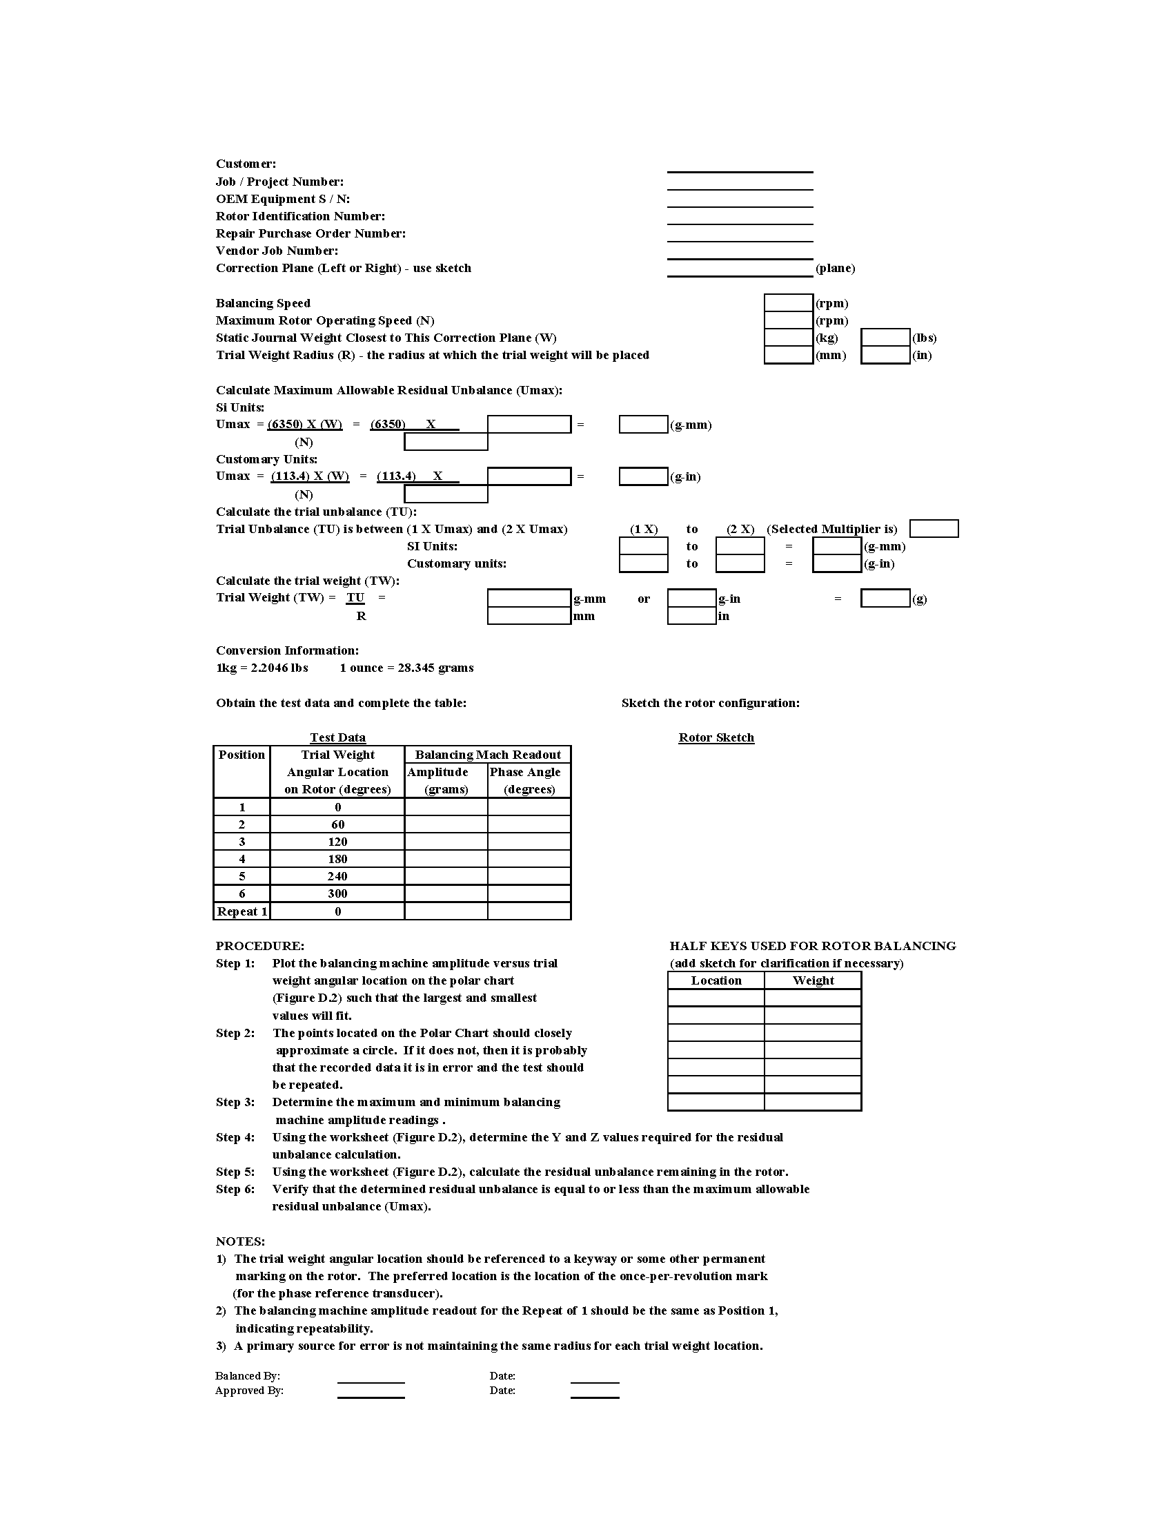

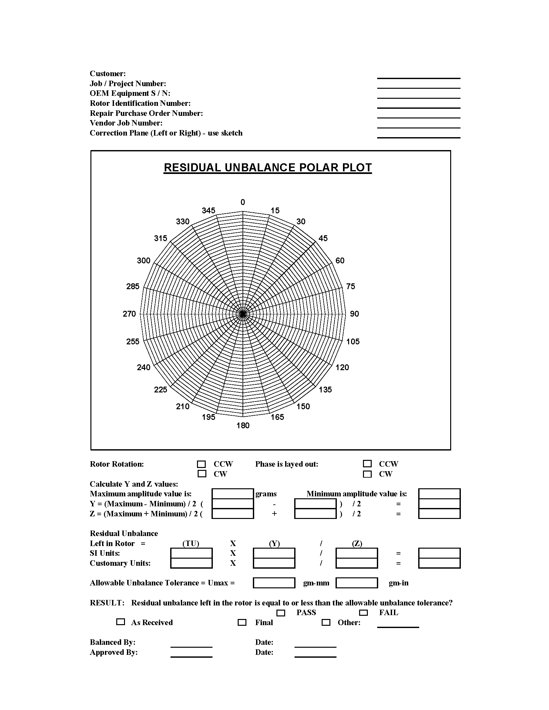

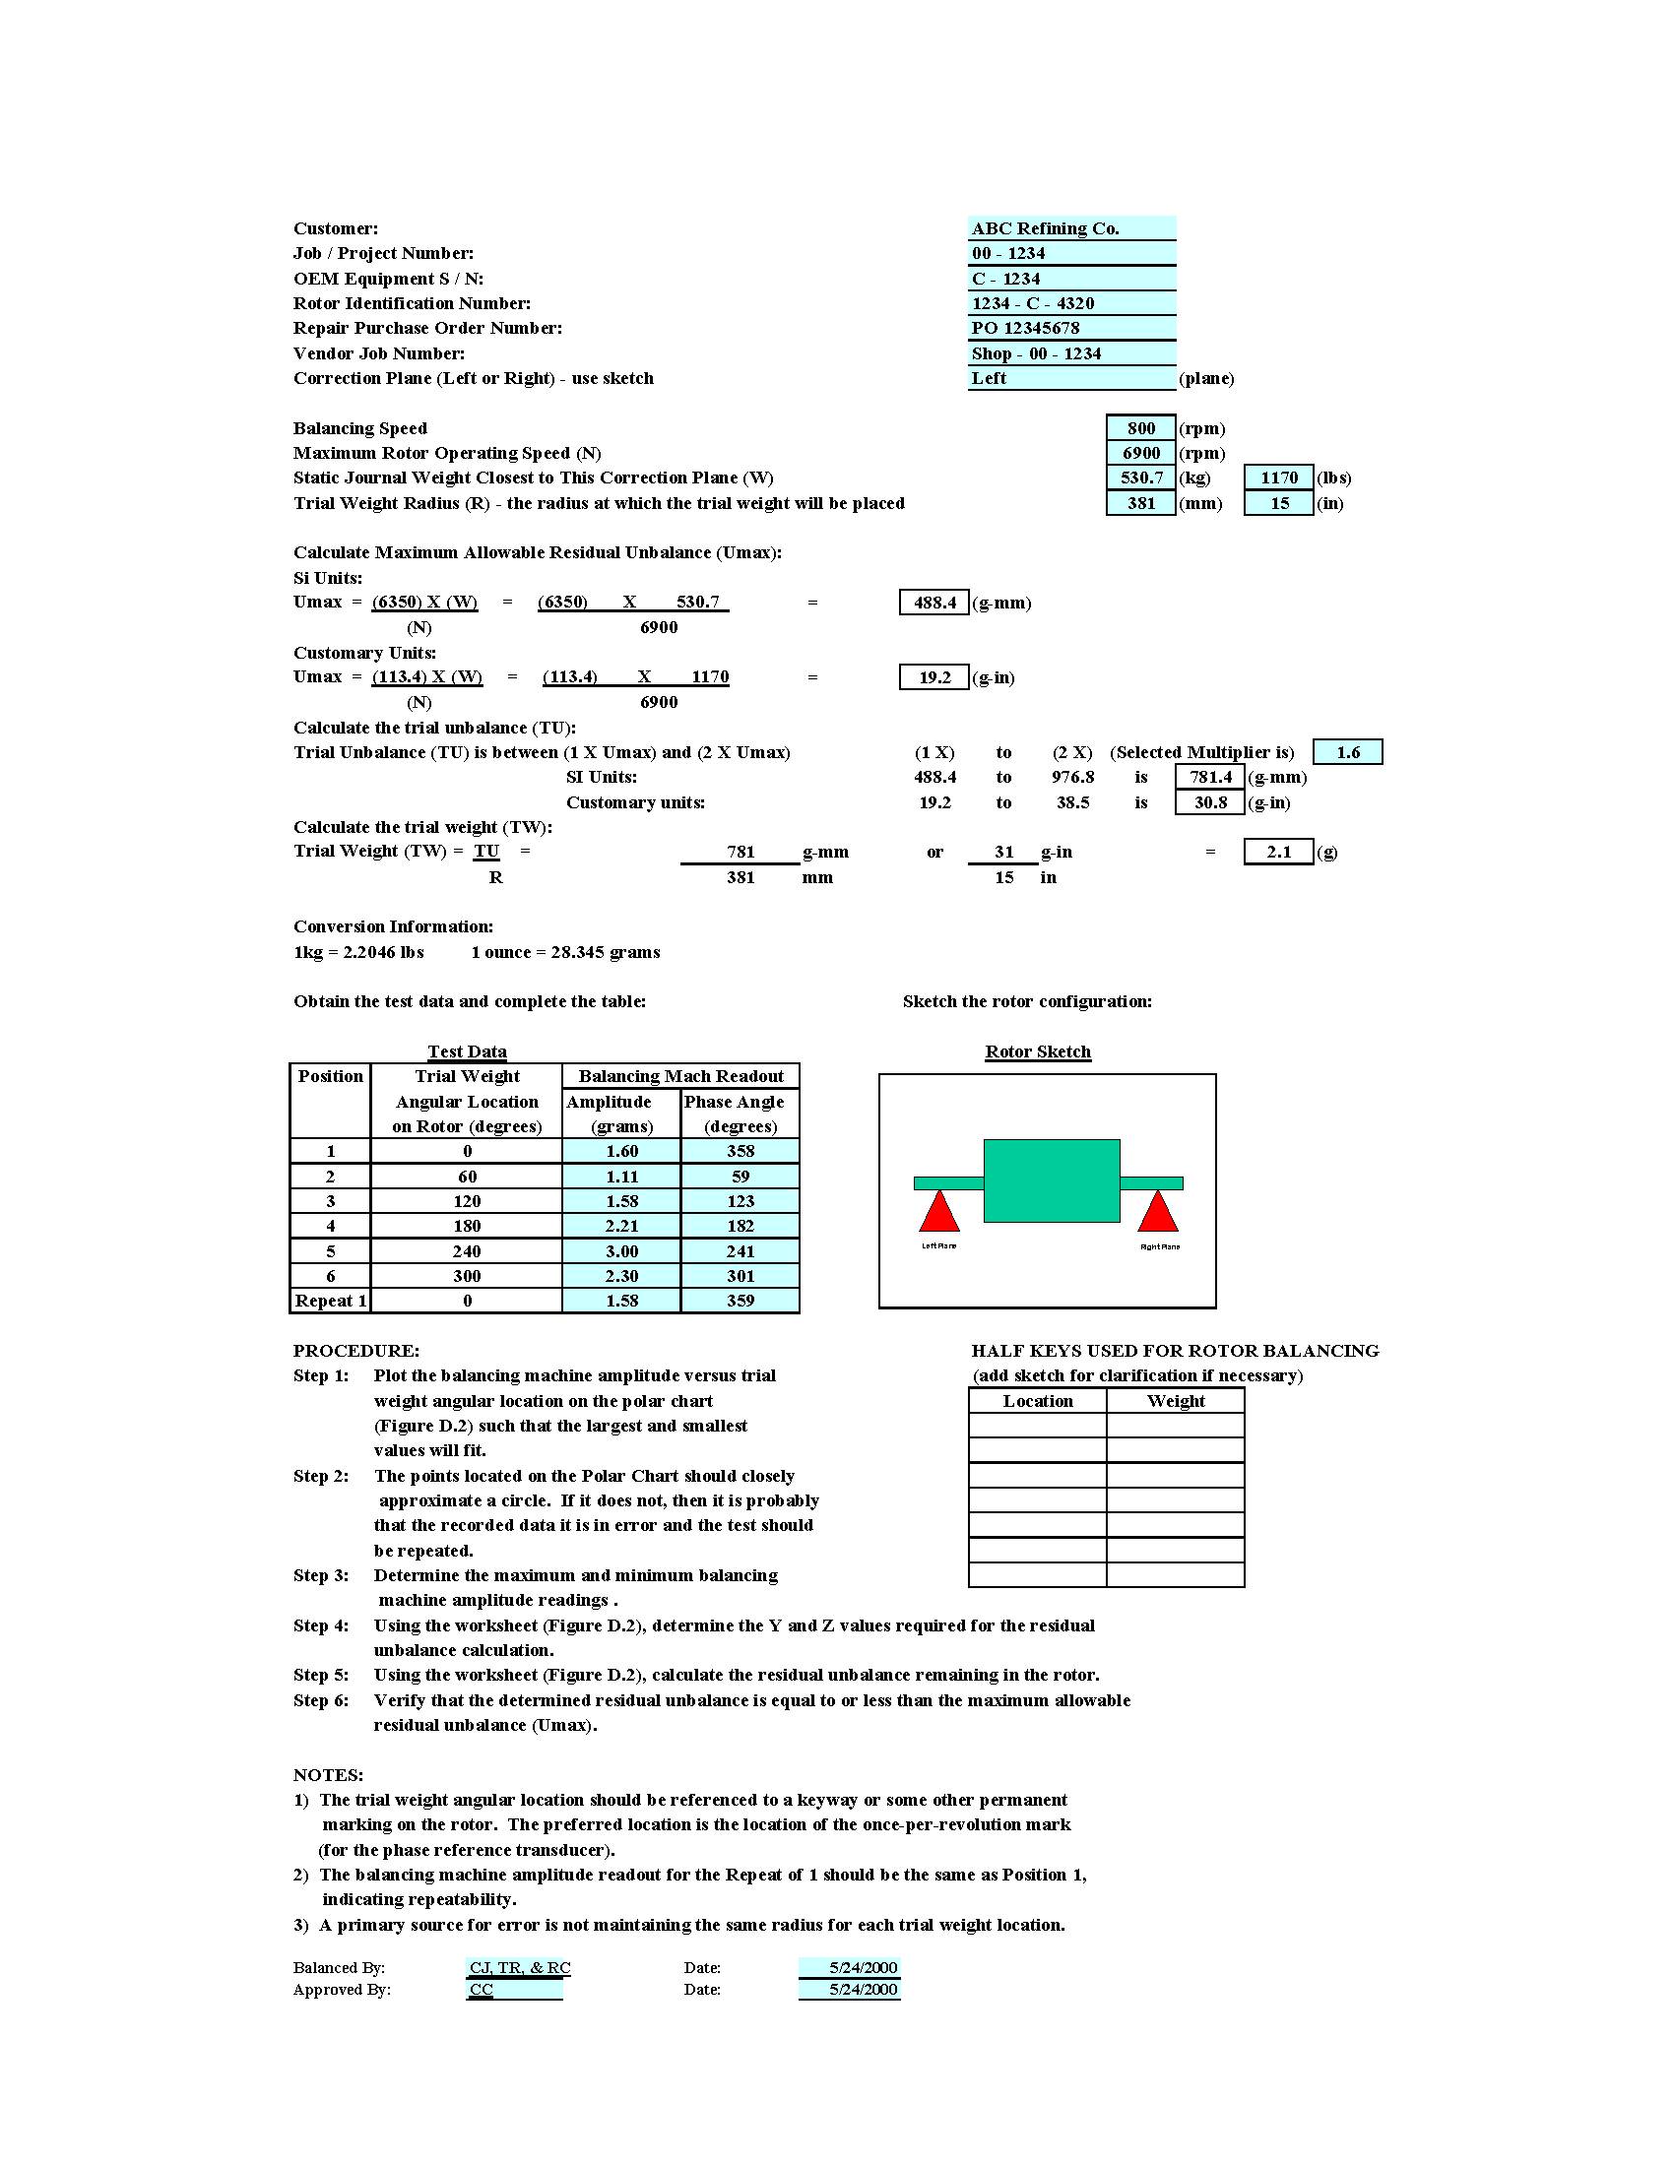

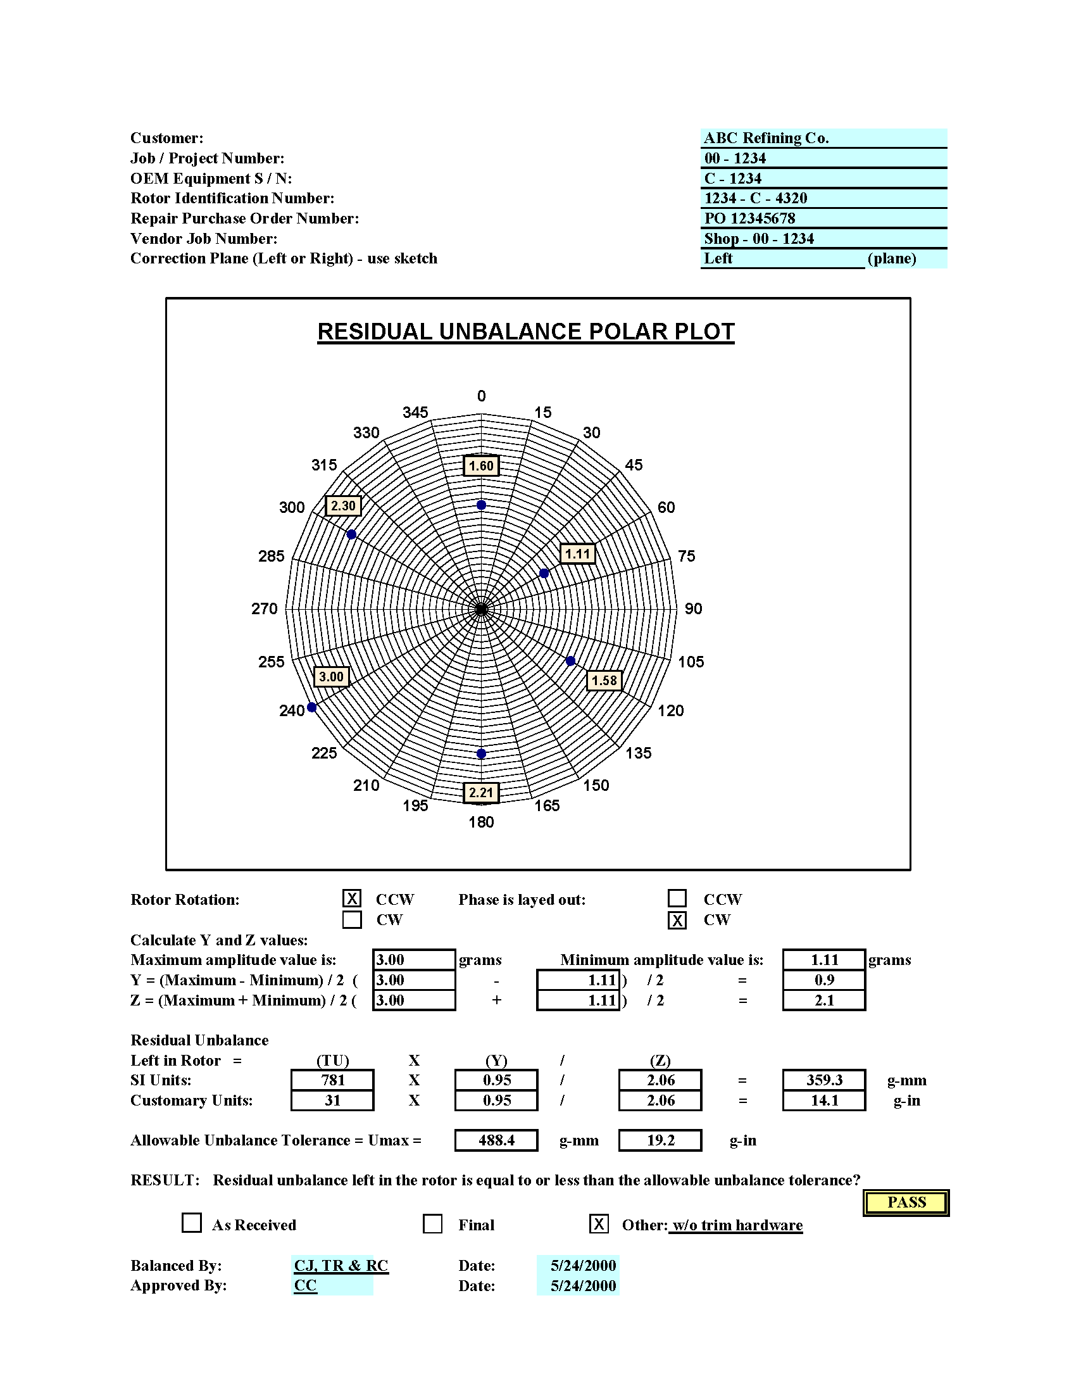

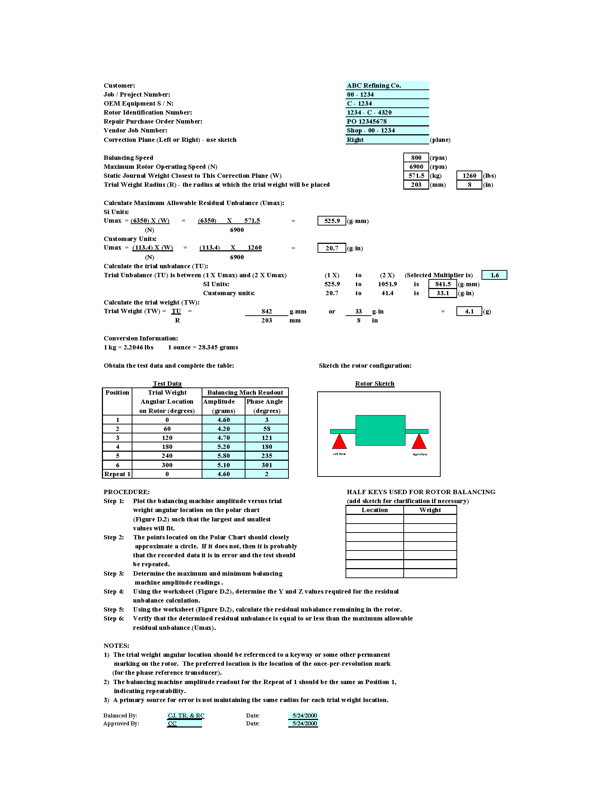

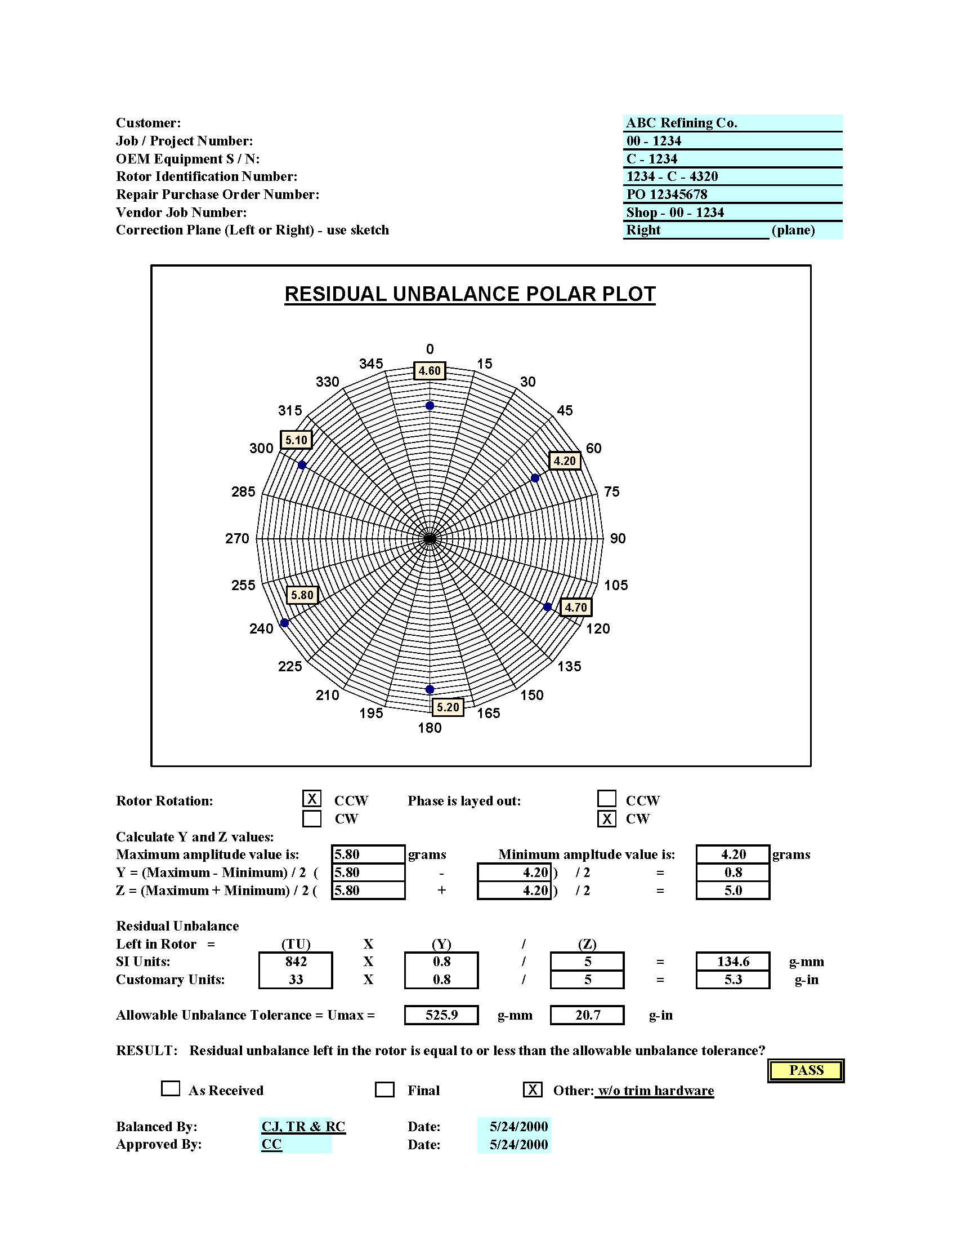

**Annex E**

(informative)

**Procedure and Guidance for Determining the Allowable Resultant Vector Change During a Heat Run Test**

The purpose of this procedure is to verify that the rotor has minimal movement of the squirrel cage winding, laminations, and rotor end rings. Some small amount of change in vibration will always occur because of the movement of the rotor components when the rotor is heated from cold to the running condition.

This procedure is used to verify that the amount of movement of the rotor components is acceptable and repeatable. It also describes further tests that can be performed, at the purchasers' option, to establish repeatability when the motor does not meet the requirements. Other methods are available to demonstrate thermal stability and should be agreed to by the purchaser prior to accepting the motor.

Vectors are used to represent the amount of vibration that this procedure describes. A vector is a measure of a quantity that has both magnitude and direction or phase angle. In vibration analysis, vectors are used to represent vibration quantities and their relative location, expressed in degrees, with respect to a reference point on the shaft that supports the rotor. The point of reference for the vector orientation is usually the keyway or another fixed point on the shaft (e.g. reflective tape).

In each of the polar plots shown below, the arrow of the cold vibration vector represents the starting point and magnitude of the vibration vector at the beginning of the heat run test. The cold point is achieved when the bearing temperature has stabilized at the no load condition. The arrow of the hot vibration vector represents the end of the heat run test. The resultant vector represents the change from the cold vibration to hot vibration.

The vibration vectors in the following figures are filtered at one times running speed and represent the fundamental frequency of vibration.

The vibration vectors are represented using a polar plot format. In such a format the angle of displacement from the reference point on the shaft starts at 0° in the first quadrant and encompasses 360° in the counterclockwise direction. The magnitude of the vector starts at zero at the origin of the plot and increases as the vector length increases from the origin.

This procedure can only be used when the motor is tested with noncontact radial vibration probes.

A plot for each probe shall be performed to verify that compliance with this specification has been achieved.

For most machines, the maximum amount of vibration that is allowed is 1.2 mil displacement filtered at running speed frequency and the maximum vector change allowed from cold to hot is 0.6 mil. See 6.3.3.12, 6.3.3.13, and 6.3.3.14 in the standard for more information.

All of the following examples are presented with the vibration vectors in the first and second quadrant of the polar plot for purpose of explanation only. In practical applications, the vibration vectors may be in any quadrant, and providing the values are acceptable, compliance with the requirement has been achieved.

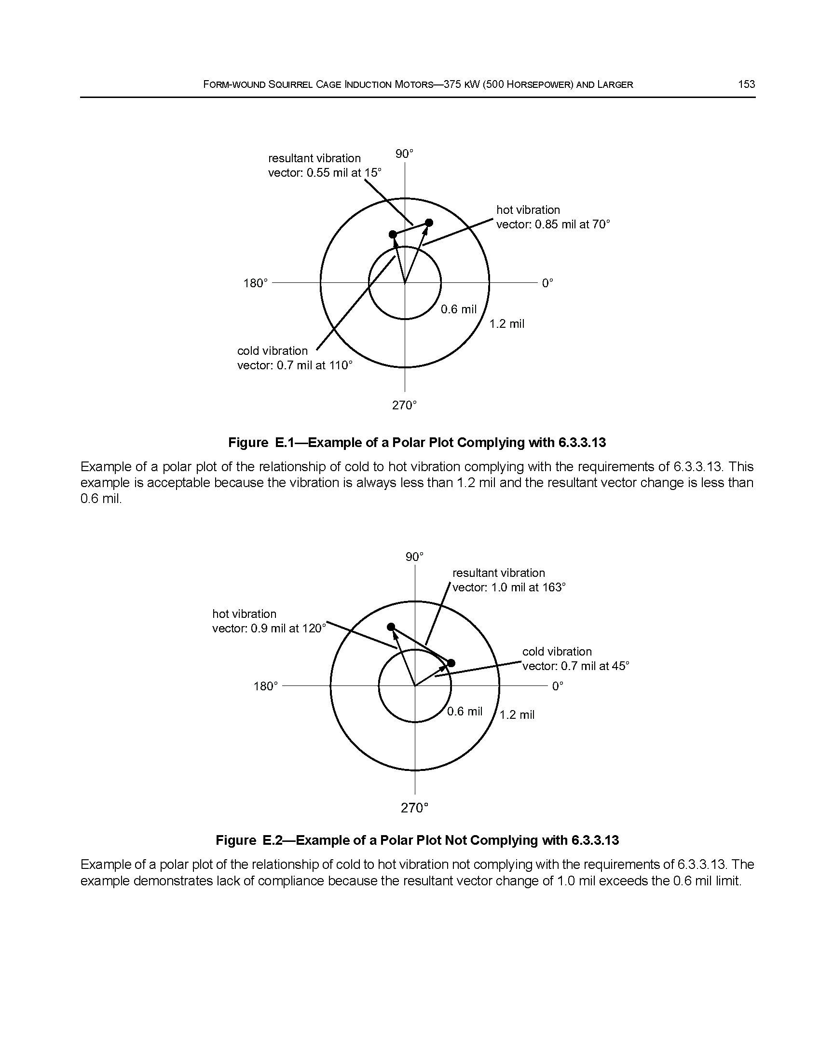

**Annex F**

(informative)

**Alternate Criteria for Defining a Well Damped Resonance**

The material in this annex provides an alternate definition of a well damped resonance to that outlined in 6.3.5.3 e). The material presented in Annex F follows the Standard Paragraphs (SP) of the API Subcommittee on Mechanical Equipment (SOME). Additional clarifications to the SP can be found in API 684.

## Definition of Terms

* + 1. *Amplification Factor (AF)* is a measure of a rotor bearing system’s vibration sensitivity to unbalance when operating in the vicinity of one of its lateral critical speeds. A high amplification factor (AF > 10) indicates that rotor vibration during operation near a critical speed could be considerable and that critical clearance components may rub stationary elements during periods of high vibration. A low amplification factor (AF < 5) indicates that the system is not sensitive to unbalance when operating in the vicinity of the associated critical speed. Examples of the effect of the amplification factor on rotor response near the associated critical speed is presented in Figure F.1. The method of calculating the amplification factor from damped response calculation or vibration measurements is also presented in this figure. This calculation method is referred to as the half-power point method.
    2. Bode Plot is a graphical display of a rotor’s synchronous vibration amplitude and phase angle as a function of shaft rotational speed. A Bode Plot is the typical result of a rotor damped unbalance response analysis and shop test data.
    3. Critical Speed is the shaft rotational speed that corresponds to a noncritically damped (AF > 2.5) rotor system resonance frequency. The frequency location of the critical speed is defined as the frequency of the peak vibration response as defined by the Bode plot, resulting from a damped unbalanced response analysis and shop test data.
    4. Undamped Unbalance Response analysis is a calculation of the rotor’s response to a set of applied unbalances. This applied unbalance excites the rotor synchronously, so the rotor’s response to unbalance will occur at the frequency of the shaft’s rotational speed. This analysis is used to predict critical speed characteristics of a machine. The analysis results are typically presented in Bode plots.
    5. Damping is a property of a dynamic system by which mechanical energy is removed. Damping is important in controlling rotor vibration characteristics and is usually provided by viscous dissipation in fluid film bearings, floating ring oil seals, and so forth.
    6. Phase Angle is the angular distance between a shaft reference mark and the maximum shaft displacement measured by a fixed displacement transducer during one shaft rotation. The phase angle is useful in determining unbalance orientation, critical speed locations, and the amplification factors associated with critical speeds.
    7. Resonance (Natural Frequency) is the manner in which a rotor vibrates when the frequency of the harmonic (periodic) forcing function coincides with a natural frequency of the rotor system. When a rotor system operates in a state of resonance, the forced vibrations from a given exiting mechanism (e.g. unbalance) are amplified according to the level of damping present in the system. A resonance is typically identified by a substantial vibration amplitude increase and shift in the phase angle.
    8. Sensitivity to Unbalance is a measure of the vibration amplitude per unit of unbalance.
    9. Separation Margin defines how close the operating speed of a machine may be to its critical speed. If a machine has a AF < 2.5, then by definition, this is not a critical speed and requires no separation margin.
    10. *Unbalance* is a measure that quantifies how much the rotor mass centerline is displaced from the centerline of rotation (geometric centerline) resulting in an unequal radial mass distribution on a rotor system. Unbalance is usually given in gram-millimeters or ounce-inches.

## F.2 Comparison of Annex F to API 541, 6.3.5.3 e)

The main body of API 541 does not differentiate between a highly damped resonance and critical speed. As such, no method of calculating the amplification factor or separation margin is made.

Definitions F.1.1 through F.1.10 are based on the API SOME Standard Paragraphs. According to these standard paragraphs, these definitions consider modes of vibration with AFs below 2.5 to be critically damped. These modes are not considered critical speeds because they do not result in high levels of rotor vibration.

**Annex G**

(informative)

AC Stator Form Coil Data

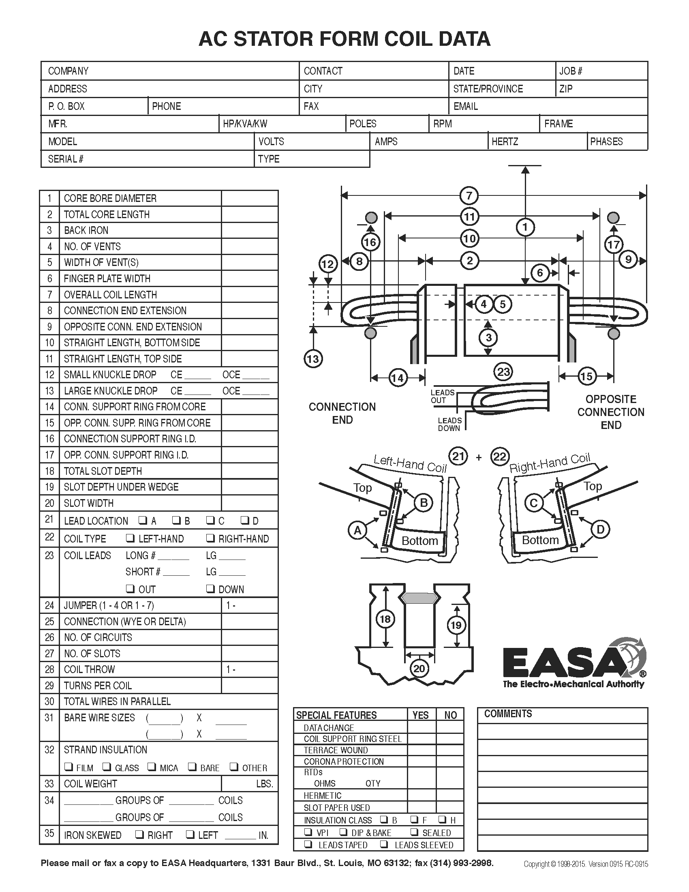

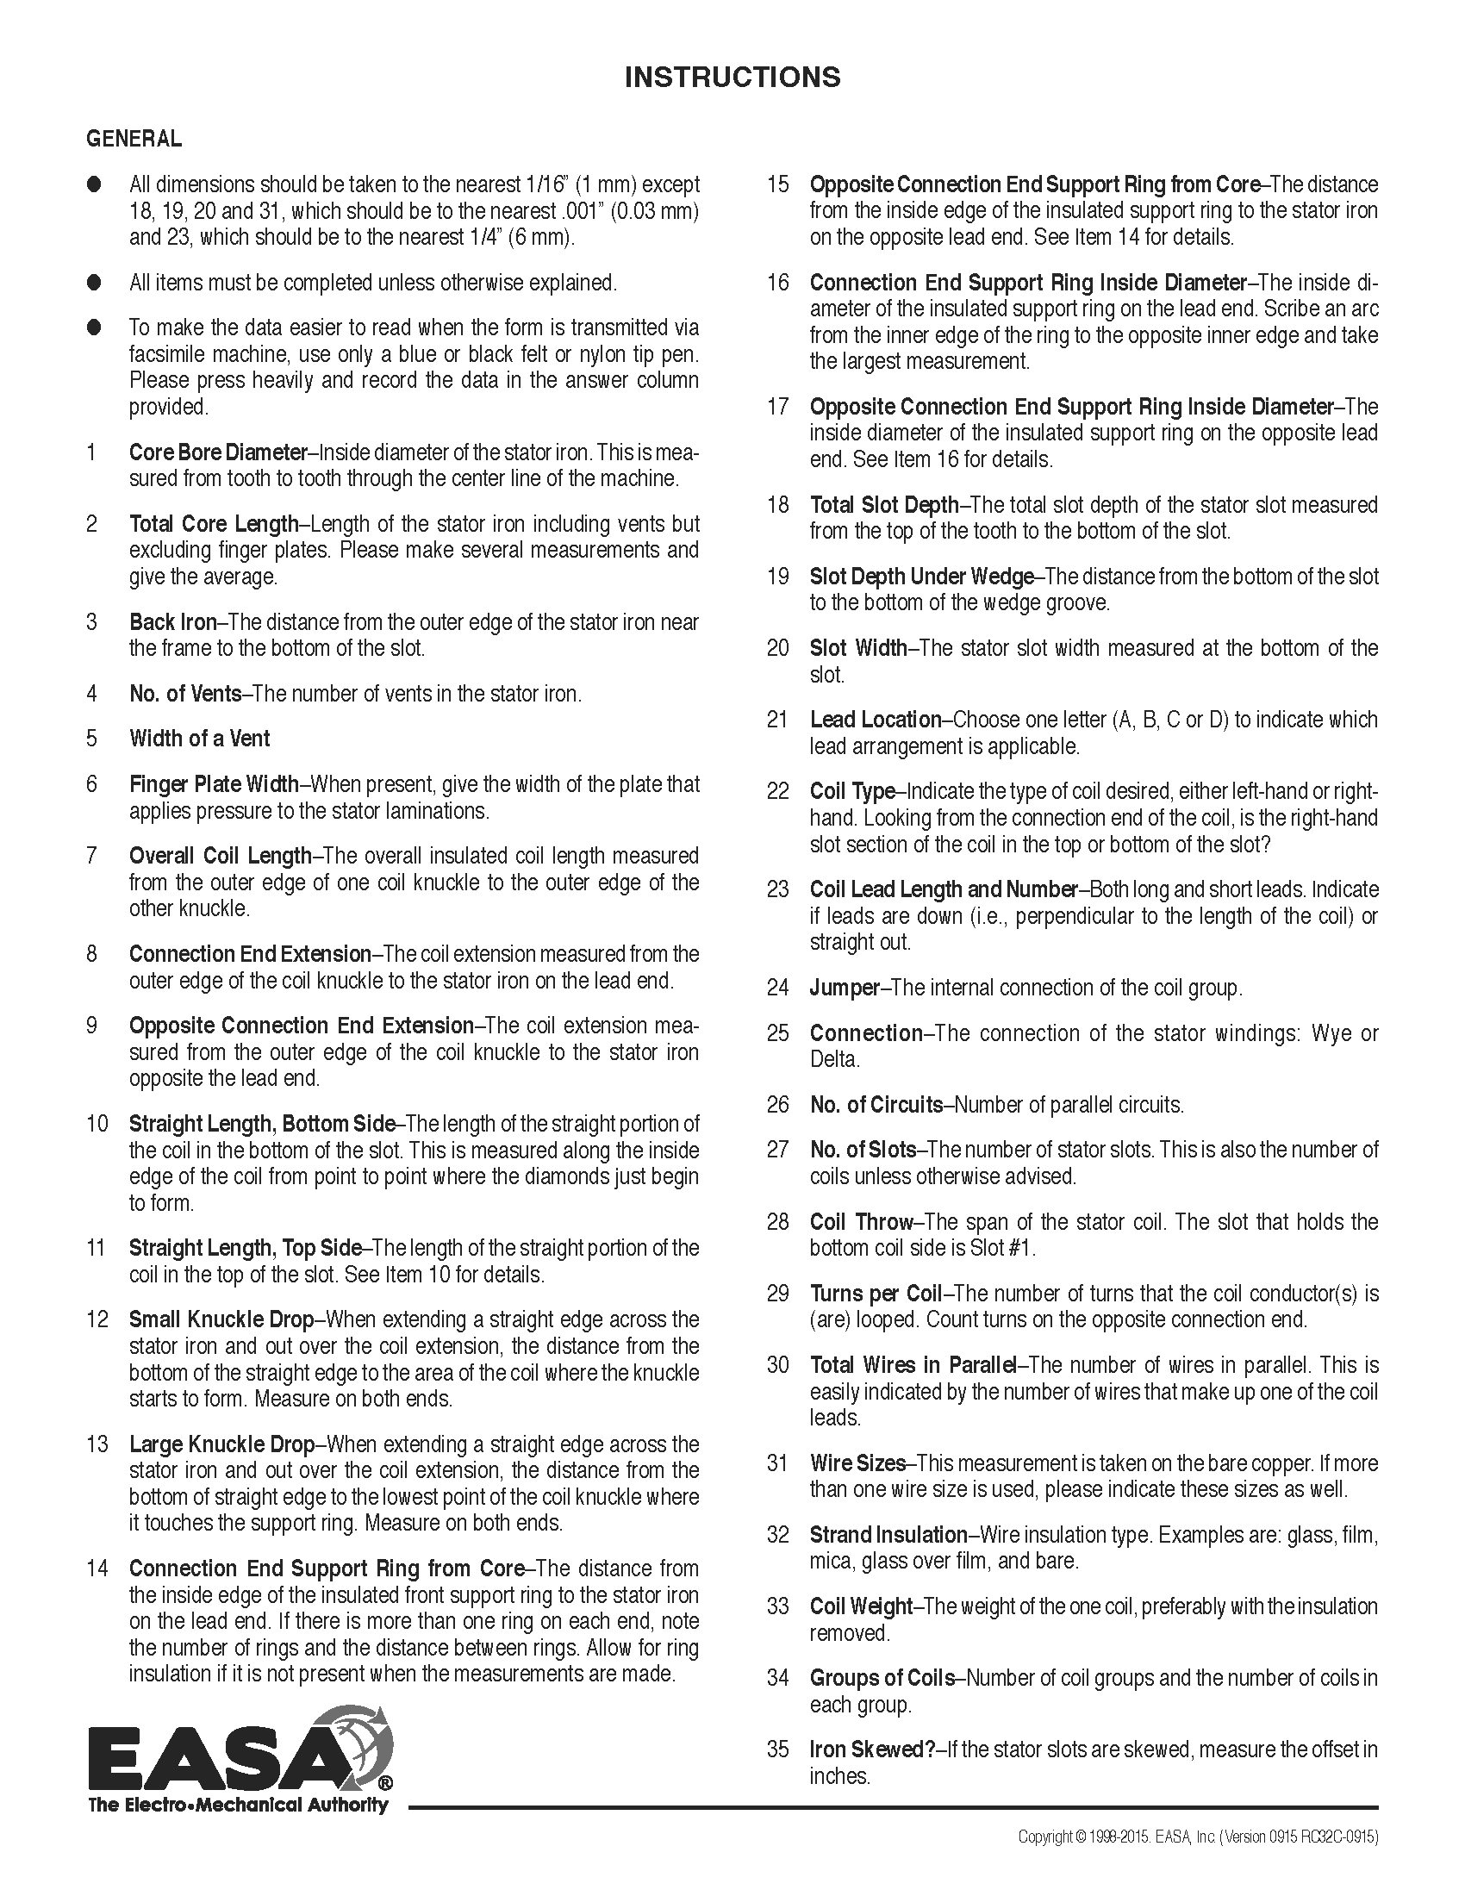

**ANNEX H**

(normative)

**Super Synchronous High Speed Motor Applications**

This annex modifies the requirements of API 541 to address situations where a motor is driven by an ASD at synchronous speeds over 3600 rpm (3000 rpm for 50 Hz locations). This annex is only applicable for motors operated by an ASD with maximum frequencies more than 10% above line frequency.

The requirements of API 541 6th Edition: Form-Wound Squirrel Cage Induction Motors—375 kW (500 Horsepower) and Larger apply, except where superseded by a Clause in this document. Clauses requiring change, deletion, or addition are listed below:

* + 1. **Scope: (Add)** This document covers induction motors rated above 3600 rpm (for locations with 60 Hz supply) synchronous speeds (3000 rpm for locations with 50 Hz supply) and driven by an ASD.

**2 Normative References (Add)**

ISO 14839 - 1 *Mechanical vibration — Vibration of rotating machinery equipped with active magnetic bearings Part 1 : Vocabulary*

ISO 21940-12 *Mechanical vibration — Rotor balancing Part 12 Procedures and tolerances for rotors with flexible behavior*

1. **Terms and Definitions (Add)**

Active Magnetic Bearings: For definitions involving Active Magnetic Bearings (AMBs) refer to ISO 14839-1

**4.2.1.1 Ratings (Delete Clause)**

**4.2.1.2 Voltages (Delete Clause)**

**4.2.2 Motor Load Requirements: (Replace with)** Load requirements shall be jointly developed by the ASD, motor, and driven equipment suppliers in conjunction with the Purchaser. The effect of the torque requirements over the full envelope of operation (all known operating conditions including process materials, torque and speed operating points) plus ASD output harmonics over the entire operating speed range shall be considered.

**4.2.3.1 Starting Conditions (Replace with)** The combined motor and drive shall provide enough torque to accelerate and operate the driven equipment in the entire defined speed range, including the region of constant power, when required.

**4.2.3.2 Purchaser Information (Delete Clause)**

**4.2.4.1 thru 4.2.4.4 Motor Starting Capabilities: (Delete Clauses)**

**4.2.4.5 (Replace with)** The motor is to be operated by an ASD only (no bypass operation). The purchaser, motor vendor, and ASD vendor shall coordinate the details necessary for the integration of the scopes of supply.

*(All Notes remain unchanged)*

**4.4.1.1 Enclosures (add)** ¨f) Unless otherwise specified, super synchronous motors shall be Totally Enclosed (TE) with IP 54 protection or higher. Motors where the process gas is inside the motor shall be sealed so that there is no interchange between the outside air and the gas inside the motor.

**4.4.5.1.7 Rotating Element: (Replace with)** Shaft forgings shall be ultrasonically inspected in accordance with Clause 6.2.2.3.1.

**4.4.5.2.1 Assembly (Add)** Super synchronous motornon-laminated rotor cores shall be integral with the shaft.

**4.4.5.2.15 (Add new clause)** When the motor has process gas inside the frame, the rotor materials shall not be affected by the process gasses specified on the datasheet.

**4.4.6.2.1 Dynamic Analysis (Modify)** Delete “when specified” in the first sentence.

**4.4.6.2.1.1 c) Dynamic Analysis (Add)** When active magnetic bearings (AMBs) are used, the controller and hardware (bearing, sensor, inverter, controller electronics) transfer function (comparable to bearing stiffnesses and damping factors over frequency) shall be used to ensure stable operation.

**4.4.6.2.1.1 d) Dynamic Analysis (Add)** In cases where active magnetic bearings are used, the additional analysis shall consider the stiffnesses, damping and frequency responses of the bearings, including any variations that can be implemented.

**4.4.6.2.2 Dynamic Analysis (Modify)** Delete “when specified” in the first sentence.

**4.4.6.3.1** **Balancing (Add)** The balancing procedure of the rotor shall including balancing at the highest running speed of the rotor.

**4.4.7.1.3 Bearings (Replace clause with)** Active magnetic bearings may be used if approved by the Purchaser and shall meet the following conditions:

1. The bearings shall be part of an integrated system including position sensors, redundant power supply, control scheme, amplifiers, laminated cores, coils, and touch-down (“auxiliary”) bearings for emergency coast down and supporting the stationary shaft when the motor is not in operation.
2. There shall be two sets of orthogonal shaft position sensors per bearing for control purposes which shall feed an electronic signal of amplitude proportional to the gap between them and the shaft to the control scheme. The two sensors of a pair shall be located on opposite sides of the rotor to compensate, for example, for thermal expansion. The shaft in the sensing area shall have combined electrical and mechanical runout as specified in 6.3.3. These sensors shall take the place of other radial shaft position sensors that may otherwise be required. If axial positions sensors are specified, they shall also be integrated into the bearing system.
3. Redundant power supplies for the position sensors, control system and amplifiers shall be provided. If an uninterruptible power supply (UPS) is used as one of the supplies, its status shall be monitored and at least 30 minutes or the expected coast down time, whichever is greater, battery operation shall be available. The system power requirements shall be listed with the proposal. The Purchaser shall advise if one of the supplies is to be a plant UPS system and supplier shall design system to accept the appropriate voltage level.

NOTE: Battery operation might need to be extended beyond 30 minutes to ensure a complete stop is achieved before landing.

1. The proportional and differential control scheme shall take signals from the position sensors and use them to give signals to the amplifiers so that the shaft is maintained in the required central position. As a minimum they shall also provide adjustable bearing stiffness and damping. Vibration data shall be presented on an HMI and a digital connection plus buffer storage shall be included for data access, diagnostics and programming.
2. The amplifiers shall take the control system output signals and give power inputs to the bearing magnetic coils. The bandwidth of the frequency response of the amplifiers shall be at least twice the maximum operating speed of the motor. The magnetic circuit, coils, and amplifiers shall be able to support at least 250% of the rotor weight at all frequencies up to 200% of maximum operating speed. The performance of the magnetic bearing system shall ensure that the machine is compliant to the vibration criteria defined in ISO 14839 and API 617 with respect to the disturbances acting on the plant. These disturbances are defined by the maximum unbalance defined in ISO 21940 and API 617.
3. The coils used to magnetize the cores shall be insulated with a material that is not subject to attack by any specified chemical that may be present, and has at least rated Class F thermal rating. The temperature of the coils shall not exceed Class B limits during normal operation as measured by the installed RTDs in each coil. If a Class H rating applies for the coils, the temperature rise shall not exceed Class F limits.
4. The touch-down (auxiliary) bearing shall have a clearance of less than 50% of the air gap between the stator and rotor laminations. The touch-down bearing shall be rated to perform at least 3 landings from full speed. These landings must be able to occur without injury to surrounding personnel nor damage that requires repair of the motor rotor assembly.
5. The Vendor shall supply a service person for commissioning, startup and tuning the system on site, even if the system has an auto-tuning function.

**4.4.9.1 End Play and Couplings: (Add)** End play limits for active magnetic bearing motors are the same as for hydrodynamic bearing motors.

**4.4.9.5 End Play and Couplings: (New)** At the time of proposal, the motor vendor is to define the shaft extension that is offered, and the motor vendor is to define any specific requirements of the coupling when the coupling is not provided by the motor vendor.

**5.6.2 Surge Protection: (Modify)** Unless otherwise specified, surge protection will not be provided.

**6.3.1.3 Testing (Add Note)** Note 1: It is recommended that the motor and the associated ASD are tested as a package over the range of design speeds and loads. Experience has shown that this testing significantly reduces site problems and time during commissioning.

**6.3.3.6 Testing (Add)** After the bearing temperatures have stabilized, filtered and unfiltered vibration readings at each position shall be recorded continuously for a period of 15 minutes. This data shall be continuously plotted or tabulated at one minute increments over the 15 minute period. If the vibration modulates, the high and low values of vibration and the frequency of the modulation shall be recorded.

**6.3.3.10 Vibration limits (Add)** Where active magnetic bearings are used, the maximum allowable shaft vibration shall be less than or equal to 0.3 times the minimum radial clearance in the touch-down bearing in that axis. See API 617 Annex F, paragraph F.7.6.

**ANNEX I**

(Informative)

**Contract Documents and Engineering Design Data**

**I.1** When specified by the Purchaser in 8.1.2, the contract documents and engineering design data shall be supplied by the Vendor, as listed in this annex.

**I.1.1** The following information shall be included on datasheets, title blocks on drawings, data, curves and transmittal letters:

a. the purchaser and user’s corporate name;

b. the job and project number;

c. the equipment service name and item number;

d. the inquiry or purchase order number;

e. any other identification specified in the inquiry or purchase order;

f. the vendor’s identifying proposal number, shop order number, serial number, or other reference required to completely identify return correspondence.

**I.1.2** Each drawing shall have a title block in the lower right-hand corner with the date of certification, identification data specified in I.1.1, revision number and date and title. The title block shall be visible when the drawing is folded to A4 metric size or 8 1/2 × 11 in. Similar information shall be provided on all other documents including subvendor items and bills of materials.

**I.1.3** Documents and drawings shall be supplied in a mutually agreed electronic format. In addition, the purchaser shall state in the inquiry and in the order the number of prints and reproducibles required and the times within which they are to be submitted by the vendor (see Annex C).

**I.2 Proposals**

**I.2.1 General**

**I.2.1.1** The vendor shall forward the original proposal, with the specified number of copies, to the addressee specified in the inquiry documents.

**I.2.1.2** The proposal shall include, as a minimum, the data specified in I.2.2 through I.2.5.

**I.2.1.3** The vendor shall provide sufficient detail to enable the purchaser to evaluate any proposed alternative designs.

**I.2.1.4** All correspondence shall be clearly identified in accordance with I.1.2.

**I.2.2 Drawings**

**I.2.2.1** The drawings indicated on the Vendor Drawing and Data Requirements (VDDR) form in Annex C shall be included in the proposal. As a minimum, the following shall be included:

1. a general arrangement or outline drawing for each machine, showing overall dimensions, maintenance clearance dimensions, overall weights, erection weights, and the largest maintenance weight for each item.
2. the direction of rotation
3. the size and location of major purchaser connections. This shall include power, control, and instrument wiring; supply and drain details for lubrication oil and cooling water, and inlet and discharge details for cooling or purge air, as well as frame vents and drains. For all terminal block connections, this shall include the range of wire sizes accepted. Any piping, frame or bearing connections plugged by the vendor shall be identified.
4. cross-sectional drawings showing the details of the proposed equipment;
5. schematic diagrams, dimensional outline drawings, and bill of materials of all auxiliary systems including control systems, accessories, and instruments. The bill of materials shall include and identify all components by make, type, size, capacity rating, materials, and other data as applicable.
6. bills of material;
7. sketches that show methods of lifting the assembled machine and major components and auxiliaries, including the location of each lifting point and a description of components the lifting point is designed to support. (This information may be included on the drawings specified in item a above.)
8. rigging provisions for removal of parts that weigh more than 135 kg (300 lb).
9. the make, size, and type of couplings (where applicable).
10. detail drawings of the bearings and bearing seals. The drawings shall include the vendor’s type and catalog number of the bearings and seals.
11. a list of any special weather-protection and climatization features supplied by the vendor and required by the purchaser.
12. a list of auxiliary or other equipment furnished by the vendor for mounting by the purchaser.
13. complete information to permit adequate foundation design by the purchaser. This shall include the following items:
14. the size and location of hold down bolts;
15. the weight distribution for each bolt and sub-soleplate location;
16. any unbalanced forces or moments generated by the unit or units in the specified operating range;
17. the location of the center of gravity; and
18. foundation forces as a result of worst-case transient conditions.

**I.2.2.2** If “typical” drawings, schematics and bills of material are used, they shall be marked up to show the weight and dimension data to reflect the actual equipment and scope pro-posed.

**I.2.3 Technical Data for Proposal**

**I.2.3.1** All technical data shall be given in units of measurement according to the purchase order. If needed, the technical data in alternate units can be included in parentheses.

**I.2.3.2** Vendor’s proposals shall provide the information specified in this section and include completed “Motor Proposal Data” of the datasheets in Annex A.

**I.2.3.3** The following data shall be included in the proposal.

1. purchaser’s data sheets with complete vendor’s information entered thereon and literature to fully describe details of the offering. The vendor shall show shaft sealing and bearing details, internal construction, rotor construction, and the method of attaching the rotor bars bar to the shorting ring if applicable.;
2. Vendor Drawing and Data Requirements form (see Annex C) indicating the schedule according to which the vendor agrees to transmit all the data specified;
3. schedule for shipment of the equipment, in weeks after receipt of an order;
4. list of major wearing components;

NOTE The owner can compare these components to those used as part of any existing machines for interchangeability. Substitution of these wearing components with those that are interchangeable with any existing machines could be discussed during the design review meeting in I.3.5.

1. list of spare parts recommended for start-up and normal maintenance purposes;
2. list of the special tools furnished for maintenance; The vendor shall list any metric items included in the offering.
3. description of any special weather protection and winterization required for start-up, operation, and periods of idleness, under the site conditions specified on the data sheets. This description shall clearly indicate the protection to be furnished by the purchaser as well as that included in the vendor’s scope of supply.
4. complete tabulation of utility requirements, e.g. steam, water, electricity, air, gas, lube oil (including the quantity and supply pressure of the oil required, and the heat load to be removed by the oil), and the nameplate power rating and operating power requirements of auxiliary drivers. Approximate data shall be clearly indicated as such.
5. when specified, the vendor shall provide a separate price for each test that is specified and a packaged price for all the tests specified on the datasheets. ;

**●**

1. a list of machines, similar to the proposed machine(s), that have been installed and operating under conditions analogous to those specified in the inquiry;
2. any start-up, shutdown, or operating restrictions required to protect the integrity of the equipment;
3. a list of any components that can be construed as being of alternative design, hence requiring purchaser’s acceptance (4.1.1.3).
4. a list of any components with a design life less than that of the overall machine (4.1.14).

**I.2.3.4** When the evaluation factor (e.g. dollars per kilowatt) is shown on the datasheets, machines shall be evaluated on the basis of life-cycle cost (purchase price plus present worth of losses).

**I.2.3.5** The vendor shall provide complete performance curves and data to fully define the envelope of operations and the point at which the vendor has rated the equipment, including the following items [Items a), b), d), and e) are not required for motors that are designed to operate only on ASDs].

**●** a) Average torque and twice slip frequency pulsating torque versus speed during starting at rated voltage and minimum starting conditions (voltage and short circuit MVA) and any other specified conditions.

**●** b) Current versus speed during starting at rated voltage and minimum starting conditions (voltage and short circuit MVA) and any other specified conditions.

* The inertia of the rotor.

**●** d) Estimated times for acceleration at rated voltage and minimum starting conditions (voltage and short circuit MVA) and any other specified conditions.

**●** e) The locked-rotor (stalled) withstand time, with the motor at ambient temperature and at its maximum rated operating temperature for rated voltage and minimum starting conditions (voltage and short circuit MVA) and any other specified conditions plus the limit curves and wait times specified in 4.2.4.2.

**●** f) Expected efficiencies as determined in accordance with IEEE 112, IEC 60034-2-1, or IEC 60034-2-2, or by certified data from previously tested designs. The purchaser shall specify on the datasheet the efficiency test method to be used. For motors driving reciprocating machines, the expected pulsating currents shall be considered in calculating the efficiencies. For motors to be driven by ASDs, the vendor shall state the methods of efficiency determination to be used along with the base frequencies and the harmonics present in the supply waveform(s).

**●** g) For motors that drive reciprocating machines the maximum current variation under actual operating conditions. Compressor crank-effort diagrams, power supply system information, and other relevant data shall be supplied by the purchaser for the determination of current pulsations.

NOTE To verify performance, it may be necessary to check motor current pulsations under load in the field using an appropriate digital waveform recording instrument.

h) This paragraph left intentionally blank.

**I.2.3.5.2** This paragraph left intentionally blank.

**● I.2.3.6** When specified, information shall be supplied with the proposal to facilitate a preliminary power system short-circuit analysis. The required machine parameters include *Xdv*” [rated voltage (saturated) subtransient reactance], *X2v* [rated voltage (saturated) negative-sequence reactance], *Ta3* [rated voltage (saturated) armature time constant (seconds)], rated MVA, and rated terminal voltage.

NOTE IEEE Std C37.010, Table 8, footnote “a,” describes the use of the above information to determine the effective resistance to be used for the *X/R* of the machine during short circuit calculations

**I.2.3.7** The vendor shall provide net weights and maximum erection weights with identification of the item. This data shall be stated individually where separate shipments, packages, or assemblies are involved. This data shall be entered on the datasheets.

**I.2.3.8** The vendor shall provide a preliminary general arrangement drawing in accordance with I.2.2.1.

**I.2.3.9** If applicable, the vendor shall provide schematic diagrams of auxiliary subsystems (e.g. lube-oil or cooling water systems).

**I.2.3.10** The vendor shall provide technical data, specifications, catalog cut sheets, or similar information that describe all the auxiliary equipment.

**● I.2.3.11** When specified, the vendor shall provide a statement of the rate for furnishing a supervisor for installation and erection of the machine as well as an estimate of the length of time the supervisor’s services will be required under normal conditions. The vendor shall also include the rate and estimated time required for the services of a startup commissioning supervisor or engineer.

**● I.2.3.12** When specified, materials defined by the purchaser shall be identified in the proposal with their applicable AISI, ANSI, ASTM, and ANSI/ASME or ISO numbers, including the material grade. When no such designation is available, the vendor’s material specification, giving physical properties, chemical composition, and test requirements shall be included in the proposal. ng water systems).

**I.2.4 Curves**

**I.2.4.1** The vendor shall provide complete performance curves to encompass the map of operations, with any limitations indicated thereon (I.2.3.5).

**● I.2.4.2** When specified by the purchaser, the vendor’s performance curves and response curves shall be supplied in a mutually agreed electronic tabular format so that the purchaser can insert the information into computer program models.

**I.2.5 Optional Tests**

The vendor shall furnish an outline of the procedures to be used for each of the special or optional tests that have been specified by the purchaser or proposed by the vendor.

**I.3 Engineering Design Data**

**I.3.1 General**

**I.3.1.1** Engineering data shall be furnished by the vendor in accordance with the Vendor Drawing and Data Requirements (VDDR) form in Annex C.

NOTE - The VDDR form provided in Annex C can be modified by the purchaser to match the specific inquiry requirements.

**● I.3.1.2** Review and acceptance of the vendor’s data by Purchaser does not constitute permission to deviate from any requirements in the order unless specifically agreed in writing. After the data have been reviewed and accepted, the vendor shall furnish certified copies in the quantities specified on the datasheet. Drawings shall be clearly legible.

**I.3.1.3** A complete list of vendor data shall be included with the first issue of major drawings. This list shall contain titles, drawing numbers, and a schedule for transmittal of each item listed. This list shall cross-reference data with respect to the VDDR form (see Annex C).

Note: Standard drawings of sub-equipment is typically supplied with a cover sheet in the instruction manual.

**I.3.1.4** Subsequent to the issuance of a contract, the vendor shall submit the “Order Data” pages of the datasheets in Annex A. These pages shall be marked “As Designed.”

**I.3.2 Drawings and Technical Data**

**I.3.2.1** The drawings and data furnished by the vendor shall contain sufficient information so that together with the manuals specified in I.3.7, the purchaser can properly install, operate, and maintain the equipment covered by the purchase order.

**I.3.2.2** All contract drawings and data shall be clearly legible (8-point minimum font size even if reduced from a larger size drawing), shall cover the scope of the agreed VDDR form, and shall satisfy the applicable detailed descriptions in this Annex.

**I.3.3 Progress Reports**

The vendor shall submit progress reports to the purchaser at intervals specified which shall, as a minimum, include the following:

1. overall progress summary,
2. status of engineering,
3. status of document submittals,
4. status of major suborders,
5. updated production schedule,
6. inspection/testing highlights for the month,
7. any pending issues.

**● I.3.4 Coordination Meeting**

When specified, the vendor shall support a coordination meeting to be held as soon as possible after the purchase order placement. The meeting should include the owner, the electric machine supplier, driven equipment or prime mover supplier, ASD supplier (as applicable), engineering firm, consultant and other sub-suppliers as required. The following items should be reviewed:

1. the purchase order, scope of supply, unit responsibility, sub-vendor items, document procedures and lines of communications;
2. contract data and API 541 datasheets (see Annex B (VDDR));
3. API 541 comments and exceptions, applicable specifications, and previously agreed exceptions;
4. speed-torque curves (for motors) and rotating equipment inertias;
5. schedules for the transmittal of data, production, testing, and shipment (Annex C);
6. the quality assurance program and procedures;
7. equipment performance, alternate operating conditions, start-up, shutdown and any operating limitations;
8. instrumentation, controls, and any other interfaces;
9. scope, performance, operating parameters, and P&IDs for auxiliary subsystems (e.g. lube oil or cooling water consoles);
10. identification of items requiring design review;
11. inspection, test procedures and related acceptance criteria; and
12. other technical items.

**● I.3.5 Design Review Meeting**

When specified, a design review meeting shall be held at the electric machine vendor’s manufacturing facility at the time certified drawings and data are available for approval by the purchaser. The meeting should include the owner, electric machine supplier, driven equipment or prime mover supplier, ASD supplier (as applicable), engineering firm, consultant and other sub suppliers as required. Suggested items for review are as follows:

1. contract data and API 541 datasheets (see Annex B (VDDR));
2. performance curves, e.g. thermal limit curves, acceleration times, allowable stall times, temperatures of rotor parts, capability curves, etc.;
3. method of efficiency determination and guarantee of efficiency;
4. current pulsations for reciprocating loads;
5. number of starts allowed (for motors);
6. inertia of the machine and coupled equipment;
7. stator winding and winding insulation system;
8. rotor design, mechanical design, fits, construction, balance;
9. shaft design stress, short-circuit torques;
10. torsional and lateral critical speed analysis, and rotor sensitivity analysis (response to an intentional unbalance);
11. foundation and base stiffness;
12. coupling type and coordination;
13. bearing and seal details;
14. bearing and coupling insulation;
15. lubricating oil type and oil inlet temperature range;
16. test agenda;
17. “witness" and “observe" points for inspections and tests;
18. data for performance of electrical power system studies by the purchaser;
19. excitation system design and interconnection with other equipment;
20. review of machine drawings, and where applicable: P&IDs, auxiliary subsystem console drawings;
21. installation and commissioning procedures; and
22. packaging, shipping and long term storage.

NOTE It is important that the design review meeting be held early enough in the project cycle so any needed design modification will not adversely affect machine cost and manufacturing schedule.

**I.3.6 Parts Lists and Recommended Spares**

**I.3.6.1** The vendor shall submit complete parts lists for all equipment and accessories supplied. These lists shall include part names, manufacturers’ unique part numbers and materials of construction (identified by applicable international standards). Each part shall be completely identified and shown on appropriate cross-sectional, assembly-type cutaway or exploded-view isometric drawings. Interchangeable parts shall be identified as such. Parts that have been modified from standard dimensions or finish to satisfy specific performance requirements shall be uniquely identified by part number. Standard purchased items shall be identified by the original manufacturer’s name and part number.

**I.3.6.2** The vendor shall indicate on each of these complete parts lists all those parts that are recommended as start-up or maintenance spares, and the recommended stocking quantities of each. These shall include spare parts recommendations of subvendors that were not available for inclusion in the vendor’s original proposal.

**I.3.7 Installation, Operation, Maintenance, and Technical Data Manuals**

**I.3.7.1 General**

The vendor shall provide written instructions and a cross-referenced list of drawings to enable the purchaser to install, operate, and maintain the complete equipment covered by the purchase order. This information shall be compiled in a manual or manuals with a cover sheet showing the information listed in I.1.2, an index sheet, and a complete list of the enclosed drawings by title and drawing number. The manual pages and drawings shall be numbered. If the instruction manuals apply to more than one model or series of equipment, the instructions shall clearly indicate the specific sections that apply to the equipment involved. The manual or manuals shall be prepared specifically for the equipment covered by the purchase order. “Typical” manuals are unacceptable.

**I.3.7.1.1** A draft manual(s) shall be issued to purchaser 8 weeks prior to mechanical testing for review and comment.

**I.3.7.1.2** Refer to the VDDR Form (see Annex B) for number of copies. Hard copies as well as electronic copies shall be provided as described on VDDR (see Annex B).

**I.3.7.2 Installation Manual**

**I.3.7.2.1** All information required for the proper installation of the equipment shall be compiled in a manual that shall be issued no later than the time of issue of final certified drawings. For this reason, it may be separate from the operating and maintenance instructions.

**I.3.7.2.2** This manual shall contain information such as special alignment procedures, bearing and bearing seal installation considerations, utility specifications (including quantity), and all installation design data.

**I.3.7.2.3** All drawings and data specified in L.2.2 and L.2.3 that are pertinent to proper installation shall be included as part of this manual.

**I.3.7.2.4** One extra manual, over and above the specified quantity, shall be included with the first equipment shipped.

**I.3.7.2.5** All recommended receiving and storage procedures shall be included.

NOTE - Refer to API 686 for data required for installation.

**I.3.7.3 Operating and Maintenance Manual**

**I.3.7.3.1** A manual containing all required operating and maintenance instructions shall be supplied at shipment. In addition to covering operation at all specified process conditions, this manual shall also contain separate sections covering operation under any specified extreme environmental (e.g. temperature) conditions.

**I.3.7.3.2** The following items shall be included in the manual:

1. Instructions covering start-up, normal shutdown, emergency shutdown, operating limits, and routine operational procedures.
2. Outline and sectional drawing, schematics, and illustrative sketches in sufficient detail to identify all parts and to clearly show the operation of all equipment and components and the method of inspection and repair. Standardized sectional drawings are acceptable only if they represent the actual construction.

**●** c. When specified, detailed instructions, including pictures and sketches, outlining the appropriate methods for disassembly, inspection, re-assembly and maintenance of the machine’s bearings and bearing seals.

**● I.3.7.3.3** When specified, one complete set of photographs showing the assembly of the machine shall be provided. Each step of the bearing assembly shall be individually photographed.

**● I.3.7.3.4** When specified, copies of documentation for Nationally Recognized Testing Laboratory (NRTL) certification, positive material identification (PMI), material certification, or other unique records relating to the provision of the order shall be provided.

**I.3.8 Final Data**

**I.3.8.1** Subsequent to completion of manufacture and testing, the vendor shall revise and resubmit the previously supplied purchase data (see L.3) and completed “Vendors Sections” of datasheets in Annex A. These datasheets shall be marked “As Built”. Drawings shall be marked and re-submitted as “Final.”

**I.3.8.2** The vendor shall provide the following additional information to the purchaser.

**●** a. A record of shop test data which the vendor shall maintain for at least five years after the date of shipment. Included are the shop test reports for auxiliary subsystems (e.g. lube oil or cooling water consoles). When specified, the vendor shall submit certified copies of the test data to the purchaser before shipment. This requirement is also applicable to sub-vendors and sub-contractors.

**●** b. When specified, the calculated rotor-response curves (4.4.6.2.1).

c. The rotor balance report.

d. Complete winding data presented on a form shown in Annex G. The data shall be sufficient to permit the owner to have a set of stator coils built if required and shall include:

1. number of coils, winding connection and throw;
2. total copper weight, copper strand sizes and details of both turn and ground wall insulation;
3. turns per coil and number of parallel circuits;
4. length of iron including vents;
5. stator bore diameter, slot depth and width, plus depth below wedge; and
6. finished coil dimensions in slot, plus details of semi-conducting finish and stress or gradient paint treatment at the coil end turns, if any.

**ANNEX J**

(informative)

**Guidance and Alternate Procedures for Balance Check with Half Coupling**

The material in this Annex provides guidance to help determine the probable causes for a vibration change when the half coupling is installed and alternate acceptance procedures for the half coupling balance check.

**J.1 Troubleshooting cause of vibration change**

## J.1.1 Runout

**J.1.1.1** Check the runout at low speed (e.g. a few RPM) on the shaft while it is still assembled in 2 locations as follows:

1. Identify a reference point (e.g. keyway, etc.) to be used for both measurements.
2. At the closest accessible point on the shaft next to the bearing, record the value and angular location with respect to the reference point for the highest and lowest reading. The calculated magnitude to be used is the highest minus lowest reading.
3. At the closest accessible point on the shaft next to the coupling, record the value and angular location with respect to the reference point for the highest and lowest reading. The calculated magnitude to be used is the highest minus lowest reading.
4. The resultant vector change between measurement (ii) and (iii) is the indication of the possible amount of bowing of the shaft.

**J.1.1.2** Check the runout of the coupling hub (or flange) with the indicator placed parallel with the shaft (e.g. axial runout). The intent is to determine if the coupling face is perpendicular to the shaft.

Note: If the machine is too large to be rotated at a low speed by hand, then check with the electric machine manufacturer for methods to achieve safe shaft rotations for achieving runout checks listed above.

## J.1.2 Coupling key

If the shaft is keyed, then typically a special key is required to perform the balance check with the half coupling. If the key is not sized properly, then an unbalance will result. The key needs to be sized to fill the keyways, of both the shaft and half coupling. The top half of the key is not to extend beyond either end of the coupling.

## J.1.3 Stable vibration readings

Leveling (or stabilizing) on bearing temperatures may not be sufficiently level for the vibration readings. Investigate if vibration readings are sufficiently stable from the runs performed.

## J.1.4 Half coupling unbalance

The cause of the vibration change may be due to an unbalance in the half coupling.

**J.1.4.1** If the coupling is not keyed (or if it has two opposite keys), the coupling could be rotated. If there is a change in angle of the 1X vibration vectors, it is an indication that the issue may be with the half coupling balance. When this occurs the purchaser and electric machine vendor need to mutually agree on a path forward regarding the half coupling unbalance.

**J.1.4.2** Some couplings do not have an interference fit. These couplings typically have screws that push against the key. If the coupling clearance is large enough, the difference in concentricity between shaft centerline and coupling centerline can result in an unbalance. When this occurs the purchaser and electric machine vendor need to mutually agree on a path forward regarding the half coupling unbalance.

**J.1.4.3** Confirm that the half coupling was balanced in accordance with API 671 or better.

Note: Couplings are often balanced at speeds of 400 – 600 rpm. If the electric machine operates at speeds significantly higher than this, it is possible that the balance machine used for the coupling doesn’t have sufficient sensitivity to achieve a balance adequate to pass the criteria (unbalance force is proportional to the square of the speed).

**J.2 Alternate procedures for balance check with half coupling**

The following outlines two alternate acceptance procedures to paragraph 6.3.1.5 that could be used if the purchaser and electric machine vendor mutually agree to its use. The half coupling balance check is deemed acceptable if either of these criteria are met.

**J.2.1** With the half coupling mounted, the machine shall be properly installed on a massive foundation and run at a voltage suitable to maintain magnetic center until the bearing temperatures stabilize and a complete set of vibration data recorded. All data shall be within the limits given in Figure 2, Figure 3, Figure 4 and Figure 5.

**J.2.2** Perform testing to determine the residual unbalance (reference Annex D). The residual unbalance shall not exceed 1 unit of unbalance (U) as defined in paragraph 4.4.6.2.1.3.

1. American Bearing Manufacturers Association, 2025 M Street, NW, Suite 800, Washington, DC 20036, www.abma-dc.org.
2. American Gear Manufacturers Association, 500 Montgomery Street, Suite 350, Alexandria, Virginia 22314, www.agma.org.
3. Acoustical Society of America, 1305 Walt Whitman Road, Melville, NY 11747-4300, www.acousticalsociety.org.
4. ASME International, 3 Park Avenue, New York, New York 10016-5990, www.asme.org.
5. ASTM International, 100 Barr Harbor Drive, West Conshohocken, Pennsylvania 19428, www.astm.org.
6. American Welding Society, 550 NW LeJeune Road, Miami, Florida 33126, www.aws.org.
7. European Committee for Standardization, Avenue Marnix 17, B-1000 Brussels, Belgium, www.cen.eu.
8. International Electrotechnical Commission, 3 rue de Varembé, P.O. Box 131, CH-1211 Geneva 20, Switzerland, www.iec.ch.
9. Institute of Electrical and Electronics Engineers, 445 Hoes Lane, Piscataway, New Jersey 08854, www.ieee.org.
10. International Organization for Standardization, 1, ch. de la Voie-Creuse, Case postale 56, CH-1211 Geneva 20, Switzerland, www.iso.org.
11. National Electrical Manufacturers Association, 1300 North 17th Street, Suite 1752, Rosslyn, Virginia 22209, www.nema.org.
12. National Fire Protection Association, 1 Batterymarch Park, Quincy, Massachusetts 02169-7471, www.nfpa.org.
13. Canadian Standards Association, 5060 Spectrum Way, Suite 100, Mississauga, Ontario, L4W 5N6, Canada, www.csa.ca.